Communications and Public Relations

Communications & Public Relations 2
Special Olympics Global Brand Alignment 2
The Official Special Olympics Logo 2
Special Olympics Wisconsin Photograph Release Statement 2
Official Special Olympics Wisconsin Credit Line 2
Language Guidelines 2
Spokesperson Tips 2
Special Olympics Wisconsin Messaging and Talking Points 2
Communicating with the Media 2
Agency Communications 2
Agency Newsletter Template 2
Social Media Policy 2
Crisis Communications 2
Possible Crisis Situations and Levels of Impact 2
SOWI Crisis Team Phone Tree 2
Notification of Crisis to Special Olympics Wisconsin 2
Crisis Communication Response Flow 2
Crisis Fact Sheet 2
Materials Available Online 2

Left Blank Intentionally

Communications & Public Relations

Communications & Public Relations is not just working with the media to get in the paper and on television. It is communicating, and demonstrating, our brand to internal and external audiences through a combination of many methods including: media relations, public speaking, promotions, working with sponsors, internal communications, community relations, educational relations, merchandising, development/fundraising, special events and more!

Communications & Public Relations can help you…
- Communicate specific information with a specific target group.
- Recruit athletes, families, volunteers and coaches.
- Drive fundraising campaigns, silent auctions and special events.
- Educate the public about the abilities of people with intellectual disabilities.
- Change public opinion and behavior.
- Motivate participants – athletes, families, volunteers, etc.
- Promote games and events to generate community support.

Special Olympics Global Brand Alignment

Our brand is our reputation, a reputation shared by all of the programs within Special Olympics. This reputation exists in the hearts and minds of our stakeholders. Our reputation is informed primarily by what we do but is also influenced by what and how we communicate.
Our brand identity alignment and guidelines responds to a clear ask from athletes, coaches, volunteers and partners to equip people throughout our movement with tools to better convey our core messages, mission, vision and Programs. The global brand alignment also assists in reaching goals of the 2011-2015 Strategic Plan by leveraging the power of our brand to raise funds more effectively, strengthen and build partnerships and foster inclusive communities worldwide.
We can all serve as Brand Ambassadors, helping to steward positive brand adherence. Special Olympics Wisconsin asks that all authorized users of the Special Olympics logo and name review, become acquainted with, and adhere to the following: Brand Quick Guide, Special Olympics Brand Identity Guidelines, Brand Guidelines Sub-Program Frequently Asked Questions, Brand Model, Special Olympics Style Guide, and Special Olympics Messaging and Talking Points. These resources can be found in the Media Room at SpecialOlympicsWisconsin.org.
These are also Brand Guidelines for Healthy Athletes®, Young Athletes™ and Project UNIFY®, available at resources.specialolympics.org. There are many changes to the Branding Guidelines. Please review this section carefully before ordering new uniforms or utilizing the logo on Agency collateral.
Special Olympics Wisconsin will be phasing in the ‘new’ branding. The ‘new’ official logo should be used on all Special Olympics materials created once your inventory has depleted. You do not need to replace everything that has the logo on it at this time. Our current guideline is to have SOWI offices fully implement this branding by the end of 2015. This gives us time to find ways to fund and explore group purchasing options that can save us all money.
If there are any questions, contact either the Director of Communications or Vice President of Marketing.
The Official Special Olympics Logo

Logotype: Special Olympics Grey
Pantone® 418
Symbol: Special Olympics Red
Pantone® 186

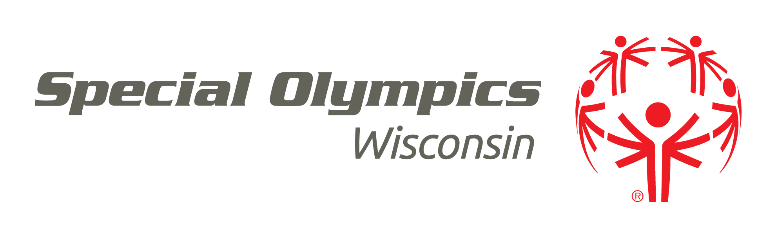
For Accredited Programs, the Special Olympics Logo/Mark includes Symbol, Logotype and Program Name. When incorporating the Special Olympics Wisconsin logo in your materials, please adhere to the following:
- The mark should always be used in its full lockup version (Symbol, Logotype and Program Name) for all official communications including documents, T-shirts, uniforms, banners, etc.
- Our primary color palette includes Special Olympics Red (Pantone® 186) and Special Olympics Grey (Pantone® 418), and are supported by Black, Biscuit (light tan) and White. The logo is available in two color, single color (Special Olympics Red, Special Olympics Grey, or Black) and white. Teal is no longer a part of the Special Olympics primary color palette. Our core objective is to build brand recognition in the color red and our core symbol. Red naturally draws your eye to the symbol.
- Please discontinue using the “be a fan” tagline in any new materials. This official logo should be used on all Special Olympics Wisconsin materials created once your current inventory has depleted.

Ubuntu is the preferred typeface of Special Olympics. It should be used for informational communications produced by Special Olympics. If using Ubuntu typeface within Microsoft Office documents (Word/PowerPoint) please note that these documents should only be shared with third parties or member of the public in PDF format. Otherwise Arial should be used in place of Ubuntu. Arial is available as standard on all PC and Mac computers. Ubuntu is available as a free Mac or P.C. download at font.ubuntu.com.

There are many requirements logo usage as well as other branding standards. Please use the Special Olympics Brand Identity Guidelines, Special Olympics Quick Guide and the Special Olympics Brand Guidelines Frequently Asked Questions found at SpecialOlympicsWisconsin.org as a reference for your questions and to ensure you are properly using the logo. If you are designing uniforms, banners, marketing materials, etc., you can obtain an electronic version of the logo from the SOWI website, by calling your Regional staff, or by contacting the Director of Communications.

Sub-Program (Agency/Region) Logos

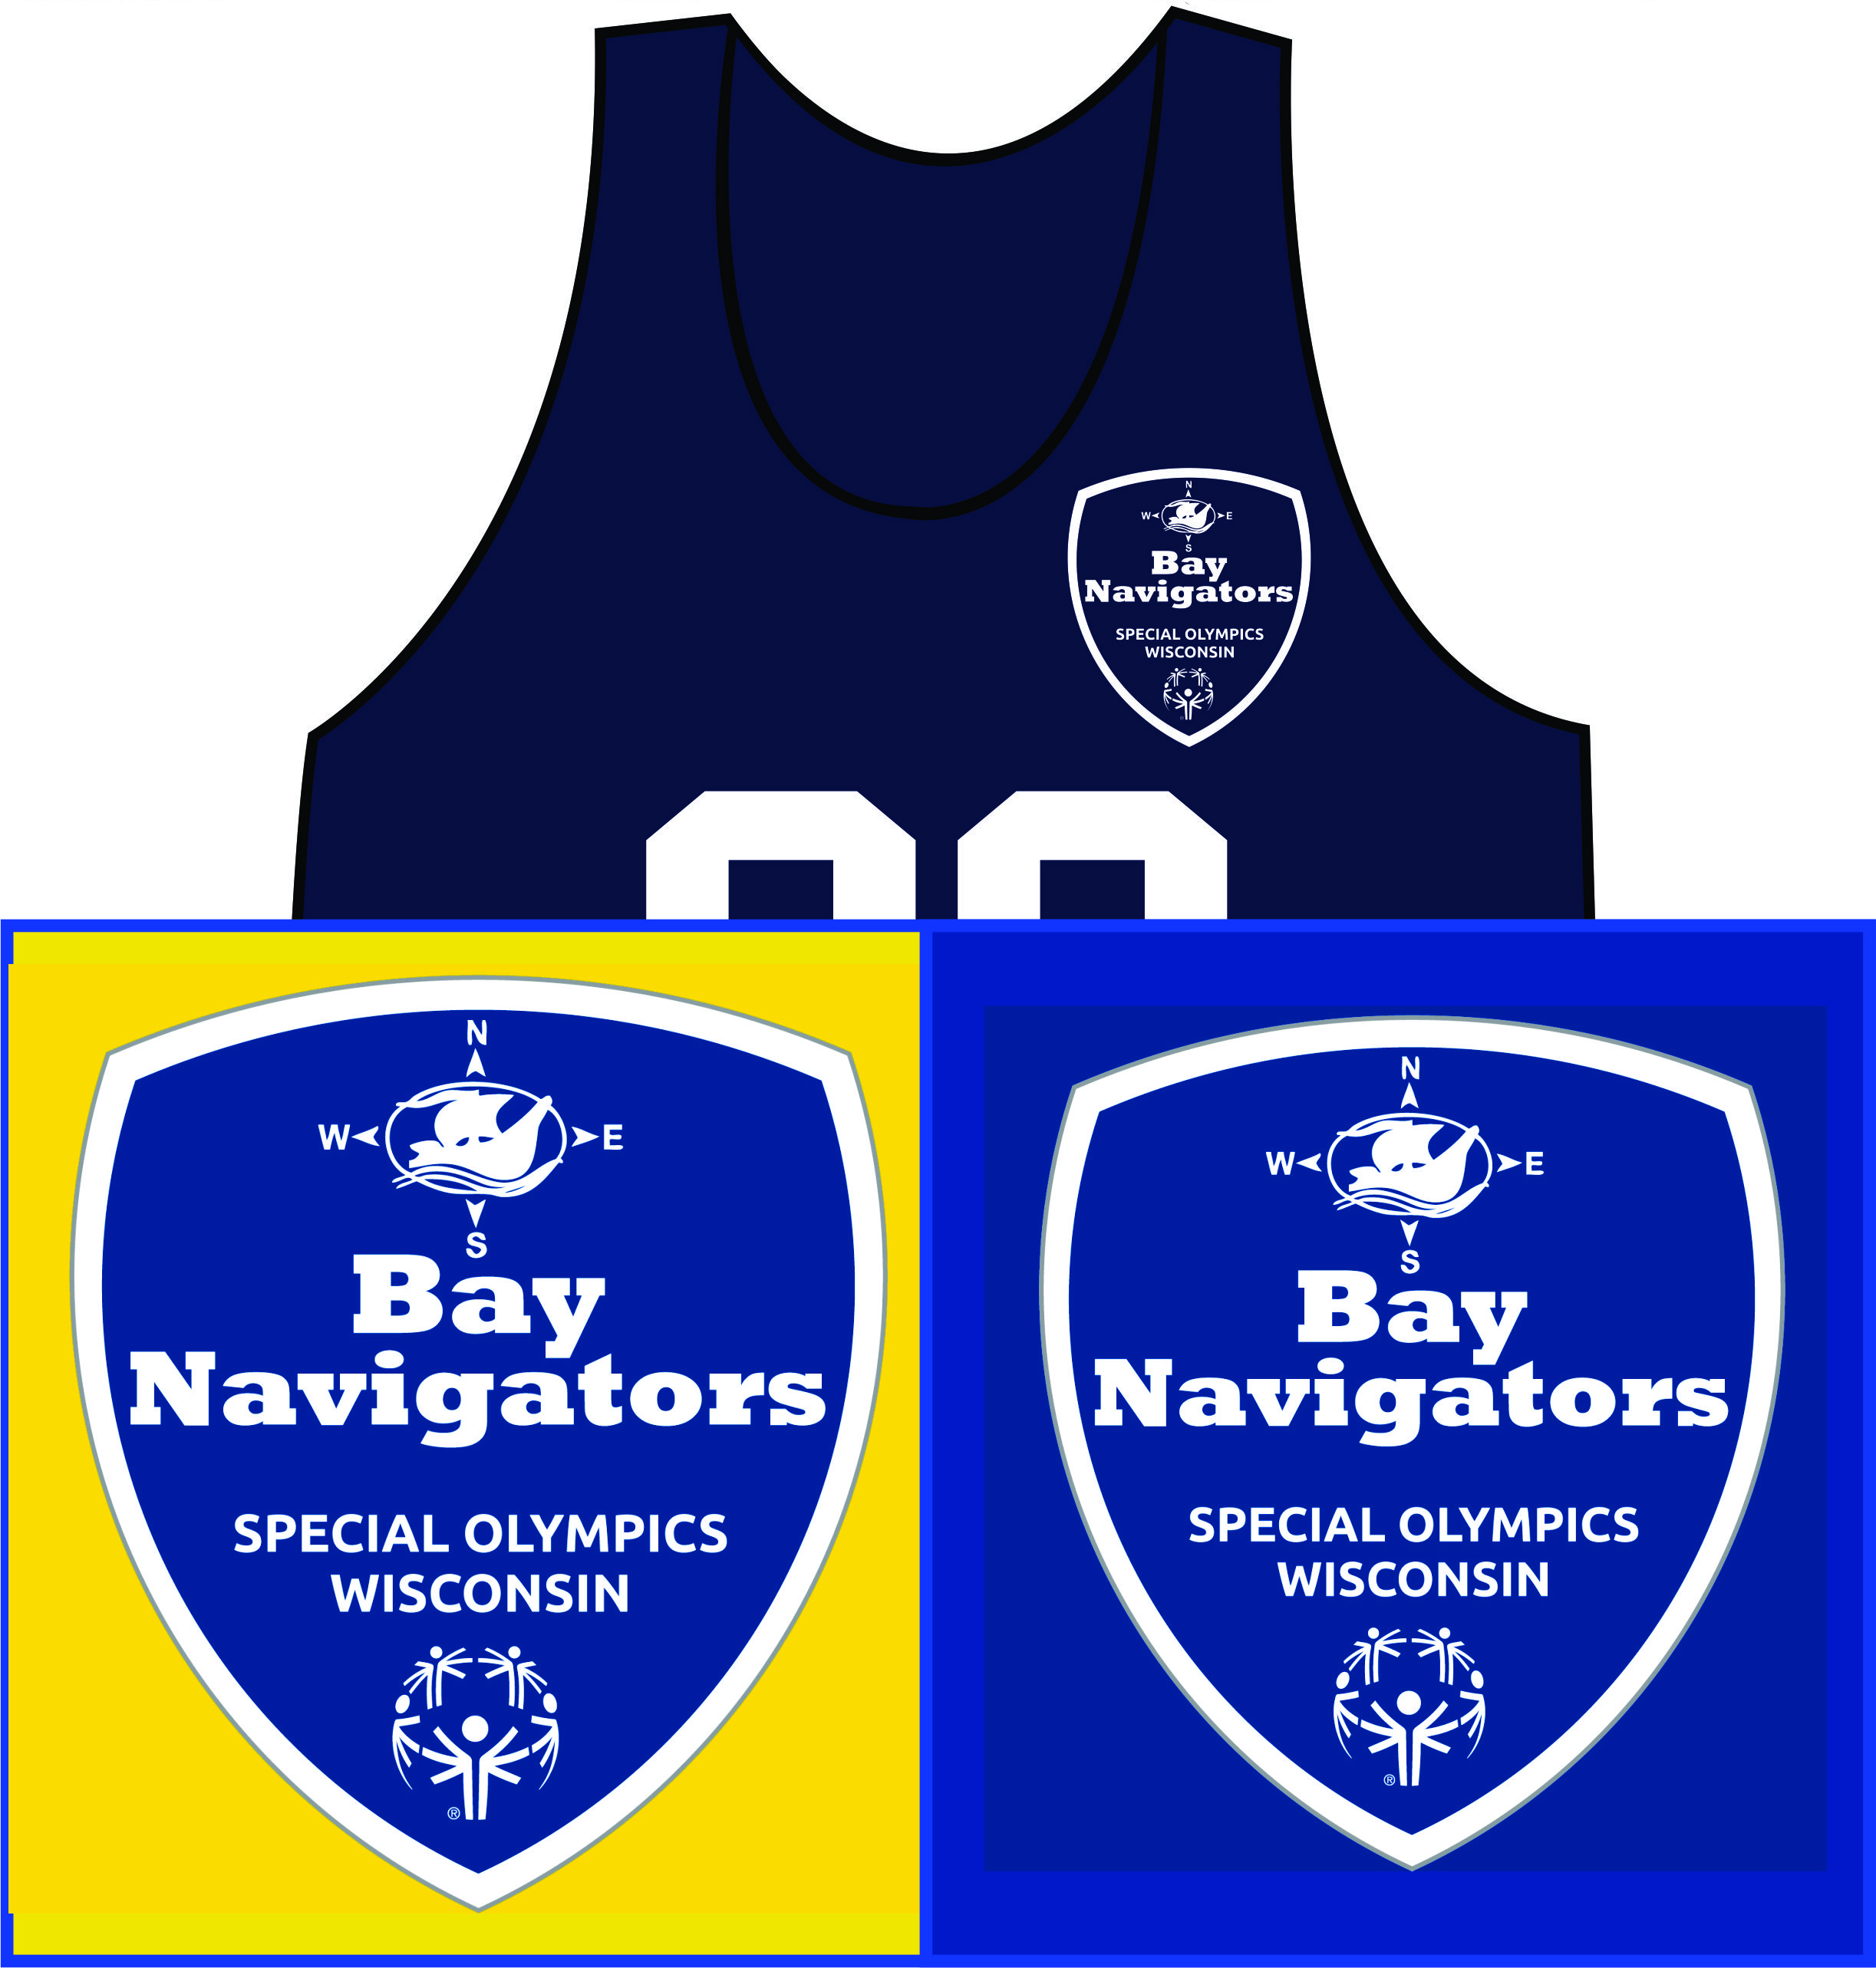
Please look at the “T-shirts” section of the Special Olympics Brand Identity Guidelines (beginning on page 81-84) to see examples of how to implement sub-Program recognition. Please fill out the Branding Request Form found online and contact the Special Olympics Wisconsin Marketing & Communications department to have your designs created and reviewed to ensure the brand guidelines are followed. We will work with you to send the design to your printer. Below are three examples of how the sub-program branding may appear on a T-shirt:
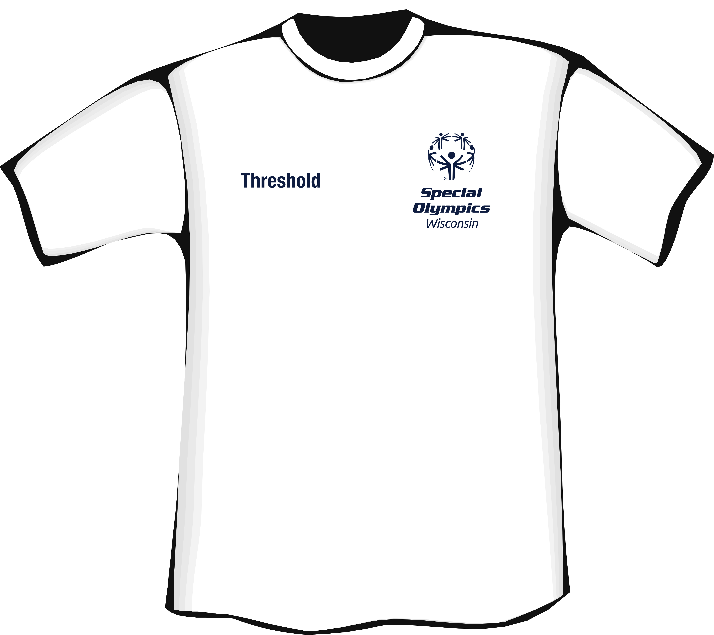
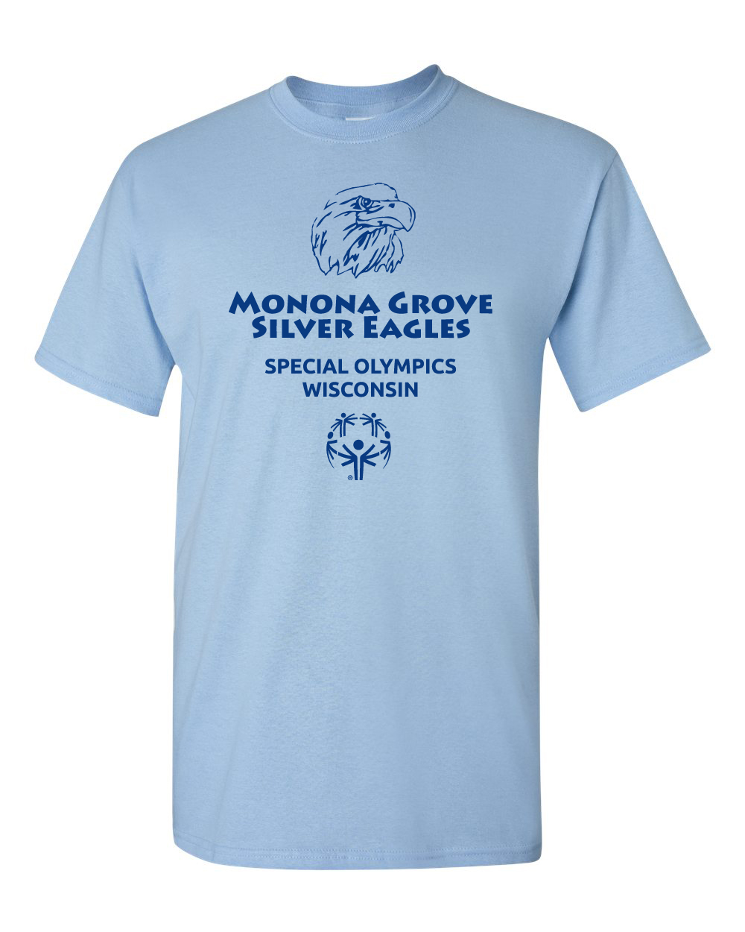

Please read through the “Brand in Action” section of the Special Olympics Brand Identity Guidelines to see examples of how to implement sub-Program recognition on collateral (stationary, brochures, newsletters, etc.). Agencies are able to download templates for e-letterhead, fact sheets, powerpoints, and report covers on the Agency log in of the website.
- To order an Agency banner with the new branding, please download an order form on the Agency log in of the website and submit to the preferred provider listed on the form.
- To order Agency stationary (letterhead, envelopes, and business cards) please submit the order form found on the Agency log in of the website to the preferred provider listed on the form.

Please note: in text/copy form, the accredited Program name should come first, followed by the sub-Program name, with a hyphen or comma between the two. Example: Special Olympics Wisconsin-North Central Region or Special Olympics Wisconsin-Northern Access 2-11.
For general questions about sub-Programs, please read the Brand Guidelines sub-Program FAQ on the Agency log in page of the Special Olympics Wisconsin website. If you have not created a website password, contact the Digital Marketing Manager.

Special Olympics Wisconsin Photograph Release Statement

Pictures are worth a thousand words, and photos of our athletes and volunteers truly tell the story of SOWI.
To compete in any SOWI event, an athlete must have a signed parent/guardian release statement on file (which is part of the athlete registration process to participate in SOWI). Also, signed Class A and Class B volunteer forms serve as a volunteer’s photo release. The statement grants permission for SOWI and the media to use the athlete’s name, likeness, voice and words in television, radio, films, newspapers, magazines and other media for the purpose of promoting and publicizing, educating the public about, and raising funds for Special Olympics.
Should attendees/spectators be photographed, a photo release form should be signed. The form is available for downloading on the Agency log in page of the SOWI website.

Official Special Olympics Wisconsin Credit Line

The official credit line to be used by all Accredited Programs (the "Official Credit Line") consists of the phrases:
Created by the Joseph P. Kennedy, Jr. Foundation. Authorized and Accredited by Special Olympics, Inc. for the Benefit of Persons with Intellectual Disabilities.
The Official Credit Line shall be displayed prominently on all stationery, brochures, annual reports, news releases, and other printed materials, on websites and in films, slides or video presentations, which are produced or distributed by Accredited Programs. When feasible, the Official Credit Line should also be included in television credits displayed in connection with any programming which is filmed and broadcast by a local station within an Accredited Program's jurisdiction.

Language Guidelines

The following language guidelines have been developed by experts in the field of intellectual disabilities for use by anyone writing or speaking about persons with disabilities to ensure that all people are portrayed with individuality and dignity. These are also available in the Media Room on the website.

Appropriate Terminology
- In accordance with the People First bill, please use “intellectual disability” in lieu of “cognitive disability” to describe our athletes.
- A person has intellectual disabilities, rather than is suffering from, afflicted with, or a victim of mental retardation.
- Do not use the adjective unfortunate when talking about persons with intellectual disabilities. Disabling conditions do not have to be life-defining in a negative way.
- It should be said that our athletes are individuals, persons, or people with intellectual disabilities, NOT intellectually disabled people.
- A person uses a wheelchair rather than is confined or restricted to a wheelchair.
- Distinguish between adults and children with intellectual disabilities. Use adults or children or older or younger athletes. Do not use the label kids when referring to Special Olympics athletes. Adult athletes are an integral part of the program.
- “Down syndrome” has replaced “Down’s syndrome” and “Mongoloid.”
- Refer to participants in Special Olympics as athletes. In no case should the word appear in quotation marks.
- A person is disabled rather than crippled.
- Do not use the word “the” in front of Special Olympics unless describing a specific Special Olympics event or official.
- Do not sensationalize the accomplishments of persons with disabilities. While these accomplishments should be recognized and applauded, people in the disability rights movement have tried to make the public aware of the negative impact on referring to the achievements of persons with physical or intellectual disabilities with excessive hyperbole.
- Do not use the word special when talking about persons with intellectual disabilities. The term is distancing and inappropriate and describes that which is different about any person.
- Use the words “Special Olympics Incorporated” when referring to the worldwide Special Olympics Program.
- Refer to persons participating in our programs as Special Olympics athletes, not as Special Olympians.

Spokesperson Tips

Often times, reporters wish to interview coaches, athletes, volunteers, supporters, and family members about their experience at our events.

Committee members, staff, and our athletes are our primary media spokespersons. But anyone could be tapped by a reporter to share their personal story. We are all SOWI spokespersons! Here are a few tips to prepare you to be in the spotlight.

As a spokesperson:
- Relax and speak “from the heart” – you care! Be warm and genuine; don’t be afraid to show your personality.
- State the most important information first.
- Without using athlete last names, share a specific example of how SOWI has made a difference for an athlete’s life.
- EVERYTHING you say to reporters is on the record!
- Never say anything that is untrue or that you cannot be 100% sure about. If you don’t know the answer, just say so!
- Never say, “No Comment.” You lose an opportunity to say something. Bring it back to your message by saying, “I don’t know the answer to that question, but I do know…” or, “What I’m really here to talk about today is…”
- Don’t look at the camera when being interviewed, address the interviewer.
- Reference our language guidelines for appropriate terms for our athletes.
- Reference our talking points for background information about Special Olympics.

If you are asked to speak with a reporter -- before, during or after an event -- and are not interested or unavailable, it's OK to say, "No, thank you." The Communications & PR team wants you to feel comfortable, so another spokesperson can be identified.

In the event of crisis communication, please refer media to the Director of Communications. See later in this section for details.

Special Olympics Wisconsin Messaging and Talking Points

These facts are great for use in media interviews . . .
- Special Olympics Wisconsin provides year-round sports training and athletic competition in a variety of Olympic-type sports to children and adults over the age of 8 with intellectual disabilities, giving them continuing opportunities to develop physical fitness, demonstrate courage, and experience joy.
- Special Olympics is a global organization that unleashes the human spirit through the transformative power and joy of sport, everyday around the world. (Special Olympics Brand Promise).
- Through programming in sports, health, education and community building, Special Olympics is changing the lives of people with intellectual disabilities solving the injustice, isolation, intolerance and inactivity they face throughout the world.
- The Special Olympics values are sportsmanship with joy, athlete leadership, unity, bravery and perseverance.
- With 229 Accredited Programs in more than 170 countries, Special Olympics is providing opportunities for more than 4 million athletes. Special Olympics Wisconsin serves nearly 10,000 athletes in approximately 180 communities across the state.
- Special Olympics reveals the champion in all of us (Special Olympics Guiding Idea). Everyone who comes in touch with Special Olympics is impacted in a way that helps them strive to achieve their personal best.
- Special Olympics is able to remove barriers and stigmas that people with intellectual disabilities face, to share with the community the gifts and talents of people with intellectual disabilities.
- Special Olympics is working to position people with intellectual disabilities as leaders in engendering and sustaining acceptance and respect within schools and communities through inclusive sports, fitness and youth activation programming.
- SOWI offers 17 different sports: Alpine Skiing, Aquatics, Athletics, Basketball (team and skills), Bocce, Bowling, Cross-country Skiing, Flag Football, Golf, Gymnastics (artistic and rhythmic), Powerlifting, Snowshoe Racing, Snowboarding, Soccer, Softball/Tee Ball, Tennis, and Volleyball.
- SOWI holds five state competitions: Winter Games, Indoor Sports Tournament, Summer Games, Outdoor Sports Tournament, and Fall Sports Tournament.
- SOWI hosts three signature events: The Law Enforcement Torch Run®, the Polar Plunge®, and the World’s Largest Truck Convoy®. Over the Edge is held at Miller Park in Milwaukee and Lambeau Field in Green Bay.
- Funding for SOWI is provided by individuals, organizations, foundations, businesses, and the government.

For additional talking points, visit the Media Room at SpecialOlympicsWisconsin.org.

Communicating with the Media

Press releases are the primary channel of communication with the media. We encourage press releases to be used to announce Games, special events, etc. You may also use a press release to find new volunteers or publicize unique or newsworthy accomplishments of athletes, coaches or volunteers. The ultimate goal of a press release is to spark enough interest in the media to get them to publicize it.

SOWI’s Marketing and Communications department is committed to helping you maximize earned media opportunities. Please reference the press release templates available on the Agency log in of the website, include the details to the best of your ability, then submit to the Director of Communications. We will work with you to finalize the release and distribute to your local media outlets.

Helpful Hints:
- Answer questions, “WHO?, WHAT?, WHERE?, WHEN?, AND WHY?” in the first paragraph.
- Avoid including opinions – just the facts. Check your facts carefully.
- Use statistics to help illustrate your point (the event raised more than $$$).
- Point out notable accomplishments of athletes, sponsors, coaches, volunteers, etc.
- E-mail the release a week or two before the event, followed by a phone call or a second e-mail a couple of days before the event.

Agency Communications

It is required that Agencies regularly distribute information to athletes, families, volunteers, sponsors/partners and the general public, as well as to their Regional office.

Information can be distributed timely and efficiently in a newsletter (see example below: the newsletter template found on the Agency log in of the website), regular e-mail updates by the Agency, or through social media.

Maintaining an up-to-date website requires ample time and resources, so SOWI recommends Agencies create a Facebook group (not a Facebook page) to reach your constituents (please see social media policy in this section of the handbook before creating a Facebook group). In any communication your can share information with others in your Agency such as:
- Important dates to remember (competition schedules, medical deadlines, etc.)
- Upcoming events – fundraisers, competitions, etc. or a recap of a past event
- Contact names and numbers
- Any important paperwork needed from coaches or athletes for events
- Stories about a coach or athlete
- Inspiring quotes

There is no such thing as too much communication! To insure that everyone involved with your Agency is up-to-speed, over communicate! People lead busy lives and the more a date is reinforced, the more likely they will remember.

Agency Newsletter Template

Template found on the Agency log in of the website.

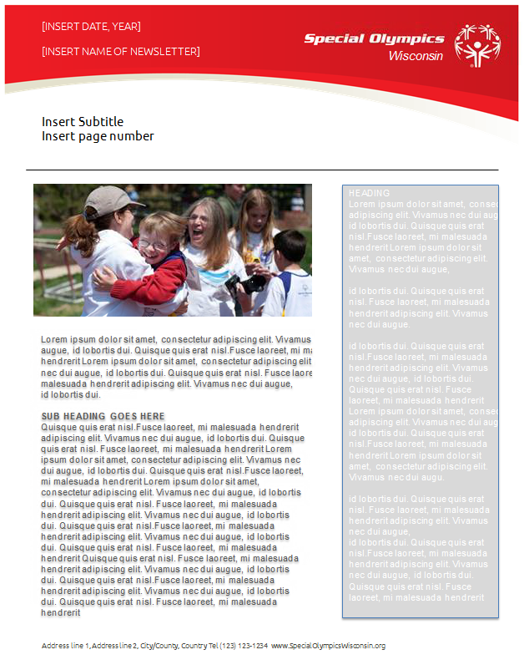

Social Media Policy

Purpose of Social Media
Thanks to social networking sites like Facebook and Twitter, people bond with others by joining online communities not only for personal reasons, but also to promote organizations they care about. Social media allows SOWI employees and volunteers to speak in real-time, with a genuine voice.

Social Media Guidelines
SOWI utilizes one central, branded channel of communications for each primary social media outlet: Facebook, Twitter, YouTube, Flickr, and LinkedIn account. These social media channels are managed and maintained by the SOWI Marketing & Communications department with input for content from the staff and volunteers from our seven Regions.

Agencies may develop a Facebook group to communicate with local audiences. Creating a group is a great way to share photos, stories, practice times, updates, participate in chats, invite members to events, and even upload registration documents. A “group” is a much better tool than a “page” because EVERY member of your group will see EVERY one of your post. With a page Facebook only shows your posts on a page to around 10-16% of your fans.

If you are interested in creating a “group”, please read and follow the Social Media Guidelines found on the Agency log in of the website and contact the Digital Marketing Manager. We will direct you to the following great resources (also available on the Agency log in of the website) to help you get started:
- Copy for your Facebook groups “About us” page
- How to set up a Facebook group (step by step instructions), including adding the Digital Marketing Manager as an admin so they can help connect others to your group.
- Transition posts (if you need help moving your “pages” fans into a “group”)

Five Tips for creating Facebook “groups”
1) Be Responsible
Say what is on your mind, but be cautious that you are representing the organization. Don’t behave differently online than you would in any other public setting. Give a timely response and monitor your conversations. If you don’t have all the facts, do not make them up. Check with a SOWI staff member who has knowledge about the subject before providing an answer or ask this staff member to follow up directly.

2) Consider Your Audience and Bring Value
Your group members are parents, athletes, coaches, teachers, volunteers, Agency managers, donors, sponsors/partners and staff. Consider what you are publishing and make sure it caters to the needs of these individuals without alienating anyone. Consider posting frequency: Find the balance between keeping the community updated and turning them off with too many posts in your group. When deciding whether to post information, decide how much value this will bring to others. Consider the journalistic five W’s and H (Who, Why, When, Where, What, How). How does this impact the people you are communicating with and why do they care?

3) Pick Your Battles and Accept Your Mistakes
Don’t pick fights and be the first to correct your own mistakes. If a Facebook group member says something in poor taste, respond to them politely and try to answer the question or correct the facts in a professional manner.

4) Protect Confidential/ Copyrighted Information and Don’t Cite Donors/Partners without Approval
If it’s questionable, keep it quiet. Ask partners/sponsors, donors, etc. for approval before you link back to their website or tag their Facebook page.

5) Be Transparent
If there is a crisis situation, state what information the organization has agreed to release. Follow the rules stated in the crisis communication plan. Do not release information before instructed by the Director of Communications or appropriate staff member as referenced in the plan. When in doubt, consult the Director of Communications. Social media is a natural way to further SOWI’s mission and we want to work together to do so.

Crisis Communications

A crisis is an unexpected situation or incident posing potential or actual harm to Special Olympics’ reputation and viability. Information about any incident that could have a negative impact on the image of Special Olympics Wisconsin (SOWI), can lead to a crisis situation.

While it is not always possible to anticipate or prevent a crisis, a crisis communication plan is in place to assist at all levels of the organization. Advanced preparation takes some of the tension out of the air, and when dealing with the media, the more you can appear to be in control of the situation, the less likely they are to investigate on their own.

Possible Crisis Situations and Levels of Impact

In the event of a crisis situation at any level, it is critical that the appropriate Special Olympics staff or volunteers are contacted according to the phone tree. If you aren’t sure if the incident qualifies as a crisis, err on the side of contacting the SOWI Crisis Team. Below are levels of crisis situations, some of which require immediate attention to Special Olympics North America (SONA), Special Olympics, Inc. or to Headquarters staff:
Level 1 - A minor incident or accident
- Delayed event (but to be held the same day)
- Sick participant not requiring hospitalization
- Injured participant/spectator/volunteer treated on-site or taken to emergency room but released
- Minor venue property damage
- Severe weather watch
Level 2 - A serious incident, accident or situation
- Canceled event
- Postponed event
- Moved event/change of venue
- Injured or ill participant/spectator/volunteer – requiring hospitalization
- Food poisoning/contamination
- Allegations of wrongdoing by participant/spectator/volunteer/staff/guest or celebrity (if financial, see level 3)
- Missing participant
- Illegal use of drugs/alcohol
- Major venue property damage
- Transportation accident
- Severe weather warning
- Honored Guest concerns, i.e.: crowds, protection, threats
-Contact SOWI, SOWI contacts (SONA), SONA contacts Special Olympics, Incorporated.
- Protests/Demonstrations
-Contact SOWI, SOWI contacts SONA, SONA contacts Special Olympics, Incorporated.
- Allegations or actions against an organization that impacts Special Olympics (i.e., Paralympics)
-Contact SOWI, SOWI contacts SONA, SONA contacts Special Olympics, Incorporated.
- Attack by the media against Special Olympics or constituents
-Contact SOWI, SOWI contacts SONA), SONA contacts Special Olympics, Incorporated.
- Negative campaigning against Special Olympics or Special Olympics-involved party
-Contact SOWI, SOWI contacts SONA, SONA contacts Special Olympics, Incorporated.
- Alleged discrimination against Special Olympics participant within or outside of Special Olympics
-Contact SOWI, SOWI contacts SONA, SONA contacts Special Olympics, Incorporated.

Level 3 - A critical incident or situation
All situations considered Level 3 should be directed to SOWI, SOWI contacts
SONA, SONA contacts Special Olympics, Inc.

- National/State or Provincial declared emergency (i.e., natural disaster, power outage, terrorist attack).
- Actual impact of severe weather (i.e., tornado)
- Flood (if it shuts down office operations)
- Bomb threat
- Contagious health threat or outbreak
- Missing participant or volunteer under suspicious circumstances
- Death of a participant
- Death of spectator or volunteer
- Fire
- Criminal activity
- Financial fraud or fundraising scandal
- Sexual abuse/Arrest of a participant/spectator/volunteer/staff/guest/celebrity

SOWI Crisis Team Phone Tree

Listed below are the names and telephone numbers (work and cell) of the SOWI Crisis Team in preference order. The Crisis Team will contact Special Olympics North America (SONA) and/or American Specialty if deemed necessary as well as consult with an attorney if death, serious injury, loss of property or allegations of wrongdoing by the Program occurs.
Contact | Work Telephone (during Business Hours) | Cell Phone
Chief Operating Officer | (608) 442-5663 | (608) 770-7902
Director of Communications | (608) 442-5672 | (262) 389-5210
VP of Marketing | (608) 442-5669 | (608) 469-5242

This chart provides contact information for emergency assistance as well as a space to insert your area key emergency/medical relief organizations.

Contact | Work Telephone | Cell Phone
Insurance Emergency Claims Service | (800) 566-7941 (24 hours a day, 7 days a week)
General Emergency | 9-1-1
Local Police Department

Local Fire Department

Local Medical Facility

Notification of Crisis to Special Olympics Wisconsin

The following steps should be taken by staff/volunteers in the event of a crisis situation:

- In case of an emergency, determine whether proper authorities have been notified (e.g., police, fire department, rescue squad). The first priority is to prevent further injury and give necessary treatment to individuals who are injured.
  - Attend to and assess any victims.
  - Request first aid assistance or call 9-1-1. Have medical information ready if applicable.
  - Administer CPR by a qualified person only, if it is appropriate. Instruct volunteer(s) to not render any treatment beyond his/her training. Do not move an injured individual unless he/she is in immediate danger.
  - Request staff/volunteers to maintain crowd control.
  - If an ambulance is not necessary and a family member/guardian/friend cannot accompany the victim to the hospital, either stay with the individual or appoint someone to do so until a family member/guardian/friend can arrive.

- If necessary, take a count of athletes, coaches, volunteers, etc. to keep the group together, whether in a hotel or at an event (remember to always keep a list of individuals who are attending the event with your team).

- Contact the Crisis Communication Team as listed on the Crisis Team Phone Tree.

- If necessary, the SOWI staff will notify appropriate field staff, the insurance company, legal representative, athlete/family members, Board of Directors, key sponsors/volunteers, Special Olympics North America or Special Olympics, Inc.

- Cooperate with any medical personnel and/or law enforcement in completing any necessary paperwork.

- In the event of media presence, the standard response is, “A statement will be released by SOWI after the organization has gathered all the facts and has time to review the situation.” Refer all media to call the Director of Communications or the available member of the Crisis Team. The Special Olympics Wisconsin Crisis Team representative will gather all facts (which will be kept confidential) and formulate a statement to release to the media. Credibility is built much easier if a select few remain the lead contacts. Follow the steps in the “Crisis Communication Flow” section and fill out the “Crisis Fact Sheet” (in this section). While volunteers’ assistance will be requested in providing information to the crisis team for the preparation of an official statement, under no circumstance should a volunteer attempt to answer questions from media representatives at the scene. A hasty response lends itself to the emotions of the crisis and can very often be misinformation, which may damage the program. Such misinformation is hard, if not impossible, to correct.

- Record names and phone numbers of directly involved individuals present at the time of the incident for use on the Incident Report Form and for subsequent questions.

- Once incident/crisis is over and all involved have been released to their own supervision or the supervision of others, call the Crisis Team to appraise the status.

- Complete an Incident Report Form and submit to Special Olympics Wisconsin within 24 hours (see “Forms for Duplication” section of the Agency Manager Handbook).

Crisis Communication Response Flow

- First Response to the Media: The Crisis Team representative will need to gather facts from all involved for the preparation of an official statement. If anyone is questioned before facts are gathered, NEVER REPLY WITH “NO COMMENT.” The reply should be:
“A statement will be released by Special Olympics Wisconsin after the organization has gathered the facts and has time to review the situation.”

Misinformation and rumors can be extremely dangerous to all levels of the organization. You have no obligation to answer any questions you do not want to answer and we ask you to please refer all media calls to the Crisis Team representative.

- Identify the Crisis: Using the “Potential Levels of Crisis” document, determine the level of crisis.

- Fact Gathering: The Crisis Team representative may need your assistance completing the “Crisis Fact Sheet” below. These facts should be kept confidential and not released to media or by any party involved in the incident.

Crisis Fact Sheet

Detailed location of incident.

Name of individual reporting the situation (name and contact information, include primary and secondary phone numbers, e-mail and mailing address). How is this person involved with Special Olympics?

Who else is involved or present (names and contact information)?

What happened?

When did it happen (include date and time)?

Was there any injuries, fatalities or damage? Explain in detail.

What actions have already been taken? Have law enforcement or other Agencies been contacted?

Was Special Olympics, Inc. Headquarters, SOWI or the Regional office notified? If so, who was contacted?

Has there been any media attention? If so, what outlet(s) (e.g., television, radio, newspaper, magazine, Internet)? Cite specific media alerted.

Other comments?

Materials Available Online

- Brand Identity Guidelines
- Special Olympics Brand FAQ
- Special Olympics Branding webinar
- Special Olympics Messaging and Talking Points
- Special Olympics Style Guide
- Special Olympics sub-Program FAQ
- Branding Request Form
- SOWI Stationary Order Form
- SOWI Banner Order Form
- Electronic Letterhead
- Photo Release Form (for those not covered by SOWI athlete, volunteer, or fundraising event releases)
- SOWI Social Media Tools and Policy information
- Press Release Template
- SOWI Report Cover Template
- SOWI PowerPoint Template
- SOWI Newsletter Template
- Headquarters Office Informational Brochure & Matching folder
- SOWI Statewide Fact Sheet
- Region Fact Sheets
- Agency Fact Sheet Template and sample
- SOWI Families and Friends Handbook
- SOWI Prospective Agency Packet
- Video/DVD library of many of the programs and topics listed above (available on YouTube or upon request)
- Photo Release Form

