

**WISCONSIN LAW ENFORCEMENT TORCH RUN®**

**DALE BRUNNER HALL OF FAME AWARD**

***The Wisconsin Law Enforcement Torch Run® Dale Brunner Hall of Fame Award recognizes outstanding individuals who have significantly contributed to the statewide success of the Law Enforcement Torch Run® for Special Olympics Wisconsin.***

**2015 Inductees**

Andrew J. Dewitt, Wisconsin Rapids Police Department

David Kleinhans, Department of Justice

Robert Roeske, Retired, Rothschild Police Department

**2014 Inductees**

Lori Casper, Dane County Sheriff’s Office

Jeff Smith, Retired, West Allis Police Department

**2013 Inductees**

Dennis Alldridge, Special Olympics Wisconsin

Mark Mauthe, Menasha Police Department

Jennifer Merlin, Department of Corrections

**2012 Inductees**

Mark Horstmann, Verona Police Department

Brian Krueger, Sheboygan Police Department

**2011 Inductees**

Dave Gerber, Walworth County Sheriff’s Office

Kathy Schult, Milwaukee Police Department

**2010 Inductees**

Jenny LeBelle, Winnebago County Sheriff’s Office

Gene Rousseau, Retired, Brown County Sheriff’s Office

Michael Teem, Honorary Induction, Raleigh (NC) Police Dept.

**2009 Inductee**

Daryl Pries, Cadott Police Department

**2008 Inductees**

Dan Brauer, Glendale Police Department

Tammy Kubisiak, Grand Rapids Police Department

**2007 Inductees**

Peggy Frank, City of Eau Claire

Mark Moan, Jackson County Sheriff’s Office

**2006 Inductees**

Richard LaMunyon, Honorary Induction, Founder Law Enforcement Torch Run® for Special Olympics, Kansas

John Graham, Retired, Fond du Lac Police Department

Colleen Handrick, Globe University

Ray Merlin, Kenosha County Sheriff’s Office

Anthony Zblewski, Stevens Point Police Department

**2005 Inductees**

Julie (Buedding) Drake, Special Olympics Wisconsin

Lisa Walter, UW-Stout Police Department

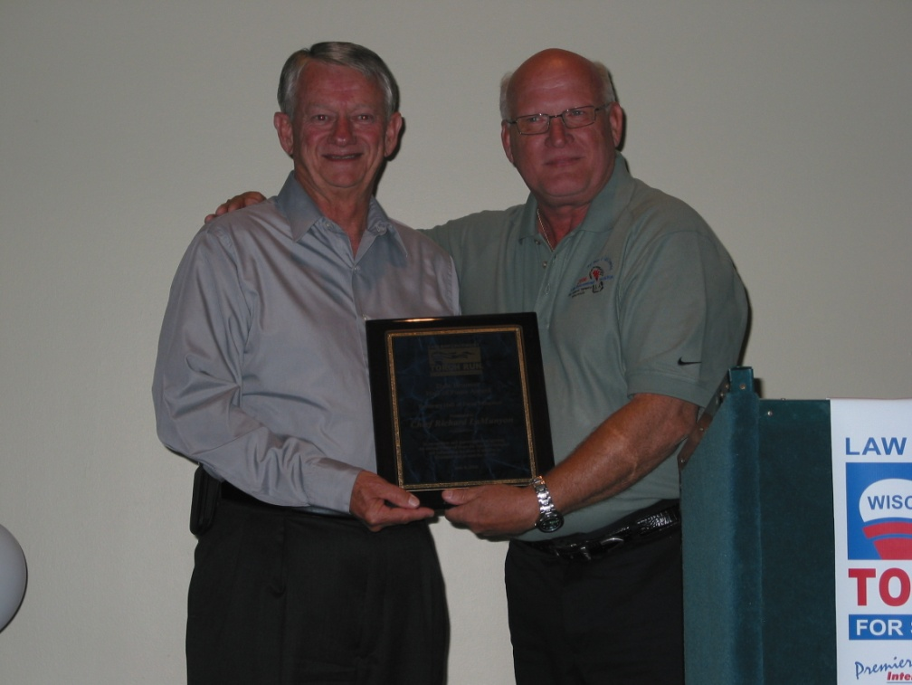

**2004 Inductees**

John Fischer, Retired, New Berlin Police Department

Gerry Flunker, Appleton Police Department

**2003 Inductee**

Andrew Garcia, Retired, Madison Police Department

**2002 Inductees**

John Boyer, Retired, Oneida County Sheriff’s Office

Jason Plaza, Marathon County Sheriff’s Office

**2001 Inductees**

James Briggs, Retired, Marinette County Sheriff’s Office

John Charewicz, Portage County Sheriff’s Office

**2000 Inductee**

Doug Rosemeyer, Presented Posthumously

**1999 Inductee**

The Onalaska Police Department & Chief Randy Williams

Chief Richard LaMunyon, Founder of the Law Enforcement Torch Run®, with Dale Brunner, Wisconsin’s first LETR Director

**SELECTION:**

An individual, a law enforcement agency or a Special Olympics program may submit nominations/applications. All nominations and/or applications should include a completed nomination form that is provided in this packet. There may be one or more inductees per year, to provide for the growing number of quality applicant and/or nominees. The Selections Committee determines the decision as to the number of inductees and the selection.

**CRITERIA:**

The nominee’s involvement shall demonstrate a **sustained and significant contribution** to the achievement of the goals of the Law Enforcement Torch Run®. The minimum requirements for this award are at least five (5) years of participation with the Torch Run, achievement in program development, organization and fund raising success. (We recognize our athletes in numerous ways, including leadership awards such as the Mike Schulte Athlete Leadership Award and the Special Olympics Male and Female athlete of the year’s awards; therefore they are not eligible for this award.)

**PROCESS:**

Nominees whom are not selected will remain in consideration for two (2) years. Supportive nominee information may be supplied each year. At the end of two (2) years, nominees’ files will be removed unless re-nominated.

All nominations or inductees will be kept confidential with inductees being announced at the Law Enforcement Torch Run® Celebration Party on Thursday, June 9, 2016 in Stevens Point.

All nominees will receive a letter of recognition from the Chair of the Selections Committee in honor of their nomination with a copy to the nominee’s agency.

**All 2016 Nomination Forms must be returned by Friday, April 15, 2016 to:**

**Julie Drake**

**Director of Development, Law Enforcement Torch Run®**

**Special Olympics Wisconsin**

**2310 Crossroads Drive, Suite 1000**

**Madison, WI 53718**

**608-442-5668**

**800-552-1324 Ext. 5678**

**Fax: 608-222-3578**

[JDrake@specialolympicswisconsin.org](mailto:JDrake@specialolympicswisconsin.org)

******Wisconsin Law Enforcement Torch Run®**

**Dale Brunner Hall of Fame Award**

**Nomination Form**

**Nominee Information:**

|  |  |
| --- | --- |
| Rank/Title and Name of Nominee: |  |
| Cell Phone: |  |
| Fax: |  |
| Law Enforcement Agency: |  |
| Business Address: |  |
| City, State & Zip: |  |
| E-mail Address: |  |
| Nominee’s Supervisor’s Contact Information including Name/Phone number/E-mail address: |  |

**Criteria for this award:**

The nominee’s involvement must demonstrate a sustained and significant contribution to the achievement of the goals of the Law Enforcement Torch Run®. The minimum requirements for this award are at least five years of participation with the Torch Run, achievement in program development, organization and fund raising success.

|  |  |  |
| --- | --- | --- |
| 1. | How many years has the nominee been involved with the Torch Run? |  |
| 2A. | Please list the nominee’s involvement with **Special Olympics and the Torch Run**. Please be specific and highlight activities, positions held (coaching athletes, etc), accomplishments, length of service, money raised, sponsors acquired, etc. – Local involvement (town, city): |  |
| 2B. | Please explain any State or National involvement: |  |
| 2C. | Please explain any International involvement: |  |

|  |  |  |
| --- | --- | --- |
| 3. | What impact has this person had on furthering the mission of the Wisconsin Torch Run? |  |
| 4. | Please list any other information you believe the selection committee should know about the nominee. |  |
| 5A. | Has the nominee attended any International conferences? | □ Yes □ No |
| 5B. | If yes, what year(s): |  |

**Person Completing This Form:**

|  |  |
| --- | --- |
| Your Name: |  |
| Law Enforcement Agency/Organization: |  |
| Phone (day): |  |
| Fax: |  |
| E-mail Address: |  |
| Street Address |  |
| City, State, Zip: |  |
| Special Olympics Region: |  |
| Involvement with Torch Run (Regional Director/ Staff) |  |

**Nominations must be postmarked no later than Friday, April 15, 2016 and sent to**:

Julie Drake

Director of Development, Law Enforcement Torch Run®

Special Olympics Wisconsin

2310 Crossroads Drive, Suite 1000

Madison, WI 53718

608-442-5668

800-552-1324 Ext. 5668

Fax: 608-222-3578

[JDrake@specialolympicswisconsin.org](mailto:JBuedding@specialolympicswisconsin.org)