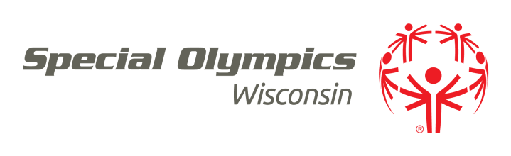

SPECIAL OLYMPICS WISCONSIN

POSITION DESCRIPTION

**TITLE**

Regional Athletic Director

**DESCRIPTION**

The Regional Athletic Director manages all competition and training opportunities for regional athletes as well as providing on-going sports training and technical support to the Agencies within the Region. This position works directly with the Headquarters Office and other Regional directors as part of a team designed to the coordinate and run the entire sports program for Special Olympics Wisconsin. In addition, the Regional Athletic Director will work with the community and other Headquarters Staff to promote Special Olympics, recruit athletes and volunteers, coordinate programs, and assist local agencies in accordance with established policies in order to further achieve the goals, objectives, standards and mission of Special Olympics Wisconsin. This position is exempt.

**QUALIFICATIONS**

* Bachelor’s degree in Sports Management, Recreation, Adaptive Physical Education, or at least three years of related experience
* Experience and knowledge of sports, event management, volunteer management and persons with intellectual disabilities
* Strong Computer skills (Experience with Windows and Microsoft Office preferred)
* Excellent communication and organizational skills
* Valid Wisconsin driver’s license
* Ability to make presentations to groups
* Night and some weekend work may be required

**RESPONSIBILITIES**

* Abide by the SOWI Guiding Values
* Participate with the Vice President of Program Services and other Regional Athletic Directors in creation and coordination of the statewide sports plan including traditional sports and Unified sports for Special Olympics Wisconsin
* Recruit and manage volunteers, volunteer committees and/or athletes to work/attend sporting events
* With Regional Director of Development, prepare and submit annual budget
* Review and approve monthly budget statements
* Approve, code and forward all invoices to the Program Office for payment
* Manage all regional sports competitions, traditional and unified, in accordance with the standards and rules of Special Olympics Incorporated and SOWI.
* Participate as an active member of State Games Management Teams and recruit, train and direct volunteers for State Games located in the Region.
* Initiate and maintain working relationships within the local sport professional community including local athletic departments (high school, college and professional). Recruit experienced and sports knowledgeable volunteers to serve as games directors for each regional competition, and manage capable, productive committees to assist with regional sports management and competitions.
* Serve as a resource and support for regional Agencies and coaches with regard to training, competition and Unified Sports.
* Provide regular communication of activities and events within the region to Agencies, coaches, families, volunteers and the Headquarters office.
* Abide by and uphold compliance to regional deadlines.
* Attend meetings, public speaking events, workshops, seminars, clinics, conferences and program events and serve on committees and task forces as needed.
* Support Special Olympics Incorporated and Special Olympics Wisconsin fundraising projects as directed.
* Promote and carry out the mission of Special Olympics.
* Other duties as assigned by the Vice President of Program Services.

**SUPERVISION RECEIVED**

The Regional Athletic Director reports to the Vice President of Program Services of Special Olympics Wisconsin.

**SUPERVISION EXERCISED**

The Regional Athletic Director has direct supervisory responsibility for all regional competition volunteer staff and the Games Management Teams (GMTs). The Regional Athletic Director also has responsibility to provide supervision and management assistance to Agency Managers, regional competition volunteers and coaches.

***MISSION***

*The mission of Special Olympics Wisconsin is to provide year-round sports training and athletic competition in a variety of Olympic-type sports for children and adults with intellectual disabilities, giving them continuing opportunities to develop physical fitness, demonstrate courage, experience joy and participate in a sharing of gifts, skills and friendship with their families, other Special Olympics athletes and the community.*

__ __________________

Regional Athletic Director Signature Date