Thank you for contacting us to create your Agency’s team uniform.
Please mark which of the following three options you would like to use on your Agency’s team uniforms.
Please note, two of the three options have multiple designs, so please indicate which option (1, 2 or 3) and which design (a, b, c, etc.) you would like to use. In the blanks below describe what colors, font and illustration (if you should choose to use one) you would like to use. Please note that while each example below varies in style of uniform (t-shirt, polo, jersey etc.), Agencies can choose what style uniform their team will wear. Once completed, e-mail this form to the Marketing & Communications Assistant at krozenbergs@specialolympicswisconsin.org.

*If you have an illustration that you would like to use for options 2 or 3, please attach the image in an e-mail.

Option 1: Special Olympics Wisconsin Logo

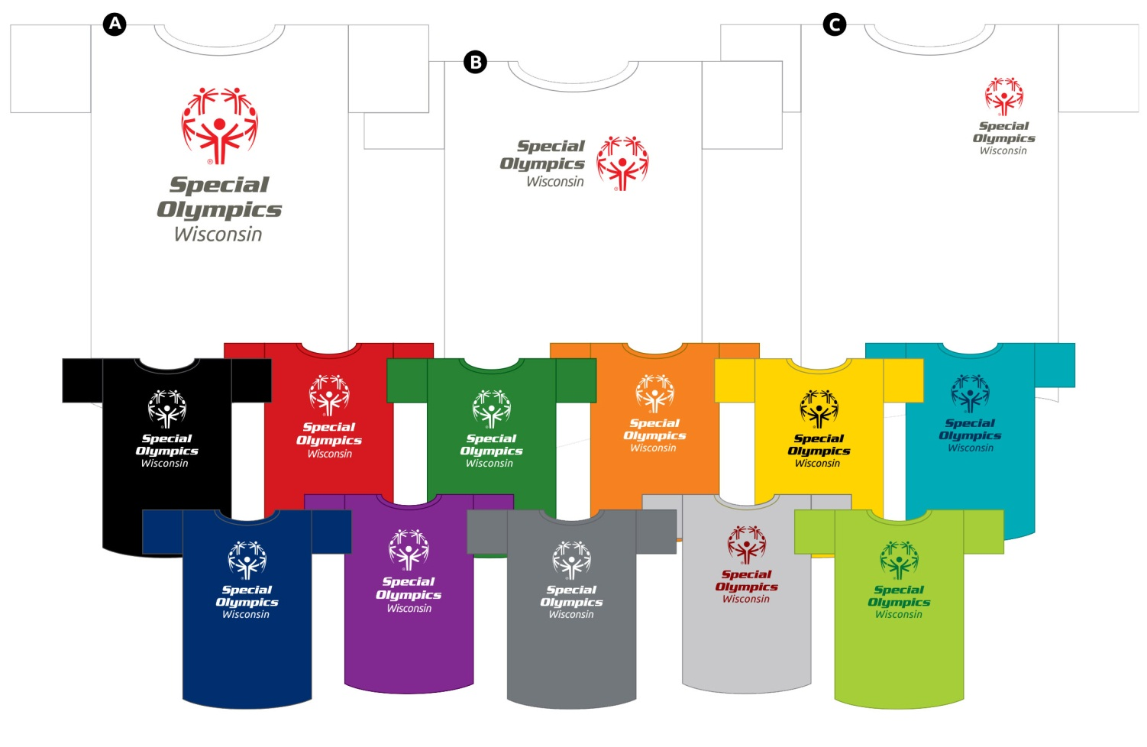

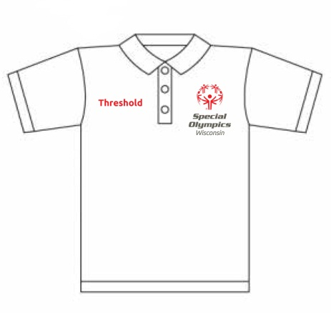

Examples of color range and usage.

Color(s):______________________________________________________________________________________________________________________________________________________________________________________Font(s):_______________________________________________________________________________________________________________________________________________________________________________________
Notes:________________________________________________________________________________________________________________________________________________________________________________________

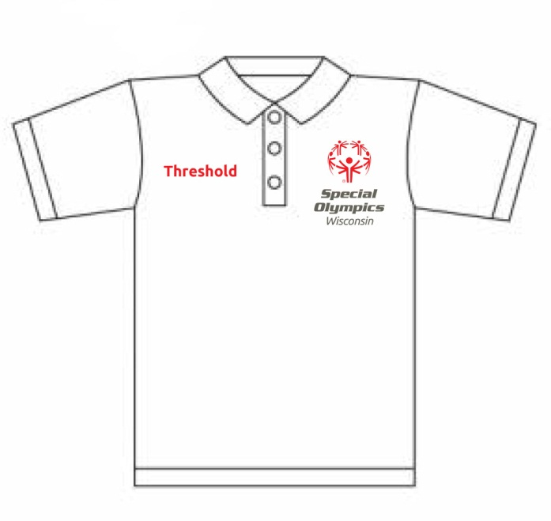
Color(s):______________________________________________________________________________________________________________Font(s)________________________________________________________________________Notes:________________________________________________________________________________________________________________
D

E
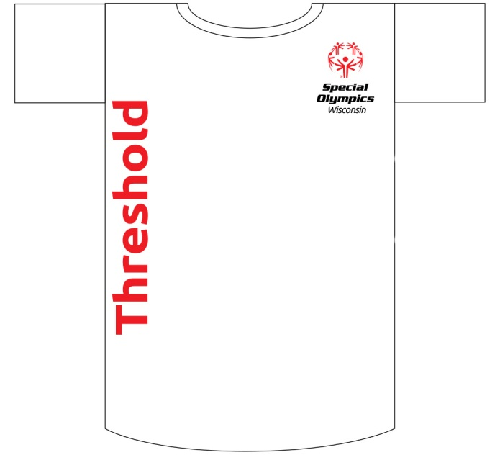
Color(s)______________________________________________________________________________________________________________Font(s)________________________________________________________________________Notes:_________________________________________________________________________ _______________________________________

Option 2: Team Mark or “Lock-up”
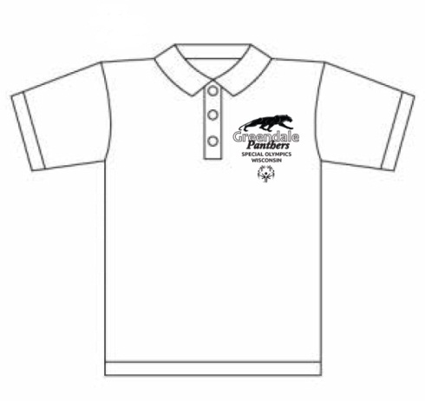
Color(s):______________________________________________________________________________________________________________Font(s):________________________________________________________________________Notes:________________________________________________________________________________________________________________
A

Color(s):______________________________________________________________________________________________________________Font(s):________________________________________________________________________Notes:________________________________________________________________________________________________________________
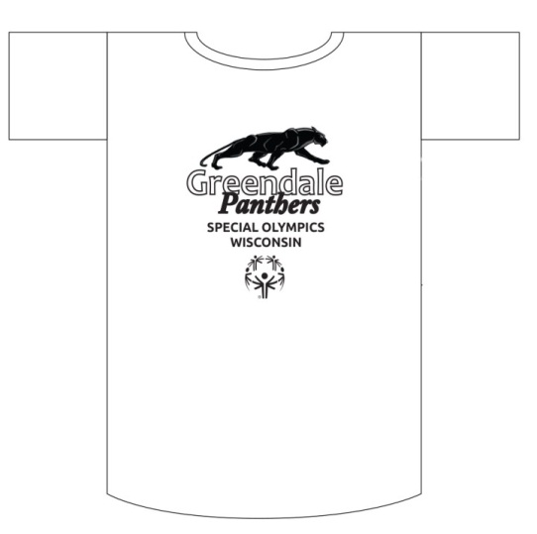
B

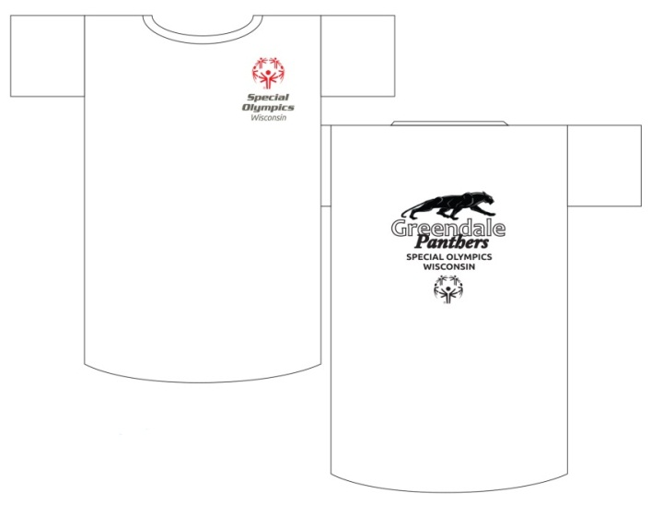
C
Color(s):______________________________________________________________________________________________________________Font(s):________________________________________________________________________Notes:________________________________________________________________________________________________________________

Front

Back

Option 3: Team Badge
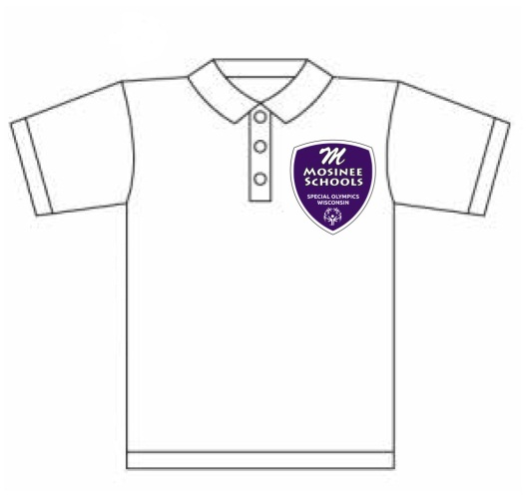
Color(s):______________________________________________________________________________________________________________Font(s):________________________________________________________________________Notes:________________________________________________________________________________________________________________

