Northern Access Special Olympics Agency #2-11  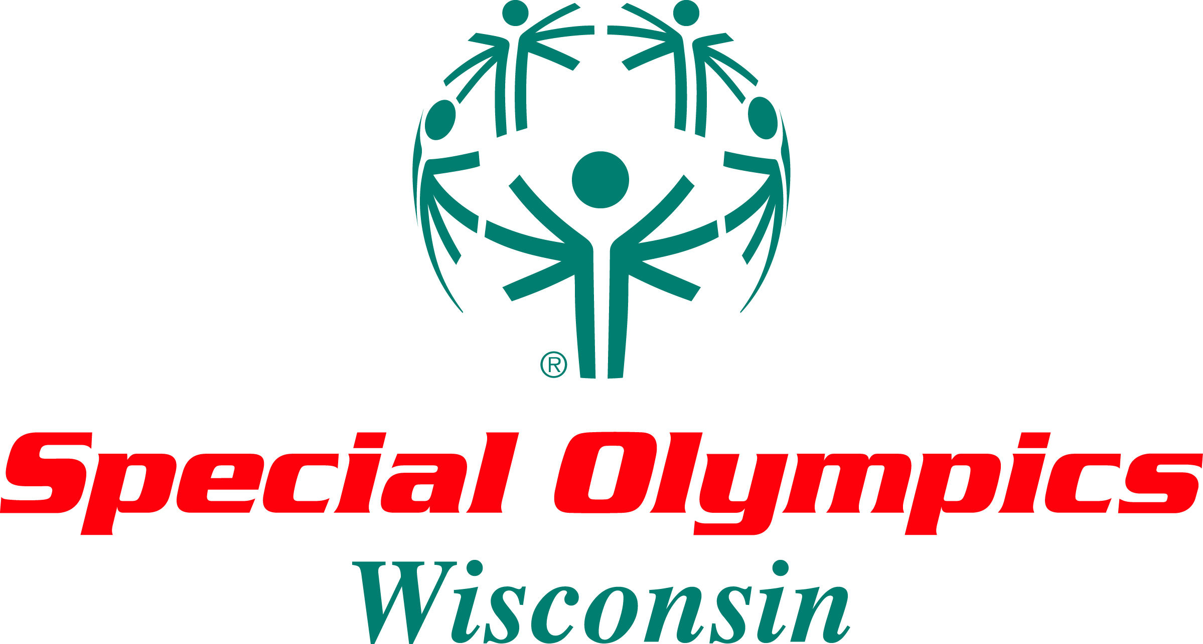  Jessica Chuckel – Agency Manager  Phone: 715.891.5447  Emily Rhode – Agency Co-Manager  Phone: 715.891.5902  PO Box 1835  Eagle River, Wisconsin 54521  Website: www.northernaccess.org  Email: info@northernaccess.org | Northern Access Special Olympics Agency #2-11  Jessica Chuckel – Agency Manager  Phone: 715.891.5447  Emily Rhode – Agency Co-Manager  Phone: 715.891.5902  PO Box 1835  Eagle River, Wisconsin 54521  Website: www.northernaccess.org  Email: info@northernaccess.org
Northern Access Special Olympics Agency #2-11  Jessica Chuckel – Agency Manager  Phone: 715.891.5447  Emily Rhode – Agency Co-Manager  Phone: 715.891.5902  PO Box 1835  Eagle River, Wisconsin 54521  Website: www.northernaccess.org  Email: info@northernaccess.org | Northern Access Special Olympics Agency #2-11  Jessica Chuckel – Agency Manager  Phone: 715.891.5447  Emily Rhode – Agency Co-Manager  Phone: 715.891.5902  PO Box 1835  Eagle River, Wisconsin 54521  Website: www.northernaccess.org  Email: info@northernaccess.org
Northern Access Special Olympics Agency #2-11  Jessica Chuckel – Agency Manager  Phone: 715.891.5447  Emily Rhode – Agency Co-Manager  Phone: 715.891.5902  PO Box 1835  Eagle River, Wisconsin 54521  Website: www.northernaccess.org  Email: info@northernaccess.org | Northern Access Special Olympics Agency #2-11  Jessica Chuckel – Agency Manager  Phone: 715.891.5447  Emily Rhode – Agency Co-Manager  Phone: 715.891.5902  PO Box 1835  Eagle River, Wisconsin 54521  Website: www.northernaccess.org  Email: info@northernaccess.org
Northern Access Special Olympics Agency #2-11  Jessica Chuckel – Agency Manager  Phone: 715.891.5447  Emily Rhode – Agency Co-Manager  Phone: 715.891.5902  PO Box 1835  Eagle River, Wisconsin 54521  Website: www.northernaccess.org  Email: info@northernaccess.org | Northern Access Special Olympics Agency #2-11  Jessica Chuckel – Agency Manager  Phone: 715.891.5447  Emily Rhode – Agency Co-Manager  Phone: 715.891.5902  PO Box 1835  Eagle River, Wisconsin 54521  Website: www.northernaccess.org  Email: info@northernaccess.org
Northern Access Special Olympics Agency #2-11  Jessica Chuckel – Agency Manager  Phone: 715.891.5447  Emily Rhode – Agency Co-Manager  Phone: 715.891.5902  PO Box 1835  Eagle River, Wisconsin 54521  Website: www.northernaccess.org  Email: info@northernaccess.org | Northern Access Special Olympics Agency #2-11  Jessica Chuckel – Agency Manager  Phone: 715.891.5447  Emily Rhode – Agency Co-Manager  Phone: 715.891.5902  PO Box 1835  Eagle River, Wisconsin 54521  Website: www.northernaccess.org  Email: info@northernaccess.org

