Special Olympics Wisconsin-[insert Agency Name here]

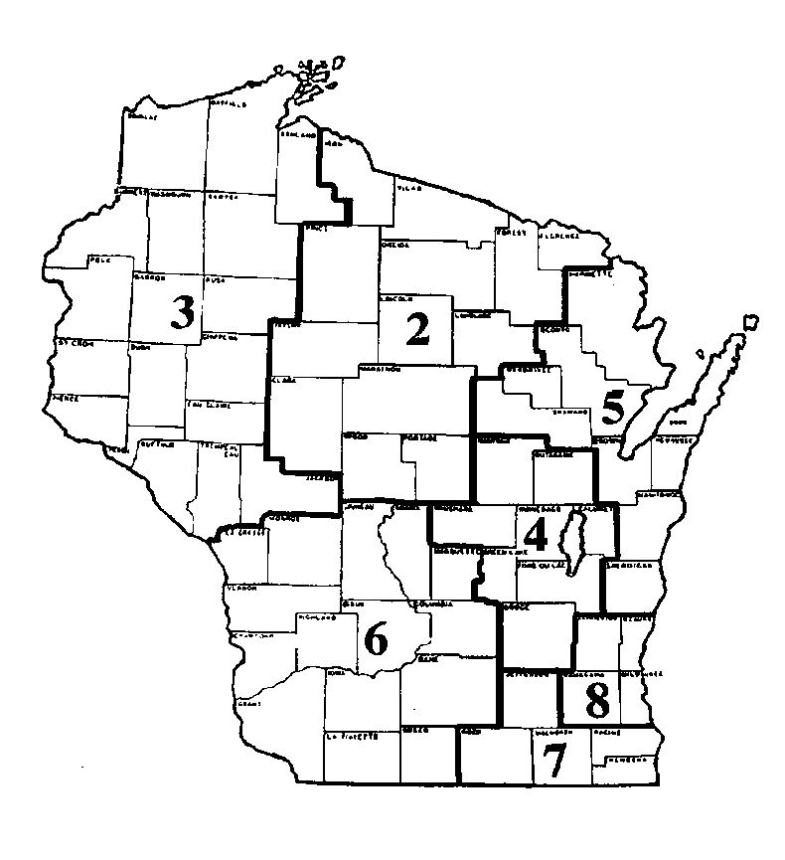
Agency Office:

Agency Manager:

Athletes Served:

Communities Served:

Volunteers Used:

Sports Offered:

Volunteer Opportunities:

Events:

What Funds Raised Go Toward:

Other Interesting Information:

