FOOTBALL (SOCCER)

2016 GENERAL RULES

The Official Special Olympics Sports Rules shall govern all Special Olympics football (soccer) competitions. As an international sports program, Special Olympics has developed these rules based upon Federation Internationale de Football Association (FIFA) rules for football (soccer). FIFA rules shall be employed except when they are in conflict with the Official Special Olympics Sports Rules. For more information, visit www.fifa.com.

OFFICIAL Events offered:
1. Five-a-Side Soccer
NOTE: Teams must play a minimum of two (documented) games against other Special Olympics teams prior to registration for district competition (unified teams must play unified teams). The team roster must remain the same for the two qualifying games, district competition and State competition. Teams that modify their rosters will forfeit all games. Qualifying games must be played against other teams with an Intent to Play Form on file. One game must be played against a team from another Agency. Forfeited games do not count toward the scrimmage requirement.

SECTION A – RULES FOR COMPETITION
1. Team Competition
a. Divisioning
1) Teams will be divisioned according to coaches' input and scores of at least two games played versus other Special Olympics teams.

2) The head coach must identify his/her seven best players in terms of their onfield playing ability by placing a star next to their names on the roster.

2. Modifications
a. The playing time of the game shall be 30 minutes. There shall be two equal halves of 15 minutes each with a five-minute interval between halves. Teams must be ready to field a legal team within 10 minutes of the official declaring the game started or the game will be forfeited.

b. Offsides will not be called.

c. In tournament play, if the score remains tied at the end of regulation time, one five-minute period shall be played to completion (not sudden death). If at end the score is still tied, then a second five-minute period will be played to completion. The winning team will be awarded three points and the losing team zero points, or if a tie each team will be awarded 1 point.

1) If the score remains tied after the second overtime period, penalty kicks shall determine the winner.
a) Five players are selected from each team. Only players on the field at the end of the second overtime can be used. Each team must select the order in which the players will take the penalty kick.
b) Each player takes a penalty kick, alternating teams with each shot.
c) The highest score after five penalty kicks is declared the winner.
d) If the game is still tied after five penalty kicks, the penalty kicks continue on a “sudden death” basis. Kicks continue to be taken in the same team order, using the same players in the same kicking order until a winner is decided and one team has scored a goal more than the other from the same number of kicks.
e) The game is recorded as a victory by one point over the team defeated.
3. Team and Players
- Each team roster shall consist of a minimum number of five players with a maximum of 12 players. A team must have five players to start a game. Failure to start with five players will result in a forfeiture of the game(s). Teams must be ready to field a legal team within ten minutes of the declared start of the game or the game will be forfeited.

- During play, due to injury or player disqualification, a team may play with as few as three players. However, if a team is unable to field at least three players, the game shall be forfeit. At no time can play continue with less than the minimum number of players.

c. Substitutions are unlimited in number (players may return to the field after being substituted). Substitutions can be made anytime the ball is out of bounds, between periods, after a goal is scored, or during a timeout for an injury. The coach must signal the referee or linesman in order to make a substitution. The player must come to the center line near the scorer’s table in order to enter the game as a substitute (the player cannot enter as a substitute directly from the bench area). A substituted player can only come on to the field when given a signal by the referee.
d. There are no timeouts (except official due to injury or rules/score clarifications) allowed at anytime during competition.
e. A maximum of three coaches will be allowed on the bench during games.

4. Start of Play
a. A ball must be kicked at least one full revolution forward from the center-spot before being touched by another player. A score can occur from the initial kickoff. The ball is not required to touch a player to be counted.

5. Ball in and Out of Play
a. Ball over the sideline results in kick-in
b. Ball over the end line results in a goal-clearance or a corner kick
c. Ball completely over the line is considered out-of-play
6. Goal Clearance
a. When the ball passes over the goal line (not in the goal), having last been played by an attacking player, the goalkeeper, standing within his own penalty area, shall throw the ball back into play beyond his own penalty area, but not further than the halfway line (i.e. the ball must touch the ground or another player before crossing the halfway line). The ball shall be deemed in play as soon as it passes outside the penalty area.

b. The above rules of goal clearance also apply when a goalkeeper gains possession, with his hands, of a ball that is still in play.

c. Infringement penalties
1) If the ball thrown by the goalkeeper passes beyond the goalkeeper's half of the field without first having been touched by a player or without having touched the ground, the referee shall award an indirect free kick for the opposing team from any point on the halfway line.

2) If the ball is touched by an opposing player inside the penalty area, from the goalkeeper's throw, the throw shall be retaken.

- Method of Scoring: the whole ball must have completely crossed the line inside the goal to count as a goal.

- Officials shall have full authority to interpret rules. For further questions, the tournament rules committee shall be consulted.

9. Officials shall have the power to make all decisions on any points not specifically covered in the rules.

10. Fouls and Misconducts: Slide tackling, whether intentional or unintentional, pushing, handball or charging results in a direct free-kick. Obstruction or dangerous play results in an indirect.
a. If a player is expelled from the game (receives two yellow cards or a red card), this player may not re-enter the game or play the following game. His team must play a player down for two minutes unless a goal is scored before the two minutes have elapsed. In this case the following shall apply:
1) If there are five players against four players and the team with the larger number scores a goal, the team with four players may be completed.

2) If both teams are playing with four players and a goal is scored, both teams may be completed.

3) If there are five players playing against three or four and the team with the larger number scores a goal, the team with fewer players may be increased by one more player only.

4) If both teams are playing with three players and a goal is scored, both teams may add one more player.

5) If the team scoring the goal is the one with fewer players, the game shall continue without changing the number of players.
a) Keeping check of the two minutes shall be the task of the timer or fourth official.

b) The player who enters the game as a substitute after two minutes may only do so with the consent of the referee and when the ball is out of bounds.

b. Restart exception:
1) Any free-kick that is awarded to the defending team inside their own penalty area will be restarted with a throw from the goalkeeper.

c. Free-kick
1) Opposing players must retire at least 5m from the ball for all free kicks.

d. Penalty
1) Penalty is taken from the 7m line. All players except the kicker and the goalkeeper must retire outside the penalty area and arc. The goalkeeper must stand on his/her goal line until the penalty kick is taken.

e. Kick-In (Equivalent to the throw-in)
1) When the whole ball passes over a sideline, it shall be kicked back into the game from the place where it crossed the line (on the sideline) by a player from the opposing team to that of the player who last touched it. The ball must be stationary before being kicked. It shall be deemed in play immediately after it has traveled the distance of its own circumference. The ball cannot be played again by the kicker until it has been touched by another player. The players from the opposing team must retire at least 5m from the spot where the kick is being taken.

- A goal cannot be scored directly from a kick-in unless touched by another player from either team (including the goalie). If the ball goes in the goal without being touched, no goal is allowed.

3) A goalkeeper may not pick up a ball passed back to him from a kick-in.
4) A goalkeeper may not pick up a ball passed back to him/her by their own player. If the pass was made from within the box, the opposing team gets a penalty kick. If the pass was made from outside the box, the opposing team gets a free kick from the spot the pass was made.

f. Infringement penalties
1) If the player taking the kick-in plays the ball for a second time before it has been touched by another player, an indirect free kick is awarded to the opposing team from the point where the infringement occurred.

11. Corner Kick is awarded to the attacking team when a player from the defending team kicks the ball over his/her own end line.
a. Opposing players must retire at least 5m from the ball.

12. Coaching from the bench area:
a. A team bench area will be provided for each team within each area.

b. Each bench area will be defined by a marked off rectangle, 15m in length, located on the sideline at least 5m away from the sideline and within 10m of the halfway line.

c. Substitute players and coaches are expected to remain seated within the bench area at all times except when making a substitution.

d. Coaches are expected to restrict their coaching to simple verbal encouragement. A maximum of three coaches will be allowed on the bench during games.

e. Coaches must remain within the bench area while coaching.

f. Verbal abuse of players or officials, or excessive and explicit coaching from the sidelines will be considered unsportsmanlike conduct and may result in a warning from the referee. If such behavior persists, the referee may eject the offending coach from the field.

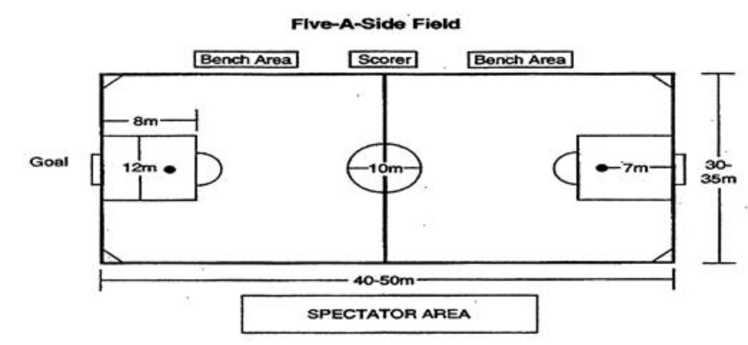

SECTION B – FACILITIES AND EQUIPMENT
1. Field Dimensions
a. The size of a five-a-side field is 50m x 35m.
b. Both goals shall be of equal size. The area of the goals shall range in size from 1.5m (5') by 3m (9.8') to 2m (6’7”) by 4m (13’2”).

2. Equipment - A number five size soccer ball is to be used for SOWI competitions.
- Players with illegal uniforms will not be allowed to play. Players with non-matching uniforms will be penalized accordingly. Legality of a uniform may be determined by the referee or by the event coordinator.

4. Proper uniforms and uniform numbering will be enforced! Individuals who do not adhere to uniform regulations will not be allowed to enter a game. Uniform tops must have a number on the back a minimum of six inches high – a front number of a minimum of four inches high is optional but numbers are to be in direct contrast to the color of the top. No taped on numbers will be allowed. If there are duplicate numbers, then one player will not be allowed to participate until the issue is rectified. Legal numbers are 1 – 99. An individual may wear leg tights, leotards or sweat pants but they must be the same color of the team’s uniform shorts. Athletes wearing improper uniforms will not be allowed to participate.

5. The basic compulsory equipment of a player shall consist of a jersey or shirt, shorts, stockings, shin-guards and footwear which consists of tennis shoes or soccer shoes with rubber cleats. A player shall not wear anything which is dangerous to another player. Undershirts, if worn, must match the sleeve color of the uniform. Under shorts, if worn, must match the shorts color of the uniform.

6. Shin-guards, which must be covered entirely by the stockings, shall be made of a suitable material (rubber, plastic, polyurethane or similar substance) and shall afford a reasonable degree of protection.

- The goalkeeper shall wear colors which distinguish him from the other players and from the referee. The goalkeeper jersey does not have to have a number associated to the jersey.

- Only soccer shoes or tennis shoes are allowed for competition. (For reference, a soccer shoe does not have a toe cleat and has a more limited number of cleats on the bottom.) Baseball or football shoes/cleats are not allowed and a player will not be allowed to participate with these shoes. The toe cleat cannot be cut off the baseball or football shoe to conform. The types of cleats, size and number prohibit the use of baseball or football cleats.

PUNISHMENT – Equipment Infractions
For any infringement of this law, the player at fault will not be allowed on the field or shall be sent off the field to adjust his equipment and he shall not return without first reporting to the referee, who shall satisfy himself that the player's equipment is in order. The player shall only re-enter the game at a moment when the ball has ceased to be in play.

The Soccer Individual Skills Assessment has been moved to the Appendix of the Competition Guide

