CONVERSION TABLE – ENGLISH/METRIC MEASUREMENTS
Meters into Feet & Inches |  |  |  |  |  | Centimeters into Feet & Inches |  |  |  |  |  | Feet into Meters |  | Inches into Centimeters
M | FT | IN | M | FT | IN | CM | FT | IN | CM | FT | IN | FT | M | IN | CM
1 | 3 | 3 3/8 | 51 | 167 | 3 7/8 | 1 |  | 0 3/8 | 51 | 1 | 8 1/8 | 1 | .31 | 1/4 | .63
2 | 6 | 6 3/4 | 52 | 170 | 7 1/4 | 2 |  | 0 3/4 | 52 | 1 | 8 1/2 | 2 | .61 | 1/2 | 1.27
3 | 9 | 10 1/8 | 53 | 17 | 10 5/8 | 3 |  | 1 1/8 | 53 | 1 | 9 1/4 | 3 | .91 | 3/4 | 1.9
4 | 13 | 1 1/2 | 54 | 173 | 2 | 4 |  | 1 5/8 | 54 | 1 | 9 1/4 | 4 | 1.22 | 1 | 2.54
5 | 16 | 4 7/8 | 55 | 177 | 5 3/8 | 5 |  | 2 | 55 | 1 | 9 5/8 | 5 | 1.52 | 1 1/4 | 3.17
6 | 19 | 8 ¼ | 56 | 180 | 8 3/4 | 6 |  | 2 3/8 | 56 | 1 | 10 | 6 | 1.83 | 1 1/2 | 3.81
7 | 22 | 11 5/8 | 57 | 183 | 0 1/8 | 7 |  | 2 3/4 | 57 | 1 | 10 1/2 | 7 | 2.13 | 1 3/4 | 4.44
8 | 26 | 3 | 58 | 187 | 3 1/2 | 8 |  | 3 1/8 | 58 | 1 | 10 7/8 | 8 | 2.44 | 2 | 5.08
9 | 29 | 6 3/8 | 59 | 190 | 6 7/8 | 9 |  | 3 1/2 | 59 | 1 | 11 1/4 | 9 | 2.74 | 2 1/4 | 5.71
10 | 32 | 9 ¾ | 60 | 193 | 10 1/4 | 10 |  | 3 7/8 | 60 | 1 | 11 5/8 | 10 | 3.05 | 2 1/2 | 6.35
11 | 36 | 1 1/8 | 61 | 196 | 1 5/8 | 11 |  | 4 3/8 | 61 | 2 | 0 | 20 | 6.1 | 2 3/4 | 6.98
12 | 39 | 4 1/2 | 62 | 200 | 5 | 12 |  | 4 3/4 | 62 | 2 | 0 3/8 | 30 | 9.15 | 3 | 7.62
13 | 42 | 7 3/4 | 63 | 203 | 8 3/8 | 13 |  | 5 1/8 | 63 | 2 | 0 3/4 | 40 | 12.2 | 3 1/4 | 8.25
14 | 45 | 11 1/8 | 64 | 206 | 11 3/4 | 14 |  | 5 1/2 | 64 | 2 | 1 1/4 | 50 | 15.25 | 3 1/2 | 8.89
15 | 49 | 2 1/2 | 65 | 209 | 3 | 15 |  | 5 7/8 | 65 | 2 | 1 5/8 | 60 | 18.3 | 3 3/4 | 9.52
16 | 52 | 5 7/8 | 66 | 213 | 6 3/8 | 16 |  | 6 1/4 | 66 | 2 | 2 | 70 | 21.35 | 4 | 10.16
17 | 55 | 9 1/4 | 67 | 216 | 9 3/4 | 17 |  | 6 3/4 | 67 | 2 | 2 3/8 | 80 | 24.4 | 4 1/4 | 10.79
18 | 59 | 0 5/8 | 68 | 219 | 1 1/8 | 18 |  | 7 1/8 | 68 | 2 | 2 3/4 | 90 | 27.45 | 4 1/2 | 11.43
19 | 62 | 4 | 69 | 223 | 4 1/2 | 19 |  | 7 1/2 | 69 | 2 | 3 1/8 | 100 | 30.5 | 4 3/4 | 12.06
20 | 65 | 7 3/8 | 70 | 226 | 7 7/8 | 20 |  | 7 7/8 | 70 | 2 | 3 5/8 | 110 | 33.55 | 5 | 12.7
21 | 68 | 10 3/4 | 71 | 232 | 11 1/4 | 21 |  | 8 1/4 | 71 | 2 | 4 | 120 | 36.6 | 5 1/4 | 13.33
22 | 72 | 2 1/8 | 72 | 236 | 2 5/8 | 22 |  | 8 5/8 | 72 | 2 | 4 3/8 | 130 | 39.65 | 5 1/2 | 13.97
23 | 75 | 5 1/2 | 73 | 239 | 6 | 23 |  | 9 | 73 | 2 | 4 3/4 | 140 | 42.7 | 5 3/4 | 14.6
24 | 78 | 8 7/8 | 74 | 242 | 9 3/8 | 24 |  | 9 1/2 | 74 | 2 | 5 1/8 | 150 | 45.75 | 6 | 15.24
25 | 82 | 0 1/4 | 75 | 246 | 0 3/4 | 25 |  | 9 7/8 | 75 | 2 | 5 1/2 | 160 | 48.8 | 6 1/4 | 15.87
26 | 85 | 3 5/8 | 76 | 249 | 4 1/8 | 26 |  | 10 1/4 | 76 | 2 | 5 7/8 | 170 | 51.85 | 6 1/2 | 16.51
27 | 88 | 7 | 77 | 252 | 7 1/2 | 27 |  | 10 5/8 | 77 | 2 | 6 1/4 | 180 | 54.9 | 6 3/4 | 17.14
28 | 91 | 10 3/8 | 78 | 255 | 10 7/8 | 28 |  | 11 | 78 | 2 | 6 3/4 | 190 | 57.95 | 7 | 17.78
29 | 95 | 1 3/4 | 79 | 259 | 2 1/4 | 29 |  | 11 3/8 | 79 | 2 | 7 1/8 | 200 | 61 | 7 1/4 | 18.41
30 | 98 | 5 1/8 | 80 | 262 | 5 5/8 | 30 |  | 11 3/4 | 80 | 2 | 7 1/2 | 210 | 64.05 | 7 1/2 | 19.05
31 | 101 | 8 1/2 | 81 | 265 | 9 | 31 | 1 | 0 1/4 | 81 | 2 | 7 7/8 | 220 | 67.1 | 7 3/4 | 19.68
32 | 104 | 11 7/8 | 82 | 269 | 0 3/8 | 32 | 1 | 0 5/8 | 82 | 2 | 8 1/4 | 240 | 70.15 | 8 | 20.32
33 | 108 | 3 1/4 | 83 | 272 | 3 ¾ | 33 | 1 | 1 | 83 | 2 | 8 5/6 | 250 | 73.2 | 8 1/4 | 20.96
34 | 111 | 6 5/8 | 84 | 275 | 7 1/8 | 34 | 1 | 1 3/8 | 84 | 2 | 9 1/8 | 260 | 76.25 | 8 1/2 | 21.59

CONVERSION TABLE – ENGLISH/METRIC MEASUREMENTS
Meters into Feet & Inches |  |  |  |  |  | Centimeters into Feet & Inches |  |  |  |  |  | Feet into Meters |  | Inches into Centimeters
M | FT | IN | M | FT | IN | CM | FT | IN | CM | FT | IN | FT | M | IN | CM
35 | 114 | 10 | 85 | 278 | 10 1/4 | 35 | 1 | 1 3/4 | 85 | 2 | 9 1/2 | 270 | 79.3 | 8 3/4 | 22.26
36 | 118 | 1 3/8 | 86 | 282 | 1 5/8 | 36 | 1 | 2 1/8 | 86 | 2 | 9 7/8 | 270 | 82.35 | 8 3/4 | 22.86
37 | 121 | 4 3/4 | 87 | 285 | 5 | 37 | 1 | 2 5/8 | 87 | 2 | 10 1/4 | 280 | 85.4 | 9 | 23.5
38 | 124 | 8 1/8 | 88 | 288 | 8 3/8 | 38 | 1 | 3 | 88 | 2 | 10 5/8 | 290 | 88.45 | 9 1/2 | 24.13
39 | 127 | 11 3/8 | 89 | 291 | 11 3/4 | 39 | 1 | 3 3/8 | 89 | 2 | 11 | 300 | 91.5 | 9 3/4 | 24.77
40 | 131 | 2 3/4 | 90 | 295 | 3 1/8 | 40 | 1 | 3 3/4 | 90 | 2 | 11 3/8 | 310 | 94.55 | 10 | 25.4
41 | 134 | 6 1/8 | 91 | 298 | 6 1/2 | 41 | 1 | 4 1/8 | 91 | 2 | 11 7/8 | 320 | 97.6 | 10 1/4 | 26.04
42 | 137 | 9 1/2 | 92 | 301 | 9 7/8 | 42 | 1 | 4 1/2 | 92 | 3 | 0 1/4 | 330 | 100.65 | 10 1/2 | 26.67
43 | 141 | 0 7/8 | 93 | 305 | 1 1/4 | 43 | 1 | 4 7/8 | 93 | 3 | 0 5/8 | 340 | 103.7 | 10 3/4 | 27.31
44 | 144 | 4 1/4 | 94 | 308 | 4 5/8 | 44 | 1 | 5 3/8 | 94 | 3 | 1 | 350 | 106.75 | 11 | 27.94
45 | 147 | 7 5/8 | 95 | 311 | 8 | 45 | 1 | 5 3/4 | 95 | 3 | 1 3/8 | 360 | 109.75 | 11 1/4 | 28.58
46 | 150 | 11 | 96 | 314 | 11 3/8 | 46 | 1 | 6 1/8 | 96 | 3 | 1 3/4 | 370 | 112.8 | 11 1/2 | 29.21
47 | 154 | 2 3/8 | 97 | 318 | 2 3/4 | 47 | 1 | 6 1/2 | 97 | 3 | 2 1/8 | 380 | 115.8 | 11 3/4 | 29.85
48 | 157 | 5 3/4 | 98 | 321 | 6 1/8 | 48 | 1 | 6 7/8 | 98 | 3 | 2 5/8 | 390 | 118.85 | 12 | 30.48
49 | 160 | 9 1/8 | 99 | 324 | 9 1/2 | 49 | 1 | 7 1/4 | 99 | 3 | 3 | 400 | 121.9
50 | 164 | 0 1/2 | 100 | 328 | 0 7/8 | 50 | 1 | 7 5/8 | 100 | 3 | 3 3/8

CRITERIA FOR DEVELOPMENT OF NEW EVENTS

Listed are the criteria and conditions which must be met in order for new official sports events to be considered for statewide sanctioning by Special Olympics Wisconsin (SOWI). Development of new official sports events will be initiated at the local level.

CRITERIA AND CONDITIONS
- Special Olympics Wisconsin athletes and coaches may train in any sport that is not prohibited, however in order to be considered for official SOWI competition, a sport must meet the following conditions:
  - The proposed event is not required to be an officially recognized sport and event by Special Olympics, Inc., however, the following type(s) of sports are prohibited:
    - Shooting sports
    - Motorized racing sports other than electric wheelchair
    - Combative or full contact sports

  - All official Special Olympics Sports Rules (if available) and appropriate National Governing Body Sports Rules are to be strictly adhered to.

  - Athlete training and competition must be developed and conducted at a local level.

Criteria:
A. To be offered as an official SOWI competitive opportunity*, a sport must meet the minimum qualifications:
a. 2 Regions represented
b. 3 Agencies represented
c. 20 athletes that train and compete in that sport
d. Team sports must involve a minimum of 12 teams
*A competitive opportunity may include: Demonstration; Invitational; District; or State-level event.

B. To offer a multi-level competition opportunity** for a sport, there must be at a minimum:
a. 3 Regions represented
b. 6 Agencies represented
c. 50 athletes that train and compete in that sport
d. Team Sports must involve a minimum of 20 teams
**A multi-level competition opportunity may include: invitational; regional; district; sectional; State-level event.

Re-evaluating and deleting sports:
• Once an existing sport’s statewide participation fails to meet the above criteria, the number of available competitive opportunities will be adjusted accordingly.

• If a sport’s participation falls below the stated criteria to be considered for a competitive opportunity for two consecutive years, it will be evaluated by the SOWI Sports Department to assess the sport’s viability and status as an officially offered sport within SOWI.

Note:
The SOWI sports staff reserves the right to adjust the criteria in the following cases:
- Criteria may be suspended for a period of time for the purposes of Introduction of a new sport
- In the case where a sport or event meets a specific need of the program, the criteria may be relaxed or exempted in order to meet that need.
APPROPRIATE SPORTS AND EVENTS SELECTION FOR ATHLETES

What would have happened if someone selected the sports that you played in high school or community leagues and you were told that you had no other choice but to participate in those activities? Do you think you would have looked forward to practice or competition?

One of the most important factors that influence an athlete's motivation in sports is having a choice in selecting the sport in which he/she wants to take part. A Special Olympics athlete is no different. The problem is that there are many people who play a role in the selection process and that may, in fact, create more obstacles to overcome. It is important for coaches to recognize these obstacles and to do everything possible to allow their athletes to compete in sports in which they will learn and develop skills, and most important of all, have fun.

The Special Olympics athlete may be influenced by coaches, family members, peers, teachers or role models in sports. The coach has the difficult job of working with all of these people along with other factors, which influence the selection of sports.

Variables that Influence the Selection of Sports
- AGE APPROPRIATENESS - While physical developmental needs may be a primary concern, athletes may need some guidance in selecting a sport appropriate for their age.

- READINESS LEVEL - A Special Olympics athlete needs to be ready for competition both mentally and physically.
  - Mental Readiness - Athletes must want to play and understand the rules. There should be a desire to participate and a level of confidence to experience success.

  - Physical Readiness - Athletes must be physically fit. Athletes must develop fitness levels required for successful participation in the sport selected.

- ABILITY LEVEL - Coaches know that there is a minimal skill level required for participation in competition for each and every sport offered in Special Olympics. Athletes must demonstrate these skill levels in order to compete according to the rules and ensure safe participation. Athletes may also develop high enough skills that they are no longer appropriate for an event; such as, the softball throw or the 25m walk and can move up to an event more appropriate to their skills.

- ATHLETE PREFERENCE - An athlete should be offered every opportunity to select the sport in which he/she will participate, however, this freedom of choice may need to be supervised by the coach. All factors must be considered.

5. PEER INFLUENCE - Athletes may select a sport because a friend is participating in it. The element of socialization is a goal of athletes who train and compete in Special Olympics. On the other hand, an athlete who participates in a sport "just because his/her friends play" may require direction from the coach.

OTHER FACTORS:
1. Budget: How much money will facilities, equipment, uniforms, etc. cost?

- Trained Coaches: Do you have enough volunteer coaches who know the sport? How about the athlete who selects aquatics and none of your coaches swim?

- Facilities: While a gymnasium may fit the budget, can you get access to tennis courts? Ice time? A pool?

4. Equipment: Do you have the necessary equipment? Is it safe to use?

- Administrative Support: Will your administration support your efforts to develop a team? Do they encourage athletes to take full advantage of all opportunities?
- Family Support: At-home training, transportation to practices and competitions, and moral support from family members are all necessary for successful participation in Special Olympics. Are your athletes' families involved in Special Olympics?

- Time: How much time do you have? Can you compromise selections of sports and the time available to volunteer? Who selects the sport for an athlete? Knowing that all of these variables exist will allow you to help your athletes select the sport in which they will experience the most success and enjoyment.

COMPETITION AND THE DIVISIONING PROCESS

Introduction
Special Olympics competitions provide athletes with the opportunity to demonstrate sports skills they have acquired during training. Special Olympics athletes, like all dedicated athletes, strive for their best performance at each competition. To enhance their competitive experience, competitions should be organized to highlight the athletes. In Special Olympics, this means that, regardless of an athlete's place of finish, each performance is considered a personal victory. The athlete is most important.

Special Olympics has developed modified rules, when necessary, in order to maximize the successful participation of all athletes and encourage competition throughout every level of the organization. Competitions must be conducted consistently, in accordance with these rules, and capably officiated.

The fundamental difference which sets Special Olympics competitions apart from those of other sports organizations is that athletes of all ability levels are encouraged to participate and every athlete is recognized for his or her performance. Competitions are structured so that athletes compete with other athletes of similar ability in equitable divisions. Historically, Special Olympics has suggested that all divisions be created where the variance between the highest and lowest (or slowest and fastest) scores within a division not differ by more than 10%. This "10% statement" is not a rule, but should be used as a starting point or a guideline for establishing equitable divisions when the number of athletes competing is appropriate.

Divisioning Procedures
An athlete's ability is the primary factor in divisioning Special Olympics competition. The ability of an athlete or team is determined by an entry score from prior competition(s) or a preliminary event/trial at the competition itself. Other factors which are also significant in establishing competitive divisions are age and gender.

Ideally, competition is enhanced when all divisions accommodate at least three and no more than eight competitors or teams of similar ability. In some cases, however, the number of athletes or teams within a competition will be insufficient to achieve this goal. The following are examples of procedures utilized to attempt to create equitable divisions:
- Divide Athletes by Gender (unless identified as coed)
  - Females vs. Females/Males vs. Males
  - Males and females may compete against each other if similar in age and ability.
  - If the athlete is the only member of his/her sex in a division, he/she may compete against the opposite sex similar in age and ability.

d. Special Olympics rules regulate that all athletes must be divisioned against at least one other person (two if possible) for competition purposes.

e. If there is only one athlete of any age or ability in an event, he/she may still compete as a single-person division.

2. Divide Athletes by Age -- An athlete's age group for competition is determined by his/her age on the opening date of the competition.
- Divide athletes into age groups: 8-11, 12-15, 16-21, 22-29, 30+, 50+
b. Athletes should compete in their age group unless:
  - An age group has less than three competitors, so they shall compete in the next oldest group.

2) The athletes are "moved up," so they will be grouped by ability with athletes in that group. (Example: 8-11 year olds move up to 12-15 group and some divisions become Juniors, 8-15 years.)

3. Divide Athletes by Ability
- Rank athletes from high to low performances from entry scores or preliminary/trial scores. Group as many possible together per division (based upon three to eight per division and utilizing a starting point of 10% difference - though 15% or 20% may be necessary to create divisions when athlete populations are low.)

- When athletes' extreme highs and lows are problems, athletes should be merged with higher age groups or combined with similar ability groups of the opposite sex. Finally, if an athlete's score is so extreme, he/she should be assigned to a division more similar to their own ability, regardless of age group, in order to ensure the chance to compete against other athletes.

c. If preliminary/trial events are held, these "onsite" scores will be utilized in a manner similar to the previously noted divisioning procedures. The value of preliminary/trial events is the similarity of judging, playing facility, environmental conditions, etc. for all athletes and the resulting consistency of scores to aid in the divisioning process and, hopefully, to create equitable competition.

4. Team Divisioning -- Teams will be based upon ability with divisions that are created via scores of previous competitions, competitions on site - preliminary rounds/games (volleyball and bocce will also include the Special Olympics Skill Assessments Tests – SAT’s).
- If possible, divisions will also be based upon same sex competition.
b. If possible, divisions will be based upon age groups.
Note: A team with at least one male on it will be categorized as a male team. Similarly, a team will be placed in an age category based upon the oldest player's age.

Conclusion
The goal is always to create equitable divisions of three to eight athletes or teams. A variation of 10% in ability from highest to lowest performances in each division is the ideal situation; however, 15% or 20% is often necessary if numbers and abilities vary. Sex, age and ability may be "merged" in order to guarantee the chance for athletes to compete against others. These types of "merges” are most often categorized as coed, open or coed open division. Lastly, despite the most perfect 10% groupings, finishes may vary greatly - sport is affected by weather, illness, excitement, state of mind, medicine, time of day, sleep, diet, etc. There is no "sure thing" in the divisioning process or in any event's final outcome.

Official Sports

Special Olympics Inc. summer and winter rules allow programs to offer 27 official sports. Currently, Special Olympics Wisconsin offers competition in 18 sports and over 75 different events. Local Agencies and Regions have the option to train and conduct competition in any official sport or event listed in the Special Olympics, Inc. Rule Books. Please contact your Region or Program office if you have any questions concerning official sports.

SOWI Uniform Requirements at a Glance
This section includes highlights of the rules for uniforms. Specific uniform rules can be found in the specific sports rules for each sport.

Uniform commonality: SOWI uniform rules have been modified to make it easier for Agencies who wish to use uniform shirts for multiple team sports. The following guidelines should be used for teams wishing to create uniform shirts that can be used for all SOWI team sports. Please note that this only pertains to numbering and not to specific uniform types required by each sport.
• Numbers should be a minimum of 4 inches in height on the front and 6 inches in height on the back
• The stripe forming the numbers must be a minimum of ¾ inch (2cm) in width
• Legal numbers that can be used for all SOWI sports are: 1-5, 10-15, 20-25, 30-35, 40-45, 50-55

Bowling:
- Athletes must be neat in appearance
- Athletes in Teams and Doubles must wear matching shirts.
- No numbers are required

Volleyball
- All Jerseys must be of identical color, trim, cut and style except for the libero player where the top is opposite color of team
- Numbers must be a minimum of 4 inches in height on the front and 6 inches in height on the back
- The stripe forming the numbers must be a minimum of ¾ inch (2cm) in width
- Legal numbers 1 – 99

Alpine Skiing/ Snowboarding
- An approved snow sports helmet must be worn by all athletes for all events.

Snowshoe racing
- Snowshoes must be a minimum of 17.78 x 50.8 cm (7 inches x 20 inches) as measured by the frame. Snowshoes must be made of a frame with decking material (no plastic shoes are allowed)
- The attachment of any additional “spikes” is not permitted.
- The foot must be secured through a direct mount binding system to the snowshoe.
- The use of poles is optional.

Basketball Skills
- Athlete must wear athletic attire.
- No denim is allowed.
- Appropriate athletic shoes are required.
- No number is required

Team Basketball
- All uniforms must match in color, trim, cut and style
- Numbers must be a minimum of 4 inches in height on the front and 6 inches in height on the back
- The stripe forming the numbers must be a minimum of ¾ inch (2cm) in width
- Legal Numbers are: 0 or 00, 1-5, 10-15, 20 -25, 30-35, 40-45, 50-55

Gymnastics
- Male gymnasts shall wear tank tops (leotards) and long gymnastics pants or white gymnastics shorts.
- T-shirts that are tucked in may replace the tank tops.
- Gymnasts may compete in white socks, gymnastics slippers or bare feet.
- Female gymnasts shall wear a long sleeve leotard; have bare legs, bare feet, and wear white peds or gymnastics slippers.
- Flesh colored tights with bare feet are permitted, but not recommended. No deduction will be taken for use of flesh colored tights.
- No jewelry is allowed.

Aquatics
- Athletes must wear proper swimming attire as outlined by USA Swimming Rules and Regulations. Goggles may be worn.
- No competitor shall be permitted to use or wear any device that may aid his/her speed, buoyancy or endurance during a competition (such as webbed gloves, flippers, fins, etc.). Only those athletes in assisted events may utilize flotation devices.

Athletics
- Competitors must wear athletic clothing including an athletic shirt, shorts or sweatpants and athletic shoes.
- No denim or dress clothes are
- No hats may be worn
- All relay team members shall wear identical singlets or shirts.
- Athletes may compete in shoes with spikes provided the host facility allows spikes.
- No jewelry may be worn during competition.

Soccer
- All uniforms must be identical in color, trim, cut and style.
- Numbers must be a minimum of 4 inches in height in front and 6 inches in height in back
- The stripe forming the numbers must be a minimum of ¾ inch (2cm) in width
- Legal numbers 1 – 99
- An individual may wear leg tights, leotards or sweat pants but they must be the same color of the team’s uniform shorts.
- Shin guards are required and must be covered completely by the stockings.
- Tennis shoes or soccer shoes are required. No metal cleats are allowed. Baseball or football cleats are not allowed.
- Undershirts, if worn, must match the sleeve color of the uniform.
- Under shorts, if worn, must match the shorts color of the uniform.
- The goalkeeper shall wear colors which distinguish him from the other players and from the referee. The goalkeeper jersey does not have to have a number associated to the jersey.

Powerlifting
- Plain shorts and T-shirts may be worn and can include the Special Olympics logo and Agency name only.
- No sweatpants, bike shorts, tank tops (unless paired with an undershirt) or sweatshirts may be worn. T-shirts must be tucked-in at all times. If a lifting suit is worn, the costume shall consist of a one-piece, full-length lifting suit of one-ply stretch material without any patches or padding. A non-supportive weightlifting/wrestling type suit is also a legal suit. For specific rules on lifting suits see powerlifting rules.
- Long pants may not be worn.
- Undershirt – A T shirt of any color or colors must be worn under the lifting suit by all competitors during the performance of the squat and the bench press. It is optional for men, but mandatory for women to wear a T-shirt during the performance of the deadlift.
- Specialized “squat briefs” or other types of supportive briefs shall not be worn.
- Footgear - Long socks (up to the knee, completely covering the shin) must be worn for the dead-lift. Use of duct or athletic tape is acceptable.
- Athletic shoes for training, powerlifting or weightlifting boots ONLY must be worn. No hiking or work boots allowed. The height of the heels shall not exceed 5cm.
- Belt - A belt made of leather, vinyl, nylon, or other similar non-stretch or non-metal (other than buckle and stub attachments material) may be worn on the outside of the suit. Dimensions: Width – a maximum of 10cm; thickness – a maximum of 13mm. The belt may not encircle the body more than once. Belts shall not have additional padding.
- Wraps – Wrist wraps of a maximum width of 8cm and a maximum length of 1m may be worn.
- Supportive wraps – Only IPF approved wraps shall be permitted for use in powerlifting competitions. Non supportive wraps: Wraps made of medical crepe or bandage and sweatbands do not require IPF approval.
- Baby powder, pool hall chalk, liquid chalk, resin, talc or magnesium carbonate are the only substances that may be added to the body or attire. The use of oil, grease, or other lubricants is forbidden.
- Athletes with physical disabilities (e.g. wheelchair, cerebral palsy, amputees) may wear a two-piece outfit with both upper and lower pieces being form fitting. Either snug fitting track trousers or snug fitting shorts may be worn. A full-length aerobic suit may be worn while performing the bench press. Lifting with prosthesis is allowed and orthotics with shoes will be allowed.

Bocce
- Teams must wear uniform tops that match in color, trim, cut and style.
- Uniform bottoms do not need to match.
- No denim or cut-off shorts are allowed.
- Shoes must cover the athletes’ toes. No sandals or flip flops are allowed.
- Numbers are not required

Softball/Tee Ball
- Players must wear uniforms that are identical in color, trim, cut and style.
- Team pants must either be all long or all short in style.
- Ball caps, visors and headbands are optional for all players. If worn, they can be mixed, but must be worn properly. Player socks need not match.
- Numbers must be a minimum of 6 inches in height and are required on the back only
- Legal numbers: 1-99
- During warm-ups or during play, the catcher is required to wear a face mask and a batter's or catcher's helmet and a chest protector. Shin guards are strongly suggested for safety but not required.
- Steel spikes, street shoes and jewelry are not allowed. Gym, tennis, running, and soft or hard rubber spike shoes will be allowed.
- Gloves are required. A first baseman's trapping style mitt may be worn by the first basemen or catchers only.
- Batting helmets with two ear flaps and chin straps are required for all offensive players while batting and base running. The batter must wear the batting helmet at all times while still on the base paths.
- Only bats marked by the manufacturer as "Official Softball" may be used. In addition, any bat that is not on the approved bat list shown on http://www.teamusa.org/USA-Softball/Play-ASA/Certified-ASA-Equipment will be considered illegal and may not be used for competition

Tennis
- Athletes must be neat in their dress and wear proper tennis clothing.
- Soft-soled athletic shoes are required.
- No blue jeans, cut-off shorts, loud sports shirts or street shoes are allowed.

Golf
- Appropriate golf attire is required.

Flag Football
- All players on a team must wear uniforms (shirt and pants) that are identical in color, trim, style and material. All uniform shirts must be tucked in. Taped numbers on pinnies are not legal in SOWI competition.
- Numbers must be a minimum of 4 inches in height in front and 6 inches in height in back.
- Receiver’s gloves may be worn
- All players' pants shall be either all long or all short in style and must not have pockets.
- No cut-off shorts or denim jeans are allowed.
- Hats (baseball style caps or caps with hard visor) may not be worn
- No jewelry is allowed.
- An intermediate (youth) size football will be used in all divisions. Leather, synthetic leather, or rubber footballs are appropriate for use in training and competition. Nerf footballs may be used in training to assist athletes who are having difficulty catching the ball, but will not be used in competition.
- A protective mouthpiece must be worn at all times.
- Players must wear rubber-cleated or flat-soled athletic shoes.
- Metal cleats, spikes, hiking boots or other equipment deemed dangerous by officials will not be allowed.
- A one-piece, three-flag belt will be worn during the game at all times.



NON-ESSENTIAL SPORTS ASSESSMENTS AND SKILLS

While these skills assessments are not essential for registration for SOWI events, some Agencies have found them to be useful for internally gauging the skill level of athletes. As volleyball and bocce skills assessment tests are required for registration, they are included with their respective sports rules.

Soccer 12F

Golf 15F

Softball 24F

Flag Football 31F

FOOTBALL (SOCCER) TEAM SKILLS ASSESSMENT TEST (FSAT)
These skills are designed to help determine a preliminary idea as to the ability level of the athletes. They should
be used as a teaching method for basic skills used during a game setting.

a. Football (Soccer) Team Skills Assessment Test – Dribbling
1) Set-up: 12m dribbling slalom: five cones (minimum 18" high), 2m apart, staggered 0.5m from central line, and three to five balls at the start line.

2) Test: (Time: one minute) Player dribbles through slalom as quickly as possible, rounding all cones. Player leaves ball over the finish line (ball must be stopped) and sprints back to the start. If there is time remaining, player starts with second ball and repeats. Player continues to repeat until one minute has elapsed to signify the end of the test. A whistle will be blown when one minute has elapsed to signify the end of the test.

- Scoring: Player scores five points for each cone passed (to the outside) (i.e. 25 points per successful run). Cones that are knocked down do not count.

b. Football (Soccer) Team Skills Assessment Test – Control and Pass

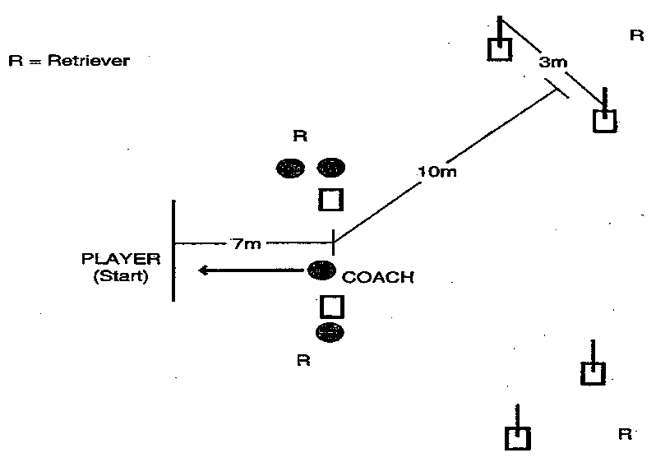

1) Set Up: Two cones to form a "passing gate" 5m wide, 7m from the starting line, two passing "target gates" (cones and 1m flags if possible) as shown, and four to eight soccer balls. (If balls are in short supply, use four balls but have an efficient retrieval system for returning the balls to the coach.)

2) Test: (Time: one minute) Coach rolls the ball at a moderate pace to the waiting player. The player may wait on the line or move towards the ball once it has been rolled. Player controls the ball and dribbles through the passing gate. Coach alternately calls and physically indicates "left" or "right" to designate target. Ball 1: Right / Ball 2: Left / Ball 3: Right, etc. Players can dribble as close as they like before passing the ball through the target. The coach will roll the next ball as soon as the player returns to the starting line. At one minute, a whistle will be blown to signify the end of the test.

3) Scoring: Player scores 10 points for each successful pass through a target gate. A ball that hits the cone and goes through will count.

c. Football (Soccer) Team Skills Assessment Test – Shooting
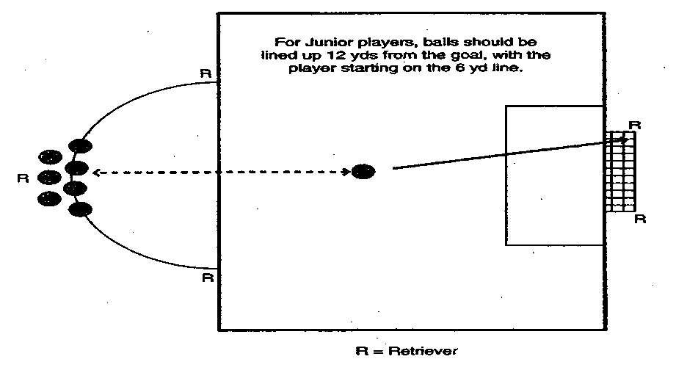
1) Set Up: Penalty area and full-size goal, with nets, on a regulation field and four to eight balls at the top of the penalty arc. (If balls are in short supply, the test can be run with four to five balls with a good retrieval and return system.)

2) Test: Player starts at the penalty spot, runs to the first ball, dribbles into the penalty area and shoots, attempting to shoot the ball in the air into the goal. Players can shoot from whatever distance they choose once they are inside the penalty area. As soon as the player has shot, he/she returns and repeats with another ball. A whistle will be blown after one minute to signify the end of the test.

3) Scoring: Player scores 10 points for each shot traveling from foot to goal in the air and five points for each shot that touches the ground before entering the goal.

FINAL FSAT SCORING: Total the final score for each of the three FSAT skill tests for each player. This score should then be entered on the roster entry form for district and State competition.

FOOTBALL (SOCCER) SKILLS ASSESSMENT (FSAT) SCORE SHEET

NAME |  | DRIBBLING | CONTROL & PASS | SHOOTING | FINAL TOTAL
1
2
3
4
5
6
7
8
9
10

Sum of the top seven athletes’ total scores: divided by 7 = (Team Score)
NOTE: These scores must be transferred to the district and State registration rosters.
Golf Level 1 – Individual Skills Contest (Not offered as competition by SOWI)
The purpose of Level 1 individual skills is to allow athletes to train in basic golf skills. The development of these key skills is necessary to advance to Level 2. A maximum of 120 points may be scored in Level 1.
a. Short Putt
- Purpose: To measure the athlete's ability to putt focusing on the short putt.
- Equipment:
    - A regulation putting green with a properly marked (target) hole
    - One putter for each athlete
    - Five balls for each player
    - A chalker may be used to mark the circle targets around the hole
- Description:
    - A target hole is selected and two circles are placed around the hole. The first circle shall have a radius of .5m and the second shall have a radius of 1.5m from the hole.

    - The athlete will have five attempts from a clearly marked spot, 2m from the hole.

    - The short putt should be set up on a green with as flat a surface as possible.

4) Scoring:
- The athlete will have five attempts to putt the ball at the hole from a line 2m from the hole, scoring points according to where the ball comes to rest.

- The athlete will score one point for making a stroke at, and striking the ball. (A swing and a miss counts as one attempt, and the athlete receives a score of zero.)

- A second point is scored if the ball stops on or within the 1.5m circle.
- A third point is scored if the ball stops within the .5m circle.
- If the ball goes in the hole, a total of four points will be awarded for that attempt.

f) The short putt score shall be the sum total from the five attempts.

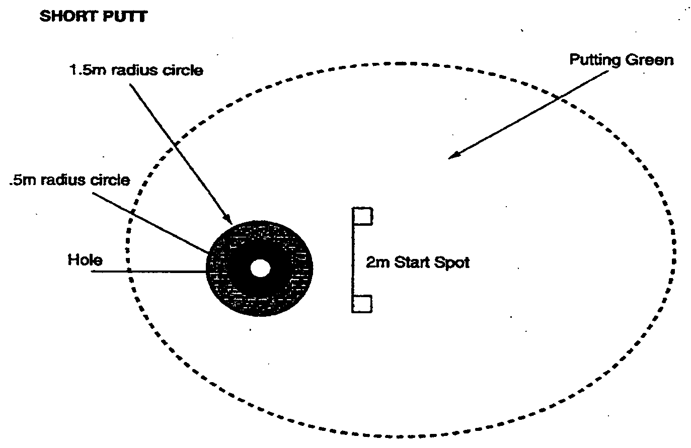
b. Long Putt
1) Purpose: To measure the athlete's ability to putt focusing on the long putt.
2) Equipment:
- One putter for each competing athlete
- A regulation putting green with a properly marked (target) hole
- Five balls for each hole being used
d) A chalker to put the target circles around the hole

3) Description:
- A target hole is selected and two circles are placed around the hole. The first circle shall have a radius of .5m and the second shall have a radius of 1.5m from the hole.

- The athlete will have five attempts from a marked spot, 8m from the hole.
- The long putts should be set up on a green with as flat a surface as possible.
- NOTE: Putting uphill is recommended.
- Scoring:
    - The athlete will have five attempts to putt the ball at the hole from a spot 8m from the hole, scoring points according to where the ball comes to rest.

    - The athlete will score one point for making a stroke at, and striking the ball. (A swing and a miss count as one attempt and receive a score of zero.)

    - A second point is scored if the ball stops on or within the 1.5m circle.
    - A third is scored if the ball stops on or within the .5m circle.
    - If the ball goes in the hole, a total of four points will be awarded for that attempt.

    - The long putt score shall be the sum total from the five attempts.
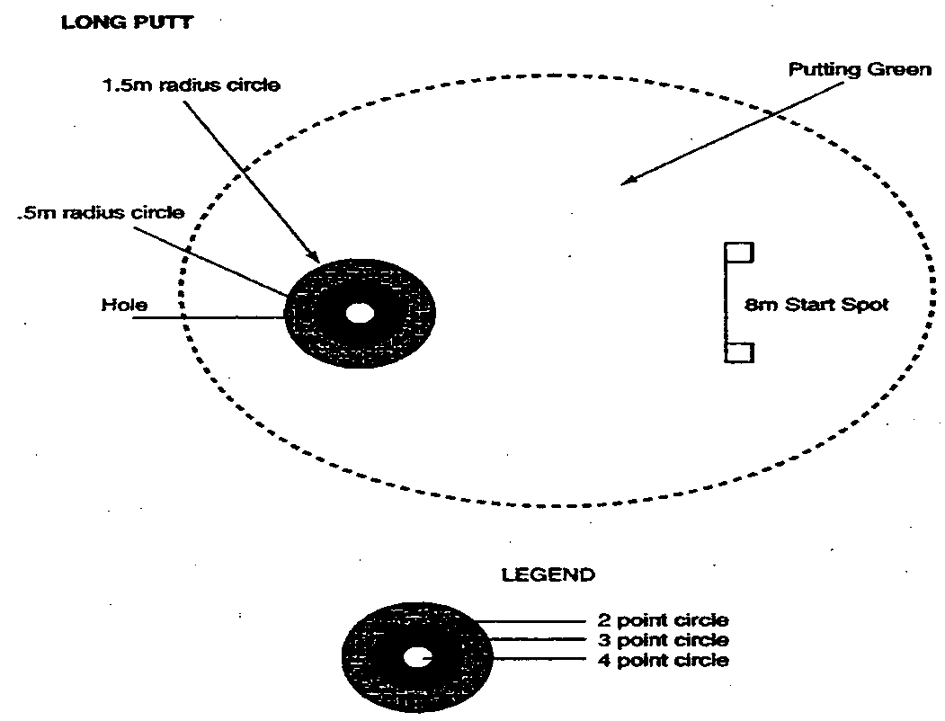

c. Chip Shot
1) Purpose: To measure the athlete's ability in hitting chip shots at 14m from the hole.
2) Equipment:
- An assorted number of irons for both right-handed and left-handed players
NOTE: Woods and putters are not permitted for this skill.

- Five balls for each hole being used
- A putting green with clearly marked target flag and hole
3) Description:
- A chipping area is set up which includes a 3m by 3m square hitting area 14m from the hole. The chipping area should be between 3m and 4m from the edge of the green.

- A 3m radius circle and a 6m radius circle will be placed around the hole.
- A safely marked hitting area 3m x 3m square will be chalked up and marker provided.

d) The athlete is instructed to chip the ball at a designated hole getting it as close to the hole as possible.

4) Scoring:
- The athlete will attempt five shots at the target, scoring points according to where the ball comes to rest.

- Athletes will score one point for making a stroke at and striking the ball. (A swing and a miss counts as one shot and receives a zero score for that shot.)

- A second point is scored if the ball comes to rest inside the 6m circle around the hole.

- A third point is scored if the ball comes to rest inside the 3m circle around the hole.

- A fourth point is scored if the chip shot comes to rest in the hole.
- The total score from the five attempts will be the athlete's final score for the chip shot.

5) Diagram (Chip Shot):
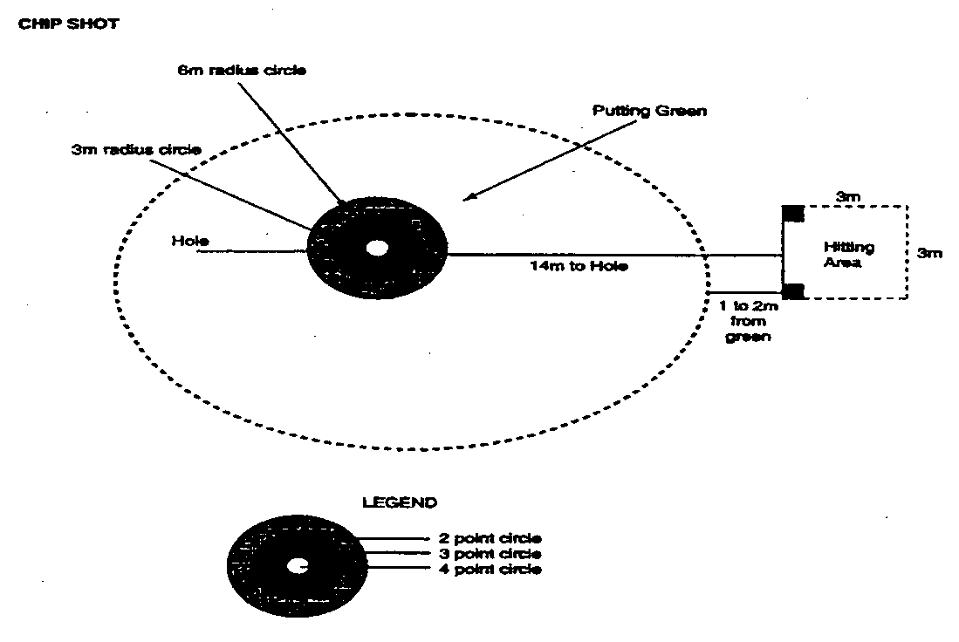
d. The Pitch Shot
1) Purpose: To measure the athlete's ability in hitting controlled pitch shots in the air in the proper direction to a defined circular target area.

2) Equipment:
a) An assorted number of pitching irons for both right-handed and left-handed players

- Five golf balls for each station being used
- A marked hitting area, paint or chalk and marker
- Shag bags or tubes to retrieve balls at station
- A target flag and hitting mat or artificial surface
- A banner sign, net or barrier that measures 1m in height by 5m wide. Two support poles measuring 2m to be used to support the banner, sign, net or barrier

3) Description:
- A target area shall be defined as a circle with a 12m diameter
- The distance from the hitting area to the 1m high barrier shall be 5m
- The distance from the 1m high barrier to the target area shall be 5m
- The golfer shall make five attempts. The athlete is instructed to pitch the ball over the barrier at the designated target area. NOTE: The skill station should be located in a restricted area such as a range in order to provide the safest environment. If an unrestricted area is used, it should be roped off and clearly identified for volunteers, spectators and athletes.

4) Scoring:
a) The athlete will attempt five shots at the target, scoring points according to where the ball lands.

b) Athletes will score one point for making a stroke at and striking the ball. (A swing and a miss counts as one shot and receives a zero score for that shot).

c) A second point is scored if the ball goes over the barrier and between the upright poles.

d) A third point is scored if the ball lands inside the 12m circle and rolls out, or if the ball lands outside the 12m circle and comes to rest inside the circle.

e) A fourth point is scored if the ball lands inside the 12m circle and comes to rest inside the circle.

f) The pitch shot score shall be the sum total from the five attempts.
- Diagram (Pitch Shot):
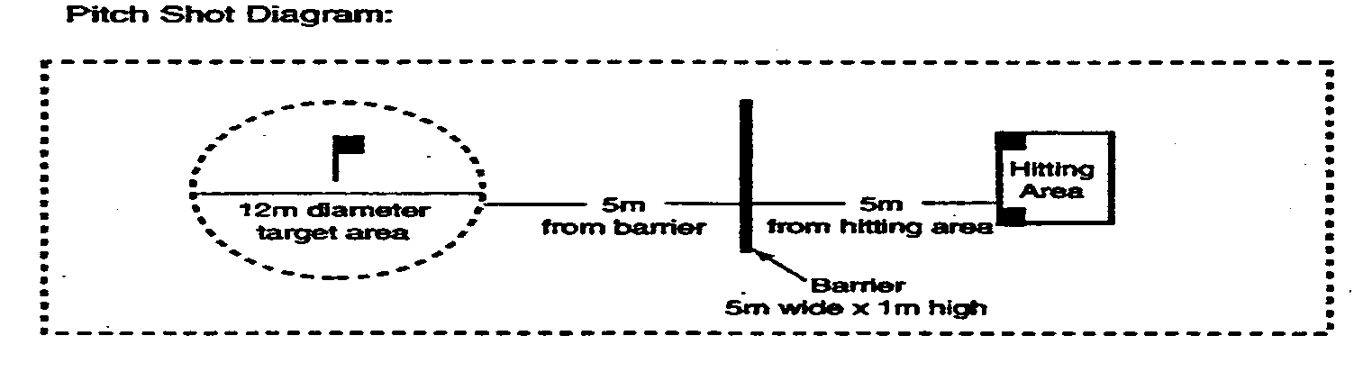
e. Iron Shot
1) Purpose: To measure the athlete's ability to hit an iron shot for distance within a set hitting area.

2) Equipment:

a) An assorted number of irons for right-handed and left-handed players
  - An appropriate number of golf balls based on the number of competitors. It is recommended that five balls per athlete be available to eliminate having to retrieve balls.

  - Marking paint or chalk, and marker to mark hitting area and boundary lines. (½" cord or rope can be substituted for marking boundary lines and making them more visible.)

d) Hitting mat or carpet, tees, helmets, a safety zone for score keepers to stand in and shag bags or tubes to retrieve balls (if necessary)

e) A target flag and eight cones or other viable markers to identify distance locations

3) Description:
a) The athlete may choose to hit the ball off a tee, mat or the ground. The athlete is instructed to hit the ball from the teeing area toward a designated flag in the hitting area trying to keep the ball within the boundary markers and achieving a distance of more than 90m.

4) Scoring:
a) The athlete will attempt five shots at the target, scoring points according to where the ball comes to rest.

- Athletes will score one point for making a stroke at and striking the ball. (A swing and a miss counts as one attempt and the athlete receives a score of zero for that shot).

c) Two points are scored for a ball that comes to rest between the 30m and the 60m lines within the 35m wide boundary lines.

d) Three points are scored for a ball that comes to rest between the 60m and 90m lines within the 35m wide boundary lines.

e) Four points are scored for a ball that comes to rest beyond the 90m line with the 35m wide boundary lines.

f) The athlete’s score for the iron shot shall be the sum total of the five attempts.
5. Diagram (Iron Shot):
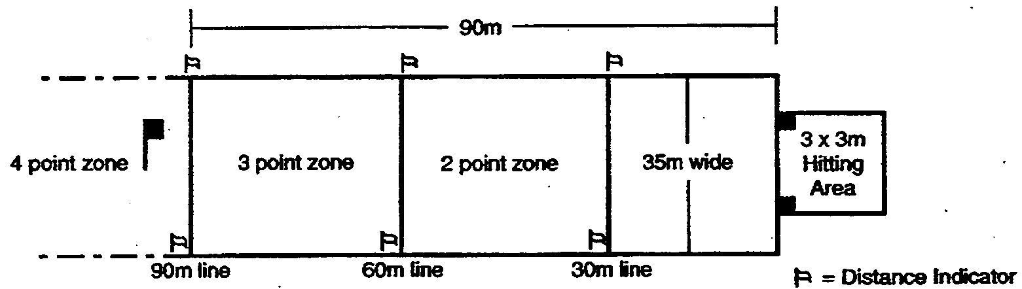

f. Wood Shot:
1) Purpose: To measure the athlete's ability to hit a wood shot for distance within a set hitting area.

2) Equipment:
- An assorted number of woods for right-handed and left-handed players
- An appropriate number of golf balls based on the number of competitors. It is recommended that five balls per player be available to eliminate having to retrieve balls.

c) Marking paint or chalk, and marker to mark hitting area and boundary lines. (A ½" cord or rope can be substituted for marking boundary lines, making them more visible.)

d) Hitting mat or carpet, tees, helmets, a safety zone for scorekeepers to stand in and shag bags or tubes to retrieve balls (if necessary)

e) A target flag and eight cones or other visible markers to identify distance locations

3) Description: The athlete may choose to hit the ball off a tee, a mat or the ground. The athlete is instructed to hit the ball from the teeing area toward a designated flag in the hitting area trying to keep the ball within the boundary markers and achieving a distance of more than 90m.

4) Scoring:
- The athlete will attempt five shots at the target, scoring points according to where the ball comes to rest.

- Athletes will score one point for making a stroke at and striking the ball (a swing and a miss counts as one attempt and receives a score of zero for that shot).

- Two points are scored for a ball that comes to rest between the 60m and 90m lines with the 50m wide boundary lines.

d) Three points are scored for a ball that comes to rest between the 90m and 120m lines with the 50m wide boundary lines.

e) Four points are scored for a ball that comes to rest beyond the 120m line with the 50m wide boundary lines.

f) The athlete’s score for the wood shot shall be the sum total of the five attempts.

5) Diagram (Wood Shot):
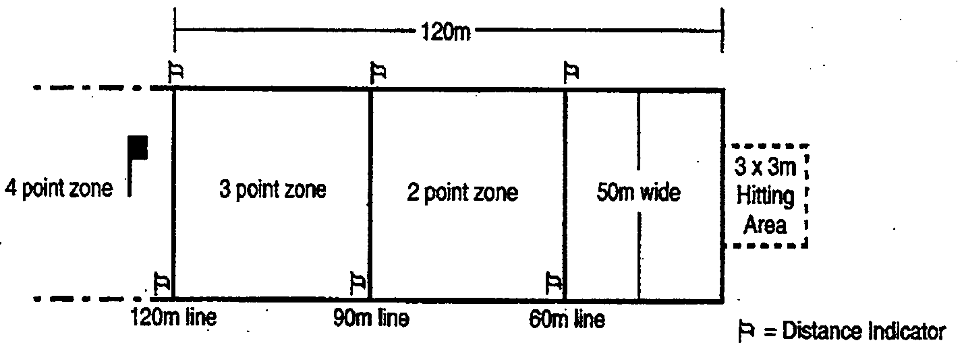

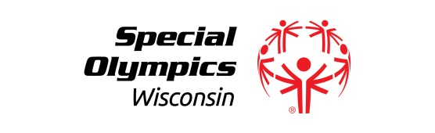
GOLF – LEVEL I - INDIVIDUAL SKILLS
Scorecard

Name:
Agency Name:
Agency Number: Division:
(If Applicable)

SHORT PUTT
Miss = 0 Points
TRIAL 1 – 5 PUTTS |  |  |  |  |  | TRIAL SCORE
#1 | #2 | #3 | #4 | #5
Strike = 1 Point
Within 1.5m circle = 2 Points
Within .5m circle = 3 Points
In the hole = 4 Points
Maximum Score = 4 Points per Putt and 20 Points per Trial

LONG PUTT
Miss = 0 Points
TRIAL 1 – 5 PUTTS |  |  |  |  |  | TRIAL SCORE
#1 | #2 | #3 | #4 | #5
Strike the ball= 1 Point
Within 1.5m circle = 2 Points
Within .5m circle = 3 Points
In the hole = 4 Points
Maximum Score = 4 Points per Putt and 20 Points per Trial

CHIP SHOT
Miss = 0 Points
TRIAL 1 – 5 CHIP SHOTS |  |  |  |  |  | TRIAL SCORE
#1 | #2 | #3 | #4 | #5
Strike the ball= 1 Point
Within 6m circle = 2 Points
Within 3m circle = 3 Points
In the hole = 4 Points
Maximum Score = 4 Points per Putt and 20 Points per Trial

PITCH SHOT
Miss = 0 Points
TRIAL 1 – 5 PITCH SHOTS |  |  |  |  |  | TRIAL SCORE
#1 | #2 | #3 | #4 | #5
Strike the ball = 1 Point
Ball over barrier = 2 Points

Ball lands in 12m circle or lands outside 12m circle and comes to rest inside the circle = 3 Points Maximum Score = 4 Points per Putt and 20 Points per Trial

Ball lands in 12m circle and
comes to rest inside the circle = 4 Points

IRON SHOT
Miss = 0 Points
TRIAL 1 – 5 IRON SHOTS |  |  |  |  |  | TRIAL SCORE
#1 | #2 | #3 | #4 | #5
Strike the ball= 1 Point
*Past 30m Line = 2 Points
*Past 60m Line = 3 Points
*Past 90Mm = 4 Points
Maximum Score = 4 Points per Putt and 20 Points per Trial
*(Within Width Boundary)

WOOD SHOT
Miss = 0 Points
TRIAL 1 – 5 WOOD SHOTS |  |  |  |  |  | TRIAL SCORE
#1 | #2 | #3 | #4 | #5
Strike the ball = 1 Point
*Past the 60m Line = 2 Points
*Past the 90m Line = 3 Points
*Past the 120m Line = 4 Points
Maximum Score = 4 Points per Putt and 20 Points per Trial
*(Within Width Boundary)

FINAL SCORE – COMBINE TRIALS

Softball Skills Assessment Test (SAT)
* The Skills Assessment Tests are no longer mandatory to complete*
1. Test Procedures
    - Softball Team Skills Assessment Test (SAT)
1) Test #1 Base Running – SAT

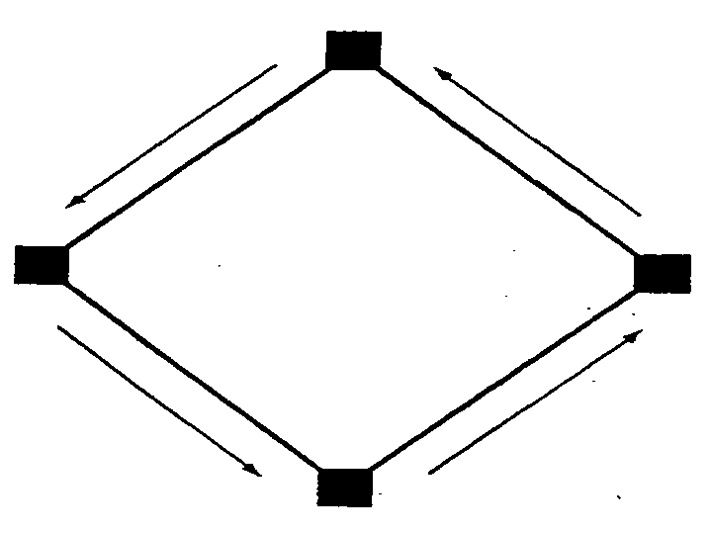

a) Set Up: Standard softball field – three bases, home plate, stopwatch
b) Test: Bases are set up like a baseball diamond and positioned 19.81m (65') apart. The athlete is instructed to start at home plate and run around the bases as fast as possible, touching each base en route.

- Scoring: The time starts when the athlete leaves home plate. The time stops when the athlete touches home plate after circling the bases. The time elapsed in seconds is subtracted from 50 to determine the point score. A penalty of five seconds for each base missed or touched in an improper order shall be assessed. The best score of two trials is recorded. Athletes should not be asked to take the two trials consecutively.

2) Test #2 Throwing – SAT

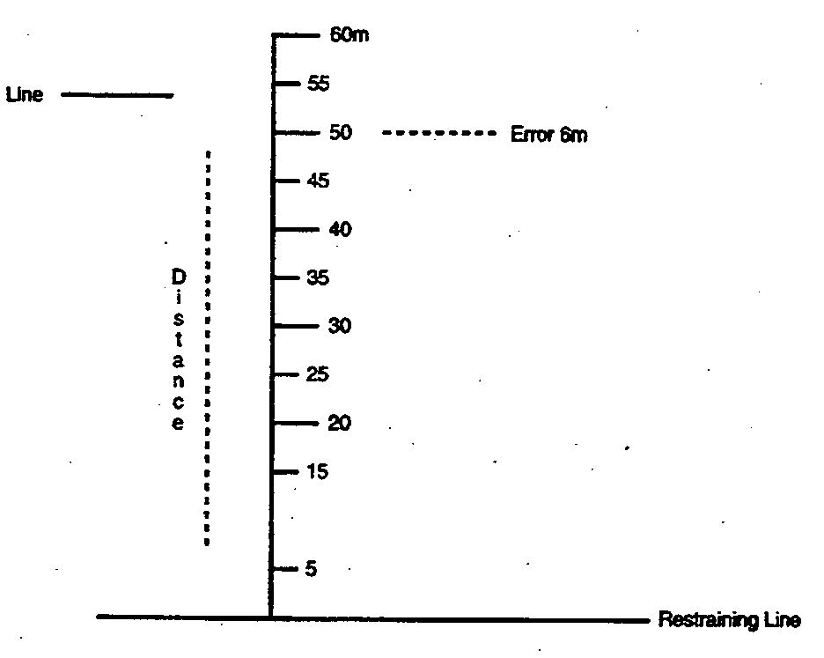

- Set Up: An outfield or a smooth grass field that can be marked off in feet
Needed: two measuring tapes, softballs, two small cones or marking stakes

b) Test: The player being tested stands behind the throwing line, back far enough to take one or more steps in preparation for throwing. The player has two trials to throw the softball as far and as straight as possible down the throwing line, without stepping over the restraining line. Coaches, assistants or other waiting players should be positioned in the field to indicate, using a cone or marking stake, the spot where each ball first touches the ground. The better of the two throws is measured and recorded as the player's score. If a player steps on or over the restraining line before releasing the ball, the trial must be repeated. There will be a maximum of two repeats.

c) Scoring: The net throwing score equals the throwing distance, measured at a point on the throwing line straight across from (perpendicular to) the spot where the ball landed, minus the error distance – the number of meters the ball landed off target, away from the throwing line. The player’s score is the better of two throws. Both error scores and distance scores are measured to the nearest meter.

Scoring example: If a ball lands even with (perpendicular to) the 50m point on the measuring tape, but is 6m off to one side, the player's score is 44 points. [Distance thrown (50m) minus number of meters off target (6m) results in a net score of 44m.] Athletes score one point per meter, i.e.: 44m = 44 points. If the score falls between meters, it should be rounded down, i.e.: 44.73 = 44 points.

3) Test #3 Fielding – SAT

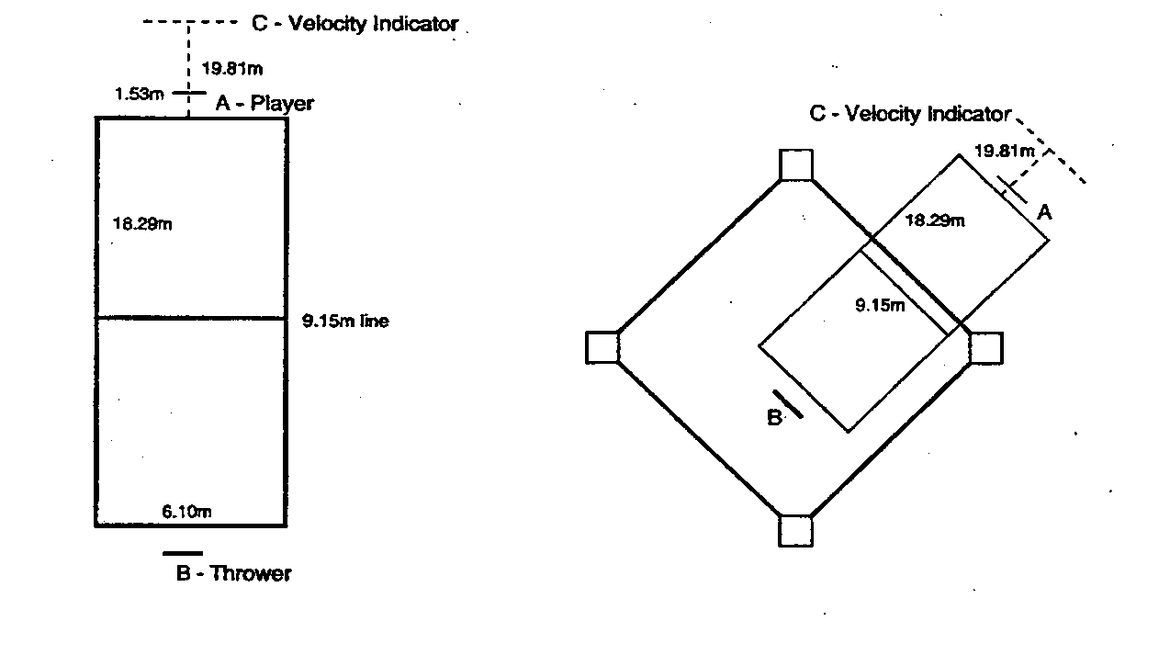
a) Set Up: Standard infield or a smooth field with short grass on which chalk markings or cones can be placed, softballs, fielding gloves, measuring tape

b) Test: The player being tested stands in a ready position (A) behind a 1.53m (5') restraining line. A thrower stands behind the throwing line and throws two practice and six test balls to each player. Each throw must strike the ground before the 9.15m (30') line and must stay within the sideline boundaries of the marked area. The throw should be made sidearm, with sufficient velocity to carry an untouched ball to line C – the velocity indicator distance beyond the endline.

The prescribed distance beyond the endline is marked by a cone or similar object. Of the six test trials, two balls should be thrown directly to the player – two to the right and two to the left side of the player. The player attempts to field each ball cleanly, i.e. with no noticeable bobbling or temporary loss of control, and tosses it back to the thrower.

In each trial the player starts beyond the 1.53m (5') restraining line, but must move ahead of the 18.29m (60') line toward the approaching ground ball in order to obtain maximum points. Any throw not made as specified should be repeated.

NOTE: It is important to periodically check the velocity of the throw by occasionally instructing the player to let a ball go by untouched. Throws should reach the velocity marker.

c) Scoring: Each ball cleanly fielded in front of the 18.29m (60') endline counts for five points. A ball which is bobbled, but stopped from going past the player, equals four points. Balls fielded behind the 18.29m (60') line receive three points for cleanly fielded balls, and two points for bobbled balls. Balls are considered to have been fielded in front of the 60' endline when at least the player's glove and ball are clearly in front of the line. Any ball which is missed entirely, or touched but gets by the player, scores no points. The score is the sum of all six trials. It is recommended that the scorer stand just outside the marked area, even with the 18.29m (60') endline. The maximum score for this test is 30 points.

4) Test #4 Batting - SAT

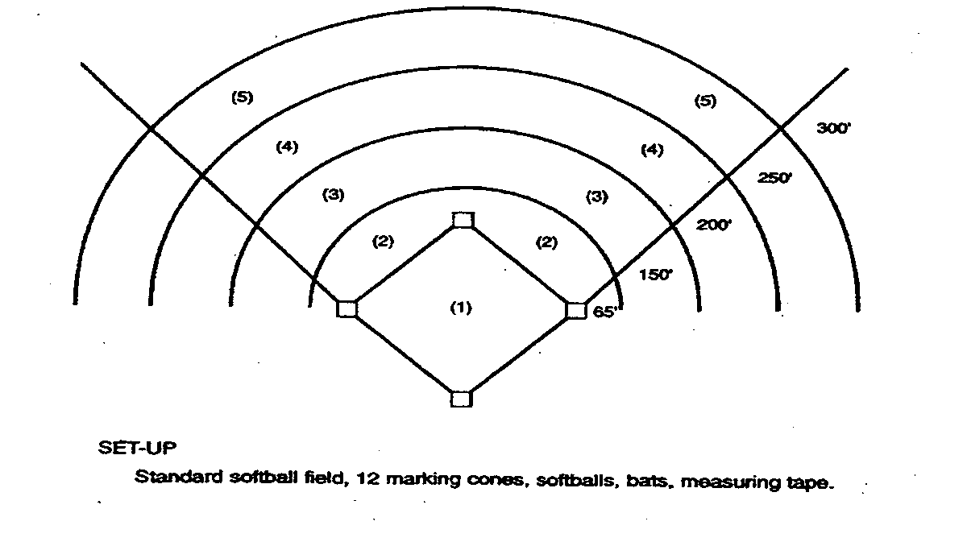
a) Set Up: Standard softball field, 12 marking cones, softballs, bats, measuring tape

b) Test: The batter assumes a normal batting stance at the plate. From the pitchers mound, a coach will throw five hittable pitches that the batter attempts to hit as hard and far as possible. These pitches should be within a 6'-12' regulation arc. Only five swings are allowed to each batter. An individual (another coach recording results) should determine whether pitches are within the regulation arc and are hittable. For tee ball, five hits are allowed off the tee.

- Scoring: The distance of the longest hit shall determine the athlete's final score. The distance of a hit is measured from home plate to the point where the ball first touches the ground. The distance is measured to the nearest meter (1 meter = 1 point, 46 meters = 46 points). If the score falls between meters, it should be rounded down, i.e.: 46.73 = 46 points.

SOFTBALL INDIVIDUAL SKILLS CONTEST SCORE SHEET

Coaches are asked to administer the Skills Assessment Test (SAT) for each of their players on three separate occasions before district tournament registration to properly assess the overall team skill level which contributes to divisioning.

NAME |  | BASE RUNNING |  |  | THROWING |  |  | FIELDING |  |  | HITTING |  |  | FINAL TOTAL
 |  | 1 | 2 | 3 | 1 | 2 | 3 | 1 | 2 | 3 | 1 | 2 | 3 | FINAL TOTAL
1
2
3
4
5
6
7
8

THIS IS NOT A DISTRICT ENTRY FORM!
SOFTBALL INDIVIDUAL SKILLS CONTEST SCORE SHEET

NAME |  | BASE RUNNING |  |  | THROWING |  |  | FIELDING |  |  | HITTING |  |  | FINAL TOTAL
 |  | 1 | 2 | 3 | 1 | 2 | 3 | 1 | 2 | 3 | 1 | 2 | 3 | FINAL TOTAL
9
10
11
12
13
14
15

Sum of the top 12 athletes’ total scores: divided by 12 = (Team Score)

SPECIAL OLYMPICS WISCONSIN – SOFTBALL

INDIVIDUAL SKILLS CONTEST SCORE CARD

Name:
Agency Name:
Agency Number: Division:
(If Applicable)

EVENT CODE:
 | TRIAL 1 | TRIAL 2 |  | BEST SCORE

BASE RUNNING

THROWING

FIELDING

HITTING
 |  |  |  | TOTAL SCORE
DATE:
PLACE:
(If Applicable)

INDIVIDUAL SKILLS CONTEST SCORE CARD

Name:
Agency Name:
Agency Number: Division:
(If Applicable)

EVENT CODE:
 | TRIAL 1 | TRIAL 2 |  | BEST SCORE

BASE RUNNING

THROWING

FIELDING

HITTING
 |  |  |  | TOTAL SCORE
DATE:
PLACE:
(If Applicable)

THIS IS NOT A DISTRICT ENTRY FORM!

Flag Football Individual Skills Assessment Test
Catching: “Run & Catch”

- Purpose: To measure athlete’s ability to catch a football.

- Equipment: Five footballs, measuring tape, field paint, 28 cones, or numbered mats to mark catching spots and start/finish lines.

- Description: A starting line, finish line, quarterback box, and five catching spots should be marked/ placed on the field. The catching spots should be marked 1-5 (left to right).
- The quarterback box should be placed in between the starting and finish line.
- The quarterback box will be 4 yards X 4 yards.
- Catching spots are 1 yard X 1 yard.
- Catching Boxes 1 & 5 will be 5 yards from the quarterback box.
- Catching Boxes 2 & 4 will be 12 yards from the quarterback box.
- Catching Box 3 will be 20 yards from the quarterback box.
- The starting line should be placed on the left side of the quarterback and the finish line should be placed on the right side of the quarterback. Athletes will start to the left of the quarterback and finish on the right side of the quarterback.
- Each athlete will begin at the starting line. Once the official quarterback gives the signal, the athlete must run to each catching box (in numerical order), stopping to catch a pass at each spot. Once the ball is completely caught, the athlete drops the ball and goes to the next catching box. Once the last ball is caught, the athlete will sprint through the finish line. If a throw from the QB is deemed inaccurate, athletes will receive an additional throw from the same spot.

4. Scoring: Athletes will receive points for completing catches.
- 2 pts: for a complete catch (clearly caught with both hands)
- 0 pts: if athlete is unable to catch or touch a well-thrown pass.
- Athletes can gain a maximum of 10 points in this drill.
- Officials will be present to confirm point total.
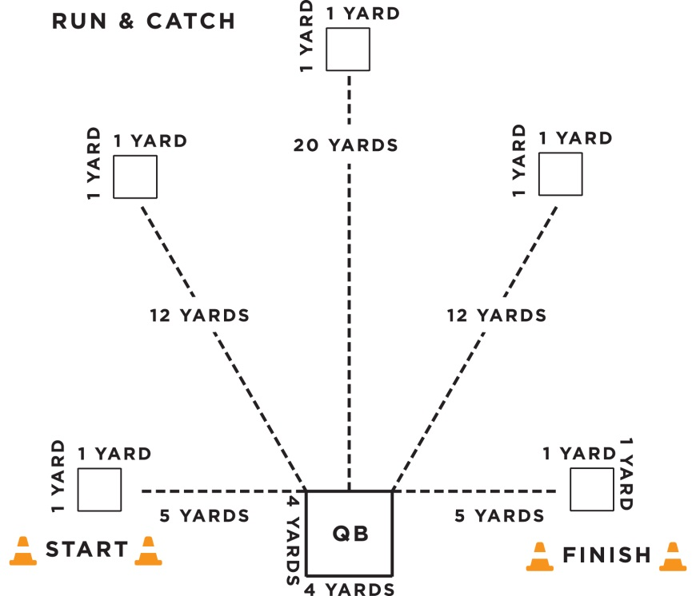

Throwing for Accuracy

- Purpose: To measure the athlete’s ability to throw a football accurately.

- Equipment: Five footballs, measuring tape, field paint, 28 cones, or numbered mats to mark catching spots and start/finish lines.

- Description: A starting line, finish line, quarterback box, and five catching boxes should be marked/ placed on the field. The catching boxes should be marked 1-5 (left to right).
- The quarterback box should be placed in between the starting and finish line.
- The quarterback box should be placed in between the starting and finish line.
- The quarterback box will be 4 yards X 4 yards.
- Catching spots are 1 yard X 1 yard.
- Catching Boxes 1 & 5 will be 5 yard from the quarterback box.
- Catching Boxes 2 & 4 will be 12 yards from the quarterback box.
- Catching Box 3 will be 20 yards from the quarterback box.
- The starting line should be placed on the left side of the quarterback and the finish line should be placed on the right side of the quarterback.
- The player being tested stands inside of the quarterback box. Five human targets/volunteers are placed in each catching spot. The athlete must throw to each target (in numerical order), gaining points for completed passes. The receiver must stay in the catching box. Scoring is based on accuracy of the throw not on the volunteer catching the pass.

4. Scoring: Athletes will receive points for completed passes.
- 2 pts: For an accurate & completed throw.
- 0 pts: Receiver is unable to catch or touch ball in targeted area. If the ball hits the ground prior to reaching the target, the throw will be recorded as a failed attempt.
- Athletes can gain a maximum of 10 points in this drill.
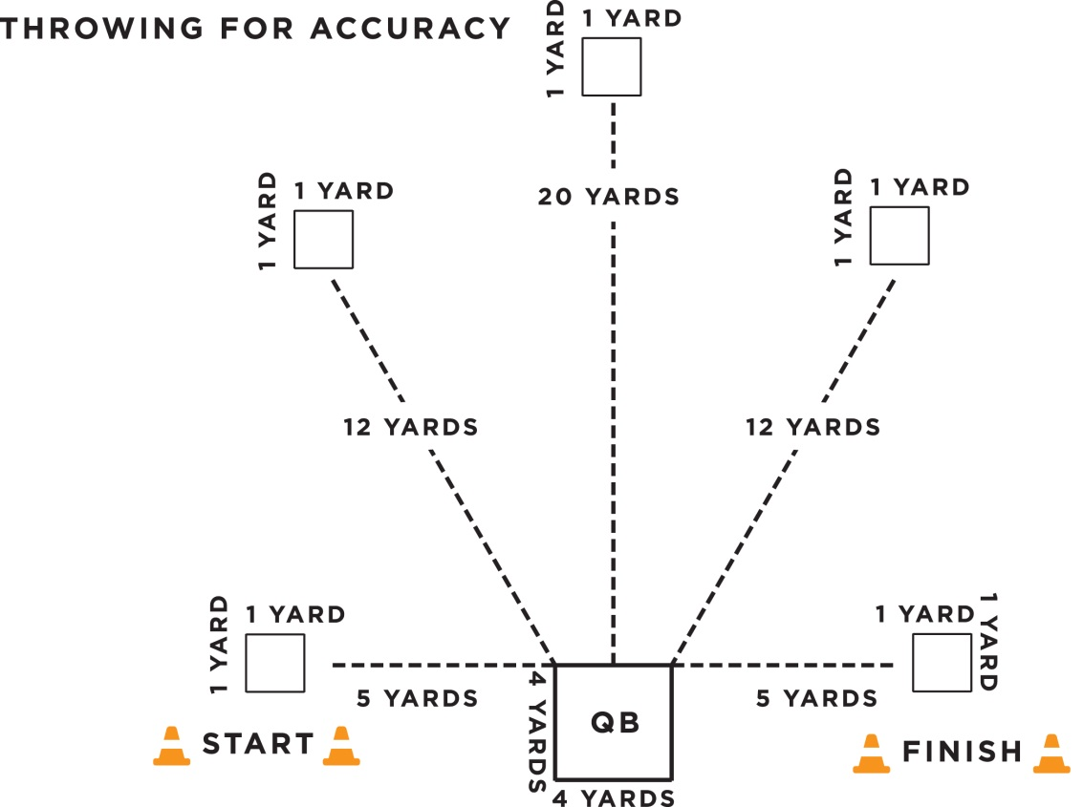

Throwing for Distance

- Purpose: To measure the athlete’s ability to throw a football for distance.

- Equipment: Three-five footballs; measuring tape; field paint; four cones

- Description: Athlete gets two attempts to throw football as far as possible. The goal line of a Special Olympics flag football field can be used as the starting line.

- Scoring: Athletes will receive a maximum of five points per throw.
- 1 pt: 0-10 yards
- 2 pt: 10-20 yards
- 3 pt: 20-30 yards
- 4 pts: 30-40 yards
- 5 pts: 40+ yards
- Athletes can gain a maximum of 10 points in this drill.

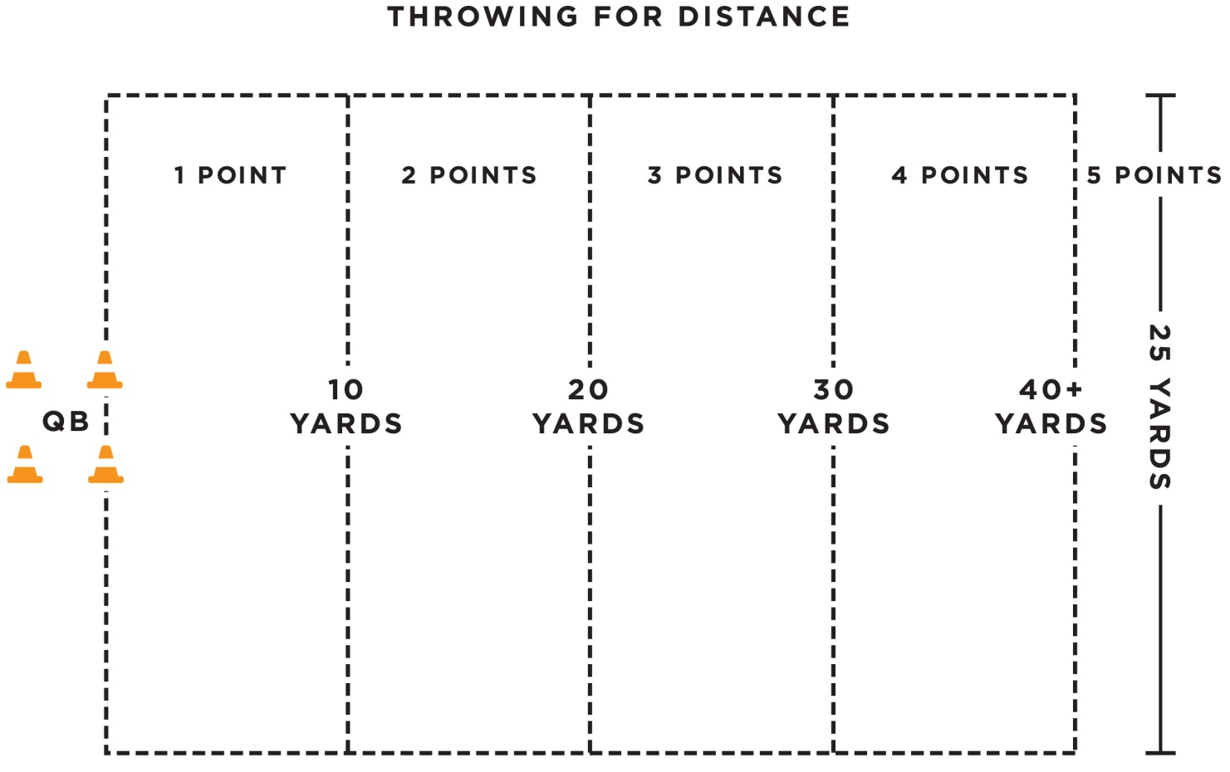

Agility & Speed: Hand-Off

- Purpose: To measure the athlete’s speed, agility and ability to receive a hand-off.

- Equipment: Three footballs, eight cones, field paint, measuring tape, and stop watch

- Description: The ball is marked at the 20-yard line or 20 yards from the goal line. The quarterback will be position 20 yards from the goal line. Athlete begins five yards behind the quarterback and between the cones.
- The quarterback will give the signal and hand the ball off to the athlete.
- The clock will start on the quarterbacks signal.
- The athlete must maneuver around the four cones and sprints to the finish line/end-zone between the cones and must maintain possession of the football.
- Each cone will be 1.25 yards apart
- A fumble at the exchange between the QB and the athlete would be a redo.
- If an athlete losses control of the ball, the clock continues to run. The athlete can recover the ball. However, if the ball goes outside the 3m lane, the athlete can either pick up the nearest back-up football or recover the errant football to continue the event.

4. Scoring: The athlete will receive two attempts. The athlete can receive a max of five points per attempt for a total of 10 points.
- The athlete will be timed from QB’s signal to when he/she crosses the finish line between the cones with possession of the football.
- One-second will be added for every missed cone.
- Conversion Chart will indicate score. Athlete can gain a maximum of 10 points.
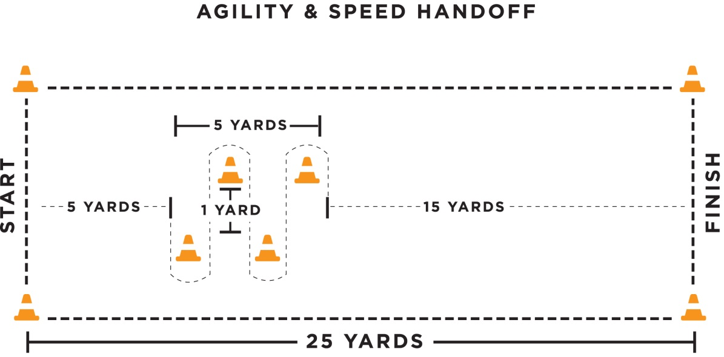

Agility & Speed: Hand-Off
Conversion Chart
Seconds Points
Under 7.5 seconds | 5
7.5-9 | 4
9.1-10.5 | 3
10.5-12.0 | 2
12.1 and over | 1

Flag Pulling

- Purpose: To measure the athlete’s ability to pull an opponent’s flag.

- Equipment: Five footballs, four cones, five volunteers and measuring tape

- Description: The athlete stands in the middle of a 5 X 5 yard grid.
- Volunteers will one at a time jog through the grid with a football and attached flags. The athlete attempts to pull the volunteers flag before the volunteer leaves the grid. Volunteers will move straight through the box without attempting to elude athlete. Speed of volunteers will increase incrementally until the last volunteer is sprinting through.
- This is not a timed event. Each additional attempt will not start until the athlete has repositioned themselves at the center of the grid.

- Scoring: The athlete will receive five attempts
- The athlete will receive two points for successful flag pull.
- The athlete will receive one point for any unsuccessful flag pull in which either the flag or ball carrier was touched, but the flag did not come off.
- The athlete will receive zero points for any unsuccessful flag pull in which the flags or ball carrier are not touched at all.
- Once the jogging volunteer leaves the grids, the athlete must reposition themselves in the center of the grid.
- Athletes can gain a maximum of 10 points in the drill.

FLAG PULLING
5yards

5 yards

Athlete
Volunteers


Flag Football Individual Skills Assessment Score Sheet
Name
Agency
Assessment Date

Scoring:
- The highest attainable score for each Skill is 10 points.
- Catching: “Run & Catch”, Throwing for Accuracy and Flag Pulling will be scored on one attempt each.
- Throwing for Distance and Agility & Speed: Hand-off will be scored on two attempts each. Utilize conversion charts below to determine points for each attempt.
- The FINAL TOTAL is a sum of all total scores.

SKILLS | SCORE | TOTAL
Catching: Run & Catch  2pts for a complete catch | / / / / .
Throwing for Accuracy  2pts for an accurate & completed throw | / / / /
Flag Pulling  2pts for successful flag pull  1pt for any unsuccessful flag pull in which the flags or ball carrier was still touched | / / / /
Agility & Speed: Hand-off  Use conversion chart below | 1st attempt:  / / / /  2nd attempt:  / / / /
Throwing for Distance  Use conversion chart below | /
FINAL TOTAL

CONVERSION CHARTS
Agility & Speed:  Hand-off |  |  | Throwing for Distance
Seconds | Points |  | Yards | Points
Under 7.5 | 5 |  | 40+ yards | 5
7.5-9 | 4 |  | 39-30 | 4
9.1-10.5 | 3 |  | 29-20 | 3
10.5-12 | 2 |  | 19-10 | 2
12.1 and over | 1 |  | 9-0 yards | 1

SOCCER SCORE SHEET

Field___________ Winner______________________
Time___________ Loser_______________________
Scorer______________

Team Name: ____________________________

No. | Athlete Name | Goal | Card R/Y

Score
1st | 2nd | OT | Final

Team Name: ____________________________

No. | Athlete Name | Goal | Card R/Y

Score
1st | 2nd | OT | Final

SOFTBALL SCORING

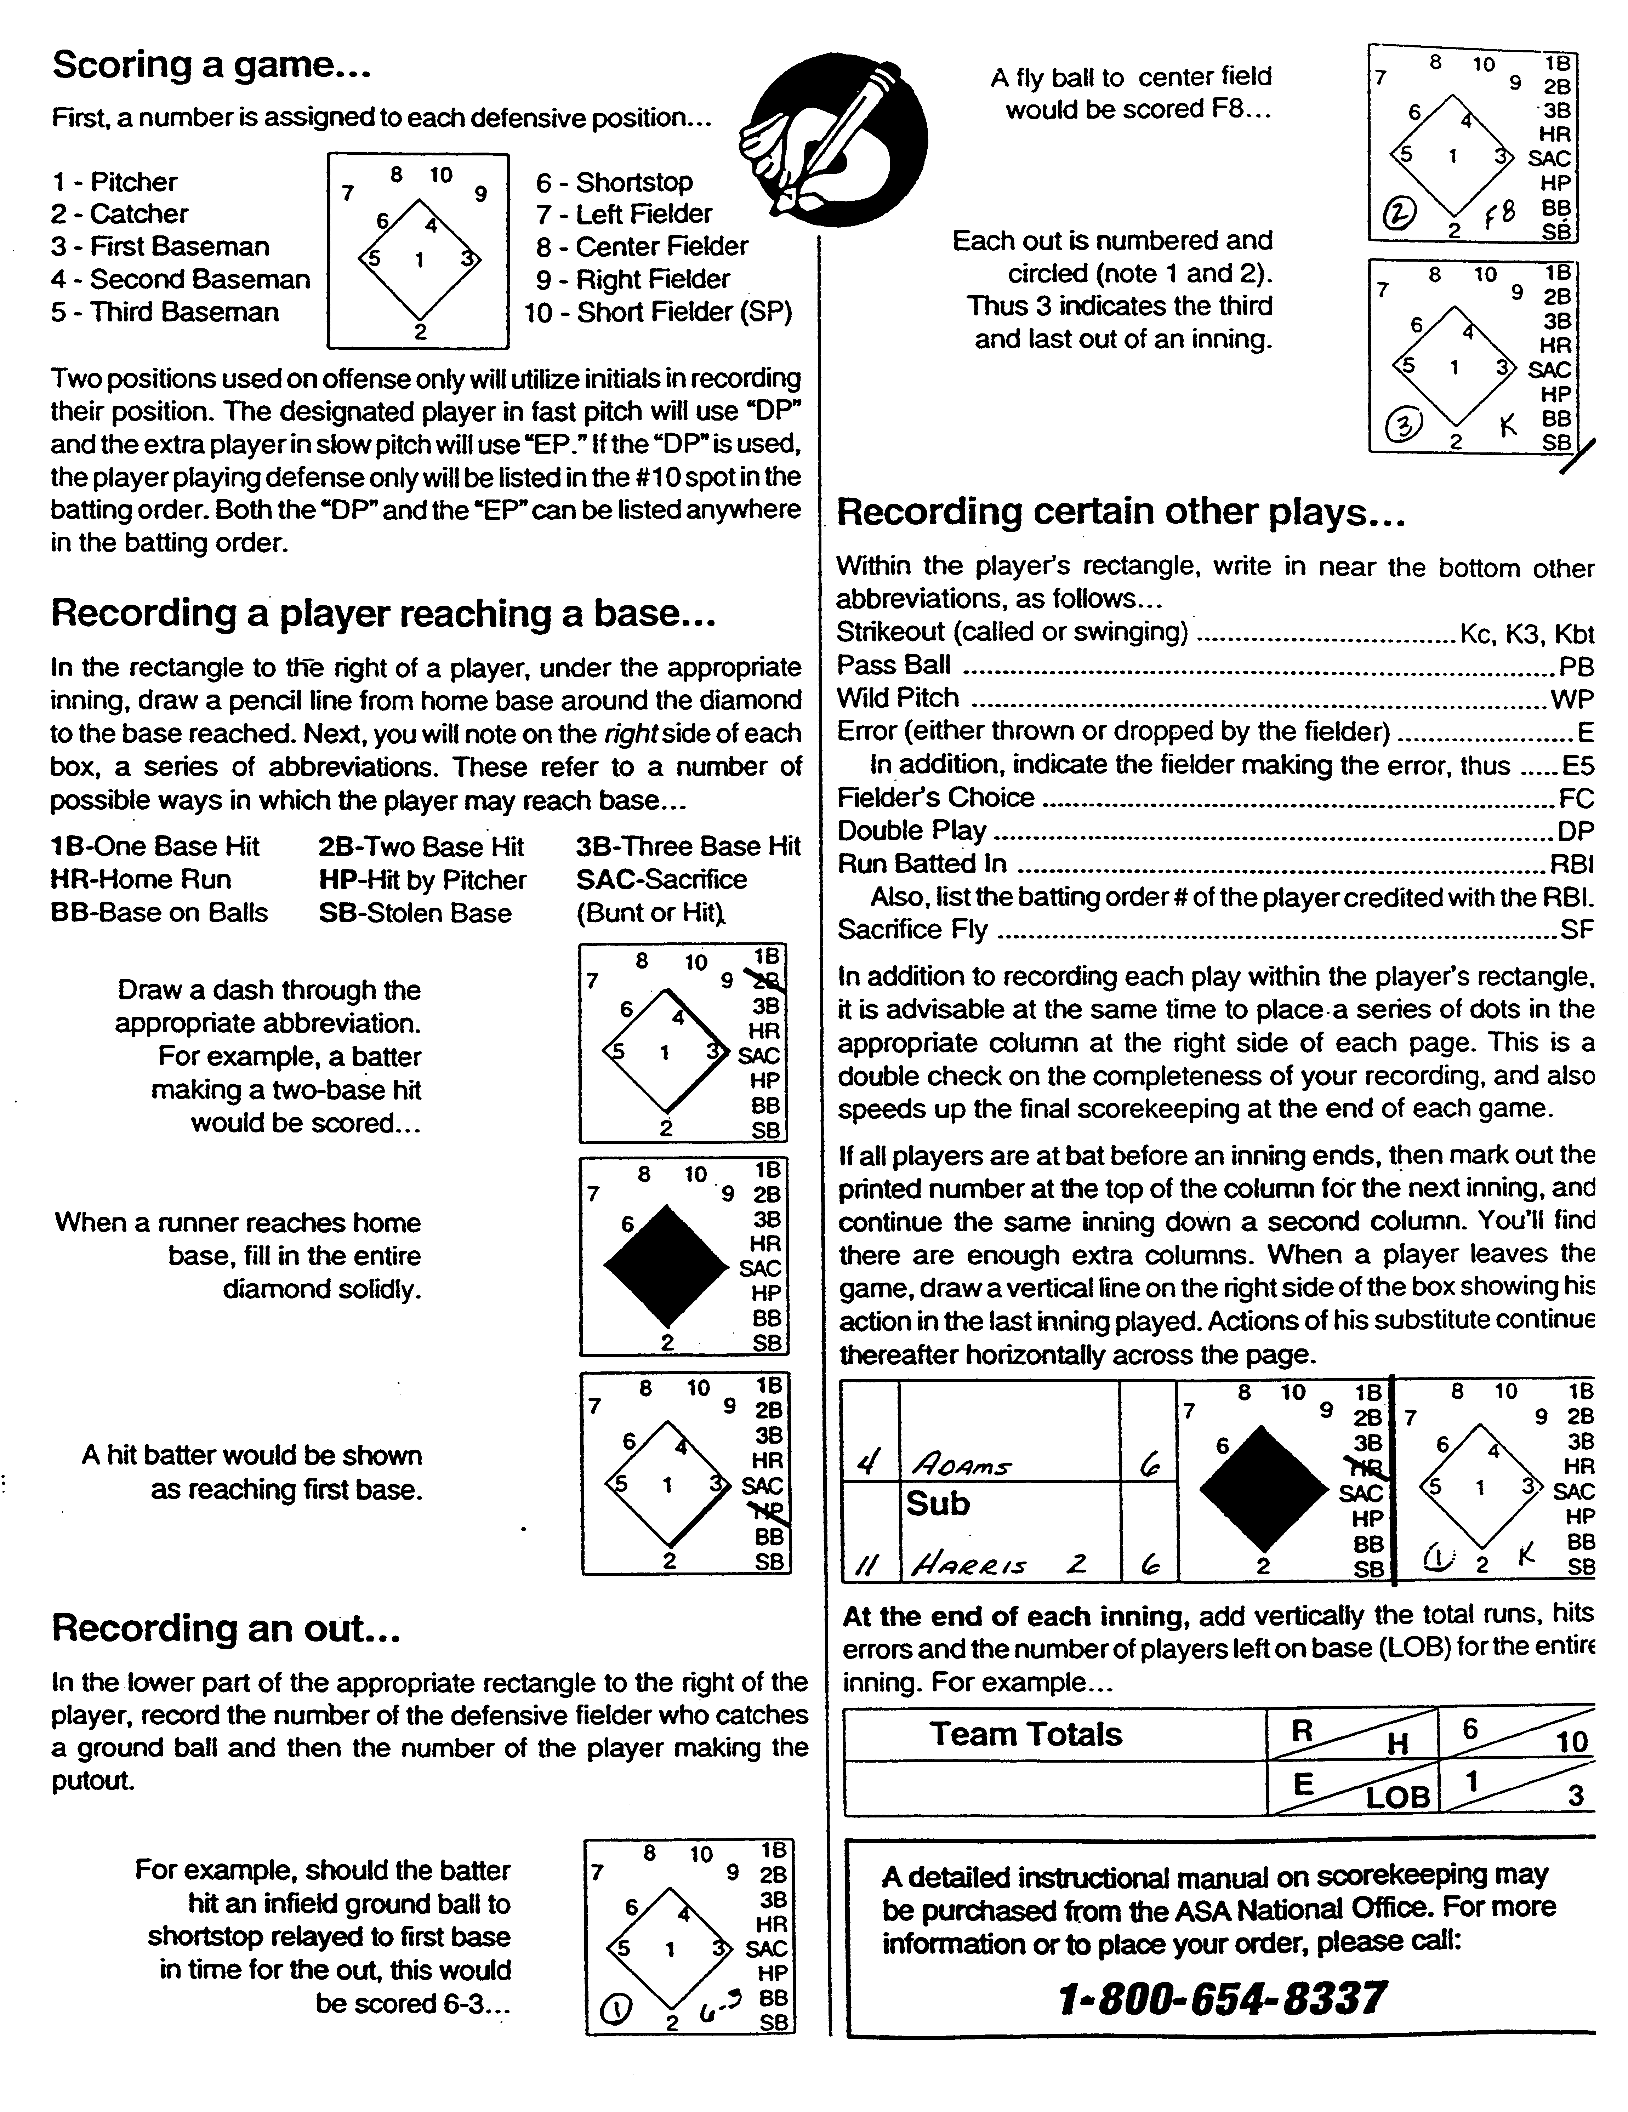

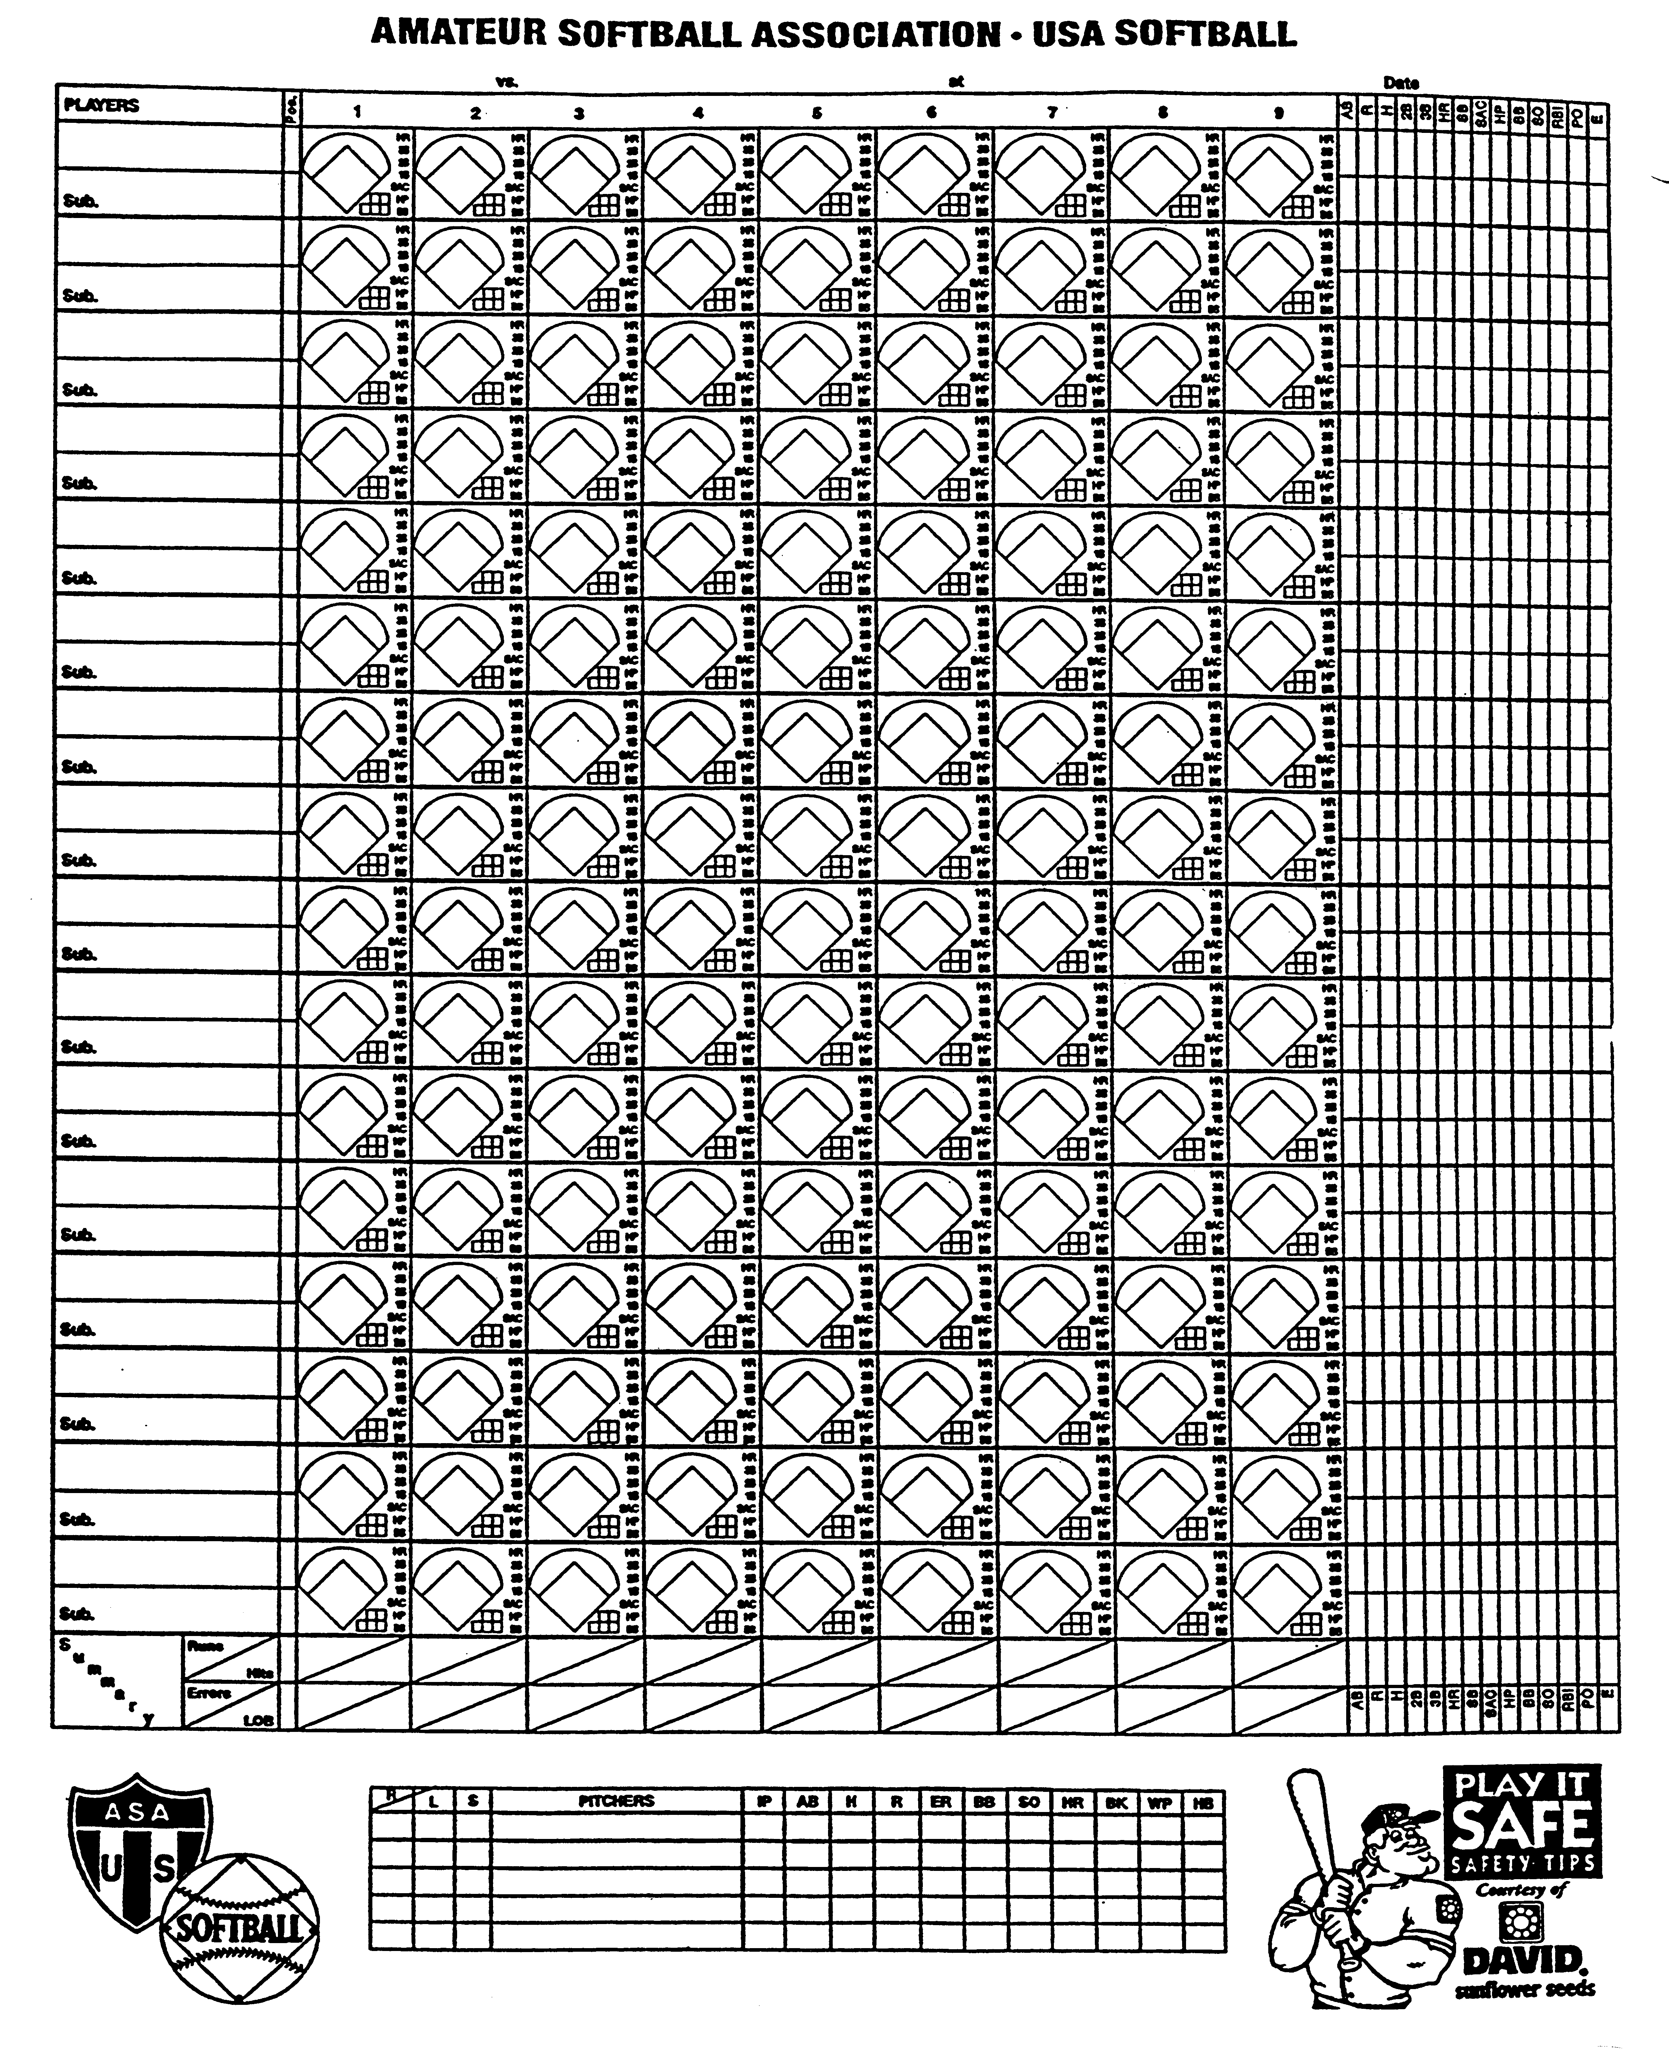

FAMILY & FRIENDS
SERVICES AT SPECIAL OLYMPICS WISCONSIN STATE COMPETITIONS

In the past, Special Olympics Wisconsin (SOWI) reserved room blocks for family members attending State Games. We have found that many times, these blocks are not used or rooms are booked and cancelled close to the event. This has made it difficult to book blocks of rooms as hotels lose money on cancellations. With these reasons, coupled with the fact that hotel deals are much more easily found on travel websites, SOWI has not made any hotel blocks for the 2015-2016 sports year.

You can also contact the city’s visitor’s bureau to find hotel deals. Here is the contact information:

Winter Games: January 23 – 24, 2016 Wausau
Competition: Alpine Skiing (Downhill), Cross Country Skiing, Snowshoe Racing, Snowboarding
Wausau Visitors Bureau: (715) 355-8788
www.visitwausau.com

Indoor Sports Tournament: TBD, Oshkosh
Competition: Basketball Skills, Team Basketball, Gymnastics
Oshkosh Visitors Bureau: (920) 303-9200
www.visitoshkosh.org

Summer Games: June 9 – 11, 2016 Stevens Point
Competition: Aquatics (Swimming), Athletics (Track & Field), Powerlifting & Football (Soccer)
Stevens Point Visitors Bureau: (715) 344- 2556
www.stevenspointarea.org

Outdoor Sports Tournament: August 6, 2016 Waukesha
Competition: Bocce, Tennis, Golf, Softball
Waukesha Visitors Bureau: (262) 542-0330
www.visitwaukesha.org

As Agency managers and coaches, you understand how important increased awareness and involvement is to our program. The athletes we serve deserve field houses and stadiums overflowing with spectators. Let’s do our part to make it happen!

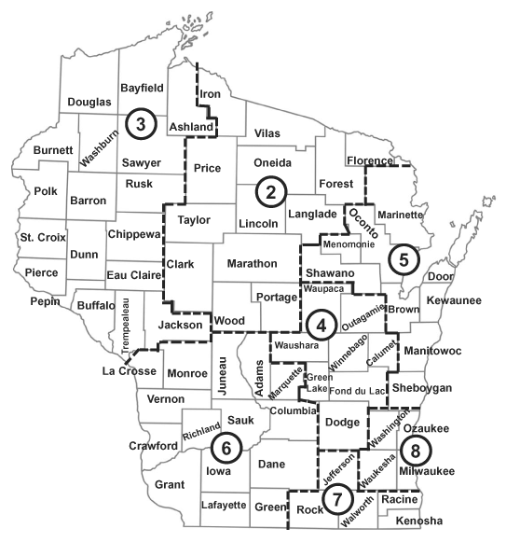
SOWI Headquarters
Dennis H. Alldridge, President

Administration
Carol Ellis
Mary Beaty
Faye Borchert
Barb Burg
Theresa Rossman

Development
Julie Buedding
Matthew Burr

Communications
Jennifer Wagner
Lindsay Russo
Shannon Adams

Program Services
Bob Whitehead
Sara Rollin
Melissa Schoenbrodt
Samantha Sotelo

2310 Crossroads Dr. Ste 1000
Madison, WI 53718
608.222.1324
800.552.1324
608.222.3578 (fax)
SpecialOlympicsWisconsin.org

North Central Region 2
Jerry Lyon
Alyssa Matelski
2804 Rib Mountain Dr. Ste. C
Wausau, WI 54401
715.848.0550
877.848.0550
715.848.0880 (fax)

Indianhead Region 3
Melissa Maxwell
Karen Kraus
2023 Fairfax Ave.
Eau Claire, WI 54701
715.833.0833
800.833.5851
715.833.0507 (fax)

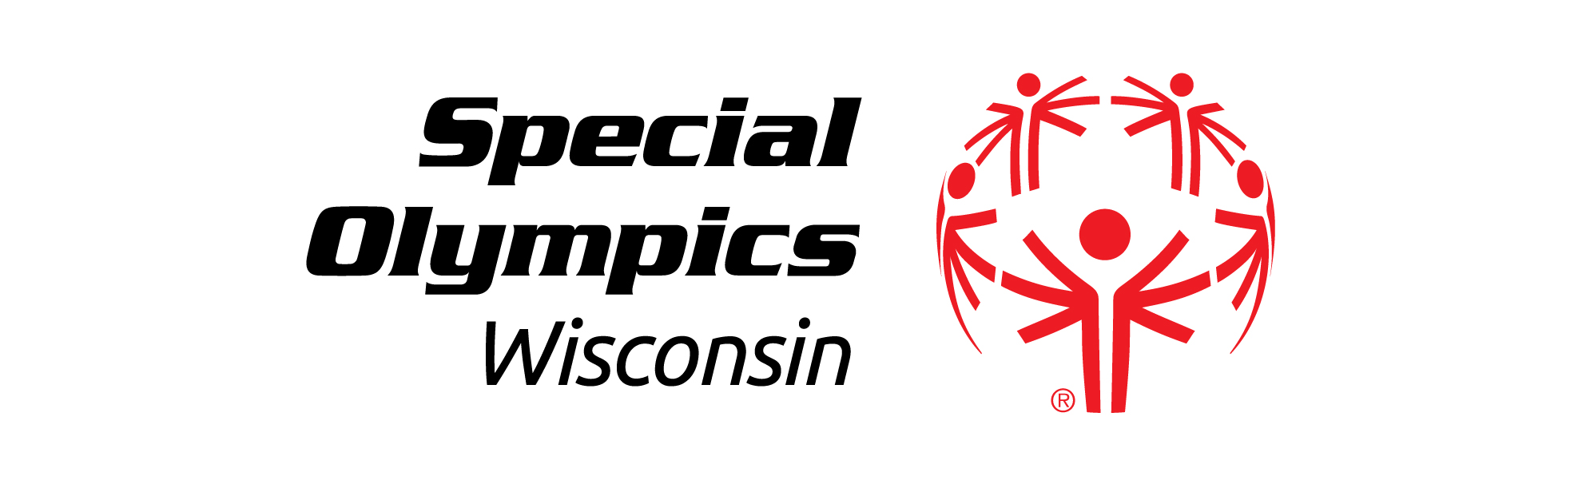

Fox Valley Region 4
Nicole Sprangers
Mark Wolfgram
W5361 County Rd. KK, Ste. D
Appleton, WI 54915
920.731.1614
800.704.1614
920.731.3691 (fax)

Northeastern Region 5
Matt Harper
Carla Lieb
2140 Holmgren Way
Green Bay, WI 54304
920.497.2422
800.707.2422
920.497.0126 (fax)

South Central Region 6
JoEllen Graber
Don Wigington
575 D’Onofrio Dr. Ste. 102
Madison, WI 53719
608.221.2900
800.679.6751
608.221.3961 (fax)

Southeastern Region 7
Troy Anderson
Brittany Neukirchen
6100 Washington Avenue
Racine, WI 53406
262.598.9507
800.924.4320
262.598.9509 (fax)

Greater Milwaukee Region 8
Jason Blank
Jessica Paczesny
10224 N. Port Washington Rd.
Mequon, WI 53092
262.241.7786
800.924.5202
262.241.5334

SPECIAL OLYMPICS WISCONSIN
HEADQUARTERS STAFF
2310 Crossroads Drive Ste 1000
Madison, Wisconsin 53718
(608) 222-1324
(800) 552-1324
(608) 222-3578 [Fax]
specialolympicswisconsin.org

NAME TITLE E-MAIL
Shannon Adams Marketing Specialist sadams@specialolympicswisconsin.org
Dennis Alldridge President dalldridge@specialolympicswisconsin.org
Mary Beaty Director of Administration and Finance mbeaty@specialolympicswisconsin.org
Faye Borchert Database Manager fborchert@specialolympicswisconsin.org
Julie Buedding Director of Development - LETR jbuedding@specialolympicswisconsin.org
Barb Burg Volunteer Records Manager bburg@specialolympicswisconsin.org
Matthew Burr Director of Development – Gov’t Relations & Strategic Grants mburr@specialolympicswisconsin.org
Carol Ellis Chief Operating Officer cellis@specialolympicswisconsin.org
Sara Rollin Sports Event Manager srollin@specialolympicswisconsin.org
Lindsay Russo Marketing Specialist lrusso@specialolympicswisconsin.org
Theresa Rossman Gift Records Manager trossman@specialolympicswisconsin.org
Melissa Schoenbrodt Director of Health Programming mschoenbrodt@specialolympicswisconsin.org
Samantha Sotelo Athlete Records Manager ssotelo@specialolympicswisconsin.org
Jennifer Wagner Vice President of Marketing jwagner@specialolympicswisconsin.org
Bob Whitehead Vice President of Program Services bwhitehead@specialolympicswisconsin.org

SPECIAL OLYMPICS WISCONSIN
COMPETITION GUIDE EVALUATION FORM
2015 – 2016

Which sections of the handbook were the most helpful?

Which section of the handbook would you delete?

What content area(s) would you recommend adding?

Errors:
Page Error

Please Return To:
Special Olympics Wisconsin Name:
2310 Crossroads Drive Ste 1000 Address:
Madison, WI 53718 City:
State: Zip:
Phone:
Email:

