Athlete Policies

Statement of Eligibility for Special Olympics Wisconsin 1
Who is the Special Olympics Athlete? 1
Athlete Registration Information 1
Official Special Olympics Release Form Explanation 2
Application For Participation in Special Olympics Explanation 2
Athlete Medical Restrictions 3
Official Special Olympics Release Form Sample 4
Application For Participation In Special Olympics Form Sample 5
Housing Addendum Sample 6
Special Examination Form Explanation 7
Special Examination Form Sample 8
Unified Sports® Partners 9
Athlete Code of Conduct 10
Athlete Code of Conduct Disciplinary Steps 12

Left Blank Intentionally
Statement of Eligibility for Special Olympics Wisconsin

Special Olympics Wisconsin (SOWI) was created, and exists today, to give individuals with intellectual disabilities¹ the opportunity to train and compete in year-round sports activities.
To be eligible to participate as a registered SOWI athlete², a person must meet the following criteria:
- Be at least 8 years of age. There is no maximum age limit. Individuals ages 2-7 may inquire about Special Olympics Wisconsin’s Young Athletes™.
- Be identified by an agency or professional as having:
  - An intellectual disability¹; or
  - An intellectual delay³ as determined by standardized measures such as intelligence quotient (IQ) or other generally acceptable measures; or
  - A closely related developmental disability. A “closely related developmental disability” means having functional limitations in both general learning⁴ and adaptive skills⁵ such as recreation, work, independent living, self direction or self care. However, persons whose functional limitations are based solely on a physical, behavioral, or emotional disability, or a specific learning or sensory disability are not eligible to participate as Special Olympic athletes, but may be eligible to volunteer for SOWI.
- Agree to abide by the Official Special Olympics Sports Rules and the SOWI Athlete Code of Conduct.
- Persons with multiple disabilities may participate in SOWI as long as they also meet the noted criteria above.
NOTE: No person shall, on the grounds of sex, race, religion, color or national origin, be excluded from participation in, be denied benefits of, or otherwise subjected to discrimination under any program or activity of SOWI.

¹ A synonym for mental retardation. May also be used synonymously with mental or cognitive disability/delay.
² To be a registered SOWI athlete, eligible persons must complete an Application for Participation (medical form) and a release form and register under one of approximately 200 SOWI accredited Agencies.
³ Learning slower than ones typical peers and requiring specially designed instruction.
⁴ General learning limitation refers to substantial deficits in conceptual, practical and social intelligence that will result in performance problems in academic learning and/or general life functioning.
⁵ Adaptive skill limitations refers to an ongoing performance deficit in skill areas considered essential to successful life functioning.

Source: Article 6.01, Special Olympics Official General Rules, Revised 2004.

Who is the Special Olympics Athlete?
Is the person identified by an agency or professional as having an intellectual disability or a cognitive delay?
Is this person 8 years of age or older?

This person is NOT eligible to participate as a Special Olympics athlete

This person is eligible to participate as a Special Olympics athlete
Is the person identified by an agency or professional as having a “closely related developmental disability” with functional limitations in both general learning and adaptive skills?

Are the functional limitations primarily due to a physical, behavioral, or emotional disability, or a specific learning or sensory disability?
This person is NOT eligible to participate as a Special Olympics athlete.

Alympics Wisconsin Release Form and Application for Participa

Athlete Registration Information
Athlete Registration Information

The Official Special Olympics Wisconsin Release Form and Application for Participation in Special Olympics serve as an athlete’s registration for Special Olympics and must be completed before an athlete participates in any Special Olympics training program. They provide for a photo release, necessary medical information, secondary insurance coverage by Special Olympics, Inc., and emergency medical treatment in the event a parent or guardian cannot be reached.

Athletes who are new to Special Olympics must submit both the Official Special Olympics Release Form and the Application for Participation in Special Olympics form postmarked by the appropriate medical deadline date. An athlete must be 8 years old by the medical deadline date for whichever sport the athlete is training. Medical deadline dates are strictly enforced. There will be no exceptions to the medical deadline policy. Completed medical forms may not be faxed or e-mailed to the SOWI Headquarters office.

Special Olympics Wisconsin Registration Policy
If an athlete’s Application for Participation in Special Olympics expires prior to the last day of the State competition for which the athlete is registered, a new Application for Participation in Special Olympics must be completed correctly and mailed to the Headquarters office, postmarked by the appropriate medical deadline date for that sport and approved. The athlete’s Release Form must also be on file by the medical deadline date. (Example: An athlete whose Application expires on January 10, 2016 wishes to compete in cross country skiing. The last day of the state competition is January 24, 2016; therefore, a new Application for Participation in Special Olympics must be postmarked by December 1, 2015.) The medical deadline dates also apply to Unified Sports® Partners. They be a current Class A volunteer by the medical deadline date for the sport in which they are registered.

If an athlete’s medical will expire prior to the last day of the State competition for which s/he is registered and the medical deadline for the state competition has passed, the athlete may practice and compete until the date their medical expires. If the athlete’s medical expires after Regional/District competition but prior to Sectional competition, the athlete may participate in the Regional/District competition but is unable to advance to the Sectional competition. If the athlete’s medical expires after a Regional/District or Sectional competition but prior to the State tournament, s/he may participate in all of the Regional/District and Sectional competitions but is unable to advance to the State tournament. Please use discretion when allowing an athlete to compete if his or her medical expires prior to Regional/District, Sectional and/or State competition.

The Application for Participation in Special Olympics must be completed at least once every three years unless otherwise stated by the physician, or if the athlete has a significant medical condition change during the three-year period for their medical. The Application for Participation in Special Olympics may be completed yearly if/when the athlete has their annual physical examination.

The Official Special Olympics Release Form only needs to be completed once unless there is a change in guardianship for the athlete.

According to Special Olympics, International (SOI) guidelines, all athletes (or the parents/guardians for athletes who are minors and/or not their own guardian) are required to sign an addendum to the Official Special Olympics Release Form indicating they are aware of SOI housing information for overnight activities and tournaments if they have not signed the Official Special Olympics Release Form dated August 2013. This requirement applies to all athletes, even if they do not participate in overnight housing for overnight activities and tournaments. The addendum must be signed and mailed to the Headquarters Office.

Official Special Olympics Release Forms, Application for Participation in Special Olympics forms and Housing Addendums are available from the Regional or Headquarters offices, the SOWI website and via e-mail – please contact the Headquarters office to obtain forms via e-mail. (Samples are included in this section of the handbook, but they are not for duplication.)
Athlete Medical Restrictions
Athletes must have their restriction lifted prior to training and competition in that particular sport. The following healthcare providers may lift a sports restriction: Doctor of Medicine (M.D.), Doctor of Osteopathy (D.O), Nurse Practitioner (N.P.), and Physician Assistant (P.A.). Releases from medical restrictions must be mailed or faxed to the Headquarters office. Medical deadline dates do not apply when lifting medical restrictions, but restrictions must be lifted by the end of the business day on the Wednesday following the event entry deadline date.

Official Special Olympics Release Form Sample
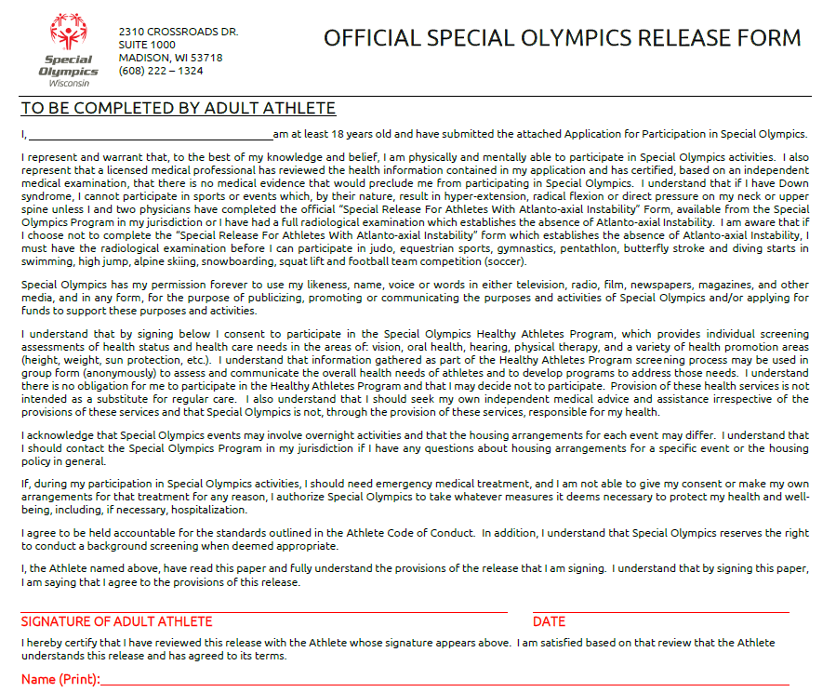

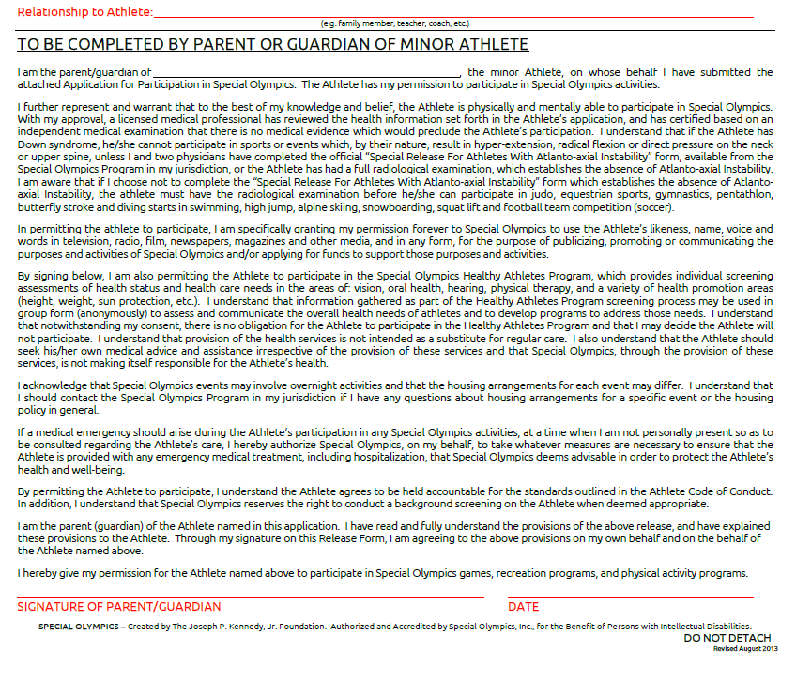

Application for Participation in Special Olympics Form Sample
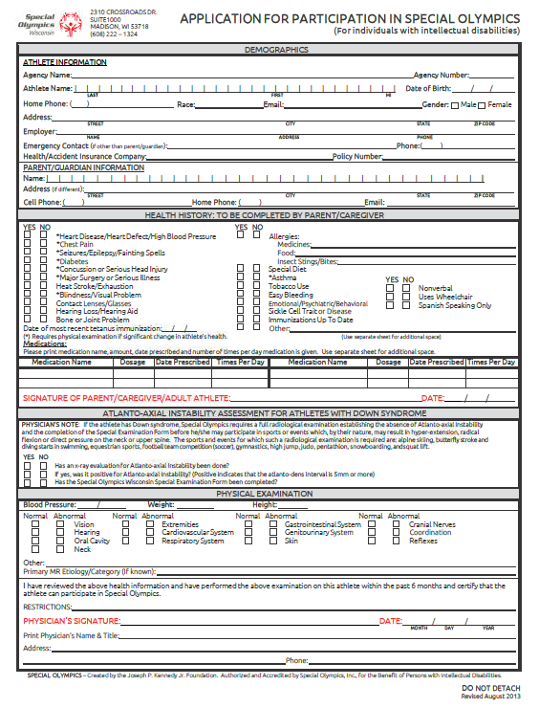

Housing Addendum Sample
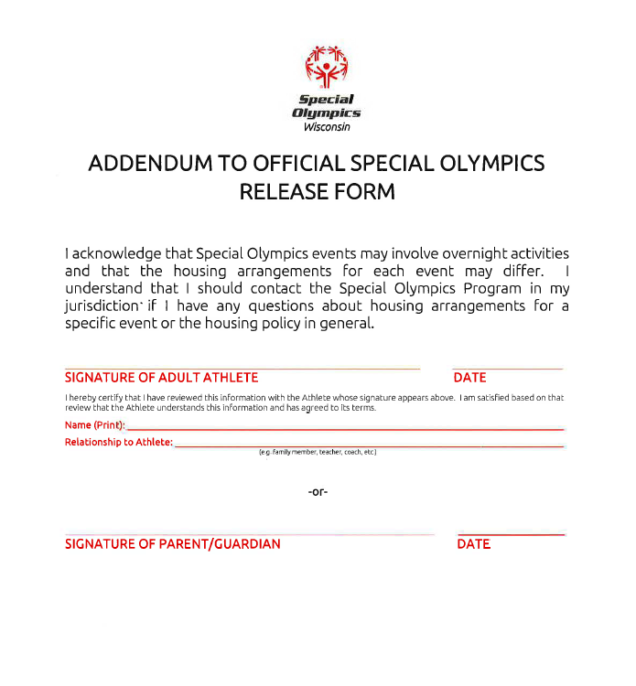

Athlete Registration – Special Examination Form

Athletes with Down syndrome may be required to complete an additional form called the Special Examination Form.
Medical research indicates that up to 15% of individuals with Down syndrome have a condition known as Atlanto-axial Instability, which is a malalignment of cervical vertebrae C-1 and C-2 in the neck. This condition exposes individuals with Down syndrome to the possibility of injury if they participate in activities that hyperextend or radically flex the neck muscles.
Athletes with Down syndrome who are participating in the following sports are required to have x-rays taken and the Special Olympics Special Examination Form completed and returned to the Headquarters office before they start training: artistic gymnastics, pentathlon, butterfly stroke (aquatics), diving start (aquatics), high jump, football (soccer), alpine skiing, equestrian, squat lift, judo, snowboarding and any warm-up exercises placing undue stress on the head and neck muscles.
If an athlete does not have Down syndrome and the healthcare provider has completed the section for Athletes with Down syndrome by mistake on the Application for Participation in Special Olympics Form, the athlete will be assumed to have Down syndrome and will be restricted from the sports listed above. A signed and dated note from a healthcare provider stating that the athlete does not have Down syndrome will need to be submitted to the Headquarters office in order to lift the sports restrictions, however, restrictions must be lifted one week following the event entry deadline.
Medical Restrictions for Athletes with Down Syndrome
Down Syndrome athletes who wish to compete in a sport they are restricted from must have their restriction lifted prior to training and competition in that particular sport by either having a signed and dated note by a healthcare provider and/or having the Special Olympics Special Examination Form completed. The following healthcare providers may lift a sports restriction: Doctor of Medicine (M.D.), Doctor of Osteopathy (D.O), Nurse Practitioner (N.P.), and Physician Assistant (P.A.). Releases from medical restrictions may be mailed or faxed to the Headquarters office. Medical deadline dates do not apply when lifting medical restrictions.
The Special Examination Form needs to be completed only once. The form is available from the Regional or Headquarters office, the SOWI website and via e-mail – please contact the Headquarters office to obtain the form e-mail. (A sample is included in this section of the handbook, but it is not for duplication.)

Special Examination Form Sample
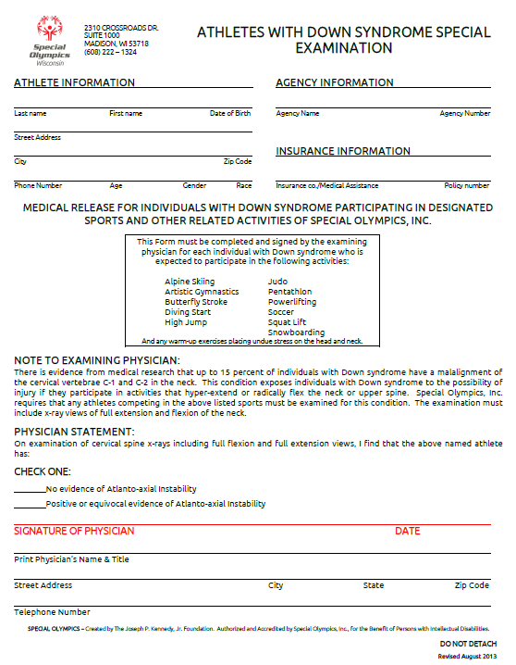

Athlete Registration – Special Olympics Unified Sports® Partners

Special Olympics Unified Sports is a program which provides individuals with intellectual disabilities (athletes) and individuals without intellectual disabilities (partners) the opportunity to train and compete together as a team. (see the Outreach section of this handbook for more details about this program and other inclusive opportunities). All individuals participating as partners in the Unified Sports program are required to be a Class A volunteer by the medical deadline date for the sport in which they wish to participate. There will be no exceptions to the medical deadline policy.
Unified Sports partners are required to complete the Protective Behaviors Training (online at SpecialOlympicsWisconsin.org) and to be re-screened every three years as required of all Class A volunteers. Please refer to the Volunteer Policies section for more information on Class A volunteers.

Athlete Code of Conduct

SOWI prides itself in sponsoring high quality sports training and competitions for people with intellectual disabilities. The primary purpose of this code of conduct is to establish a high standard of athlete behavior, which will ensure the safety and well being of all athletes involved in training and competition. All athletes (including Unified Sports® Partners) are expected to abide by the Athlete Code of Conduct as established by SOWI. Athletes should be reminded that participation in Special Olympics is a privilege, not a right, and that the Agency manager has the authority to make immediate accommodations until final decisions can be made.
By agreeing to abide by the Special Olympics Wisconsin Code of Conduct, each athlete agrees to adhere to the following athlete behavior:
- Uphold the mission, philosophy, principles and policies of Special Olympics, Inc. and Special Olympics Wisconsin
- Behave in a manner consistent with Special Olympics Wisconsin’s core values of mutual respect, positive attitude, accountability, teamwork and dedication
- Each athlete further agrees and acknowledges that participation in SOWI is voluntary and SOWI may terminate an athlete’s participation if the athlete fails to follow SOWI rules and policies, including the athlete code of conduct.
SPORTSMANSHIP
I will practice good sportsmanship.
I will act in ways that bring respect to me, my coaches, my team and Special Olympics.
I will not use bad language.
I will not swear or insult other persons.
I will not fight with other athletes, coaches, volunteers or staff.
TRAINING AND COMPETITION
I will train regularly.
I will learn and follow the rules of my sport.
I will listen to my coaches and the officials and ask questions when I do not understand.
I will always try my best during training, divisioning and competitions.
I will not “hold back” in preliminary competition just to get into an easier finals competition division.
RESPONSIBILITY FOR MY ACTIONS
I will not make inappropriate or unwanted physical, verbal or sexual advances on others.
I will not smoke in non-smoking areas.
I will not drink alcohol or use illegal drugs at Special Olympics events.
I will not take drugs for the purpose of improving my performance.
I will obey all laws and Special Olympics rules, the International Federation and the National Federation/Governing Body rules for my sport(s).
ATHLETE STANDARDS OF BEHAVIOR

The following athlete behavior is unacceptable while participating in Special Olympics training or competition, including, but not limited to, practice, in transit, and at the competition venue:
• Profanity or verbal abuse • Frequent unexcused absences
• Tobacco use in restricted areas • Exhibition of poor sportsmanship
• Use of alcohol • Violent or disruptive behavior
• Physical or verbal sexual overtures • Any unwelcome physical contact
• Physical abuse* • Possession of harmful weapons*
• Use of illegal drugs or any controlled • Public forum posts that degrade the organization
substance*
• Felony or misdemeanors (or any other illegal or socially unacceptable behavior) which seriously disrupts or impedes the participation of athletes or others*
*Criminal offenses regardless of where it occurs may result in immediate suspension from any and all Special Olympics activities.

Guidelines for limiting or denying an athlete’s involvement in SOWI
SOWI may limit or deny an athlete’s participation in SOWI based on the following, as determined by SOWI in its sole discretion.

    - Admission or adjudication of involvement in abuse, neglect, sexual assault, or conduct involving violence or threat of violence (for example, assault and battery or armed robbery)

    - Record of being charged with abuse, neglect, conduct involving violence or threat of violence (for example, assault and battery or armed robbery), or sexual assault with corroborating information

c. Extreme or repeated violations of the SOWI Code of Conduct

d. Current use of illegal drugs

e. If the safety of other athletes is at risk

Not all situations or circumstances can be addressed in these guidelines. SOWI will address each situation on a case-by-case basis.

SOWI recommends all Special Olympics athletes and Unified Sports partners review, understand and sign the Athlete Code of Conduct before sports training begins. If an athlete or Unified Sports partner participates in multiple sports seasons, he/she need only submit one form per SOWI sports year (i.e., October - September). The Agency manager should retain a copy in the Agency files throughout the SOWI sports year.

Athlete/Unified Sports Partner’s Signature Date
Print Athlete's Name
Agency #: Agency Name:

Parent/Guardian Signature (If athlete is a minor or not their own guardian.)

Athlete Code of Conduct Disciplinary Steps

The following steps may be taken by the Agency manager or a staff member from the Regional or Headquarters office. The Regional office must be contacted before an Agency manager suspends an athlete. The Regional office will discuss the circumstances and approve the action. The action will be documented in writing and presented to the athlete and parent/guardian (or caseworker) and a copy will be sent to the Headquarters office.
- Verbal warning given to the athlete
- Written warning given to the athlete with a copy to the Region office and parent/guardian or caseworker
- Personal meeting with the athlete to review unacceptable behavior and work out a plan for improvement
- If the athlete is under 18, or over 18 and not their own guardian, he/she will be accompanied by his/her parent/guardian or caseworker. If the athlete is over 18 and is his/her own guardian, he/she may choose to have another adult present. The meeting will be documented in writing and copies distributed to the athlete, Regional office, Headquarters office, Agency file, and parent/guardian or caseworker.
- Suspension from practices or competition during the specific sport season
Any further action must be referred to the Regional office. The Regional office and Headquarters staff member responsible for Regional management will approve any further action to be taken.
Further action could be, but is not limited to:
• Suspension for more than one sport season
• Expulsion for one year or more
• Permanent expulsion

Appeal Process
The athlete has the right to appeal any disciplinary actions with the Regional office. The athlete or representative must submit a written request for a meeting to appeal the decision within 30 days of being notified of the disciplinary action. SOWI will review the request and determine whether to uphold the decision of the Regional office or hold an appeal meeting to obtain additional information.
If deemed necessary, the appeal will be heard by a Regional and/or Headquarters staff representative, and an Agency manager (either the manager from that Agency or if deemed necessary a manager not involved with the situation). A decision to reverse, amend or affirm a disciplinary action will be submitted in writing to the Agency manager and should include a plan of action for the athlete to correct the unacceptable behavior that led to the disciplinary action.

