Table Of Contents

Oaths 1
Philosophy 2
Mission 2

Schedules
General Schedule 3
Meal Schedule & Menu 4
Maps
Oshkosh Area Map 5
UW–Oshkosh Campus Map 6
Kolf Sports Center Map 7
Albee Gym Map 8
Tournament Information
Gymnastics Competition 9
Individual Skills Competition 10
Team Basketball Competition 11
Filing Protests 12
Athlete Entertainment Overview 13
UW-Oshkosh Nutrition Education Station 13
Healthy Athletes® 13
Fans in the Stands Information 14
Press Release Information 14
Special Olympics Wisconsin on Social Media 14
ID Badges 15
Registration and Housing Information
Tournament Central 15
Souvenir Information 15
Emergency Telephone Numbers 16
Parking 16
Housing Information 17
Check-Out Procedures 17
Severe Weather 17
Medical Services 18
Safety & Fire Procedures 19
General Information
Indoor Sports Tournament Management Team 20
2016 State Competition Schedule 20
Partners and Friends of the Indoor Sports Tournament 21



“Let me win.
But if I cannot win,
let me be brave in the attempt.”

-Special Olympics Athlete Oath-

“In the name of all coaches and in the spirit of sportsmanship, I promise that we will act professionally, respect others, and ensure a positive experience for all. I promise to provide quality sports and training opportunities in a safe environment for all athletes.”

-Special Olympics Coach’s Oath-

“In the name of all judges and officials, I promise that we shall officiate in these Special Olympics Games with complete impartiality, respecting and abiding by the rules which govern them, in the spirit of sportsmanship.”

-Special Olympics Official’s Oath-

PHILOSOPHY

Special Olympics is founded on the belief that people with intellectual disabilities can, with proper instruction and encouragement, learn, enjoy and benefit from participation in individual and team sports, adapted as necessary to meet the needs of those with special mental and physical limitations.

Special Olympics believes that consistent training is essential to the development of sport skills, and that competition among those of equal ability is the most appropriate means of testing these skills, measuring progress and providing incentives for personal growth.

Special Olympics believes that through sports training and competition, people with intellectual disabilities benefit physically, mentally, socially and spiritually; families are strengthened; and the community at large, both through participation and observation, is united in understanding people with intellectual disabilities in an environment of equality, respect and acceptance.

******

MISSION

The mission of Special Olympics Wisconsin (SOWI) is to provide year-round sports training and athletic competition in a variety of Olympic-type sports for children and adults with intellectual disabilities, giving them continuing opportunities to develop physical fitness, demonstrate courage, experience joy and participate in a sharing of gifts, skills and friendship with their families, other Special Olympics athletes and the community.

General Schedule of Events

Saturday, April 9, 2016
9:00 am – 4:30 pm  10:30 am – 4:00 pm  11:30 am – 4:00 pm  10:30 am – 1:00 pm  12:00 pm – 4:30 pm  10:00 am  10:30 am  11:30 am  12:00 pm – 3:00 pm  9:00 am – 9:00 pm  4:30 pm – 6:30 pm  7:00 pm  7:20 pm  7:20 pm – 9:00 pm  11:00 pm – 7:00 am | Registration – Tournament Central  Healthy Athletes (Opening Eyes, Healthy Hearing, & Special Smiles)  Fun Fitness  Lunch  Team Basketball Competition  Gymnastics Warm-Ups  Rhythmic Gymnastics Competition  Artistic Gymnastics Competition  Individual Basketball Skills  Souvenir Sales*  Dinner  Opening Ceremony  Unified Basketball Game  Dance  Quiet Hours** | Kolf Sports Center (Upper Gym)  Gruenhagen  Kolf Sports Center (Upper Gym)  Blackhawk Commons  Kolf Sports Center  Kolf Sports Center  Kolf Sports Center (Lower Level)  Kolf Sports Center (Lower Level)  Albee (Upper & Lower Gym)  Kolf Sports Center  Blackhawk Commons  Kolf Sports Center (Upper Gym)  Kolf Sports Center (Upper Gym)  Kolf Sports Center (Lower Gym)

Sunday, April 10, 2016
6:30 am – 9:00 am  7:30 am – 12:30 pm  8:30 am – 12:30 pm  8:00 am – 12:00 pm | Breakfast  Tournament Central  Team Basketball  Souvenir Sales* | Blackhawk Commons  Kolf Sports Center (Upper Gym)  Kolf Sports Center & Albee Gym  Kolf Sports Center (Upper Gym)

**Quiet Hours – Coaches & athletes should be in their rooms and quiet. Violators may be asked to leave!!
* Times may change

MEALS

All meals except for gymnastics will be kept on campus at Blackhawk Commons. If an athlete or coach has special dietary needs, please contact Lisa Siwik at siwikl@uwosh.edu as soon as possible in order to give the university time to prepare for those needs.

All athletes and coaches/chaperones must wear the SOWI credentials to meals and must also have meal tickets to get a meal; credentials will act as your meal tickets. If you lose your ID badge, please report to Tournament Central. At the Blackhawk Commons, please utilize the SOWI designated serving buffet lines. The specialty food areas (i.e. Pizza/Pasta line, Hot Grill line, etc.) are not open to anyone but UW-Oshkosh students.

Gymnastics Lunches will be served at the gymnastics venue as a boxed lunch. ONLY gymnasts may pick up a boxed lunch. All others must eat at the dining center.

MENU (subject to change)

Saturday, April 9 | Sunday, April 10
Lunch: 10:30 am – 1:00 pm  Sloppy Joes on a Bun  Garden Burgers  Macaroni and Cheese  Caesar Salad  Green Beans/ Bananas  Assorted Cupcakes and Cookies | Breakfast: 6:30 am – 9:00 am  Scrambled Eggs  French Toast  Sausage Patties  Hash Browned Potatoes  Apples  Donuts and Muffins
Dinner: 4:30 pm – 6:30 pm
Baked Rotisserie Chicken
Baked Pasta Torte w/ Fontine- (baked pasta dish with spinach, tomatoes and cheese)
Mashed Potatoes and Gravy
Corn
Relish Trays with Ranch Dip
Ice Cream Novelties

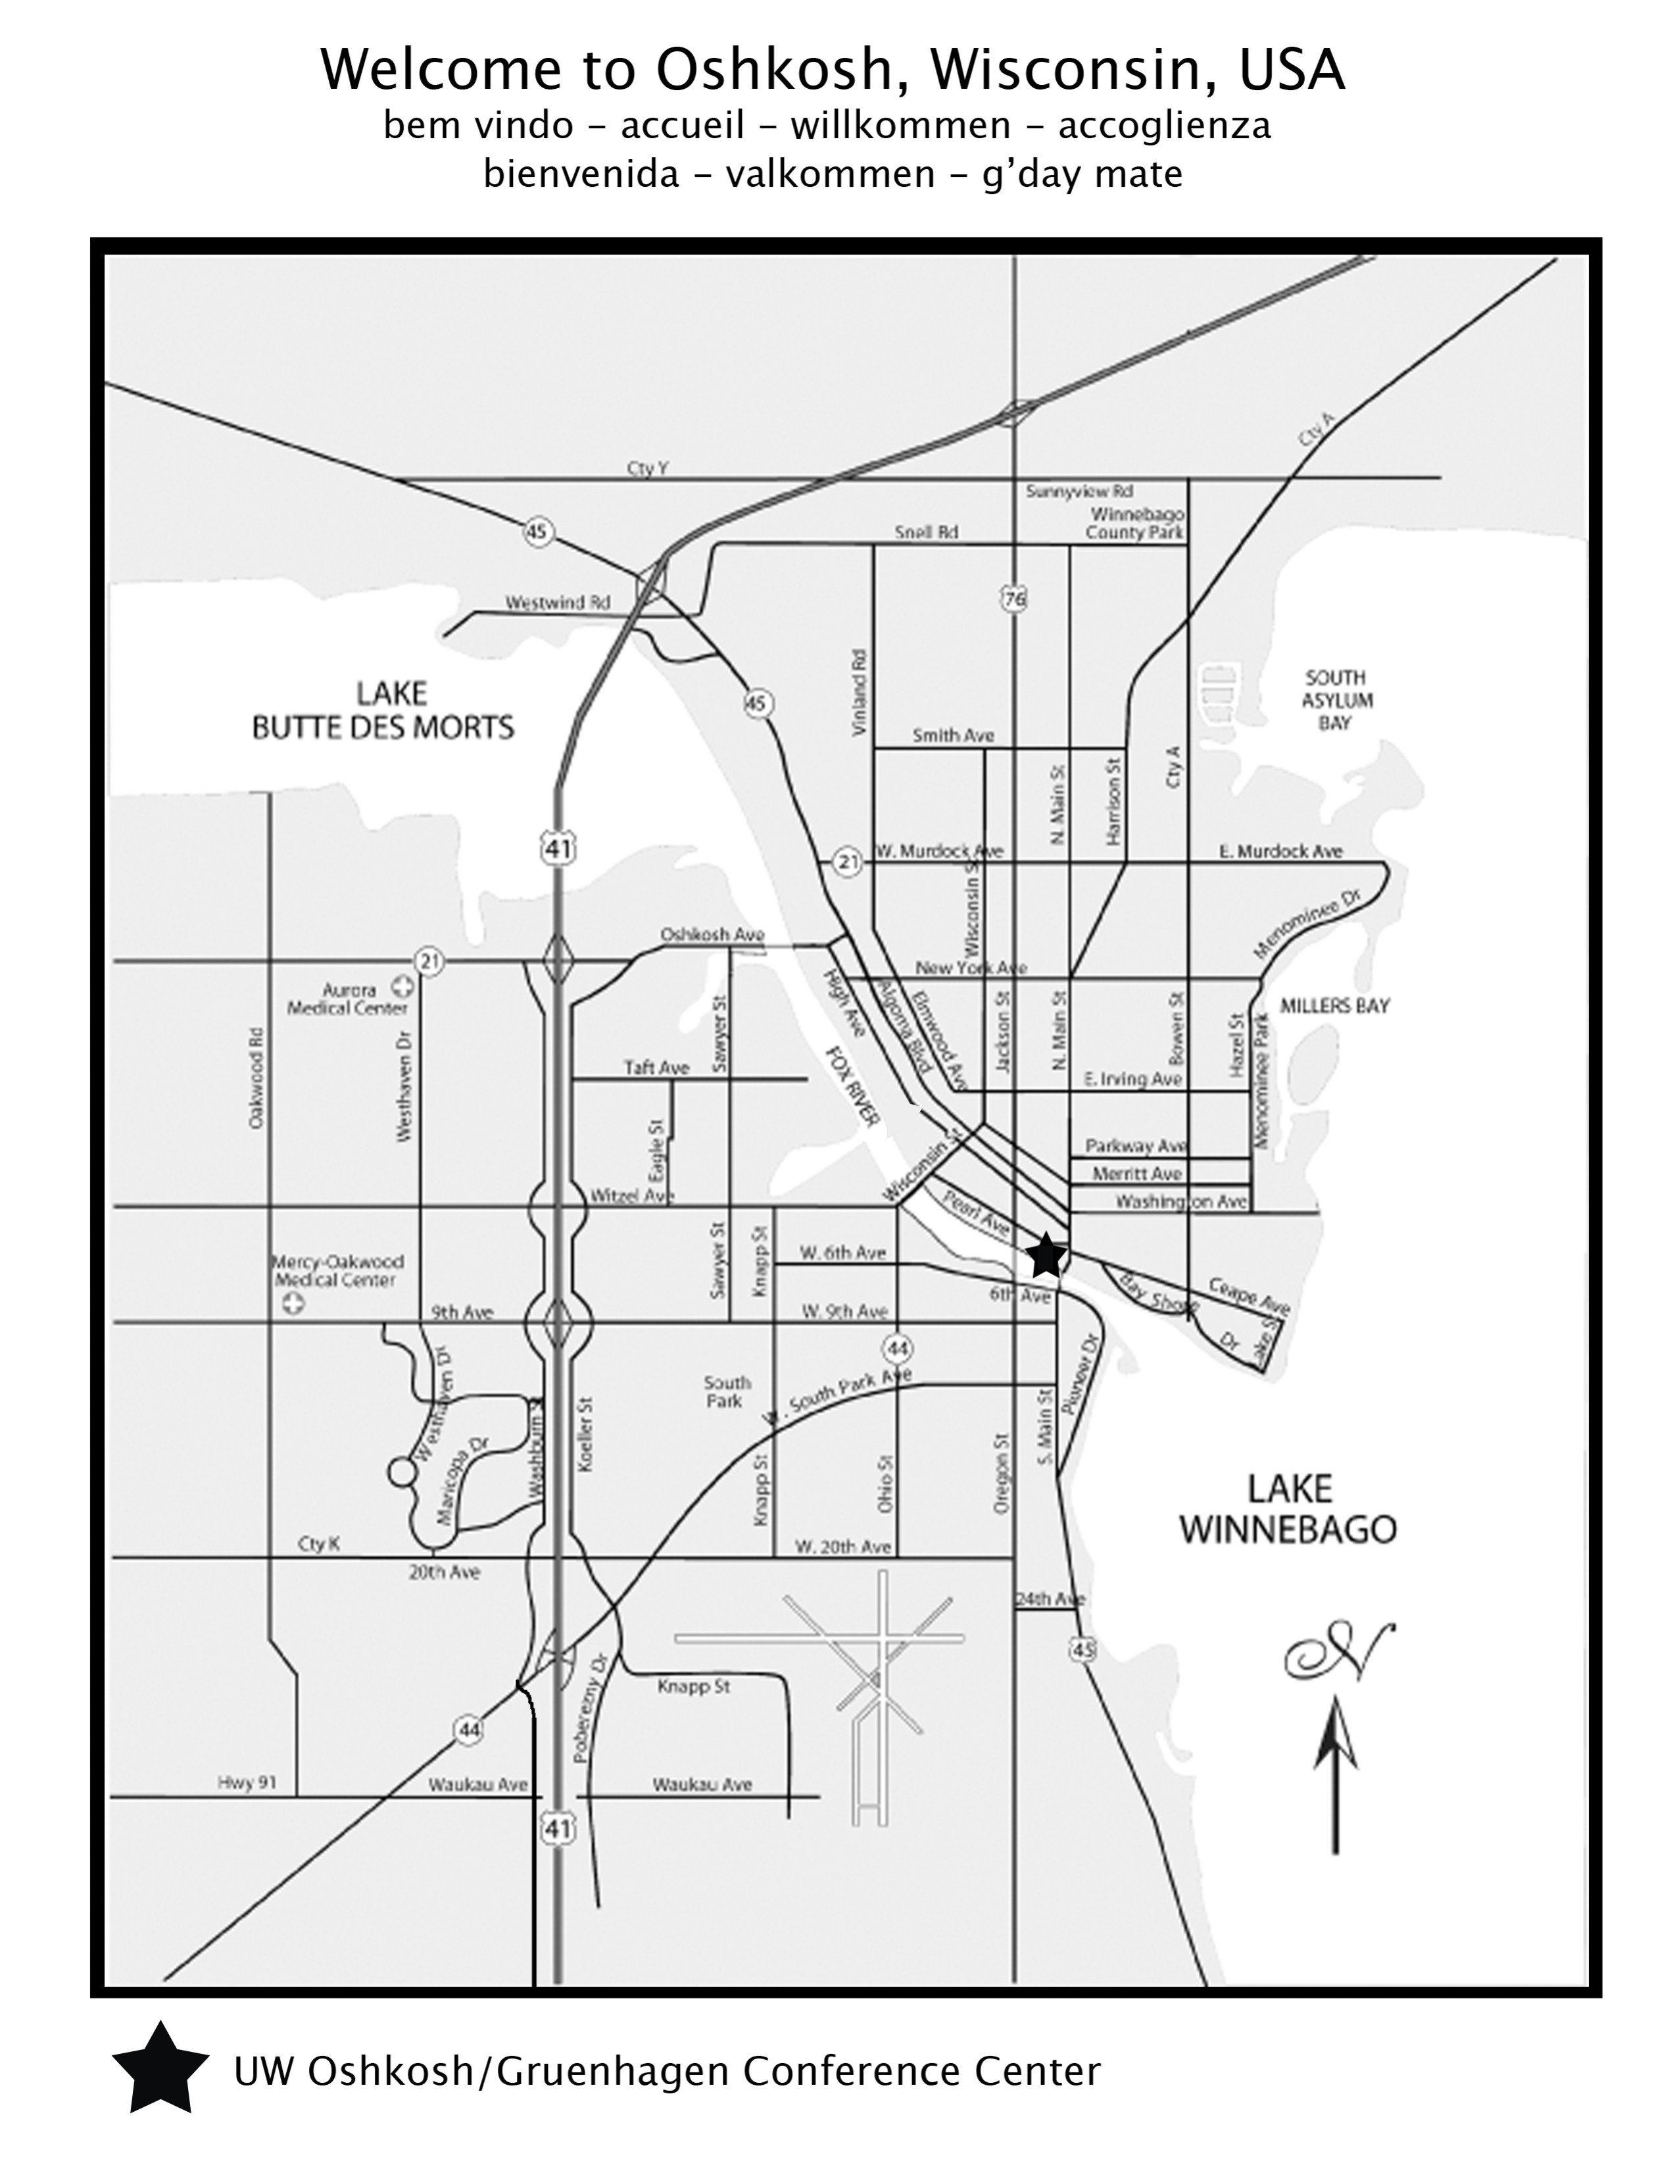

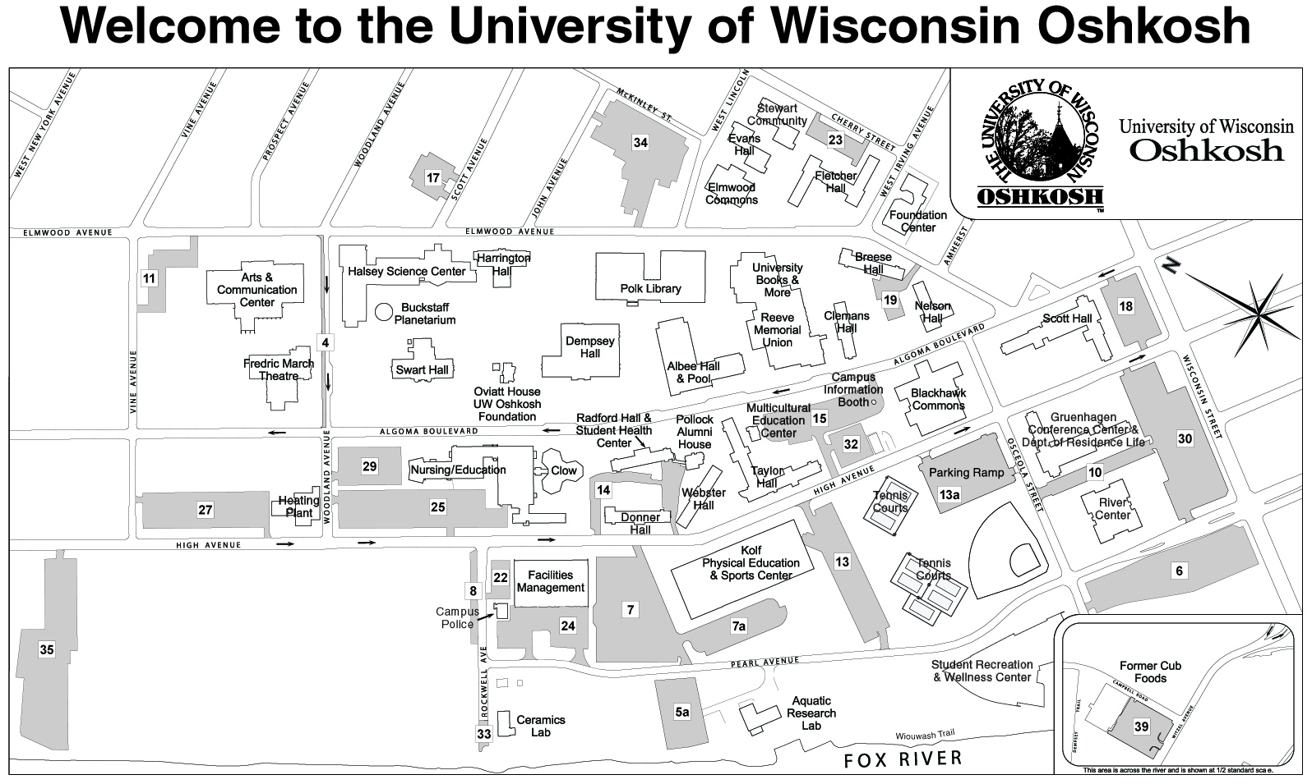
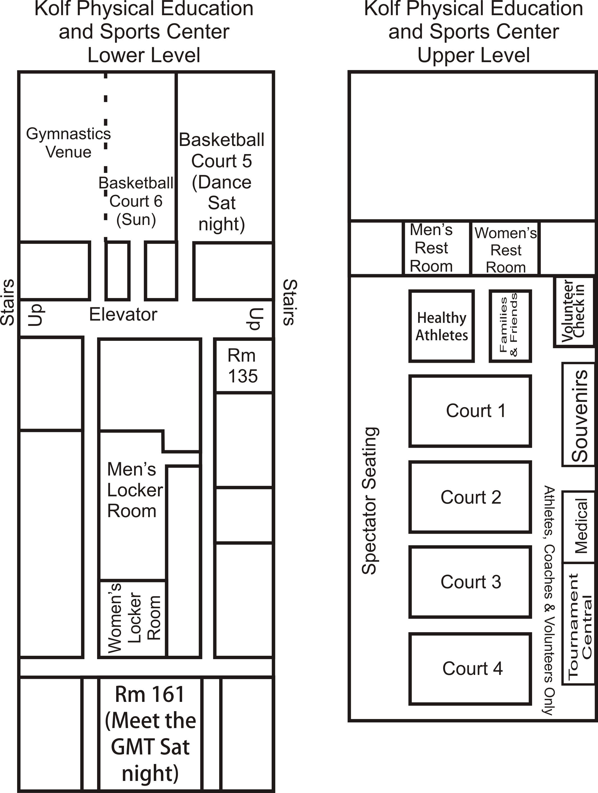

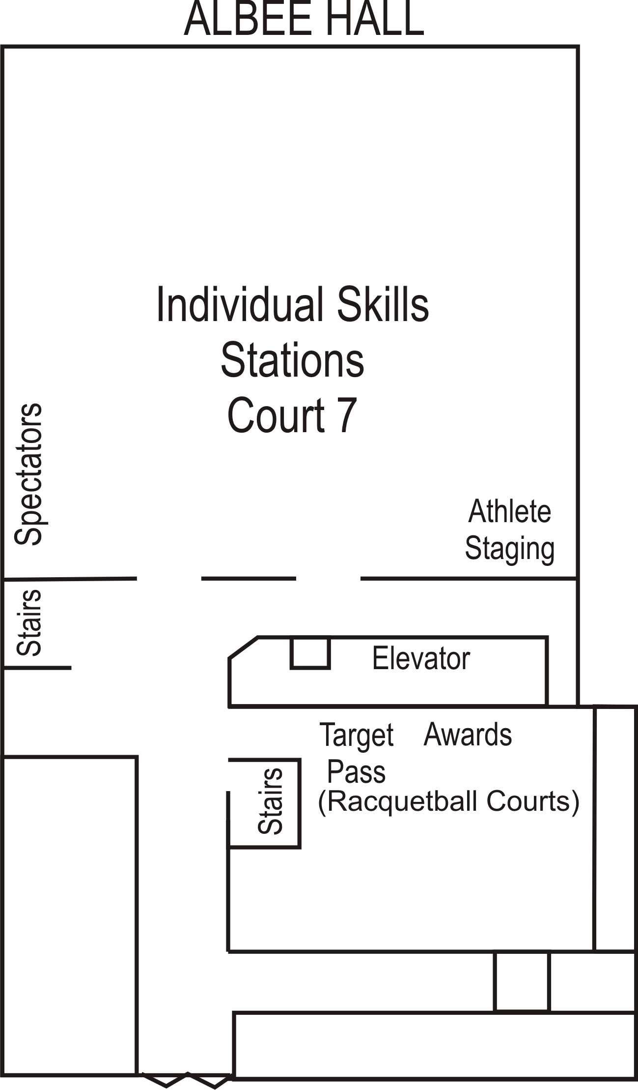

Awards

Healthy Athlete

Gymnastics Competition

Competition – Saturday, April 9, 2016 Kolf Lower Level Rooms A, B, & C

* Please see handout in pick-up packet for additional details

Please advise your athletes to bring their own water bottle to be used throughout competition.

Uniforms
Gymnasts must follow Special Olympics Gymnastics uniform guidelines as listed in the Official Special Olympics Summer Games Rules Book. Please review these guidelines, which are laid forth in the Competition Guide, before the 2016 State Competition. Special needs requests regarding uniforms are not accepted at state level competition.

Schedule
10:00 am Warm Up all athletes

Rhythmic Gymnastics
10:30 am Rhythmic Competition Begins. Competition will be held in consecutive rounds. Each round of competition will begin immediately following the previous round.
Round 1 Level 3 Ball, Rope, Clubs, Ribbon
Round 2 Level 2 Ball, Hoop, Clubs, Ribbon
Round 3 Level 1 Ball, Hoop, Rope, Ribbon
Round 4 Level B Ball, Hoop, Rope, Ribbon
Level A Ball, Hoop, Rope, Ribbon

Artistic Gymnastics
11:30 am Artistic Competition Begins. Competition will be held in consecutive rounds. Each round of competition will begin immediately following the previous round.
Round 1 All Artistic Men’s and Women’s Level A events
Round 2 Beam Level 1, Level 2, Level 3, Men’s Horizontal Bars
Round 3 Women’s Vault, Men’s Vault
Round 4 Women’s Uneven Bars, Men’s Floor Exercise
Round 5 Women’s Floor Exercise

Awards
All athletes will parade in with their agency. Awards will begin to be given out after competition has concluded in the Kolf Sports Center (Men‘s Artistic, Women’s Artistic, Women’s Rhythmic).

Lunches
Lunches for athletes and gymnastics coaches ONLY will be available at the venue starting at 10:30 am. Lunches must be eaten on the north side of the gym behind the bleachers. All other athletes and coaches must eat at Blackhawk Commons.

Individual Basketball Skills Competition

Competition – Saturday, April 9, 2016
12:00 Noon. Skills Level 2
Skills Level 1 will immediately follow Skills Level 2 at approximately 1:00 pm
* Please see handout in pick-up packet for additional details

Please have athletes report for staging 15 minutes before their age group is scheduled to begin. The times listed are approximate start times. If an athlete is not there when the division is called, they will be scratched. Special Olympics rules will govern all skills competition. Please advise your athletes to bring their own water bottle, though they should be left with a coach during competition.

Location
All basketball skills competition will be held in the main Albee Gym and the racquetball courts.

Uniforms
Uniform rules will be enforced. Those athletes in improper uniforms will not be allowed to participate. The Competition Guide clearly states that street clothing such as jeans, street shoes, skirts, dresses, etc. are not allowed. Athletes must be dressed in appropriate athletic attire.

Awards
Awards will be presented immediately after each division finishes in racquetball court #4. Medals will be given to 1st, 2nd and 3rd place and ribbons will be awarded for all other places.

Results
SOWI will post results on the SOWI website after the state competition.
Team Basketball Competition

Competition – Saturday, April 9, 2016 and Sunday April 10, 2016
Please see brackets enclosed in the mailing. The National Federation of State High School Associations (NFSHA), the Wisconsin Interscholastic Athletics Association (WIAA), and Special Olympics rules will govern all Special Olympics Wisconsin Tournament play. Reminder – all games will utilize six-minute, stop-time quarters.

Please arrive at least 15 minutes prior to game time to warm up and discuss game situations with officials. Line up cards need to be submitted to the scorer’s table 10 minutes prior to game time. Games will start as scheduled. Teams not ready to play 10 minutes after official designated starting times will forfeit the game. Please remember to bring your own basketballs for warm-up purposes. Also, please advise your athletes to bring their own water bottle to be used throughout competition. WATER ONLY will be allowed on the courts.

Location
All team games will take place at the Kolf Sports Center Courts and Albee Hall (see schedule in mailing).

Team Uniforms
  - SOWI follows the rules outlined by NFSHA regarding uniform requirements. All players must be in proper uniforms including both a uniform top and shorts that match in color and style (i.e. nylon, mesh, lettering style, etc.) in order to compete. These rules specify that the shirt (uniform top) must be worn with legal numbers on the shirt on both the front and back of the uniform top and may not contain any advertising. Hats, long pants and jewelry are not to be part of athletes’ uniforms and are not allowed. Any uniform modifications (such as for medical or religious reasons) must be submitted via a special needs form prior to competition weekend to be approved. It is the responsibility of the head coach to ensure athletes are in proper uniforms before each game. Proper court shoes are required. T-shirts worn under the uniform top must match the main color of the uniform top.
  - Undershirts, if worn, must be white, black, or match the color of the body of the uniform (not the trim). Undershirts may be worn by some or all of the players, but must be identical if worn. They may be short sleeve or tank top (no cut or ragged edges are allowed).

Introductions
If time permits, athletes will be introduced before all their games. When introduced, each athlete should take two steps out from the bench to form a line facing the scorer’s table.

Awards
Awards will be given at the end of competition for each division at the awards station in Kolf Sports Center – upper level. Medals will be presented to each athlete earning 1st, 2nd or 3rd in team competition. Ribbons will be awarded for 4th place. Those teams who would like a plaque should request one by calling Brittany Bergen at (800) 552-1324 ext. 5682 within two weeks of the end of the tournament.

Results
SOWI will post results on the SOWI website after the tournament. Brackets will be posted and updated throughout the competition near Tournament Central in Kolf Sports Center.

Filing Protests at Events

  - Protests to the Games Rules Committee may only be made concerning games presentation, structure, and conduct.
  - Protests may only be made concerning competition of athletes at a venue where, within that competition, rulings are either made or not made in regard to the fairness and equity of the competition.
  - All protests must be initiated prior to the presentation of awards.
  - Protests must be immediately presented to the head official of the event in an oral fashion so that the event officials may be made aware of the appeal.
  - Head officials may rule on appeals immediately, but if the response of the head official does not resolve the protest, a formal protest may follow.
  - All formal protests must be submitted within a half hour of the event in question.
  - All protests must be made on the specified form.
  - All protests will be brought to the attention of the Sports Rules Committee for final resolution. The decision of this committee shall be final and binding.

* Please get protest forms at Tournament Central.

“Sportsmanship Makes Winners!”

Sportsmanship is as important to Special Olympics Wisconsin as training hard and following the rules. Please help us by observing good sportsmanship and setting a good example for our athletes, fans and volunteers.

Athlete Entertainment Overview

Saturday, April 9:
Opening Ceremony – 7:00 pm

Unified Team Basketball – Kolf Sports Center, Upper Gym – 7:20 pm
Join us to watch Unified basketball competition featuring SOWI athletes and the UW-Oshkosh Titan Men’s and Women’s basketball teams!

Superhero Saturday Night Dance – Kolf Lower Gym – 7:20 pm – 9:00 pm
Come dressed as your favorite Superhero!

UW-Oshkosh Nutrition Education Station
Adaptive Physical Education and Health students from the University of Wisconsin-Oshkosh will have educational booths on Saturday from 12:00 pm - 3:30 pm in the lower level of the Kolf Sports Center, please stop by!

Healthy Athletes®

The SOWI Healthy Athletes initiative will conduct Fun Fitness® (physical therapy screen), Special Smiles® (oral health screen), Healthy Hearing® (hearing screen), and Opening Eyes® (eye exams) free of charge at Gruenhagen on Saturday from 10:30 am – 4:00 pm.

Special Smiles: 10:30 am – 4:00 pm in the Terrace Room (1st floor)
Opening Eyes: 10:30 am – 4:00 pm in the Titan Lounge (1st floor)
Healthy Hearing: 10:30 am – 3:30 pm in the University Room (basement)
Fun Fitness: 11:30 am – 4:00 pm in the Kolf Sports Center (Upper Level)

Fans in the Stands

Stop by the Family and Friends Table near Tournament Central in Kolf Gym or in Albee (Saturday only) to get schedule information and maps of the campus. Families and friends can also make signs at the table to help them cheer on the athletes and be Fans in the Stands. Help give our athletes the home court advantage.

State Competitions – Press Releases

Please contact the Special Olympics Wisconsin Marketing and Communications Department to have a press release distributed to your local media for your Agency or athlete(s) via phone at (800) 552-1324 x5672 or via email at sadams@specialolympicswisconsin.org.

Special Olympics Wisconsin on Social Media

Want to keep up with local and statewide SOWI events? Join our online community by following us on:
Twitter @sowisconsin
Facebook facebook.com/SpecialOlympicsWisconsin
YouTube youtube.com/sowisconsin
Flickr flickr.com/photos/specialolympicswisconsin/

Check out Flickr for photos and SpecialOlympicsWisconsin.org for results from the Indoor Sports Tournament!

ID Badges

ID badges are provided for each registered athlete and coach. Athletes and coaches must wear ID badges at all times! ID badges are used as identification and authorization at sports venues and dining facilities. If an ID badge is lost, broken or becomes unreadable, the coach and athlete should report to Tournament Central.

Tournament Central

General Registration: Saturday, April 9: Tournament Central and registration will be in the upper gym of the Kolf Sports Center from 9:00 am – 4:30 pm on Saturday and 7:30 am – noon on Sunday, April 10.

Scratches must be turned in when Agencies register at Tournament Central. There cannot be additions at registration. Basketball Skills Coaches should notify the Skills Event Coordinator of last-minute athlete scratches.

Any problems throughout the weekend should be reported to Tournament Central or Gruenhagen Main Desk or by calling Brittany at Tournament Central at (608) 509-4561.

Lost and Found
A lost and found area will be located at Gruenhagen Main Desk and Tournament Central in Kolf Sports Center.

Souvenir Sales

Our souvenir vendor, Promotional Designs, will sell souvenirs in Kolf Sports Center. A percentage of the proceeds will go to Special Olympics Wisconsin.

Times: Saturday, April 9, 2016 9:00 am - 9:00 pm*
Sunday, April 10, 2016 8:00 am – Noon *

*Times may change

Emergency Telephone Numbers

Housing Information:
Gruenhagen Conference Center (920) 424-1107
(Main Desk)

Emergency Telephone Numbers:

UW-Oshkosh, Gruenhagen Hall (920) 424-1106/1107

(7:00 am – 12:00 am)

UW-Oshkosh, Gruenhagen Hall (920) 420-9364

(12:00 am – 7:00 am)

UW-Oshkosh, Police (920) 424-1212

(24 hours a day)

Medical Cell Phone Number:
Main medical (715) 204-9114

Tournament Central Phone:
Available throughout the tournament (608) 509-4561

Parking

After the buses have unloaded at Gruenhagen Conference Center, they must move to permanent parking in Lot 35 (see map). Cars should park in Lots 7, 13 or 30 or should park on the 1st and 2nd levels of the parking ramp. No large vehicles are allowed in lot 10.

Housing Information

Gruenhagen Conference Center
- Agencies will be assigned a block of rooms (two people per room). Coaches are responsible for individual room assignments and must complete and return two copies of the housing list to Tournament Central as soon as possible after registration.
- Keys will be handed out at registration. All keys must be turned in to the main desk at Gruenhagen at check-out time. Lost key = $55.00 dollars. The main doors will be locked at midnight and room keys DO NOT open these outside doors.
- No pay phones will be available. House phones can be used with credit cards or phone cards. All lounges have telephones.
- Some floors have lounges with televisions.
- Sheets and pillows are furnished. Each bed will have either a blanket or a bedspread. If you feel you need another blanket, bring one. If you have an athlete who is a chronic bed wetter, you must bring your own plastic sheets. You will be charged for a ruined mattress. Remember to bring your own towels, toilet articles and other personal items. Label everything with the athlete’s name and Agency number.
- Gruenhagen Hall will be locked each night at midnight. All delegates must be in the dorm by then. Room keys will not open the outside doors.
- The Student Union will be open to the public, but with school in session, the machines will not be free.

Check-Out Procedures

Check-out will take place between 8:00 am and 3:00 pm at Gruenhagen Hall on Sunday. The following procedure should be followed:
- Remove all personal items from each room. Please double-check rooms for items left behind. The less “lost & found” the better!
- Make sure that all linens are left in the room. You will be charged for missing articles.
- Turn in keys. Lost key charges will be billed to the Agency responsible.

Severe Weather

In case of severe weather, follow the signage posted in each building for where to go.

Medical Services

Coaches are responsible for having updated medical information available for each athlete in attendance. This information is to be provided by the coach if the athlete is sent to the hospital. The hospital must have this information before they can provide any services. Please make sure that the information on file regarding the athletes’ medical condition, medications and physician’s name and telephone numbers are current. SOWI has provided medical information forms that may be filled out and updated as necessary for each athlete. This can be found in the Competition Guide. SOWI does not require the use of these cards, but does provide them as a resource.

Medical Services
An emergency medical team will be located in the dorms and competition sites. Medical personnel will be wearing either red shirts or red vests. The medical team members are equipped to handle emergency medical problems. Go to them if you need help during the Indoor Sports Tournament.

It is important that you locate the first aid station at your venue site so you know where they are if you need them. If language is a problem and you are the translator, be sure to stay with the athlete in an emergency.

SOWI will not provide medical information on athletes attending the games.

Medication
If you have athletes who are on medication, it is essential that you know what the medication is, how much is to be taken in each dosage, and when it is to be taken.

Many Agencies request that family members divide medication for each time it is to be taken and seal it in envelopes with all the vital information (name, number of pills, kind of medication, when it is to be taken, etc.) written on the outside of the envelope. Remember that during travel time all medication should be kept with the chaperone or athlete – not packed in a suitcase!

Important Note about the Flu
If you, a coach or an athlete with your delegation is sick, or has recently (within seven days) been sick with flu-like symptoms (fever with cough, sore throat, runny/stuffy nose, body aches), please ask them to stay home. We know this is a difficult decision to make, but it is for the safety of everyone that attends IST. Please call (800) 552-1324 ext. 5682 before Thursday, April 7 if someone from your delegation will not be attending. After April 7, please call Tournament Central. If you have any questions about the health of you or your athletes prior to IST, please contact Michael Clark, MD either at (715) 218-5774, or mclark911@gmail.com. Please practice thorough hand washing and other sanitary measures throughout the duration of the Games to help prevent the spread of germs.

Safety and Fire Procedures

If you discover a fire:
- Sound the alarm and leave the building by the nearest exit.
- Call the Fire Department by dialing 9 – 911. Give as much information as you can to the dispatcher. Do not hang up until the dispatcher tells you that he or she has all the information they need. The University Police number is #1212.
- Do not attempt to put out fires or rescue others unless you can do so safely.
- If there is smoke in the room drop to the floor and stay low. Smoke inhalation is often fatal. Feel the doorknob before opening the door. If hot, do not open the door. If cool, brace against the door and open slowly. If heat or heavy smoke is present, close the door and remain in the room.

If you can not leave your room or exit safely:
- Remain calm. The room is designed to withstand fire for long periods of time. Seal up the cracks around the door using wet sheets, towels or clothing to prevent smoke entering the room.
- Hang an object out of the window [sheet, jacket, or shirt] to attract the attention of the Fire Department. Call University Police #1212 or Fire Department # 9 – 911 to report you are trapped and give your location.
- Stay near the window and low to the ground. A wet cloth will aid in breathing if smoke is in the room.

If you can leave your room:
- Take a wet cloth for your face to aid in breathing if you run into smoke.
- Close the door behind you and take your keys.
- Proceed to the nearest exit. Do not use the elevator to avoid becoming trapped. If the exit is blocked with smoke or fire, proceed to another exit. Keep low to the ground if smoke is present. Cover face with wet cloth and take short breaths of air.
- Stand clear of building after evacuating and follow the directions of fire, police and residence hall personnel. Never re-enter a burning building.

if confronted with a seizure:
- Stay Calm. Do not leave the athlete alone.
- Protect the athlete from injury by involuntary muscle movements.
- Do not put anything in the athlete’s mouth.

Most seizures are self-limited and end after two minutes.

2016 Indoor Sports Tournament
Management Team

Shirley Beyer
David Bigelow
Michael Clark
Linda Dahl
Mary Fiegel
John Hough
John Kristbaum
Iris Lienhard
John Magliocco
Mike Moore
Marc Nylen
Carrie Osswald
Debbie Patrenets
Jim Rath
Pat Geigel
Jody LaPlante
Michelle Rothe
Elaine Ruh
Joey Schmid
Michelle Schmid
Andy Schumacher
Paul Wagner

SPECIAL THANKS TO UNIVERSITY OF WISCONSIN – OSHKOSH

2016 State Competition Schedule

2016 Indoor Sports Tournament – Oshkosh
April 9-10, 2016
Gymnastics, Team Basketball, Basketball Skills

2016 Summer Games – Stevens Point
June 9-11, 2016
Athletics (Track & Field), Aquatics (Swimming), Football (Soccer), Powerlifting

2016 Outdoor Sports Tournament – Waukesha
August 6, 2016
Softball, Tennis, Golf, Bocce, Unified® Golf

PROUD STATE PARTNERS


Mission Partners



State Games Partners






Friends of Indoor Sports Tournament

Neenah Lacrosse Team
ROTC
Sodexho
US Bank
Hillshire Brands
UW-Oshkosh
Trinity Youth for Christ
St. John the Baptist Catholic Church
Lions Club International
Golisano Foundation
That Photog LLC, Photo Booth Rentals



2310 CROSSROADS DRIVE, SUITE 1000
MADISON, WISCONSIN 53718
(608) 222-1324
(800) 552-1324
FAX (608) 222-3578
SpecialOlympicsWisconsin.org

Created by The Joseph P. Kennedy, Jr. Foundation.
Authorized & Accredited by Special Olympics, Inc., for the Benefit of Persons with Intellectual Disabilities.

