Outreach Initiatives

Athlete Outreach – An Overview 1
Athlete Outreach Options 2
Project UNIFY® 4
Young Athletes™ 5
Health Opportunities 6
Unified Sports® 8
Camp Shriver 10
Motor Activities Training Program 11
Fans Club 12
Get Into It® 13
Families 14
Sample Athlete Outreach Letter 15
Sample Family Outreach Letter for a New Family 16
Sample Athlete/Family Follow-up Letter 17

Left Blank Intentionally

Athlete Outreach—An Overview

Since its founding in 1968 by Eunice Kennedy Shriver, Special Olympics has reached millions of athletes with intellectual disabilities in the United States and in 170 countries.
Special Olympics Wisconsin (SOWI) serves over 10,000 individuals with intellectual disabilities in Wisconsin. There is ample room for growth, and while every individual with ID may not be interested in sports, the community support Special Olympics families enjoy is a significant benefit that many more Wisconsin families could take part in.

It is not realistic to believe that everyone with intellectual disabilities will be part of Special Olympics, but it is our mission to make Special Olympics available to those who choose to participate.
SOWI continues to focus their athlete recruitment efforts on improving services to existing Agencies through the work of the Agency Management Committee and the implementation of the Agency Management Program. It is our hope that by supporting the existing Agencies and documenting plans for new Agencies, and recruiting youth advocates and volunteers through Project UNIFY®, we are laying the foundation for future growth.
With Young Athletes™, Camp Shriver, the Spread the Word to End the Word® campaign, and Get Into It® taking off across the state, as well as a desired resurgence of Unified Sports®, all the components of Project UNIFY, we will begin to see our numbers of school age athletes increase, as well as peer participants. Additionally because of the inclusive factor of these programs, we will be making progress towards better school climates and social justice. It also alerts SOWI to the fact that we could retain more athletes by following up with athletes who move to new areas of the state to get them hooked up with an Agency in their new home community. (As Agency managers, you are the closest to this issue and can help the athlete transition by notifying the Regional office when athletes move.)
While some Agencies are searching for more athletes to create a viable program, others are straining at the seams from over enrollment. SOWI understands and respects the different demands facing Agencies, and in turn empowers Agency managers through the following guideline:
“An Agency may not discriminate on the basis of race, gender, religion, nation, origin of political policy; however, if the Agency has reached the maximum capacity for providing a safe, quality program the Agency manager may contact the Regional office to inform them of the situation so we can work together towards a viable solution.”

Athlete Outreach Options

We rely on your expertise in knowing your Agency and which strategies are most appropriate for expanding your athlete enrollment. This list should be viewed as a menu. You can pick and choose whatever strategies or information fit your specific needs.

The SOWI website has materials for an Agency manager who wants to recruit new athletes or volunteers. Additionally, the Regional office can provide additional materials or be a technical resource to an Agency manager who is contacting groups in the community.

Special Olympics Programs (Many descriptions included in this section of the handbook)
- Project UNIFY®
- Young Athletes™ (currently not accepting new programs)
- Healthy Athletes®*
- Unified Sports®
- Camp Shriver
- Motor Activities Training Programs (MATP)
- Fans Clubs
- Get Into It®
- Spread the Word to End the Word®
- Traditional Special Olympics sports programs (Agencies)

Target Areas for Athlete Recruitment
- Pre-school and Elementary Schools
  - Introduce Young Athletes for 2-7 year olds to school administrators
  - Introduce Project UNIFY
  - Introduce Get Into It to Principal or Teachers
  - Encourage schools to offer Special Olympics as an extracurricular activity
  - Make Special Olympics an extension of physical education curriculum
- Secondary Schools
  - Introduce Get Into It to Principal or Teachers
  - Introduce Project UNIFY
  - Establish sports teams coached by high school students, faculty and coaches for Special Olympics athletes
  - Create Fans Clubs which involve high school students who volunteer on a regular basis assisting Special Olympics athletes in practice and competition
  - Promote the Unified Sports program to bring together athletes with and without intellectual disabilities to practice and compete on the same teams. Unified Sports can be part of an interscholastic or intramural after-school league at the junior high or high school level
  - Involve athletes and students to coordinate the Spread the Word to End the Word campaign
- Parks and Recreation Departments
  - Introduce the Camp Shriver model to be incorporated into existing day camp programs
  - Encourage parks and recreation departments to include Special Olympics training, competition and coach’s training schools among the activities they offer
  - Work with them to gain access to facilities, transportation, publications and events
  - Encourage them to run Young Athletes
- Work Settings
  - Establish Special Olympics training programs or health awareness projects as employee fitness programs
  - Have employers enable and encourage employees to participate in local Special Olympics programs
  - Start Unified Sports programs to generate interaction between employees with and without intellectual disabilities in integrated workplaces

- Families and Athletes
  - Introduce families with children with disabilities ages 2-7 to Young Athletes family kits
  - Continue to build the Global Messengers program in which Special Olympics athletes are selected and trained to become effective public speakers to express the benefits of Special Olympics (see ALPs section of this handbook)
  - Encourage athletes and family currently participating in Special Olympics to recruit other athletes and families
  - Establish family committees wherever there is a Special Olympics program
  - Host Family Health Forums to introduce new families to Special Olympics and to provide relevant health resources to their communities

*Introduce health opportunities at all age levels and outreach targets

Project UNIFY®

What is Project UNIFY?
In 2008, Special Olympics North America was awarded a grant from the U.S. Department of Education with a goal to activate communities where all young people are agents of change, who foster advocacy for people with intellectual disabilities. To accomplish this goal, the organization formed “Project UNIFY,” a program that seeks to utilize existing state Special Olympics programs and initiatives in combination with schools.

What is Project UNIFY doing now?
We have learned from the data gathered in the first five years of Project UNIFY that the guiding principles first proposed to the Department of Education for Project UNIFY have been confirmed. For Special Olympics to be transformative within schools, state Programs need to go beyond simply providing students the opportunity to engage in single, Special Olympics-specific initiatives. It is the connection between Special Olympics initiatives, along with the youth and school’s involvement in the design and implementation of Project UNIFY that can foster a more inclusive and welcoming environment for students with intellectual disabilities. We also understand how important it is for the state Program to collaborate with educators in identifying what role Project UNIFY can play in meeting their state, district and individual school’s strategic goals, whether it be promoting school climate, developing physical fitness, building character, preventing bullying, enhancing student engagement, or any other important school reform.

As a result, the following definition of a Project UNIFY School has emerged:
A Project UNIFY School: A sustaining Project UNIFY School has a combination of at least three Project UNIFY components; sports, youth leadership/advocacy, and a school-wide activity. In a “Project UNIFY School” there is an understanding that Project UNIFY is not just an incident or event that happens for one day, or a single experience, but rather year-long or seasonal activities. In a Project UNIFY school there is an expectation that acceptance and inclusion are everyday occurrences that change entire schools and impact the whole student body.
What will be happening with Project UNIFY this year?
SOWI will enthusiastically participate in the Project UNIFY grant program for the current academic school year. The focus of the 2015-2016 school year will be inviting traditional SOWI Agencies and engage the schools and youth in their community to make both entities stronger and inclusive. They may receive funds to offer Unified Sports opportunities. Select schools will receive additional funding as they become sustaining Project UNIFY schools. For more information contact SOWI’s headquarters office.

Young Athletes™ (currently not accepting new programs)

Special Olympics Young Athletes introduces children, ages 2-7, with intellectual disabilities, their peers and families to the world of Special Olympics by pursuing the following goals:
- Engage children with intellectual disabilities through developmentally appropriate play activities designed to foster physical, cognitive and social development;
- Welcome family members of children with intellectual disabilities to the Special Olympics network of support;
- Raise awareness about the abilities of children with intellectual disabilities through inclusive peer participation, demonstrations and other events.

This program is designed to address two specific levels of play. Level 1 includes physical activities focused on developing fundamental motor tracking and eye-hand coordination. Level 2 concentrates on the application of these physical activities through a sports skills activity program and developing skills consistent with Special Olympics sports play. The activities consist of foundational skills, walking and running, balance and jumping, trapping and catching, throwing, striking, kicking and advanced skills.
Young Athletes is a versatile program that can work in various learning situations. The program is designed for families to play with their young athletes at home in a fun atmosphere but is also appropriate for preschools, schools and playgroups.
This initiative is modeled after the traditional Special Olympics program. Sites are required to practice Young Athletes a minimum of eight sessions and it is recommended that these sessions are conducted over eight consecutive weeks. Through practicing the various skills, Young Athletes are able to build on their strengths each week. After completing at least eight sessions, Young Athletes participate in a Culminating Event, much like a Regional or State Games. Here, athletes demonstrate the skills they’ve learned or improved upon over the weeks and participate in an awards ceremony in which all Young Athletes are acknowledged. It is our hope that by having a similar model to our traditional program, those that continue to participate in Special Olympics will have an easy transition to a local Agency when they turn 8 years old.
Young Athletes includes several resources to guide family members, educators and other professionals as they conduct the program with their children, brothers, sisters, cousins, grandchildren, students or patients. Sites are able to sustain a Young Athletes program by providing a Site Coordinator (much like an Agency manager), facility, volunteers, and children between the ages of 2 and 7 receive a kit, curriculum, ribbons, t-shirts, and more to conduct that program successfully at no cost. Additionally, families with a child diagnosed with an intellectual disability or delay and are unable to attend one of our current Young Athletes sites are eligible for a family kit at no cost to use at home. For more information visit SpecialOlympicsWisconsin.org.

Health Opportunities

Vision
Through local and statewide health opportunities, SOWI’s vision is to create communities where Special Olympics athletes and others with intellectual disability have the same access to health and wellness resources – and can attain the same level of good health – as others in their community.

Healthy Athletes

How it works
SOWI offers free screenings for athletes attending various State competitions in Special Smiles®, Healthy Hearing, Lion’s Club International Opening Eyes®, Fun Fitness, Fit Feet, Health Promotion and MedFest®. To be eligible to participate in these programs, athletes or their guardians sign a official release form, which is incorporated in the general Official Special Olympics Release Form. The athlete must also have a current Application for Participation in Special Olympics on file at the Headquarters office. Athletes do not have to be participating at the Games in order to take advantage of Healthy Athletes. Any athlete with a current medical on file at the Headquarters office can participate.

The providers (physicians, physician assistant, nurse practitioners, dentists, dental hygienists, optometrists, opticians, physical therapists, audiologists, podiatrists, dieticians, registered nurses and more) see the athletes in an environment familiar to them and perform exams in a setting among the athlete’s peers. The potentially nerve-wracking experience of seeing a doctor is well received by the majority of athletes in this setting.

Added Benefits
While athletes are certainly the focus of this program, medical professionals and students are given an opportunity to teach each other techniques for screening members of this population. Many of the volunteers have been deeply impacted by their experience.

Healthy Athletes Disciplines Offered
Fit Feet: Fit Feet was developed in collaboration with the American Academy of Podiatric Sports Medicine to evaluate and screen foot and ankle deformities of athletes and to provide education in proper footwear and care of the feet and toes.

FUNfitness: Physical therapy professionals provide screening and education on flexibility, functional strength, and balance and advise athletes on good fitness programs for risk prevention and for optimal function in sports training and competition.

Health Promotion: Professionals educate athletes about nutrition and exercise, as well as bone health, smoking cessation and sun safety using interactive activities and motivational information to encourage behavior change. Blood pressure and bone mineral density screenings are also available at Health Promotions.

Healthy Hearing: Audiologists assess athlete hearing and provide external ear canal inspection, evoked otoacoustic emissions screening, tympanometry and pure tone screening for those with identified need. Referrals may include further testing of middle ear problems or management of hearing loss or hearing aids, molded ear plugs or earwax removal.

Lions Club International Opening Eyes: Lions Clubs International brings eye care professionals in to offer vision health tests and possible refraction, prescription eyeglasses, prescription protective sports eyewear, and referral for follow-up care.

Special Smiles: Dental professionals provide screenings, health education and prevention services, and refer athletes for follow-up care. Fitted mouth guards and fluoride varnish are offered to athletes. Funding for Special Smiles is provided by Delta Dental of Wisconsin, Inc.

MedFest: Programs conduct standard sports physicals required for participation in Special Olympics events. These screenings permit new athletes to register and assure continued eligibility of existing athletes.

For more information on Healthy Athletes, visit SpecialOlympicsWisconsin.org, or contact the Director of Wellness Initiatives.

Unified Sports®*

Overview
Special Olympics Unified Sports is an inclusive sports program that combines an approximately equal number of Special Olympics athletes (individuals with intellectual disabilities) and partners (individuals without intellectual disabilities) on teams for training and competition. Three models exist within Unified Sports: competitive Unified Sports, Unified Sports Player Development and Unified Sports Recreation. All three models provide different types of experiences in team and individual sports. Unified Sports is now offered throughout the world and has been a Special Olympics internationally sanctioned program since 1989. Special Olympics Unified Sports promotes social inclusion through shared sport training and competition experiences for individuals with and without intellectual disabilities. Unified Sports has proven to be highly effective in achieving social inclusion. Athletes feel a sense of belonging; they can meaningfully interact with others, develop mutually rewarding relationships, are recognized as contributors and are received with acceptance and respect. All three models, defined below, have social inclusion as the core outcome; however, the structure and function of each model varies.

Unified Sports (Competitive)
The Unified Sports competitive model combines Special Olympics athletes and partners as teammates on sport teams for training and competition. Two things differentiate the competitive Unified Sports model from the other two models: 1) all athletes and partners on a Unified Sports competitive team must have attained the necessary sport-specific skills and tactics to compete without modification of the current Official Special Olympics Sports Rules; and 2) teams that participate in this model may be eligible for advancement to Regional and World Games. A Unified Sports team is an inclusive sports program with approximately equal numbers of athletes and partners. Unified Sports teams should never be comprised solely of people with disabilities. Athletes and partners should be of similar age and ability in team sports. However, a greater variance in age and ability is allowed in specific sports such as golf. Refer to Article 1 of the Official Special Olympics Sports Rules for more details regarding age and ability matching by sport.

Unified Sports Player Development
The Unified Sports Player Development model combines approximately equal numbers of Special Olympics athletes and partners as teammates on sports teams for training and competition. What differentiates Unified Sports Player Development from the other two models is: 1) teammates are not required to be of similar abilities, and 2) teammates of higher abilities serve as mentors to assist teammates of lower abilities in developing sport-specific skills and tactics, and in successfully participating in a cooperative team environment. Athletes and partners should be of similar age. However, a greater variance in age is allowed in specific sports such as bocce. Because of differences in abilities, rules modifications are necessary and designed to both ensure meaningful involvement of all teammates and define for higher ability players their roles as mentors so they do not dominate play. Each Program is given the opportunity to establish rules modifications that fulfill these outcomes.

Unified Sports Recreation
Unified Sports Recreation consists of inclusive recreational sports opportunities for Special Olympics athletes and partners. What differentiates this model from the other two is that this model does not follow any prescribed training, competition and/or team composition requirements established by Special Olympics. These recreational opportunities may take place in partnership with schools, sport clubs, the community and other private or public organizations as introductory one-day events, exhibitions or demonstrations (including Unified Sports Experiences) or ongoing activities such as physical education classes and intramurals.

*Information from Special Olympics, Inc.

Comparison among Unified Sports
Competitive, Player Development and Recreation Models

Unified Sports Competitive | Unified Sports Player Development | Unified Sports Recreation
Inclusive sports program | Inclusive sports program | Inclusive recreational sports program
Approximately equal number of athletes and partners train and compete | Approximately equal number of athletes and partners train and compete | Composition of teams should be at least 25% athletes or partners
Similar ability and age of athletes and partners | Similar age of athletes and partners | Does not require athletes and partners to be of similar age and ability
Training and competition scheduled for a season or class | Training and competition scheduled for a season or class | Preferably, participation is regularly scheduled; demonstration, fundraising and featured events applied as a catalyst for ongoing activity
Differentiation:  - Have attained sufficient & necessary sport-specific skills and tactics  - No modifications of Official Special Olympics Sports Rules  - Eligible to advance to higher levels of play beyond the Program level (such as Regional and World Games) | Differentiation:  - Not required to be of similar ability; teammates of higher ability serve as mentors to assist players of lower abilities  - Rules modifications define players’ roles, ensure meaningful involvement and prevent player dominance  - No advancement beyond the Program level | Differentiation:  - Does not follow any prescribed training, competition and/or team composition requirements established by Special Olympics  - No advancement beyond the Local level
Never comprised solely of individuals with disabilities | Never comprised solely of individuals with disabilities | Never comprised solely of individuals with disabilities
Awards based on place of finish within divisions | Program has choice of providing awards based on finish or participation (same award for all) | No awards are provided; however, recognition can be provided on a Program-by-Program basis
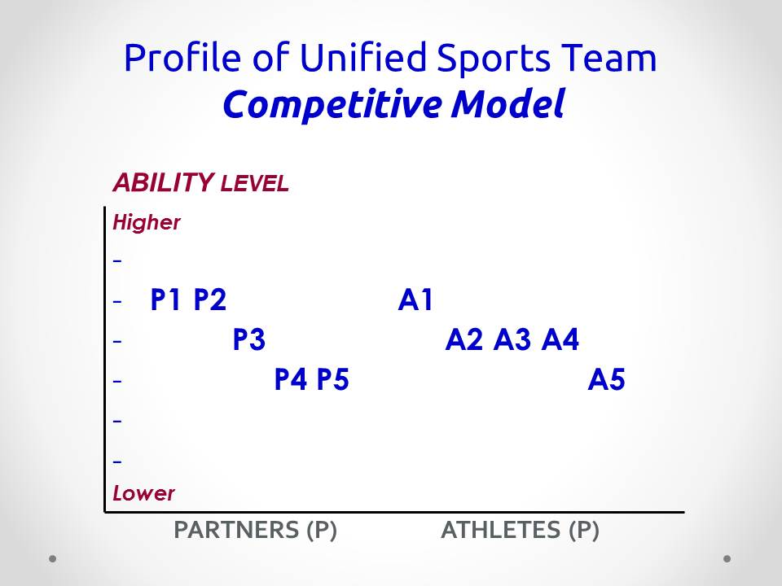 | 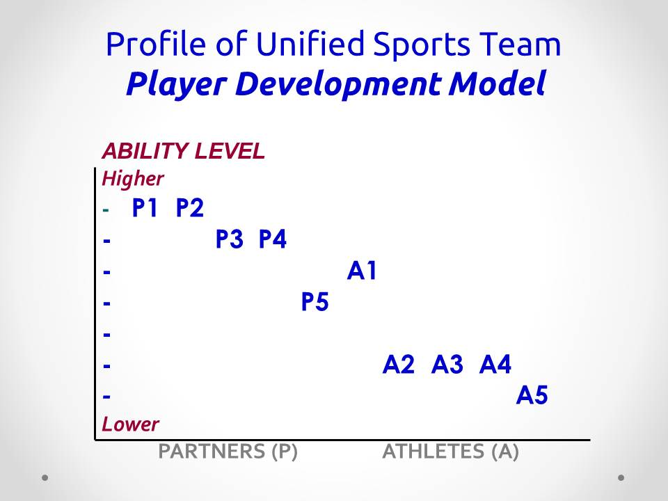 | Examples include:  - Physical Education Class  - Partner’s Club – playing sport recreationally as part of club activities  - Intramural Team or Community Free/Open Play  - Exhibitions / Demonstrations, one-day featured events like Unified Sports Experiences (purpose of which is awareness, exposure and/or fundraising)

Camp Shriver

History
Eunice Kennedy Shriver, founder of Special Olympics and the youngest sister of President John F. Kennedy opened her home in Rockville, Maryland, to a camp for 35 individuals with intellectual disabilities in the summer of 1962. Camp Shriver, as it became known, grew into an annual event through the 1960s and served as the forerunner for the Special Olympics movement, which has since grown to reach more than two million athletes worldwide. During the summer of 2006, in celebration of Shriver’s 85th birthday, the Camp Shriver concept was rekindled.
What is Camp Shriver?
The unique experience of Camp Shriver brings together an equal number of children with and without disabilities who engage in the same camp activities alongside one another. In doing so, the camp creates opportunities to promote the social inclusion of children with disabilities and to allow children without disabilities the opportunity to interact with and achieve a greater understanding and appreciation of their peers with disabilities. Unlike the school setting, where the differences between children with and without disabilities are often accentuated, the Camp Shriver model stresses the importance of recognizing the similarities that exist among all children who participate. Camp Shriver uses sports as a venue for improving not only campers’ sports skills, but also their self‐esteem, social skills, and confidence in building friendships with peers.
The specific goals are:
- To provide sports, recreational, and enrichment activities for all campers.
- To improve campers’ sports skills as well as their social skills and self‐esteem.
- To create an atmosphere of understanding and caring so that campers with and without disabilities can develop friendships.

In Wisconsin
In 2008-2009, the La Crosse Parks and Recreation Department piloted a Camp Shriver in Wisconsin through a three-day winter camp and a five-day summer camp. They have continued their success year after year and have created a model that others are now utilizing to offer similar camps (i.e. Camp Inspire, Camp UNITY, etc.) in their communities. For more information, please contact SOWI or visit SpecialOlympicsWisconsin.org.
Motor Activities Training Program

The Motor Activities Training Program (MATP) provides comprehensive motor activity and recreation training for persons with the greatest physical need who do not yet possess the physical and/or behavioral skills necessary to participate in official Special Olympics sports. With emphasis on training and participation rather than competition, MATP is part of the commitment by Special Olympics to offer sports training opportunities to individuals with intellectual disabilities of all ability levels.
After five years of consultation with educators, physical therapists and recreation specialists, and after field-testing in the United States and several other countries, MATP was launched in 1989. A comprehensive MATP Guide has been developed to assist trainers.
How It Works
MATP trains participants in motor-based recreation activities and enables them to take part in a program which is appropriate to the age and ability of each individual. After a training period of at least eight weeks, participants may take part in a Special Olympics Training Day, giving each participant a chance to demonstrate his or her “personal best” in an activity and to be recognized for this accomplishment. The skills learned through MATP also enable people with severe disabilities to participate in community recreational activities with their non-disabled peers.
While the goal of MATP is not necessarily to prepare persons with severe disabilities to participate in sports, many MATP participants will gain the skills required to compete in certain Special Olympics sports.
MATP trains participants in seven basic motor skills designed to relate to specific sports. The skills also complement training by educators and therapists in daily living skills. MATP trains participants in:
- Mobility-Gymnastics
- Dexterity-Athletics
- Striking-Softball
- Kicking-Football
- Manual Wheelchair-Athletics
- Electric Wheelchair-Athletics
- Aquatics
MATP can be implemented through schools, group homes, residential facilities and other community-based settings. Training for volunteers is available through Special Olympics Motor Activities Training Schools. For more information, please contact SOWI.

Fans Clubs

Fans Clubs for Project UNIFY® are unique school-wide clubs that are designed around empowering youth with and without intellectual disabilities to promote social justice through a variety of projects and activities. The club offers Unified Sports training and competition, as well as social, leadership, and recreational opportunities adding to students character development and acceptance of students with disabilities.
A Fans Club should be a sanctioned school club. The meeting schedule and format should follow school club policies and procedures. Fans Clubs should have a School Coordinating Team who network with administration, and the athletic, physical education, and special education departments.

Fans Clubs are encouraged to:
- Spread the Word to End the Word®
- Participate in Unified Sports
- Attend local sporting events together
- Attend or put on a Youth Activation Summit
- Arrange for a local coach to speak to the club or conduct drills
- Be “Fans in the Stands” at a local SOWI event
- Make banners to support their favorite teams
- Attend an Athlete Leadership Program (ALPs) workshop
- Sponsor a dance or movie night for the school
- Have a pizza party or other social gathering
Further Definitions
School Coordinating Team: Comprised of one special education teacher, one general education teacher, one athlete, and one youth without an intellectual disability.
Youth Activation Summit: a gathering of youth leaders with and without disabilities coming together to learn about youth leadership and social justice through Special Olympics sports and activities.
Fans in the Stands: a program designed to encourage students to get a group of friends together and make posters, banners or organize a pep rally for the Special Olympics athletes at their school. It also encourages those students to attend a Special Olympics event to cheer on their classmates.
Spread the Word to End the Word: a campaign designed to raise the consciousness of society about the dehumanizing and hurtful effects of the “R-Word” (retard) and urges people to resolve to stop using it as an insult, casual or intended comment.

ALPs: See a full description of this program in the Athlete Leadership Program section of this handbook.

Get Into It®

Get Into It, a K-12 service-learning curriculum developed by Special Olympics, is available at no cost to schools and teachers worldwide, and is fit for students with and without disabilities. Get Into It teaches young people about intellectual disabilities while empowering them to “be the difference,” by learning values of inclusion, tolerance and respect. The overall goal of Get Into It is to increase participation of youth without intellectual disabilities by establishing school-based Special Olympics Programs and activities.
There are several components to Get Into It. Made up of four lesson plans compatible with curriculum standards, Get Into It teaches youth language, arts, social studies, history, health and physical education. The lessons range from students engaging in a discussion about stereotypes to students learning about inspirational Special Olympics athletes.
In addition to increasing the participation of youth in Special Olympics, the Get Into It curriculum addresses current trends in school reform, such as the standards movement, character education, positive youth development and service-learning.
Get Into It has been endorsed by several leading educational organizations, among them the National Youth Leadership Council (NYLC), Education Commission of the States (ECS) and Association for Supervision and Curriculum Development (ASCD). Development of Get Into It has begun in the following Special Olympics regions around the world: North America, Asia/Pacific, East Asia/Chinese Program, Europe/Eurasia, Latin America and Middle East North Africa.
Schools, teachers and parents can download the Get Into It curriculum free of charge from SpecialOlympicsWisconsin.org. There also is a condensed version called Get Into It Active and an app with a variety of games appropriate for all ages!
Additionally, Movies that Move is a series of short fully licensed clips from popular Hollywood movies with age-appropriate teacher guides by Nonprofit Film Clips for Character Education. It provides an opportunity for all students, regardless of ability or background, to discuss inclusion, acceptance, the power of words, and youth leadership while building new relationships with each other and working together to transform their school climate from the inside out. The clips stimulate a love of learning, an attitude of inquiry, a passion for truth, and a questioning mind. Beyond answers alone, Film Clips help students ask the right questions, and discover their answers through mutual respect, creative thinking, reasoning, judging, and understanding.
Hard copies of the curriculum are available by contacting SOWI.
Families

A Ray of Hope, a Bright Future Ahead
When parents learn that their newborn or expected child has an intellectual disability, they are often faced with a crisis of conscience. In an instant, the joy and anticipation that these parents were experiencing turns into anxious questioning: What does the future hold for my child? What can we do? How can we cope?
Then they tell us how Special Olympics delivered a ray of hope.
Through year-round sports training and competition, Special Olympics builds self-esteem, fosters courage and teaches valuable lessons about striving, winning, losing and trying again. A recent Yale University study found that athletes participating in Special Olympics benefit from:
- Improved friendships and family relations
- Improved physical fitness and sports skills
- Enhanced self-confidence and social competency
- Greater readiness for employment
- Better preparation for independent living
- Increased ability to make personal decisions

Through SOWI, over 10,000 athletes and their families are discovering that a bright future lies ahead.
Families can find a network of people with similar concerns, questions and life experiences. They can help find medical expertise and community resources and they find a place of acceptance, respect and belonging.
Family Health Forums
Families around Wisconsin can come together at Family Health Forums to discuss topics that interest them (i.e. Health care, healthy relationships, home training, nutrition, etc.). The goal of these forums is to bring families together to learn, share, and become a strong network of support for each other. If you are interested in bringing a Family Health Forum to your community, contact The Director of Health Programs.
What Can You Do To Help?
Families and friends of Special Olympics athletes are encouraged to play an active role in their community Special Olympics program, to share in the training of the athletes, and to assist in the public education efforts needed to create greater understanding of the emotional, physical, social and spiritual needs of people with intellectual disabilities and their families. You can be a:
- Fan in the Stands
- Driver
- Home Trainer
- Fundraiser
- Spokesperson
- Family Committee Member

One or all—it is your choice! A brochure and Family Handbook in English and Spanish can be found on the Family and Friends page of the SOWI website. These are great resources for new families as they help answer many general questions about Special Olympics.
Sample Athlete Outreach Letter

Date

Dear Athlete (personalized when possible):
Congratulation on catching the spirit of (name of your Agency here)!
Would you like to join the (number of athletes in your Agency) athletes who are already receiving athletic training, improving physical fitness, achieving a sense of community, building friendships and competing in local, and State competitions?
The mission of Special Olympics is to provide year-round sports training and athletic competition in a variety of Olympic-type sports for children and adults with intellectual disabilities. Our program offers training in (name of sports your Agency offers).
Currently, we are training in (name of sport(s) currently training in). We practice (#) a week from (training time) at (training site). There is no charge for training.
A good first step is to come and watch a practice or competition so you can witness how Special Olympics reveals the champion in all of us and determine if you’d like to join our team. Please call me at (your Agency phone #) so I can give you the details and answer any of your questions.
Cordially,

Name
Position in the Agency
Address
Phone

/encl
Special Olympics Wisconsin Fact Sheet
Eligibility Statement
(Any local fact sheet or training schedule you have developed)
Sample Family Outreach Letter for a New Family

Date

Dear Family Member (personalized if possible):
From skiing to aquatics, Special Olympics is an opportunity for families to share in the accomplishments of their children, participate in a year-round sports training and competition program that the whole family can enjoy and share their joy with other families. Special Olympics reveals the champion in all of us.
The mission of Special Olympics is to provide sports training and athletic competition in a variety of Olympic-type sports for children and adults with intellectual disabilities, giving them continuing opportunities to develop physical fitness, demonstrate courage, experience joy and participate in a sharing of gifts, skills and friendship with their families, other Special Olympics athletes and the community.
More than nine out of 10 participating families say that Special Olympics has added a new dimension of happiness for their family, improved their child’s self image, and served as a strong network for the family.
Families can choose their level of involvement in our Special Olympics program. Some families provide not only encouragement and love, but may also coach, offer transportation, assist with fundraising, officiate, chaperone and train other volunteers.
Our program offers training in (name of sports your Agency offers). Currently, we are training in (name of sport(s) currently training in). We practice (#) a week from (training time) at (training site). There is no cost for training.
If you are interested in learning more about how you can involve a family member in Special Olympics, you are welcome to attend a practice and see firsthand the benefits of our program or you may call me at (your Agency phone #) so I may answer your questions directly.
Cordially,

Name
Position with Agency
Address
Phone

/encl
Special Olympics Wisconsin Fact Sheet
Statement of Eligibility
(Any local fact sheet or practice schedule you may have developed)
Sample Athlete/Family Follow-Up Letter

Date

Hello (athlete or family member name):
We are very excited that you are interested in joining (Agency Name).
The first part is to complete the Official Special Olympics Release Form AND Application for Participation. Both forms serve as an athlete’s registration and must be completed before an athlete can participate in any practices or competitions. It provides for a photo release, necessary medical information, secondary insurance coverage by Special Olympics, Inc., and emergency medical treatment in the event a parent or guardian cannot be reached.
Please complete the enclosed forms carefully making sure that all the sections are complete, accurate and clear. Mail/deliver it to me by (date you choose which gives you time to check it and still meet the Medical Deadline date).
Get ready! Here is the practice schedule so you can mark it on your calendar.
In addition, I look forward to seeing you at the family orientation meeting on (date) at (time) at (location).
Cordially,

Name
Position in the Agency
Address
Phone Number

/encl
Official Special Olympics Release Form
Application for Participation in Special Olympics
Special Exam Form (if necessary)
Training Schedule
Family Handbook

Left Blank Intentionally

