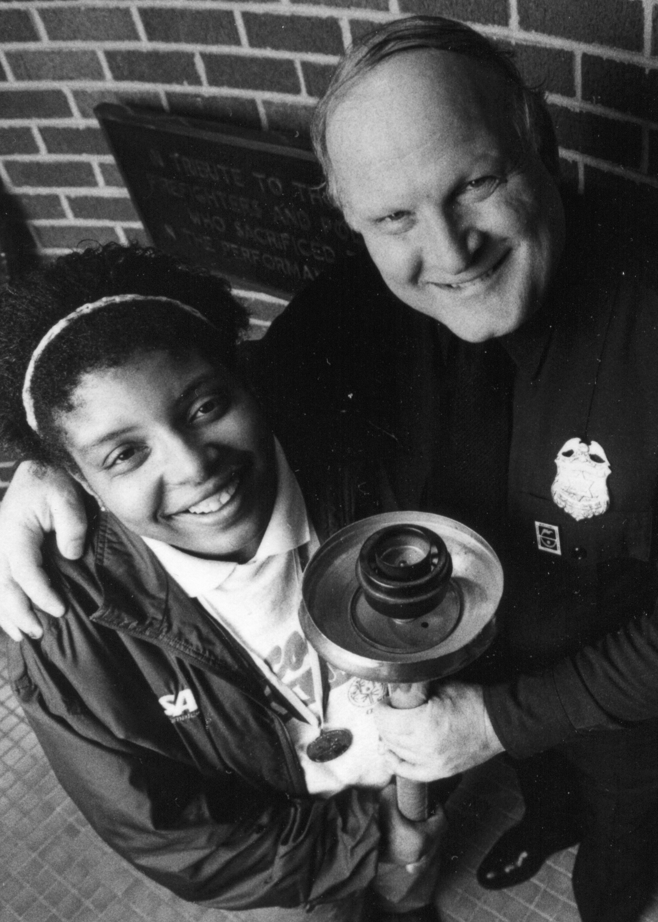


Wisconsin LETR Dale Brunner Hall of Fame Award
Wisconsin Law Enforcement Torch Run®
Dale Brunner Hall of Fame Award

In 1986, when the Torch Run began in Wisconsin, Dale Brunner ignited a spark among law enforcement officers to spread awareness of individuals with intellectual disabilities and raise money to support the athletes of Special Olympics Wisconsin. That eternal flame burns with even more vigor today.

Dale was a US Army Veteran with the 82nd Airborne “Red Devils”, a Milwaukee Police Officer for 31 years and served as a Washington County Sheriff’s Deputy for 10 years. His passion for his family and children lead to his devotion to charitable work. Most notably, Dale served as the first director of the Law Enforcement Torch Run® (LETR) for Special Olympics Wisconsin from 1986 through 1999. In February 1992, Dale was one of 11 inaugural inductees into the International Richard LaMunyon Hall of Fame, named for the founder of the Torch Run, the Hall of Fame is the most prestigious award given in the Torch Run community.
In 1999, the inaugural Wisconsin Law Enforcement Torch Run Dale Brunner Hall of Fame award was presented. This award was created to recognize Wisconsin’s outstanding law enforcement volunteers and Special Olympics staff who have significantly contributed to the statewide success of Wisconsin’s Torch Run. It is an honor bestowed on those participants who have gone above and beyond the normal call of duty in their efforts to enhance the Torch Run and its support of Special Olympics Wisconsin’s mission.

On August 12, 2014, sadly Dale passed away after a very courageous battle with brain cancer. A Final Leg run was held in his honor.

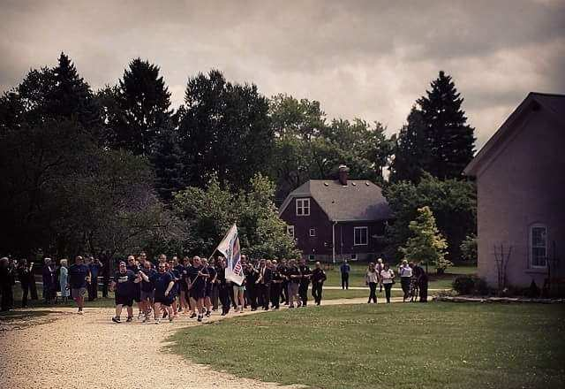

Wisconsin Law Enforcement Torch Run® Dale Brunner Hall of Fame Award

The Wisconsin Law Enforcement Torch Run (LETR) Dale Brunner Hall of Fame Award recognizes outstanding individuals who have significantly contributed to the statewide success of the LETR for Special Olympics Wisconsin.
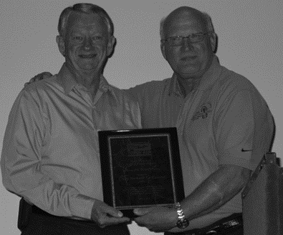

2016 Inductees
Richard Dressler, Retired, Grant County Sheriff’s Office
Matthew Harper, Winneconne Police Department & SOWI
Sara Knapp, Shiocton Police Department
Dean Wendlandt, Sheboygan Police Department

2015 Inductees
Andrew J. Dewitt, Wisconsin Rapids Police Department
David Kleinhans, Department of Justice
Robert Roeske, Retired, Rothschild Police Department
Chief Richard LaMunyon, Founder of the Law Enforcement Torch Run®, with Dale Brunner, Wisconsin’s first LETR Director
For a list of all Wisconsin LETR Hall of Fame inductees, go to
http://www.specialolympicswisconsin.org/get-involved/law-enforcement-torch-run/

SELECTION:
An individual, a law enforcement agency or a Special Olympics program may submit nominations. All nominations should include a completed nomination form that is provided in this packet. There may be one or more inductees per year, to provide for the growing number of quality applicant and/or nominees. The Selections Committee determines the decision as to the number of inductees and the selection.

CRITERIA:
The nominee’s involvement shall demonstrate a sustained and significant contribution to the achievement of the goals of the Law Enforcement Torch Run®. The minimum requirements for this award are at least five (5) years of participation with the Torch Run, achievement in program development, organization and fund raising success. (We recognize our athletes in numerous ways, including leadership awards such as the Mike Schulte Athlete Leadership Award and the Special Olympics Male and Female athlete of the year’s awards; therefore they are not eligible for this award.)

PROCESS:
Nominees whom are not selected will remain in consideration for one (1) additional year (total of 2 years – year nominated plus one year). Supportive nominee information may be supplied each year. At the end of two (2) years, nominees’ files will be removed unless re-nominated using the current year’s nomination form.

All nominations or inductees will be kept confidential with inductees being announced at the Law Enforcement Torch Run® Celebration Party on Thursday, June 8, 2017 in Stevens Point.

All nominees will receive a letter of recognition from the Chair of the Selections Committee in honor of their nomination with a copy to the nominee’s agency.

All 2017 Nomination Forms must be e-mailed by 5:00 P.M. on Friday, April 14, 2017 to both:

Lisa Walter Julie Drake
LETR Assistant Director Director of Development, LETR
Wisconsin LETR State Council Special Olympics Wisconsin
715-505-0302 608-442-5668
LWalter@uwstout.edu JDrake@specialolympicswisconsin.org
To help in completing this form, feel free to contact the Regional Director of Development highlighted below, in the Region of the state the nominee is from, for additional information.


State Headquarters
Kathleen Roach, President & CEO

Administration
Mary Beaty
Kathi Genin
Jeanne Hrovat
Theresa Rossman
Lynda Tanner

Development
Michael Mortell
Julie Drake
Claire Essman
Beth Hopkins
Brandi Niemeier

Marketing & Communication
Jennifer Wagner
Lindsay Meyer
Shannon Adams

Program Services
Bob Whitehead
Brittany Bergen
Jenna Jehlicka
Melissa Schoenbrodt
Samantha Sotelo
Don Wigington
Mark Wolfgram

2310 Crossroads Drive Ste. 1000
Madison, WI 53718
608.222.1324
800.552.1324
608.222.3578 (fax)
www.SpecialOlympicsWisconsin.org

North Central Region 2
Jordan Becker
JBecker@SpecialOlympicsWisconsin.org
Ellen Daniels
2804 Rib Mountain Dr Ste C
Wausau, WI 54401
715.848.0550
877.848.0550
715.848.0880 (fax)

Indianhead Region 3
Karen Kraus
KKraus@ SpecialOlympicsWisconsin.org
Melissa Maxwell
2023 Fairfax Ave.
Eau Claire, WI 54701
715.833.0833
800.833.5851
715.833.0507 (fax)

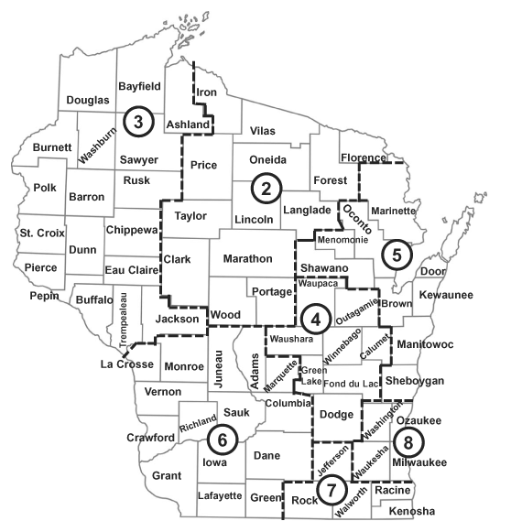

Fox Valley Region 4
Jody LaPlante
Nicole Sprangers
NSprangers@SpecialOlympicsWisconsin.org
W5361 CTY KK, Ste. D
Appleton, WI 54915
920.731.1614
800.704.1614
920.731.3691 (fax)

Northeastern Region 5
Matt Harper
MHarper@SpecialOlympicsWisconsin.org
Carla Lieb
2140 Holmgren Way
Green Bay, WI 54304
920.497.2422
800.707.2422
920.497.0126 (fax)

South Central Region 6
Kate Bergmann
JoEllen Graber
JGraber@SpecialOlympicsWisconsin.org
2310 Crossroads Drive, Suite 1000
Madison, WI 53718
608.222.1324
800.552.1324
608.222.3578 (fax)

Southeastern Region 7
Troy Anderson
Brittany Neukirchen
BNeukirchenSpecialOlympicsWisconsin.org
6100 Washington Ave., Suite E1
Racine, WI 53406
262.598.9507
800.924.4320
262.598.9509 (fax)

Greater Milwaukee Region 8
Jason Blank
Kelley Mawhinney
KMawinney@SpecialOlympicsWisconsin.org
Jessica Paczesny
10224 N. Port Washington Rd.
Mequon, WI 53092
262.241.7786
800.924.5202
262.241.5334 (fax)

Wisconsin Law Enforcement Torch Run® Dale Brunner Hall of Fame Award

Nomination Application

NOMINEE

Nominee’s Name:

Include rank if applicable

Address:

Street

City/State/Zipcode
Phone:  Work  Cell |  | Email:

Law Enforcement Agency and/or Special Olympics Region:

Nominee’s Supervisor’s Name, E-mail and Phone number

NOMINATOR

Nominator’s Name:

Address:

Street

City/State/Zipcode
Phone:  Work  Cell |  | Email:

Law Enforcement Agency and/or Special Olympics Region:

Nomination Application

The nominee’s involvement must demonstrate a sustained and significant contribution to the achievement of the goals of the Law Enforcement Torch Run. The minimum requirements for this award are at least five years of participation with the Torch Run, achievement in program development, organization and fundraising success.

Please answer each of the questions below to highlight activities, length of service, contributions, accomplishments, money raised, sponsors acquired, and volunteerism positions held by your nominee. Please be specific and provide examples as necessary. Use additional space if needed.

1. How many years has the nominee been involved with the Law Enforcement Torch Run?

2. Identify the nominee’s demonstrated comprehensive, outstanding achievement in Law Enforcement Torch Run development, organization and fund raising success at the local and, state level. Please be specific and provide examples as necessary.

3. List the nominee’s specific acts of demonstrated exceptional leadership, commitment and dedication that have made a significant impact on furthering the mission of the Law Enforcement Torch Run at the local and state levels. Please be specific and highlight activities, positions held, and accomplishments supported by examples as necessary.

4. List the nominee’s involvement with Special Olympics (coaching athletes, Unified Partner, etc.). Please be specific and highlight activities, positions held, and accomplishments supported by examples as necessary.

5. List the nominee’s National or International involvement, if any. Please be specific and highlight activities, events attended, positions held, and accomplishments supported by examples as necessary.

6. List any other information you believe the selection committee should know about the nominee.

Remember

For the nominee to be considered, the completed nomination application must be received no later than 5:00 P.M. on Friday, April 14, 2017 and accompanied by:

1. Two (2) letters of support from people who have worked closely with the nominee.

2. Four (4) to six (6) digital photos in high resolution quality

E-mail all nomination materials by 5:00 P.M. on April 14, 2017 to both:

Lisa Walter Julie Drake

WalterL@uwstout.edu JDrake@SpecialOlympicsWisconsin.org

