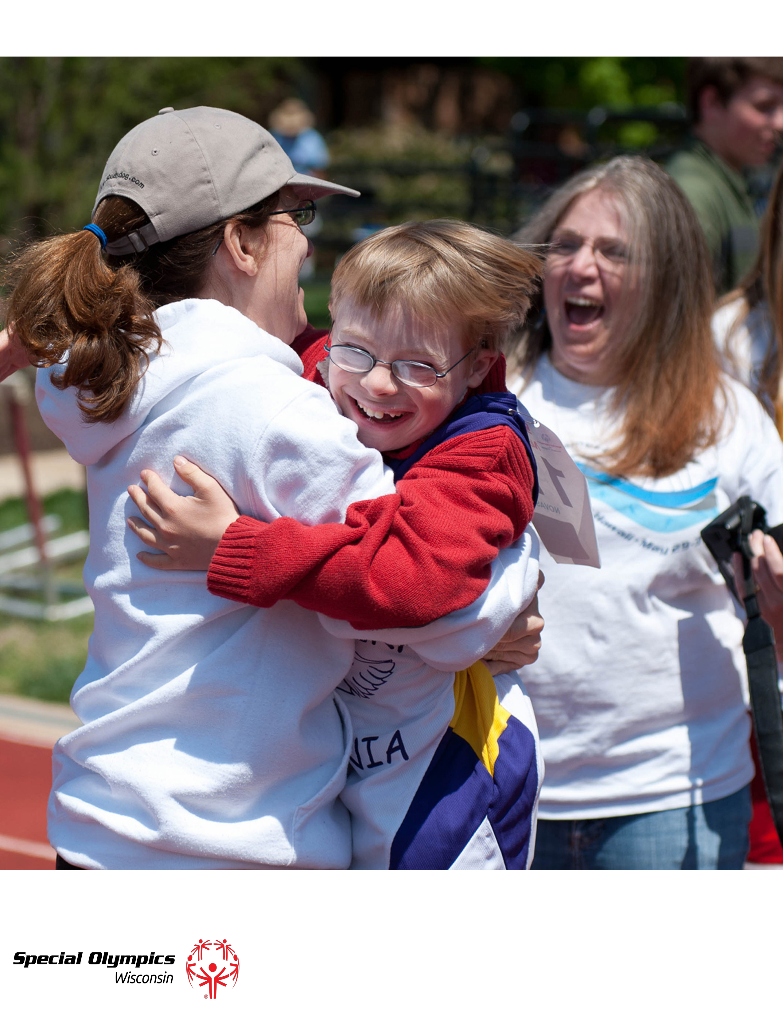

FAMILY AND FRIENDS HANDBOOK

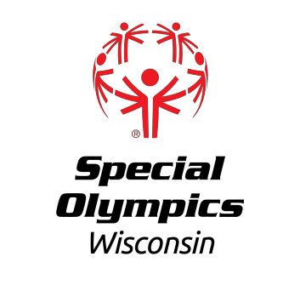

SPECIAL OLYMPICS WISCONSIN

WHAT IS SPECIAL OLYMPICS?
Special Olympics Wisconsin (SOWI) is an accredited program of Special Olympics, Inc. (SOI), which is a global non-profit organization providing sports training and competition to individuals with intellectual disabilities.

Special Olympics programs are patterned after the Olympic Games. In fact, Special Olympics is one of three organizations authorized by the International Olympic Committee to use the word "Olympics" in its corporate name. Like its Olympics Games counterpart, SOI truly has a global presence with programs in every state and in more than 180 countries.

The organization serves more than 208 million athletes and 750,000 volunteers who take part in nearly 30,000 Special Olympics games around the world, involving 30 summer and winter sports. In Wisconsin, SOWI serves nearly 10,400 athletes and has a volunteer base of more than 11,000 individuals.

MISSION
The mission of Special Olympics is to provide year-round sports training and athletic competition in a variety of Olympic-type sports for children and adults with intellectual disabilities. This gives them continuing opportunities to develop physical fitness, demonstrate courage, experience joy and participate in a sharing of gifts, skills and friendship with their families, other Special Olympics athletes and the community.

VISION
Our vision is that sport will open hearts and minds toward people with intellectual disabilities and create inclusive communities all over the world.

VALUES
Mutual Respect, Positive Attitude, Accountability, Teamwork, and Dedication...Values SOWI lives by to create an environment of integrity where winning is more than coming in first.

WHY SHOULD MY FAMILY JOIN SOWI?

ATHLETE BENEFITS
Participation in sports brings significant benefits to people with intellectual disabilities of all ages and abilities. The following also reflects benefits of sports for everyone:

- Physical: Physical fitness, increased coordination, cardiovascular fitness and endurance.

- Mental: Knowledge of rules and strategy, along with increased self-esteem, self-confidence and pride.

- Social: Teamwork, interaction with people without intellectual disabilities, family pride, opportunity to travel, explore new places, and interests, as well as increased community awareness and acceptance. This results in a richer, more rewarding life, improved skills and increased confidence in school, work, home and social life.

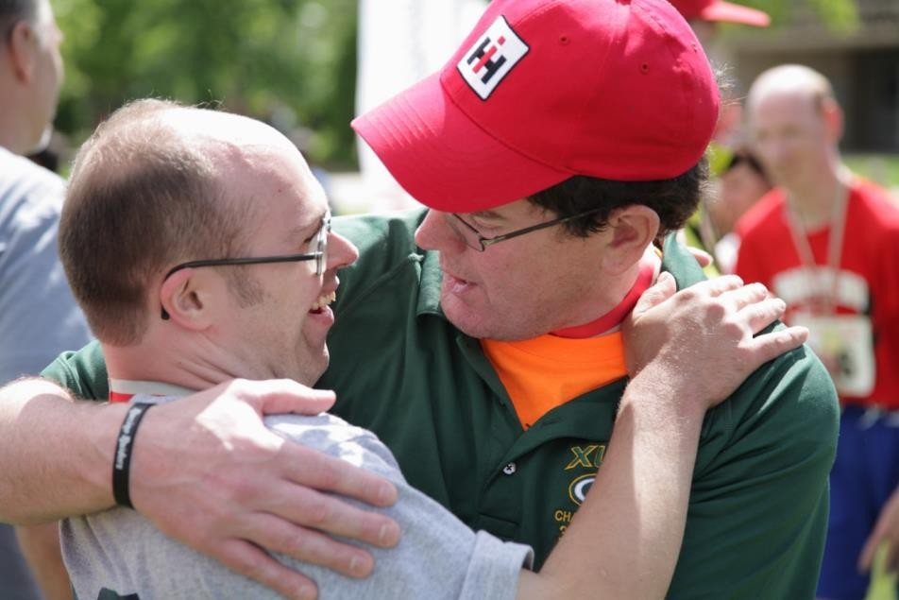

FAMILY BENEFITS
First, SOWI serves as a powerful engine for families of athletes to connect by providing opportunities for families to forge new relationships and strengthen existing ones.

Second, the organization provides athletes and their families with normative life experiences that are critical to healthy development. These enriching experiences can be found at all levels of the organization, as families naturally network in SOWI. They lean on each other for support, share experiences and cheer each other’s athletes on.

ATHLETE ELIGIBILITY
SOWI was created, and exists today, to give individuals with intellectual disabilities1 the opportunity to train and compete in year-round sports activities. To be eligible to participate as a registered SOWI athlete2, a person must meet the following criteria:

Be at least eight years of age.
An athlete must be eight years of age by the medical deadline date in order for SOWI to process the medical forms and for the athlete to compete in that sport season.
Individuals ages 2-7 may inquire about SOWI’s Young Athletes Program (YAP). There is no maximum age limit.

Be identified by an Local Program or professional as having:
    - An intellectual disability1; or
    - An intellectual delay3 as determined by standardized measures such as intelligence quotient (IQ) or other generally acceptable measures; or
    - A closely related developmental disability. A “closely related developmental disability” means having functional limitations in both general learning4 and adaptive skills5 such as recreation, work, independent living, self-direction or self-care. However, persons whose functional limitations are based solely on a physical, behavioral, or emotional disability, or a specific learning or sensory disability are not eligible to participate as Special Olympic athletes, but may be eligible to volunteer for SOWI.

Agree to abide by the Official Special Olympics Sports Rules and the SOWI Athlete Code of Conduct.

  - Persons with multiple disabilities may participate in SOWI as long as they also meet the noted criteria above.

NOTE: No person shall, on the grounds of sex, race, religion, color or national origin, be excluded from participation in, be denied benefits of, or otherwise subjected to discrimination under any program or activity of SOWI.

- To be a registered SOWI athlete, eligible persons must complete an Athlete Medical Form, a Participant Release Form and register with one of over 165 SOWI accredited agencies.
- Learning slower than one’s typical peers and requiring specially designed instruction.
- General learning limitation refers to substantial deficits in conceptual, practical and social intelligence that will result in performance problems in academic learning and/or general life functioning.
- Adaptive skill limitations refers to an on-going performance deficit in skill areas considered essential to successful life functioning.
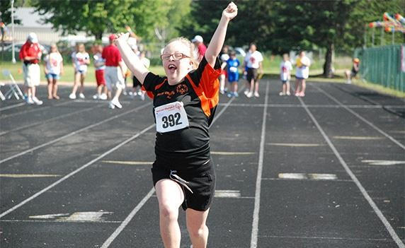

HOW DO I JOIN?
- Contact the Regional Athletic Director in your region. You can find their information at http://www.specialolympicswisconsin.org/who-we-are/regions/
- Obtain and complete the Athlete Release Form, Athlete Medical Form and COVID Waiver from your local Local Program or complete the forms available on the website (specialolympicswisconsin.org/sports-offered/become-an-athlete/)

- Return your form(s) to the local Local Program, who will then turn in your forms to Special Olympics Wisconsin Headquarters office. All new athletes must have all forms on file before they can begin practicing. Medical deadline dates are strictly enforced for upcoming competitions. Please work closely with your Local Program manager to make sure medical deadlines are met. It is your responsibility to maintain a valid medical form with Special Olympics Wisconsin Headquarters.
*If there is no local Local Program near you, you can inquire with staff about how to start one in your community.

WHY IS THE Athlete RELEASE FORM AND THE ATHLETE MEDICAL FORM NECESSARY?
The forms are similar to those required for any other sports program. They provide for:

  - Necessary medical information, including a health history, health insurance information and emergency contacts, including physician, parent or guardian.

  - Secondary insurance coverage by Special Olympics, Inc. as a secondary policy.

  - Emergency medical treatment in the event that a parent or guardian cannot be reached.

  - A photo release allowing Special Olympics Wisconsin to use any photos or video of its athletes for marketing purposes.

  - Release for athletes wishing to participate in Healthy Athletes.

For more information about medical deadlines, visit the website.
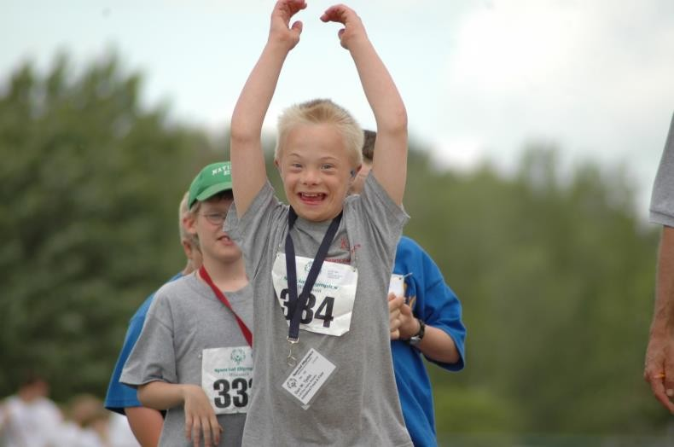

ATHLETE PARTICIPATION
Special Olympics aims to provide a variety of competition opportunities for athletes of all abilities by offering official events of various degrees of difficulty and challenge. Athletes can participate in specially modified events such as the 25-meters Assisted Walk or the 15-meter Flotation Race (Swimming).

Events for Athletes with Physical Disabilities:
There are also events for athletes who use wheelchairs. Athletes who are not yet ready to play team sports can participate in Individual Skills competitions. For example, athletes can earn medals for performing such skills as dribbling in Basketball.

Unified Sports:
Athletes with higher abilities can participate in Special Olympics Unified Sports®, a program designed to bring together equal numbers of athletes with and without intellectual disabilities on the same team. Efforts are made to match ability levels and age-appropriate peers.

Participation in Other Programs:
Special Olympics athletes may participate in other sports programs while participating in Special Olympics (e.g. Special Olympics Softball team and a city league softball team). However, sports governing bodies, such as the Wisconsin Interscholastic Athletic Association, leagues and schools may have rules prohibiting athletes from participating on more than one team per season. Coaches should encourage their athletes to participate in all sports programs, but they must be careful to protect their athletes' eligibility.

What Rules does Special Olympics Follow?
SOWI follows the Official Special Olympics Sports Rules which are based on International Sports Federation and National Governing Body rules. Rules are available on the SOWI website by sport.

Special Olympics Wisconsin offers training and competition in a wide variety of sports. Ask your Local Program Manager what sports are available in your local program. SOWI, per SOI recommendations, allows athletes to compete in one sport per season listed below:

SPORTS SEASON

WINTER GAMES
(December-January)
Alpine Skiing
Cross Country Skiing Snowboarding Snowshoe Racing

INDOOR SPORTS SEASON
(February-April) Gymnastics Skills Basketball Team Basketball
3v3 Unified Basketball

SUMMER GAMES
(March-June)
Swimming
Athletics (track & field) Soccer
Powerlifting

OUTDOOR SPORTS SEASON
(June-August)
Bocce Golf Softball Tee Ball Tennis

FALL SPORTS SEASON
(September-December)
Bowling
Flag Football Volleyball
Cornhole

TRAINING
ATHLETES
Athletes are encouraged to train a minimum of eight sessions for each sport within two months prior to Regional/District competition. Local Local Program training schedules may vary.
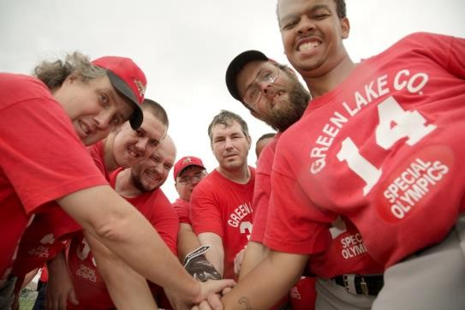

COACHES
All coaches are volunteers. SOWI requires all coaches and volunteers be registered and screened prior to their involvement.

To become a certified coach, volunteers must view and take the General Coaches certification. Sport-specific training schools are offered as an additional resource to our coaches.

Certified Training Schools are taught by knowledgeable, experienced clinicians who train coaches to work with athletes of all ability levels. In addition, Special Olympics Wisconsin provides a variety of resources to ensure all athletes receive safe, quality sports training.
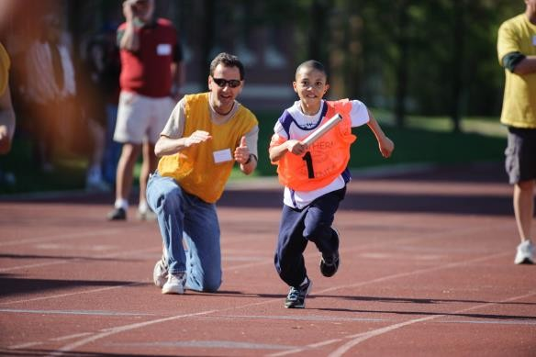

HOME TRAINING
No matter what your ability level, family members can help train their athlete at home. Information can be found on our website.

Something as basic as taking a walk together conditions your athlete. Home training not only helps your athlete, but it can help you. Best of all, it’s fun!

COMPETITION

HOW DOES DIVISIONING WORK?
What makes Special Olympics different than other sports organizations is divisioning. As outlined in the Special Olympics Competition Guide, athletes are seeded into competitive divisions based on their age, sex, and ability. Divisions are established so they are "even."

An "even" division is one in which all participants, based on training and competition performance records, have a reasonable chance of winning. In situations where there are not enough competitors to hold competition in a certain age or sex group, the athletes are combined within the same ability range. This division is then called an "open division."

Because the goal for each Special Olympics athlete is to do his/her best, every athlete receives either a medal or a ribbon for competing.

WHY ARE THERE RULES?
Special Olympics Inc. follows the National Governing Body rules for each sport to ensure the athlete’s safety during trainings and competitions. It also creates a fair atmosphere during each tournament and throughout advancement.

Athletes, coaches, spectators, and volunteers can expect the same rules at every level of the organization. Failing to enforce the rules is unfair to the athletes who have trained and competed properly within the rules.

SPORTSMANSHIP
It is expected that everyone abides by their respective code of conduct–including athletes, spectators, volunteers, and staff because Special Olympics believes “sportsmanship makes winners”!

WHO QUALIFIES FOR COMPETITION?
Special Olympics Wisconsin stresses the benefits of training and competition at the local level. Athletes train a minimum of eight weeks.

Note: Due to facility limitations, some State competitions have quotas which limit the number of athletes who advance from Regional/District/Sectional competitions. Final selection for State competition is determined by the advancement policy in the SOI General Rules.

UNIFIED SPORTS®

WHY UNIFIED SPORTS?
Unified Sports® creates unique teammate bonds through sports experiences just like any other sports team, creating a culture of inclusion and fostering understanding in schools and communities around the state. Participation in Unified Sports leads to new friendships, improved self-esteem and positive changes in attitude, behavior and performance for all students involved.

In Unified Sports, teams are made up of people of similar age and ability, which makes practices more fun and games more challenging and exciting for all. Having sport in common is just one more way that preconceptions and false ideas are swept away. Half a million people worldwide take part in Unified Sports, breaking down stereotypes about people with intellectual disabilities in a really fun way.
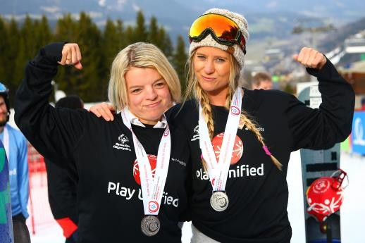

THE THREE UNIFIED SPORTS MODELS:
The foundation of Unified Sports is the principal of meaningful involvement, where every player is given an opportunity to contribute to the success of his or her team through their unique skills and qualities. Therefore, three models have been developed to ensure social inclusion: competitive, player development, and recreation.

- The Unified Sports Recreation Model involves participation of athletes with and without intellectual disabilities without any prescribed training or competition. The goals are to promote social inclusion and to increase sports skills and knowledge in a less structured environment. The recreation model often acts as an entry point or exposure to the other Unified Sports models.
- The Unified Sports Player Development Model allows teammates of higher abilities to serve as mentors to assist players with lower abilities in practices and competition, all of similar age. Rules may be modified for fair play and defined mentor roles. Player development focuses on social inclusion, development of skills and improved comprehension of game tactics for lower- ability players, developing leadership and teaching skills for players in mentoring roles, and offers sub-programs greater options when there are not athletes and partners who match in ability levels.
- The Unified Sports Competitive Model combines athletes and partners of similar age and ability as teammates for training and competition. Sports are played without modification to Special Olympics rules with competition as a focus, therefore all teammates have attained sufficient and necessary sport-specific skills and tactics.

To get more resources, visit our website.

UNIFIED CHAMPION SCHOOLS

WHAT IS A SPECIAL OLYMPICS UNIFIED CHAMPION SCHOOL?
A sustaining Special Olympics Unified Champion School is a combination of at least three components; sports, youth leadership/advocacy, and a school-wide activity. At a Unified Champion School there is an understanding that this is not just an incident or event that happens for one day, or a single experience, but rather year-long or seasonal activities. In a Unified Champion School there is an expectation that acceptance and inclusion are everyday occurrences that change entire schools and impact the whole student body.

GET INTO IT
Special Olympics Get Into It consists of online resources that include lessons, activities, videos, athlete stories and supplemental materials. At the core of Get Into It are age-appropriate lessons designed to be taught in the context of class periods. Activities with ties to service learning are completed in a classroom or community setting, as part of a club, an afterschool activity or a community based event and include involvement with local Special Olympics Programs whenever possible.

To request a kit for your school or to learn more, please visit the website.
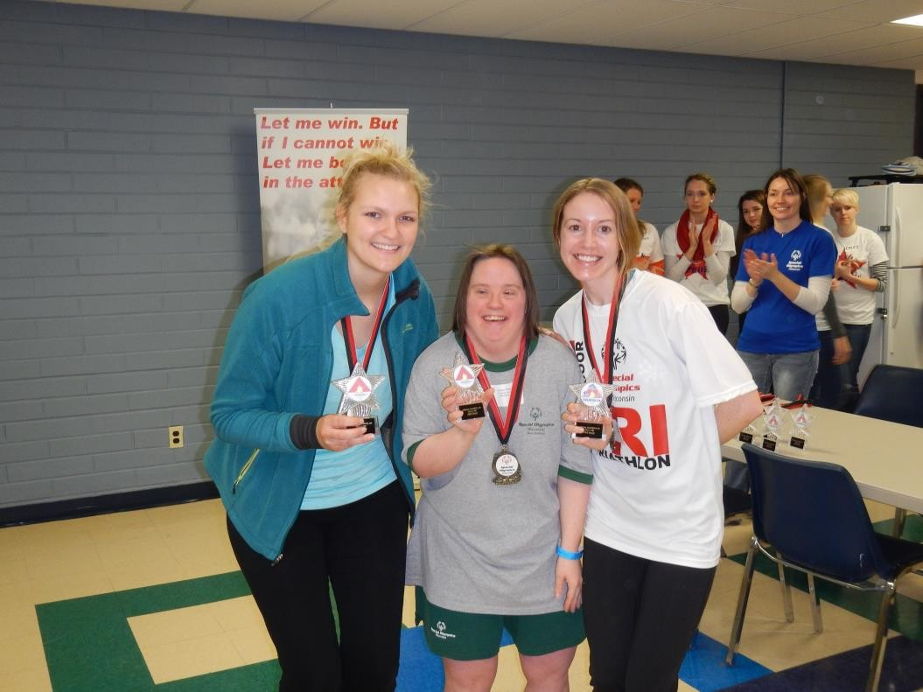

ORGANIZATIONAL STRUCTURE
HOW IS SOWI ORGANIZED?
Special Olympics, Inc., founded by Eunice Kennedy Shriver in 1968, is the organization which governs all aspects of Special Olympics. SOI gives states and other nations the right to use the name "Special Olympics," and provides guidelines for them to follow.

SOWI is accredited regularly by SOI to ensure strict compliance to these guidelines. SOWI is governed by a volunteer Board of Directors which appoints and consults with a President who develops and implements the overall state program.

Local programs register annually with SOWI and are coordinated by Local Program managers who report to Regional and program office staff. Athletes and families are the foundation of the organization.

HOW IS MONEY RAISED?
SOWI is a not-for-profit organization 501(c)3. Contributions from individuals, organizations, government/restricted grants, corporations, foundations, and special events provide the resources necessary.

The Law Enforcement Torch Run ® (LETR) is the largest public awareness vehicle and grass-roots fundraiser for Special Olympics. What started in Wichita, Kansas in 1981 as a one-day run has now expanded to include 35 countries and is a year-round fundraising program. Wisconsin’s Torch Run is one of the top in the world involving nearly 1,000 officers from 170 law enforcement agencies raising over $2.5 million annually. The LETR is managed by voluntary law enforcement and SOWI staff.

Throughout the year, Agencies can help raise funds for SOWI with opportunities to earn rebates for their own Local Program through LETR T-shirt sales and by participating in the Polar Plunge. They can also help with fundraising at the below events:

- Polar Plunge®
- Tip a Cop
- The World’s Largest Truck Convoy®

Dunkin’ Donuts “Cop on a Rooftop”
- LETR Torch Run Final Legs
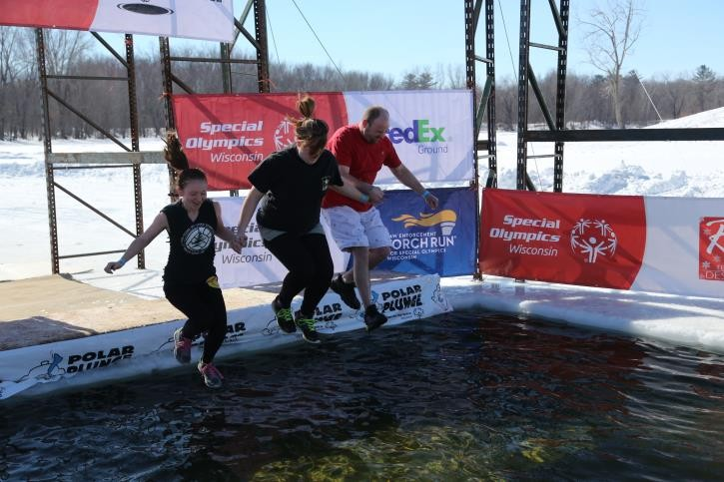

SUPPORT PROGRAMS
HEALTHY ATHLETES

Healthy Athletes® events provide free health screenings and health education in a fun, welcoming environment with a focus on removing the anxiety people with intellectual disabilities often experience when faced with a visit to a medical professional. Special Olympics recognizes that when athletes are in their best physical health they perform at their highest level both on and off the playing field. Offered in Wisconsin since 2001, Healthy Athletes has discovered undetected health problems, alleviated pain and provided health services and resources. Athletes with a current medical on file at SOWI’s headquarters are welcome to attend any Healthy Athletes event, even if they are not competing at the tournament.

Healthy Athletes is not only a program for athletes but, through training and hands-on experience at screenings, it is a program for health care students and professionals to increase knowledge of best practices in caring for people with intellectual disabilities.

The Healthy Athlete Disciplines are:

Fit Feet provides podiatric screening that includes evaluation of ankles, feet, lower extremity
biomechanics, and proper shoe and sock gear.

FUNfitness provides screening and education on flexibility, functional strength, balance and aerobic conditioning.

Health Promotion offers education on healthy eating and lifestyle choices along with fun ways to increase physical fitness.

Healthy Hearing provides hearing screening to ensure proper audiological care.

Lions Club International® Opening Eyes provides vision screenings, refractions, and dispensing of appropriate eyewear.

Delta Dental® Special Smiles provides screenings, oral health education, prevention services and follow up referrals.

Strong Minds provides athletes the tools to strengthen their coping skills.

Medfest® conducts the standard sport physical required for participation in Special Olympics.

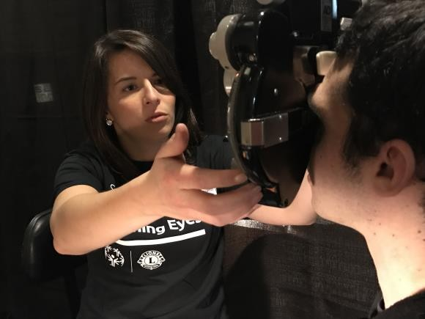

YOUNG ATHLETES
Young Athletes™ introduces children, ages 2 - 7, both with and without intellectual disabilities, and their families to the world of Special Olympics by pursuing the following goals:

- Engage children with intellectual disabilities through developmentally appropriate play activities designed to foster physical, intellectual and social development;

- Welcome family members of children with intellectual disabilities to the Special Olympics network of support;

- Raise awareness about the abilities of children with intellectual disabilities through inclusive peer participation, demonstrations and other events.

Young Athletes is a versatile program that is designed for families to play with their young athletes at home in a fun atmosphere but is also appropriate for kindergartens, schools and play groups.

The benefits for this program have been proven worldwide. First and foremost, these activities will help the children improve physically, cognitively and socially. The flexibility of Young Athletes ensures the opportunity to welcome families and their young children to the Special Olympics family. Young Athletes activities consist of foundational skills, walking and running, balance and jumping, trapping and catching, throwing, striking, kicking and incorporates advanced skills. To find out if there is a Youth Athletes near you or to simply learn more, please visit the SOWI website or contact the Director of Training, Brittany Bergen at bbergen@specialolympicswisconsin.org.
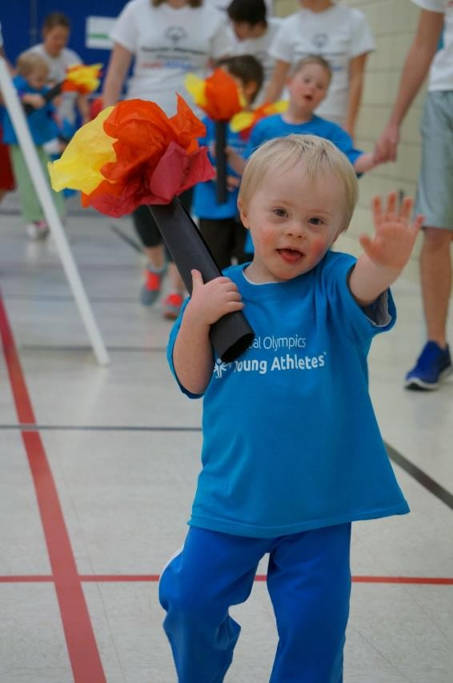

ATHLETE LEADERSHIP
Special Olympics Athlete Leadership initiatives train athletes to serve in meaningful leadership roles other than or in addition to that of “competitor.” They offer athletes an opportunity to participate as partners in all aspects of the Special Olympics movement in Wisconsin such as Board ambassadors, Global Messengers (public speakers), coaches and mentors.

Athlete Leadership allows athletes to have self-determination roles they will play in Special Olympics, puts athletes in meaningful positions of influence and leadership throughout the organization, provides training to give them the tools they need to be successful in these new roles, and maximizes their potential both on and off the playing field.

R-WORD CAMPAIGN
The R-Word Campaign is a campaign to “Spread the Word to End the Word” ™ in an effort to raise awareness of the dehumanizing and hurtful effects of the R-word (retard or retarded) and encourage people to pledge to stop the use of the R-word.

The campaign, created by youth, is intended to work with schools, organizations, and communities to rally and pledge their support at www.r-word.org. Events take place year round, however many activities are occur near March as the first Wednesday of that month has been proclaimed by many states as “Spread the Word to End the Word” Day. To learn more about how can start the campaign in community, please visit the Special Olympics Wisconsin website.
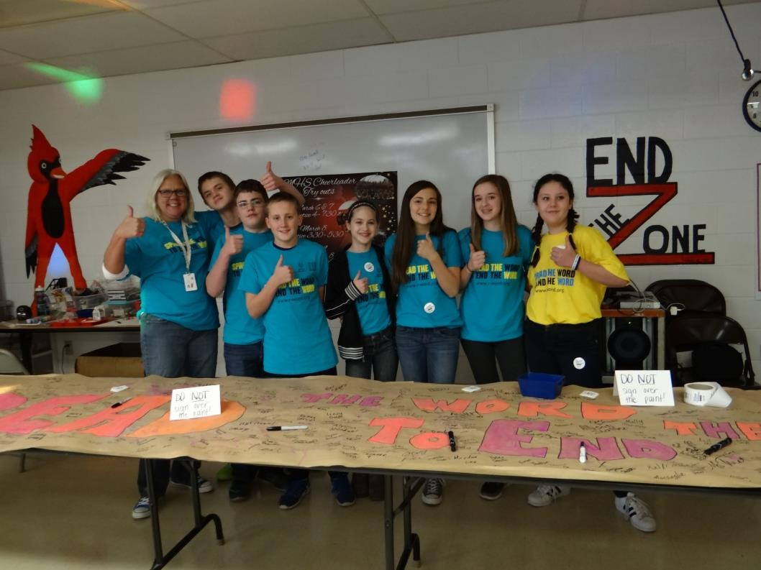

WHAT CAN YOU DO TO HELP?

GET ACTIVE!
Families and friends of Special Olympics athletes are encouraged to play an active role in their community Special Olympics program, to share in the training of the athletes, and to assist in the public education efforts needed to create greater understanding of the emotional, physical, social and spiritual needs of people with intellectual disabilities and their families.

Choose one or all. It's your choice!
- Cheerleader
- Driver
- Home Trainer
- Spokesperson
- Local Local Program Management Team Member
- Coach

GIFTS THAT KEEP ON GIVING
Memorial Programs invest in the Future of Special Olympics. Give a gift to Special Olympics in remembrance of a friend or loved one that assists in providing year-round sports training and athletic competition in a variety of Olympic-type sports for more than 10,000 children and adults with cognitive disabilities.

This expression of love through a Memorial Gift furthers our mission by giving people with intellectual disabilities continuous opportunities to develop physical fitness, demonstrate courage, experience joy and participate in the sharing of gifts, skills and friendship.

For more information or to give a Memorial Gift please call 608-222-1324.

Each Memorial Gift is acknowledged to your loved one's family or others with a card sent according to your wishes. Gift amounts are confidential.

Thank you for being a fan of Special Olympics Wisconsin!
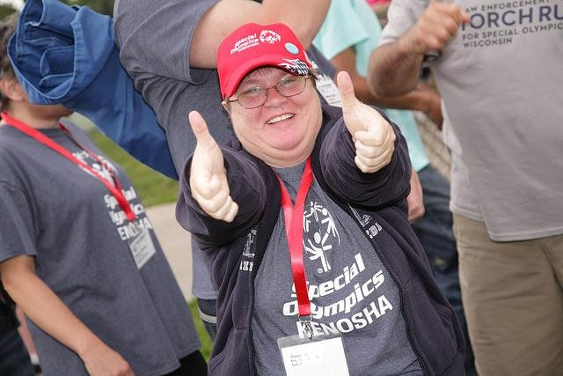

Notes

Notes

Notes

