**Voluntaro Platform – Launching 2/10/25**

1. **New Applicants**
   1. Visit our website: <https://specialolympicswisconsin.org/get-involved/volunteer/class-a-volunteer/>
      1. Follow the link to launch a new application in the Voluntaro platform: <https://app.voluntaro.com/WI/Application>
      2. Complete the required fields and click Next:
         1. **NOTE: If you plan on coaching, you must select “Coach” under Volunteer Type to have the coaching certification course assigned to you.**

* + 1. If the system identifies a record that may belong to you, you will receive this notice:

* + 1. If one of these accounts belongs to you, select the username and enter your password to login.
       1. You can also click “If you have forgotten your password, retrieve it here” to reset your password
    2. If these accounts do not belong to you, select “None of these user names belong to me,” and click Next
    3. Your name, username and email address will populate from the previous screen – fill in the remaining fields

* + 1. Click Submit
    2. Review the Consent & Release Form for ordering a background check, scrolling fully to the bottom:

* + 1. Enter your name, today’s date and your social security number before clicking Next to submit your background check authorization
    2. Review the Consent & Release Form for ordering a background check, scrolling fully to the bottom:

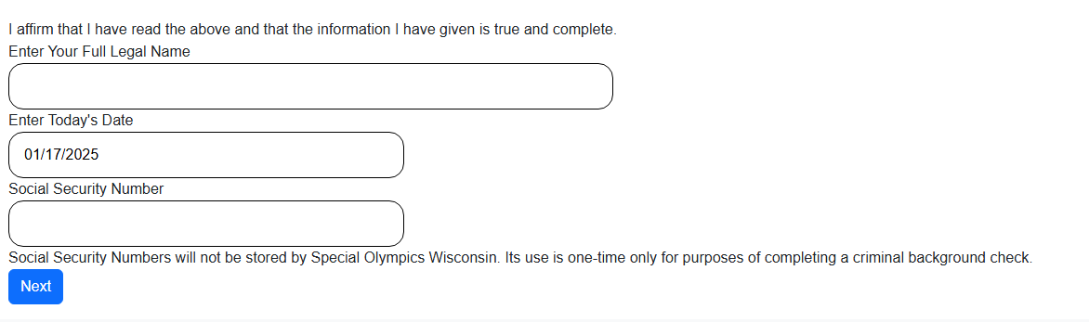

* + 1. At the below screen, select Click here to begin for coaching trainings

* + 1. You will be prompted to log into your account – enter your username, password and click Login:

* + 1. Click Begin Training Module for each required item:
    2. Read the PowerPoint slide and select Click Here to Proceed
       1. Follow the prompts for each module: review the information, watch videos, answer questions and select Click Here to Proceed
       2. When you reach the end and pass the test, click Continue

* + 1. Click Begin Training Module on the next activity assigned to you

* + 1. Complete all training modules assigned to you
    2. After the trainings are completed, click on the Home option on the menu:

* + 1. You have no further steps to take – you will receive an email when your application has been approved or denied
       1. When your application has been approved, your name will appear on your local program’s volunteer roster

1. **Returning Volunteers**
   1. Visit our website: <https://specialolympicswisconsin.org/get-involved/volunteer/class-a-volunteer/>
      1. Follow the link to launch the Voluntaro platform:
      2. Enter your username and password; click login.

* + 1. To check your status, click Home

* + 1. To make any contact information changes, click Edit My Account
    2. If you would like to review the training modules, click on the Training tab
    3. You will be notified via email when your application is due for renewal.
       1. It is essential that you update your email address if you change it to receive these reminders.

1. **Local Program Managers**
   1. Visit our website: <https://specialolympicswisconsin.org/get-involved/volunteer/class-a-volunteer/>
      1. Follow the link to launch the Voluntaro platform: <https://app.voluntaro.com/>
      2. Enter your username and password; click login.

Note: Currently, we are not using the Temporary Volunteer or Event Lists.

* + 1. To check your status or edit your information, click on Home
    2. To view current Class A volunteers, click on Class A Volunteer list

* + - 1. The active filter (green check mark status) is automatically selected. To include expired volunteers, you can move the toggle to the middle. To view only expired volunteers, move the toggle to the right.
      2. You can filter based on volunteer type, sports, restrictions, or if they are a part of the Management Team.
         1. Note: the chaperone restriction has not yet been built into the system. This information is saved on the note on a volunteer’s record.
      3. If you have a long list of volunteers and are looking for someone specifically, you can type their name in the search box and select Search
      4. If you would like to download the list, select Export List
    1. To view current applicants, in the process of completing the application and training modules, click on Applicant List

* + - 1. Here you will see what step(s) need to be completed