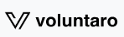


Voluntaro Platform

- Returning Volunteers
  - Visit our website: https://specialolympicswisconsin.org/get-involved/volunteer/class-a-volunteer/
    - Follow the link to launch the Voluntaro platform:
    - Enter your username and password; click login.
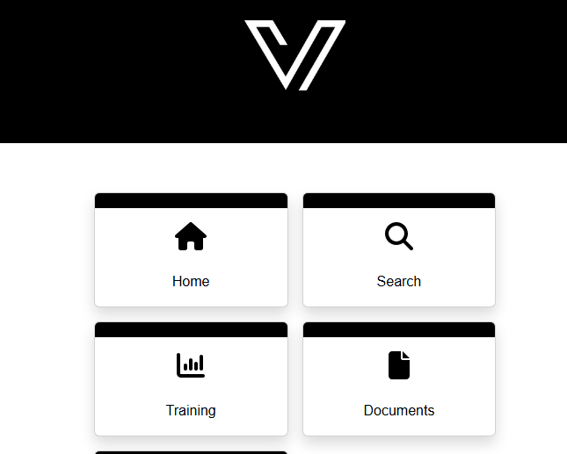
    - To check your status, click Home
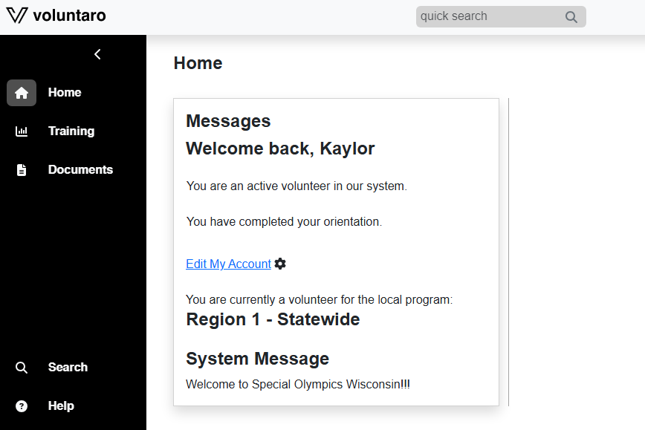
    - To make any contact information changes, click Edit My Account
    - If you would like to review the training modules, click on the Training tab
      - The Protective Behaviors course must be completed every three years
      - The Communicable Diseases Waiver must only be completed once
      - The Coaching Course must be completed every three years (if applicable)
    - You will be notified via email when your application is due for renewal.
      - It is essential that you update your email address if you change it to receive these reminders.
    - If your background check is due for renewal, you will see a message on the Home screen:

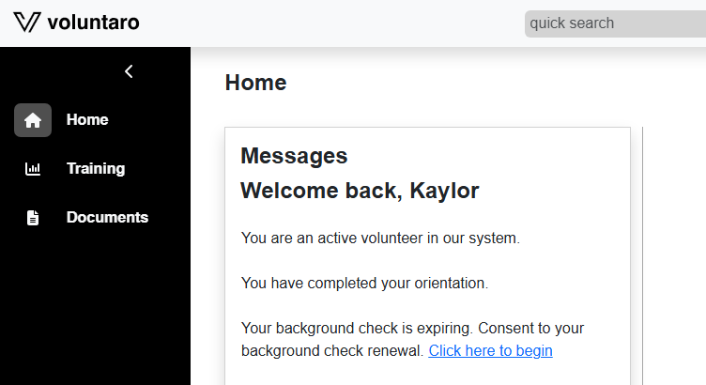
      - Select Click here to begin to initiate the background check consent
      - On the next page, you will be prompted to electronically sign your name and provide your social security number; then click Next
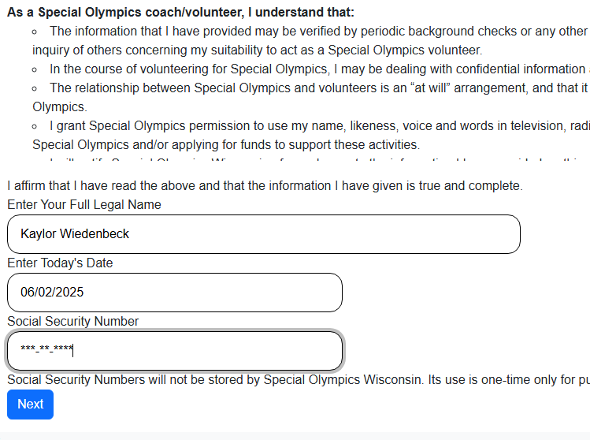
  - After completing the background check consent, you will be prompted to review the Training menu
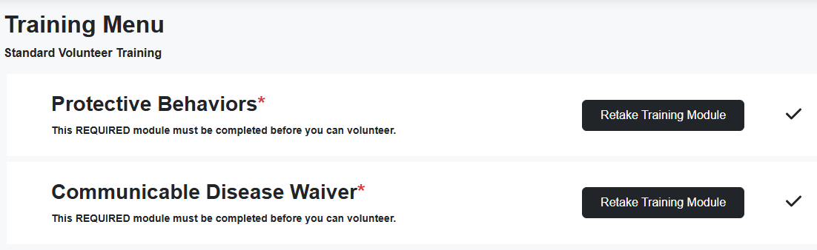
    - The Protective Behaviors course must be completed every three years; it is recommended to complete it at the same time as your background check to easily track when your Class A status is expiring.
      - To retake the course, click Retake Training Module and follow the module prompts until the course is completed with a passing score
  - For questions on the application process, see the Applicants Training Document.

