2026 WINTER INVITATIONAL
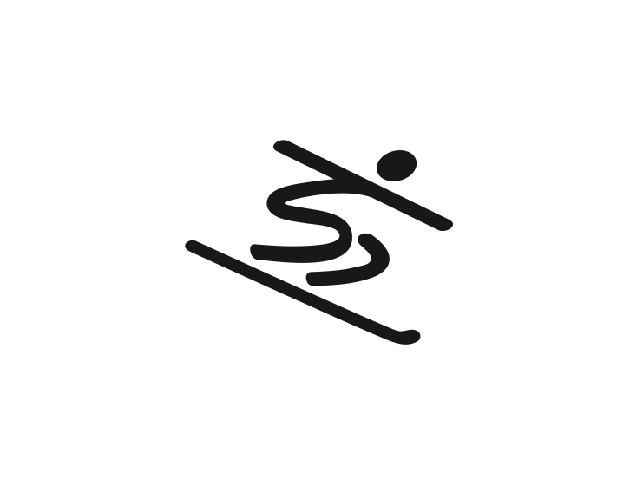
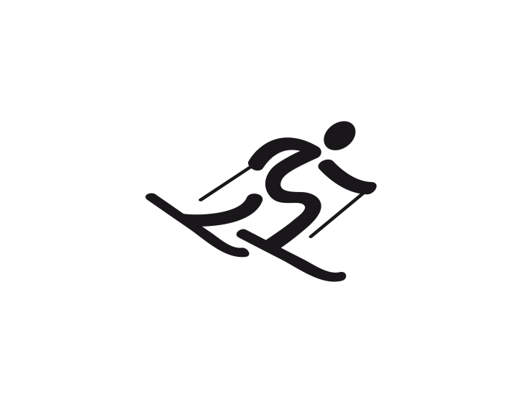
INVITATIONAL DATE: Saturday & Sunday, January 10-11, 2026
Register by January 1, 2026
Need head count for all volunteers and family members attending
by January 1, 2026 (this for food numbers)

COMPETITION SITE:
Mt. Ashwabay, 32525 Ski Hill Rd, Bayfield, WI
About 20 miles north of Ashland on Hwy 13, left at Ski Hill Rd
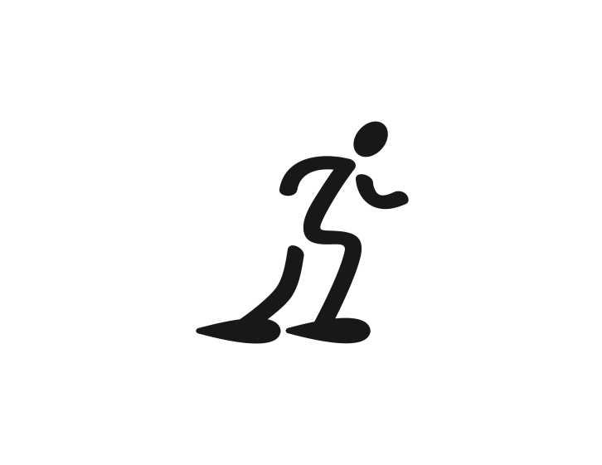
COST
$13.00/snowshoer
$13.00/cross country skier

$20.00/alpine lift ticket

HOST:
3-12 Chequamegon Bay Area
Michelle Fulweber, 715-413-1150 (C)

HOUSING:
AmericInn by Wyndham, Ashland
3009 Lake Shore Dr E, Ashland, WI 54806
Call (if paying cash/credit card) or email (if using direct billing by SOWI)
by 12/29/25 to reserve a room for either 1 or 2 nights
Using the keywords “Special Olympics room blocks”
50 Room available in Room Block- All Double Queen Rooms
Cost per night- $119.00
Direct bill- email Skip at shedican@zmchotels.com
Phone: 715-682-9950

SCHEDULE (may change slightly):
Saturday, January 10
11:00am Check-in at Mt. Ashwabay
12:00-4:30pm Skiing, Snowboarding, Snowshoeing Fun Runs/Races
6:00pm Dinner at AmericInn
7:00-9:00pm Dance
Sunday, January 11
10:00am-3:30pm Skiing, Snowboarding, Snowshoeing Competition
11:30am Lunch
1:30pm NASTAR runs for downhill skiers and snowboarders
ELIGIBILITY FOR WINTER SPORTS SEASON PARTICIPATION
1. Valid Official Special Olympics Release Form and Application For Participation in Special Olympics on file in the Headquarters office postmarked by January 1, 2026 to remain valid through January 1, 2029.
2. Athlete must have participated in at least eight weeks of official Special Olympics training prior to State competition.
3. If a cross country skiing athlete competes in the 50m and/or 100m race, s/he may not be in any other races.

Athletes can be entered in only one of the four sports offered at the State Winter Games.
OFFICIAL EVENTS OFFERED
ALPINE SKIING (three-event limit)
Event Code Event Description
ASSUGL Alpine Super Glide**
ASINSG Alpine Intermediate Super G
ASINSL Alpine Intermediate Slalom
ASINGS Alpine Intermediate Giant Slalom

CROSS COUNTRY SKIING (three-event limit)
Event Code Event Description
CC050M 50m Race Classical
CC100M 100m Race Classical
CC500MF 500m Race Freestyle
CC1KLMF 1km Race Freestyle
CC3KLMF 3km Race Freestyle
CC5KLMF 5km Race Freestyle
CC75KMF 7.5km Race Freestyle
CC4X5M 4X500m Relay

SNOWBOARDING (three-event limit)
Event Code Event Description
SBSUGL Snowboard Super Glide**
SBINSG Snowboard Intermediate Super G
SBINSL Snowboard Intermediate Slalom
SBINGS Snowboard Intermediate Giant Slalom

SNOWSHOE RACING (three-event limit)
Event Code Event Description
SN050M 50m Race
SN100M 100m Race
SN200M 200m Race
SN400M 400m Race
SN800M 800m Race
SN4X100M 4X100m Relay
SN4X200M 4X200m Relay
SN4X400M 4X400m Relay
**May not compete in super Giant Slalom, Slalom or Super G
2026 WINTER INVITATIONAL REGISTRATION
ATHLETE ROSTER

Local Program Number: Local Program Name:
**Head Coach: W:( ) H:( )
Address: _____ _
(City) (State) (Zip)
E-Mail: ______ Additional E-mail: ___________

Return this form to: special olympics wisconsin

Email: kkassens@SpecialOlympicsWisconsin.org

Are your coaches/chaperones all Class A volunteers? Yes______ No______
***NEW ATHLETES: INDICATE NOVICE, INTERMEDIATE, OR ADVANCED***
Athlete Names  (Last Name, First Name) |  | First Event | Second Event | Third Event
 |  | Event Code | Event Code | Event Code
1
2
3
4
5

(OVER)
Athlete Names  (Last Name, First Name) |  | First Event | Second Event | Third Event
 |  | Event Code | Event Code | Event Code
6.
7.
8.
9.
10.
11.
12.
13.
14.
15.

Athletes entered in a relay must also appear on the relay roster.
**Registration materials for this event will be sent to the person listed as head coach.
Athletes can compete in three events, in any one sport (cross country: two individual/one relay or two relay/one individual).

2026 WINTER INVITATIONAL
RELAY TEAM ROSTER
Please Print Clearly:
Local Program Number: Local Program Name:
IMPORTANT: Each relay can have up to six athletes entered per relay team. Any four of the six can race.

Each team must have a unique name, up to 15 characters long. This name must be used at all competitions.

Team Name:

Event Code: Event Name:
Athlete Name
(Last Name, First Name)
1.
2.
3.
4.
5.
6.

Team Name:
Event Code: Event Name:
Athlete Name
(Last Name, First Name)
1.
2.
3.
4.
5.
6.

This information must appear as one of the three events listed for the athlete on the athlete roster.

