Volunteer Policies

Volunteer Registration and Screening Information 1
Class A Volunteer Registration and Screening Policy and Procedures 1
Class A Adult Volunteer Registration Form Sample 7
Class A Minor Volunteer Registration Form Sample 9
Class B Volunteer Registration Overview 11
Volunteer Rosters 12
Coach/Volunteer Code of Conduct Philosophy and Procedures 14
Volunteer Recognition 17
Policy Regarding Volunteers and Staff Dating Athletes 18

Left Blank Intentionally

Volunteer Registration and Screening Information

Special Olympics Wisconsin (SOWI) would not exist today without the time, energy, commitment and caring of our 11,445 volunteers. SOWI relies on volunteers at all levels of the movement to ensure that every athlete is offered a safe and quality sports training and competition experience. Although SOWI cannot guarantee the safety of all participants in all circumstances, we recognize our responsibility to take all reasonable steps to ensure a safe environment for all. As a result, after considerable research and planning, Special Olympics, Inc. has developed and implemented a volunteer screening policy which is mandatory for all U.S. Programs. The policy is based on, and in compliance with, Special Olympics, Inc.’s volunteer screening policy.
In order to be considered for participation as a volunteer for SOWI, all volunteers must register as either Class A or Class B volunteers, according to their level of involvement listed below. Volunteering, like employment, with SOWI, is an “at will” relationship.

Class A Volunteer Registration and Screening Policy and Procedures

Class A Volunteer Classifications
- Volunteers who have regular, close physical contact with athletes
- Volunteers in a position of authority or supervision with athletes
- Volunteers in a position of trust with athletes
- Volunteers who have an above-average level of authority or involvement with SOWI
- Volunteers who handle cash or other assets of SOWI in amounts equal to or greater than $15,000
- Volunteers who have access to personal information of Special Olympics athletes, volunteers, and donors
Class A volunteers, adults and minors, include, but are not limited to, the following roles with SOWI:
- Agency managers and co-managers
- Coaches, including ALPs Athletes as Coaches
- Chaperones
- Unified Partners
- ALPs Mentors
- Drivers of athletes (as requested on behalf of SOWI)
- Those who have administrative and/or fiscal authority who act on behalf of SOWI
- Committee Members—State and Regional level, including ALPs
- Fundraising event committee members
- Management Team Members (Games/Region/Agency)
- Board Members
- Staff

Class A Volunteer Eligibility
- Adult Volunteer Eligibility
  - Individuals must be age 18 and over
  - Individuals must complete Protective Behaviors training
  - Individuals have submitted an adult Class A Volunteer Registration Form and have been screened and approved by SOWI
  - Adult volunteers may drive on behalf of SOWI provided they are not restricted based on the results of the background screening
  - Adult volunteers may handle cash or other assets of SOWI in amounts equal or greater than $15,000 provided they are not restricted based on the results of the background screening
- Minor Volunteer Eligibility
  - Individuals 8 - 17 years of age are eligible to volunteer for certain SOWI positions
  - Individuals must complete Protective Behaviors training
  - Individuals have submitted a minor Class A Volunteer Registration Form and have been screened and approved by SOWI
  - All minors will be automatically restricted from driving on behalf of SOWI
  - Minors will not be restricted from financial duties because the screening method used would not be able to determine whether or not a minor has a criminal record in regards to financial issues. Each Agency or SOWI event would need to make a decision whether or not to use minors for financial duties.
  - Chaperones at State competitions or overnight events must be 16 years of age or older
  - The age eligibility requirements listed below indicate the least restrictive requirements mandated by SOWI. Individual Agencies or SOWI sponsored events can adjust these to be more restrictive to reflect the needs of the Agency or event.
    - Ages 14 – 17
      - No parent or guardian need accompany the minor, but supervision by adult Class A volunteers must be present
    - Ages 8 – 13
      - Must be accompanied by parent or guardian to closely supervise the minor at the practice or event
    - No one under age 8 is eligible to be a Class A volunteer

Class A Volunteer Registration Overview
To be considered for participation as a Class A volunteer, prospective volunteers must submit a signed, completed and truthful SOWI Class A Volunteer Registration Form. Failure to do so may result in the rejection of the registration form or termination from the program.
The decision of SOWI with regards to any volunteer’s registration form and their suitability for volunteering rests with the sole and absolute discretion of SOWI. In exercising that discretion, SOWI shall be guided by its mission statement and the Volunteer Policy and Procedures.
Management of the Class A volunteer registration and background screening is performed by the Volunteer Records Manager at the Headquarters office. Registration forms are available from a Regional office, the Headquarters office or online at www.specialolympicswisconsin.org under the volunteer tab. The samples included in this section of the handbook cannot be used for duplication. Original forms are required (no photocopies).

Class A Volunteer Registration Process
- All volunteers must be registered, screened and granted official volunteer status by SOWI prior to their involvement. Once screened and accepted, Class A volunteers will be re-screened every three years. Re-registration is not required for subsequent screening, but volunteers are required to complete the online Protective Behaviors training every three years and update SOWI on any information on the form that has changed.
- For new volunteer applicants, the Adult or Minor Class A Volunteer Registration Form is to be filled out completely and an original SOWI form must be used. Copies or faxes will not be accepted. For the Adult form all areas printed in red are required. For the Minor form all fields are required. Any Class A Registration Form without the required information will be returned to the prospective volunteer. No copies or tracking is done on returned or incomplete forms. New applicants must complete the online Protective Behaviors training at the time of submitting the Class A Volunteer Registration Form (note: forms will only be held for 90 days without confirmation of Protective Behaviors completion). Volunteers must use the exact same full name and current address and e-mail address when completing the Protective Behaviors training as they do when completing the Class A Volunteer Registration Form so that records can be matched.
- It is highly encouraged that all Class A volunteers also view the General Orientation. Viewing the General Orientation is required for certified coaches. Agency managers may show the General Orientation DVD and submit a General Orientation Registration Form to the Headquarters office or Class A volunteers can view the General Orientation independently online at on the SOWI website.
- Volunteer registration forms will be processed within approximately two weeks of arrival and the volunteer applicant will be notified of their volunteer status via a letter from SOWI.
  - Volunteer applicants who are approved for full involvement will receive an approval letter and a registration card.
  - Volunteer applicants who meet the criteria for limited involvement (approved but with restrictions) will receive an approval letter with one or more of the following restriction codes listed on their registration card:
    - No transporting athletes or volunteers (this automatically appears for minors and athlete volunteers)
    - No financial duties
    - No direct contact with athletes
    - No chaperoning (this automatically appears for athlete volunteers and volunteers under the age of 16)
  - Volunteer applicants whose criminal background check discloses one of the disqualifier offenses will be sent a letter of denial. The Agency manager will be sent a letter informing them of the volunteer applicants’ denial status. Refer to the Class A Volunteer Background Screening section for more information.
- When registered minor volunteers reach the age of 18, SOWI will notify the volunteer by sending them an Adult Class A Registration Form that needs to be completed. They will be required to re-register by completing this form and mailing it into the Headquarters office within 30 days.
- Volunteers providing a professional service requiring licensing and/or certification are required to submit a copy of their license and/or certification to SOWI. This includes, but is not limited to, medical personnel, life guards and volunteer bus drivers.

Class A Volunteer Registration at Competitions
- Regional, District, and Sectional Competitions
  - Agencies are advised to have all of the coach/chaperone delegates at the Regional, District, and Sectional competitions be registered Class A volunteers. While this is not a required standard for Agencies, this is recommended as it is in the best interest for the safety of all athletes and volunteers.
- State Level Competitions
  - All coach/chaperone delegates within an Agency for a State level competition must be a registered Class A volunteer in order for the Agency to compete in that competition. Agencies listing non-class A registered coach/chaperone delegates will have their registration materials denied and will not be allowed to compete (no un-named chaperones can be listed on the event registration). At the event, the head of delegation must go to Tournament Central and have their photo ID checked or they must be visually identified by a SOWI staff member or a designated key volunteer.
  - It is the responsibility of the Agency’s head delegate to ensure compliance that all present Agency volunteers at the Games/tournament are Class A.
  - The Agency head of delegation will need to submit a Class A Event Verification Form provided by the Headquarters office when they register at Tournament Central certifying that all coaches and chaperones attending the State competition are Class A registered and that he/she has viewed photo ID’s or visually verified each coach and chaperone. If a registered Class A volunteer is unable to attend an event, the substitute must currently (by the registration deadline) be a Class A volunteer. No substitutions will be allowed for chaperones who have yet to become a Class A Volunteer. Please see the Training section of this handbook for the procedures regarding substituting a certified coach.

Class A Volunteer Privacy Policy
SOWI realizes that our current and prospective volunteers are concerned with the possibility of identity theft. As part of SOWI’s volunteer screening policy, we strive to keep all sensitive information obtained from the volunteer registration process confidential and secure.

The following guidelines are followed to ensure that prospective and registered volunteers’ confidential information is secure:
- We encourage Class A volunteers to mail their forms in envelopes marked confidential. The forms are processed by the Volunteer Records Manager, who is authorized to review and input the information into our volunteer database.
- In the volunteer database, the social security number field can only be viewed by a limited number of paid staff members.
- Class A Volunteer Registration Forms are kept in a locked file cabinet.
- Information entered to do a background check, including social security number, is entered via SOWI’s approved vendor’s secure website. A limited number of SOWI staff have authorization to perform these background checks.
- Social security number or birth date information will not appear on any report used either internally or sent to an Agency manager.

Class A Volunteer Background Screening
Background screening is conducted as part of the Class A volunteer registration process for new volunteers and on an ongoing basis for currently registered Class A volunteers. The screening process differs depending on whether the prospective or current volunteer is an adult (age 18 or over) or a minor (age 8 to 17).

- Class A Adult Volunteer Screening
  - Criminal Background Record Check
    - Special Olympics Incorporated Volunteer Screening Policy requires SOWI to perform criminal background checks on all new and currently registered adult Class A volunteers. SOWI is required to use an Special Olympics, Inc. approved national vendor who uses a national database that includes the sex offender registry for each state in which the sex offender registry is available.
  - Motor Vehicle Record Check
    - If the prospective volunteer enters “yes” to either of the questions regarding their driving record on the Adult Class A Volunteer Registration Form, or if SOWI receives information through the background check process that the applicant may have motor vehicle-related convictions, then SOWI will conduct a motor vehicle record check for prospective adult volunteers. Likewise, if during the periodic criminal background record checks for currently registered volunteers, SOWI receives information of motor vehicle-related convictions, SOWI will conduct a motor vehicle record check.
  - Photo ID Check
    - The prospective volunteer must either send in a photo copy of a picture identification (drivers license or state issued ID, passport, military ID or student ID) with their Adult Class A Volunteer Registration Form or they must have an Agency manager or SOWI staff view their photo ID and sign off on the form.
- Class A Minor Volunteer Screening
  - Background Record Check
    - Since SOWI is not able to obtain minor criminal records, a minor must have two non-related references sign and complete the reference information on the Minor Class A Volunteer Registration Form. One reference must be from the applicant’s school or a civil organization.
  - Motor Vehicle Record Check
    - A motor vehicle check is not performed for a minor since SOWI does not allow minors to drive on behalf of SOWI.
  - Photo ID Check
    - For minors, photo ID checks are required only to the extent they are available. If available, the prospective volunteer must either send in a photo copy of a picture identification (drivers license or state issued ID, passport, or student ID) with their Minor Class A Volunteer Registration Form or they must have an Agency manager or SOWI staff view their photo ID and sign off on the form.

Results of Criminal Background Record Check
Automatic Disqualifiers – Criminal
If the criminal background record check discloses a conviction for any of the offenses listed below, the prospective or current volunteer will be automatically disqualified from participation as a volunteer for SOWI in any capacity and shall not have any right of appeal:
- Child abuse
- Sexual abuse of a minor/adult
- Causing a child’s death
- Neglect of a child/individual for whom the potential volunteer had/has responsibility
- Kidnapping
- Murder
- Manslaughter
- Felony assault
- Arson
- Criminal sexual conduct
- Identity theft
Potential Disqualifiers – Criminal
If the criminal background record check discloses a conviction for any of the offenses listed below, SOWI may deny the prospective or current volunteer from participation as a volunteer for SOWI in any capacity. The volunteer does have a right to appeal in writing to the SOWI appeals committee.
- Adverse judgment for damages, settlement or civil penalty involving sexual or physical abuse
- Theft of funds
- Fraud
- Larceny or other financial crime
- Prostitution-related crime
- Controlled substance crime
- Being a subject of any court order involving any sexual abuse or physical abuse that restricts contact with another individual
Automatic Disqualifiers – Driving (for offenses occurring within a specific time frame)
If the criminal background record check or motor vehicle record check discloses a conviction for driving under the influence of alcohol or drugs, driving while intoxicated, driving while impaired by alcohol or drugs or comparable offenses within the seven years immediately preceding the record check, the prospective or current volunteer shall automatically be disqualified from driving on behalf of SOWI and shall have no rights of appeal until seven years has passed since the last conviction (as listed above) has appeared on their record. At such a time, it will be the responsibility of the volunteer to initiate a request to have the restriction removed. The request must be sent to the Headquarters office in writing. At the time of receipt, SOWI will perform a new motor vehicle record check to ensure that the restriction can be lifted. The volunteer will receive a letter with the status of the restriction, and if the restriction has been removed, a new SOWI volunteer card.
If the criminal background record check or motor vehicle record check discloses convictions for three or more moving violations within the three years immediately preceding the record check, or if the volunteer has a probationary license, the prospective or current volunteer shall automatically be disqualified from driving on behalf of SOWI and shall have no rights of appeal until a time when they have less than three moving violation convictions in three years appearing on their record. At such a time, it will be the responsibility of the volunteer to initiate a request to have the restriction removed. The request must be sent to the Headquarters office in writing. At the time of receipt, SOWI will perform a new motor vehicle record check to ensure that the restriction can be lifted. The volunteer will receive a letter with the status of the restriction, and if the restriction has been removed, a new SOWI volunteer card.
Volunteer Denial Appeals Process
Prospective volunteers denied involvement with SOWI will be notified via a letter of denial. SOWI will attempt to expedite notification as quickly as possible; however, the review process can be lengthy. A separate letter will be sent to the Agency manager informing them of the applicant’s status. Reason for denial will not be listed on either letter. Should the applicant wish to verify or contest the information on which the denial decision was made, they may contact SOWI for further information.
If a prospective volunteer was denied participation based on a criminal offense which is categorized as an Automatic Disqualifier, there can be no appeal. If a prospective volunteer was denied participation based on a criminal offense which is categorized as a Potential Disqualifier then the applicant must submit the appeal in writing with the following information:
- Description of the offense and circumstances surrounding it;
- Sentence delivered and served, if any;
- Statement about why the prospective volunteer should be allowed to be a volunteer for SOWI; and
- Name, address and telephone number of two character references who are not related to the prospective volunteer and how the references know them.
The application review committee will render a decision and notify the prospective volunteer in writing within 30 days of receiving the appeal request.

Class A Adult Volunteer Registration Form Sample

ADULT
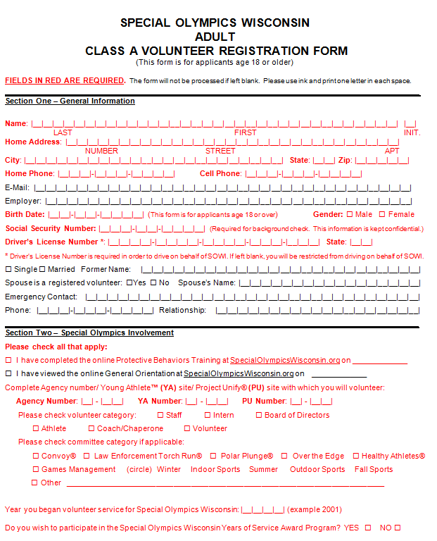
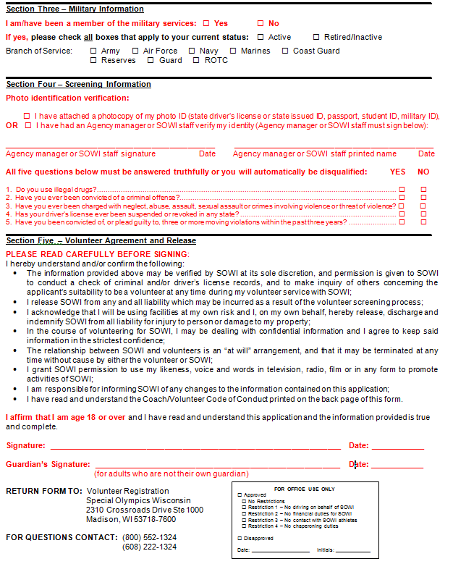

Class A Minor Volunteer Registration Form Sample

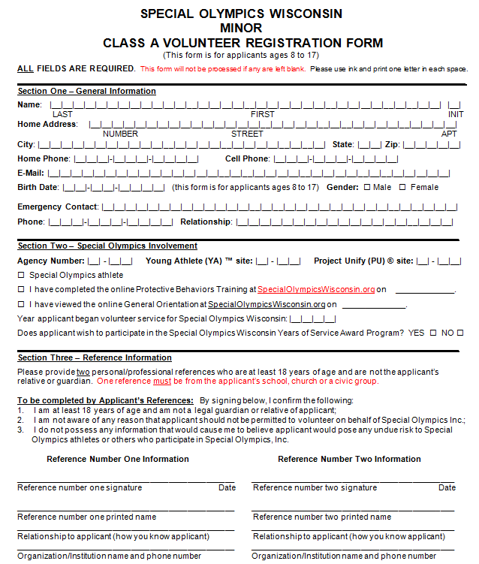

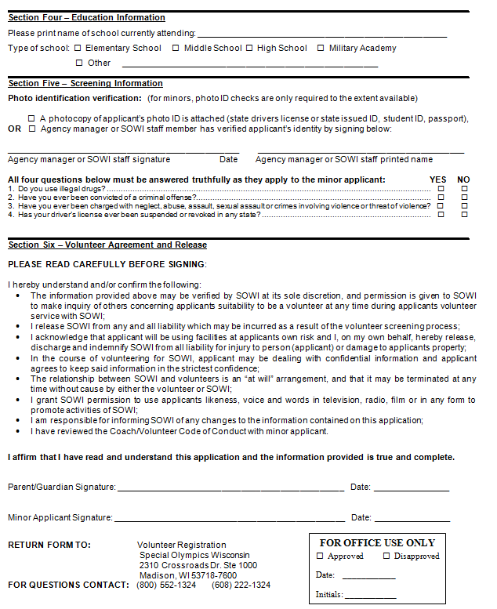

Class B Volunteer Registration Overview

Class B Volunteer Registration Overview
Class B volunteers will be managed at the level in the organization with which they participate. Examples include:
- Volunteers who have only limited contact with athletes
- Volunteers who have contact with athletes accompanied by registered Class A volunteers
Class B volunteers, adults and minors include, but are not limited to, the following roles with SOWI:
- Day of Event volunteers
- Healthy Athletes® volunteers
- Volunteers who drive on behalf of SOWI, but do not transport athletes

Class B Volunteer Eligibility
- Class B Adult Volunteers Eligibility
  - Individuals must be age 18 or over
  - Individuals have provided the registration information required by the Class B adult volunteer registration policy
- Class B Minor Volunteers Eligibility
  - Individuals age 8-17 years of age are eligible to volunteer for SOWI for certain positions
  - Individuals have provided the registration information required by the Class B minor volunteer registration policy
  - The age eligibility requirements listed below indicate the least restrictive mandated by SOWI. Individual Agencies or SOWI sponsored events can adjust the requirements to be more restrictive to reflect the needs of the Agency or event.
    - Ages 14-17
      - No parent or guardian need accompany the minor, but supervision by adult Class A volunteers or staff must be present
    - Ages 8 - 13
      - Youth groups must be accompanied by adult supervision with a minimum of one adult chaperone for every four volunteers.
      - Individual minor must be accompanied by a parent or guardian who will be closely supervising the minor at the event.
    - No one under age 8 is eligible to be a Class B volunteer

Volunteer Rosters

SOWI distributes a Class A Volunteer Roster in the yearly accreditation mailing, which is a listing of registered Class A volunteers, to the Agencies and staff for volunteer management and updating. Rosters are also available on the Agency log in page of the SOWI website or by requesting a copy from the Volunteer Records Manager.

Please review rosters regularly and identify volunteers that have not participated with your Agency in the last 12-18 months and who are not likely to return as volunteers. Then, notify your Regional office and the Volunteer Records Manager of any changes to the roster as SOWI will mark them as inactive in our volunteer database and they will no longer appear on your roster. If these volunteers should return to your Agency they can be re-activated (after making sure they are up-to-date with screening requirements) so they appear on your roster again. By identifying inactive volunteers SOWI saves postage costs and money by reducing the number of volunteers that need to be screened.

Class A Volunteer Roster Updating Guidelines
In the yearly accreditation mailing, you will be provided with two copies of your Agency’s Volunteer Roster. Use the following guidelines and please mark updates directly on roster in the appropriate columns. Pay particular attention to the items printed in red as they either state volunteer restrictions or actions needed. Once updates are completed, please return one copy to the Volunteer Records Manager at Headquarters. You also may provide feedback at any time to the Volunteer Records Manager or by reviewing the roster on the Agency log in page (through the online Volunteer Database search under the Volunteer Lookup Tab) of the SOWI website. Thank you for your time and effort in helping us keep our records accurate and for all you do for Special Olympics Wisconsin.

Athlete Volunteer Roster
Athlete Leadership Programs (ALPs) train athletes to serve in meaningful leadership roles in addition to that of competitor. As a result, SOWI now has dozens of athletes who also serve as volunteers for our program. However, there are differences in how SOWI processes their information and manages their service compared to other volunteers.
- Athletes are registered in the SOWI Games Management System (GMS) and all volunteers are registered in the Blackbaud database system.
- Of all the ALPs athlete volunteers, only athlete coaches and athletes who serve on Regional and State committees will be screened because of their direct contact with athletes and because they are in a position of authority and trust of other athletes. Athlete coaches cannot serve as chaperones at State competitions.
- Athlete volunteers cannot drive on behalf of SOWI.

At this time, athletes who are also Class A volunteers are not eligible for years of service (YOS) award. Typically, athletes are already receiving recognition from SOWI through their sports involvement and specific athlete service awards. In addition, there are many athletes who also volunteer their service for SOWI and aren’t officially registered as Class A volunteers. We maintain this YOS policy to be fair to all athletes and to ensure we continue to recognize our non-athlete volunteers. The athletes are the heart of our organization and the volunteers make it beat.

Volunteer Roster Fields
- NAME and CONTACT INFORMATION
  - Volunteer Name
  - Registration ID¹ – Volunteer Registration ID generated by the Volunteer database
  - Mailing Address, Phone Numbers and Email Addresses
- VOLUNTEER TYPE and RELATIONSHIP to SOWI
  - Volunteer Type – Adult Class A Volunteer (18 years or over) or Minor Class A Volunteers (8 – 17 years)
  - Screen Date – Date SOWI conducted the background screening with re-screening occurring three years from this date. Protective Behavior due dates are shown in red.
  - SOWI Relationships – Additional roles; such as, Agency manager, Coach Certified, Athlete, Unified Partner®, etc. (Please note that deleting a Unified Partner will affect their athlete status)
- BACKGROUND Screening and course Certification
  - Restriction(s)² – Any restrictions will be shown in red. To remove a restriction, the volunteer must submit a request in writing to the Headquarters office.
    - No Restrictions – Volunteer has no restrictions
    - Restriction 1 – No transporting athletes or volunteers on behalf of SOWI
    - Restriction 2 – No financial duties on behalf of SOWI
    - Restriction 3 – No contact with SOWI athletes
    - Restriction 4 – No chaperoning
  - Course Certifications: General Orientation, Code of Conduct if viewed, Certified Training Schools - Lists current certified training schools. Do not mark updates for missing sports certifications. For this, contact the Director of Training and Competition at the SOWI Headquarters office.
  - Date Expires/Status – Date the certification expires is December 31st of the third calendar year from the date the specific training was attended. Date listed is expiration date. Expired certification dates are shown in red.
  - Non-Certified Coach – Please check box if volunteer is coaching as a non-certified coach.
- SERVICE and AWARDS
  - Years of Service Date – The year volunteer service began for SOWI. This date is provided by the volunteer or Agency manager and will be used to determine Years of Service awards. Please enter exact date or year (for example “1999”) not the number of years.
  - Declines YOS Award – Designate if volunteer does not want to participate in Years of Service awards program.
- INACTIVE VOLUNTEERS
  - Remove from Roster – Check the Remove from Roster box if the volunteer is no longer active with your Agency
- MILITARY SERVICE INFORMATION
  - Member of the Military – Yes or No
  - Military Status – Active or Retired/Inactive
  - Branch of Service – List Branch of Service: Army, Air Force, Navy, Marines, Coast Guard, Reserves, Guard, ROTC

¹ Updates can not be made to this field
² Requested updates to this field must be approved by SOWI

Coach/Volunteer Code of Conduct Philosophy and Procedures

Special Olympics was created and developed by the Joseph P. Kennedy, Jr. Foundation to give individuals with intellectual disabilities wide-ranging opportunities for sports training and athletic competition. As in any sports program, participants need and deserve quality training, fair competition and adequate preparation and supervision.
The growth and increased recognition, awareness and support of Special Olympics deems it necessary for SOWI to protect the quality and integrity of the program. The Code of Conduct is an established standard guiding the behavior of all SOWI coaches/volunteers.
A coach’s/volunteer’s verbal and physical behavior should reflect a positive and constructive attitude toward Special Olympics competition and toward those volunteers, coaches, officials and event coordinators whose time and efforts provide that competitive opportunity. This attitude reflects the confidence that decisions of the Games/Competition Committee and sports officials are made with the best interests of a fair competitive experience in mind and are in keeping with the goals/philosophies of Special Olympics.
Special Olympics coaches’ behavior serves as a positive example for their athletes and indicates a concern that the fairest and most positive competitive experience is equally available for every Special Olympics athlete in the competition. A coach accepts responsibility for the behavior of his/her athletes, family members and spectators both in and out of the competitive arena while attending a Special Olympics event. The coach is recognized as the sole representative in dealing with the sports officials.

Special Olympics Wisconsin Coach and Volunteer Code of Conduct
SOWI prides itself in sponsoring high quality sports training and competitions for people with intellectual disabilities. The primary purpose of this Code of Conduct is to establish a high standard of coach/volunteer behavior that will ensure the safety and well-being of all athletes involved in training and competition. All coaches/volunteers are expected to abide by the code of conduct and standards of behavior as established by SOWI. Coaches and volunteers should be reminded that volunteering for SOWI is a privilege, not a right, and that the Agency manager has the authority to make immediate accommodations until final decisions can be made.
By agreeing to abide by the SOWI Code of Conduct, each coach/volunteer agrees to adhere to the following coach/volunteer behavior:
- Uphold the philosophy, principles and policies of Special Olympics, Inc. and SOWI.
- Behave in a manner consistent with SOWI’s core values of mutual respect, positive attitude, accountability, teamwork and dedication.

The following coach/volunteer behavior is unacceptable:

- Profanity or verbal abuse
- Tobacco use in restricted areas
- Use of alcohol
- Frequent unexcused absences
- Exhibition of poor sportsmanship
- Not following the rules of a sport
- Not providing adequate athlete supervision
- Submission of false or inaccurate competition qualification information
- Violent or disruptive behavior
- Physical or verbal sexual overtures
- Any unwelcome physical contact
- Use of illegal drugs or any controlled substance*
- Possession of harmful weapons*
- Physical abuse*
- Felony or misdemeanors (or any other illegal or socially unacceptable behavior) which disrupts or impedes the participation of athletes or others*
- Public forum posts that degrade the organization
- Not following the philosophy, principles and policies of Special Olympics, Inc. and SOWI

*These offenses will result in immediate suspension from any and all Special Olympics activities.

Coach/Volunteer Code of Conduct Disciplinary Steps
Should the behavior and/or attitude of any coach or volunteer be contrary to the Coach/Volunteer Code of Conduct, then the following disciplinary steps may be taken by the Agency manager or a staff member from the Regional office or the Headquarters office:
- Verbal warning given to the coach/volunteer with a request to remedy the situation for continued participation
- Written warning given to the coach/volunteer with a copy to the Regional office and if a minor, the parent/guardian or caseworker
- Personal meeting with the coach/volunteer to review unacceptable behavior and to work out a plan for improvement
    - If the coach/volunteer is under 18, or over 18 and not their own guardian, he/she will be accompanied by his/her parent/guardian or caseworker. If the coach/volunteer is over 18 and is his/her own guardian, he/she may choose to have another adult present. The meeting will be documented in writing and copies distributed to: the coach/volunteer, Regional office, the Headquarters office, Agency file, parent/guardian or caseworker.
- Suspension from volunteer service including, but not limited to, practices or competition
- The Regional office must be contacted before an Agency manager suspends a coach/volunteer. The Regional office will discuss the circumstances and approve the action. The action will be documented in writing and presented to the coach/volunteer parent/guardian (or caseworker) and a copy will be sent to the Headquarters office.
Any further action must be referred to the Regional office. The Regional office, Director of Field Services and Chief Operating Officer will approve any further action to be taken. Further action could be, but is not limited to:
- Suspension for more than one sport season
- Expulsion for one year or more
- Permanent expulsion
Volunteer Code of Conduct Disciplinary Appeals Process
A volunteer has the right to appeal a disciplinary action imposed on him/her with the Regional office, Director of Field Services, or Chief Operating Officer. The volunteer or their representative must submit a written request for a meeting to appeal the decision within 30 days of being notified of the disciplinary action. Based on the written appeal request, SOWI will make the decision on whether an appeal meeting is necessary. The relationship between SOWI and volunteers is an “at will” arrangement and it may be terminated at any time without cause by either the volunteer or SOWI.
If deemed necessary, the appeal will be heard by a Code of Conduct appeals committee. A decision to reverse, amend or affirm a disciplinary action will be submitted in writing to the individual and Agency manager and may include a plan of action for the coach/volunteer to correct the unacceptable behavior that led to the disciplinary action. The decision of the appeal committee is final and may not be appealed further.

Volunteer Grievance Procedure
Specific complaints against a coach or volunteer are to be filed with SOWI at the level of organization in which the Code of Conduct violation(s) occurred. Code of Conduct violations occurring at the local Agency or Regional/District event are to be filed with the Regional office. Code of Conduct violations occurring at a Sectional, State or National event are to be filed with the Vice President of Program Services. All complaints are to be in writing citing specific behaviors inconsistent with the philosophy of Special Olympics. Name and contact information of the person making the complaint is also required.

Within two weeks of receiving a written complaint on a coach or volunteer, SOWI will implement the following process of review:
- Contact complainant and other persons involved to further discuss the nature of the complaint and confirm all information
- Contact the Regional office and send them a copy of the complaint
- The Regional office will contact the Agency manager, explain the nature of the complaint and ask the Agency manager to confirm or deny knowledge of the allegation.
- If the Agency manager confirms the complaint, they will be asked to address the issue with the coach/volunteer and take disciplinary action if required. Severity of the disciplinary action will be determined by SOWI.
- If the Agency manager cannot confirm the complaint, SOWI will convene a coach/volunteer review team consisting of the Regional office, Agency manager, Director of Field Services, and the Chief Operating Officer. The review team will interview the coach/volunteer named in the complaint. If the nature of the complaint is confirmed, the review team shall determine the severity of disciplinary action. If the nature of the complaint is not readily confirmable, then the review team shall interview the complainant and determine if any action is justified or needed in settling the issue of the complaint.
- The decision of the review team is final and cannot be appealed.
Coach Code of Conduct Disciplinary Appeals Process
- A Conduct Review Request must be submitted to the Tournament Director at Tournament Central within a half hour of the event where the conduct is in question.
- The form must be completed by a person who witnesses a violation of the Code of Conduct and is participating in the tournament (i.e. coach, Official, Games Management member, Sports Resource Team, Regional Director of Athletics, etc.)
- The form will be evaluated by a Review Board within one week of submission.
- The Director of Training & Competition will follow up with the necessary parties, including the person submitting the form.

Volunteer Recognition

Years of Service Awards
The Years of Service (YOS) Award Program recognizes those volunteers who regularly dedicate their time to SOWI. To participate in the YOS program, volunteers must be registered as a Class A volunteer and SOWI must have the year they started their volunteer service entered in our volunteer database. The Class A volunteer form allows volunteers to indicate whether or not they would like to decline participation in the YOS program. Existing volunteers may request to decline participation in the YOS program by either notifying their Agency manager or by contacting the Headquarters office.

Volunteers receive awards for every five years of service. Following is the breakdown of years and their corresponding awards:
- 5 Year Award - Bronze 5 Year Service Pin
- 10 Year Award - Silver 10 Year Service Pin & Certificate
- 15 Year Award - Gold 15 Year Service Pin & Certificate
- 20 Year Award - Gold 20 Year Service Pin & Plaque
- 25 Year Award - Gold 25 Year Service Pin & Plaque
- 30 Year Award - Gold 30 Year Service Pin & Plaque
- 35 Year Award - Gold 35 Year Service Pin & Plaque
- 40 Year Award - Gold 40 Year Service Pin & Plaque
Years of Service (YOS) awards will continue to be delivered to the Agencies in the fall.

Policy Regarding Volunteers and Staff Dating Athletes

Introduction
Among the Special Olympics movement’s highest priorities is the well-being of, and respect for the dignity of, Special Olympics athletes*. The purpose of this document is to make clear Special Olympics, Inc.’s policy on volunteers* and staff dating Special Olympics athletes and to protect all participants in the Special Olympics movement, including athletes, coaches and staff, as well as Special Olympics organizations around the world.
Every Special Olympics, Inc. Program must take all reasonable steps to ensure that athletes* participating in Special Olympics do so in an environment that is free from abuse, intimidation, fear, pressure or coercion from any person in a position of authority, including Special Olympics staff, coaches and other volunteers. At the same time, Special Olympics respects the right of every Special Olympics athlete to be treated with dignity and to have the same rights as every other human being.
Policy
Special Olympics prohibits any Special Olympics staff member or volunteer (excluding spouses of athletes and athletes who are Class B volunteers) from dating or having a sexual relationship with any Special Olympics athlete. In the event that a Special Olympics organization learns of any dating or sexual relationship, the organization immediately shall require either: i) that the staff member or volunteer end his or her association with Special Olympics; or ii) that the association between the staff member or volunteer and Special Olympics will be terminated.
In the case of a Special Olympics athlete who is also a staff member or volunteer, the Chief Executive Officer of the organization where the athlete competes must evaluate the circumstances on a case-by-case basis and determine if an authority relationship exists between the staff/volunteer athlete and the competing athlete. If it is determined that there is such a relationship, then apply the above policy in the same manner as the policy is applied to non-athlete staff or volunteers.
Each Special Olympics Headquarters Program should determine whether it is required by its national or local laws to report certain relationships between Special Olympics staff or volunteers and Special Olympics athletes to the appropriate authorities under any “mandatory reporting” or other requirements in place for that Program’s jurisdiction, and comply with those requirements.
Special Olympics respects the right of athletes to have the full range of human relationships available to other human beings. This policy shall not be interpreted as a limitation on the rights of athletes, but only as a restriction on Special Olympics staff and volunteers.
Implementation
All Special Olympics organizations (e.g. Special Olympics, Inc., Headquarters Programs, and GOCs) shall implement the policy.
*The terms “Special Olympics athlete” and “athlete” refer to persons with intellectual disabilities. The term “volunteer” includes Unified Partners.
Frequently Asked Questions
- Why does Special Olympics need an athlete dating policy?
Many, if not most, U.S. Special Olympics Programs prohibit dating between athletes and volunteers or staff. In 2002, Special Olympics and a U.S. Program were sued by an athlete’s family alleging, among other things, that the Program had been negligent in allowing an athlete and a coach to date. During the course of discovery, it became clear that, while most U.S. Programs did not allow volunteers or staff to date athletes, there was a need to formalize that practice as a uniform policy for all U.S. Programs.

- Who reviewed the athlete dating policy before it was finalized?
Special Olympics, Inc.’s senior executive management team, all athletes with e-mail addresses who attended an Athlete Congress or Global Messenger Training in April 2003, all Regional Managing Directors, Special Olympics, Inc. Board members who are intellectual disabilities experts, and the Executive Directors of AAMR and The ARC.

- Do any other organizations have similar policies limiting dating by people with intellectual disabilities or others?
Yes, policies like ours are common. The ARC and AAMR each have a policy statement that provides individuals with intellectual disabilities the right to “Protection from sexual harassment as well as from physical, sexual, and emotional abuse and sexual relationships with paid staff.” Many organizations, such as youth sports organizations, high schools, colleges, and universities, prohibit relationships between persons in positions of authority (e.g. teachers, professors and coaches) and participants such as young athletes or students. Since Special Olympics is a volunteer-driven movement, our policy covers volunteers as well as staff.

- If an athlete is dating a volunteer or staff person who does not have an intellectual disability, does the athlete have to stop participating in Special Olympics?
No. The policy requires that the volunteer or staff person dating the athlete must either stop dating the athlete or end his or her association with Special Olympics. The athlete remains in good standing with Special Olympics.

- Can an athlete who is also a volunteer or staff person date an athlete who is not a volunteer or staff person?
Yes, under certain circumstances. Although Special Olympics normally treats an athlete acting in a non-athlete capacity the same as it would treat any other person acting in that capacity, the policy on dating makes an exception. If an athlete acting in a non-athlete capacity wants to date a participating athlete, the Program’s CEO (or comparable position) must evaluate the relationship and determine whether an authority relationship exists between the athlete in the volunteer/staff position and the other athlete. If there is no authority relationship, the volunteer/staff athlete may date the other athlete.

- What if the CEO determines that there is an authority relationship between the athlete in a volunteer or staff person position and the Special Olympics athlete?
The volunteer/staff athlete would have to stop dating the other athlete or cease serving as a volunteer or staff member in an authority relationship, either by a change in function or by ceasing to be a volunteer or staff member.

- Can an athlete who is a “day-of” volunteer (also called Class B volunteer) date a participating athlete?
Yes, an athlete who is a day-of volunteer may date a Special Olympics athlete. The policy does not apply to athletes who are Class B volunteers because it is thought that no authority relationship exists between a person who only volunteers for the day-of an event and a participating athlete.

- Can an athlete who is a staff person or is a volunteer married to another athlete continue to volunteer or work for Special Olympics?
Yes. The policy makes an exception for athletes who are married.

- Can a Unified Partner date an athlete?
No. Under the policy a Unified Partner is treated the same as any other volunteer or staff person who is not a person with an intellectual disability.

Left Blank Intentionally

