BASKETBALL SKILLS

2015 GENERAL RULES

The Official Special Olympics Sports Rules shall govern all Special Olympics basketball skills competitions. As an international sports program, Special Olympics has developed these rules based upon Special Olympics, Inc. for basketball skills. Special Olympics, Inc. rules for basketball skills shall be employed. For more information, visit www.specialolympics.org.

OFFICIAL EVENTS OFFERED:
- Individual Skills Contest Level 1 - consists of the Target Pass, 10m Dribble and the Spot Shot. This event is for beginning athletes.
- Individual Skills Contest Level 2 – consists of 12m Dribble, Perimeter Shooting, and Catch and Pass.

SECTION A – GENERAL RULES

- INDIVIDUAL SKILLS LEVEL 1

  - Event #1: Target Pass

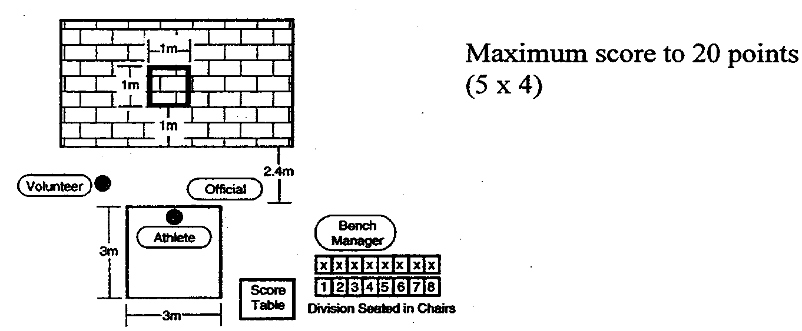

    - Purpose: To measure an athlete's skill in passing a basketball.
    - Equipment: Two basketballs, flat wall, measuring tape and chalk or floor tape. For women and junior divisions (age 15 and under), an NCAA regulation women’s basketball may be used but it must be indicated on the official entry form.. Wheelchair Athletes may choose to use a women’s or men’s size of basketball as well the hoop height of 8 feet or 10 feet; the ball size and hoop height must stay the same for qualifying scores and competition play (must be indicated on official entry form). All other competitors must use an NCAA regulation men’s basketball.

3) Description: A 1m (3' 3 1/2") square is marked on a wall using chalk or tape. The bottom line of the square shall be 1m (3' 3 1/2") from the floor. A 3m (9' 9") square will be marked on the floor and 2.4m (7'10 1/2") from the wall. The athlete must stand within the square. The back axle of an athlete's wheelchair may not pass over the line. The athlete is given five passes.

4) Scoring: The athlete receives three points for hitting the wall inside the square. The athlete receives two points for hitting the lines of the square. The athlete receives one point for hitting the wall but not in or on any part of the square. The athlete receives one point for catching the ball in the air or after one or more bounces. The athlete receives zero points if the ball bounces before hitting the wall. The athlete's score will be the sum of the points from all five passes.

  - Event #2: 10m Dribble

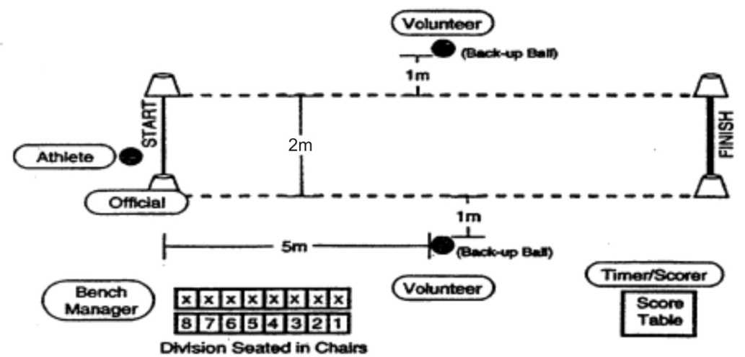

CONVERSION CHART
SECONDS | POINTS | SECONDS | POINTS
0 – 2 | 30 | 9.1 – 10 | 14
2.1 – 3 | 28 | 10.1 – 12 | 12
3.1 – 4 | 26 | 12.1 – 14 | 10
4.1 – 5 | 24 | 14.1 – 16 | 8
5.1 – 6 | 22 | 16.1 – 18 | 6
6.1 – 7 | 20 | 18.1 – 20 | 4
7.1 – 8 | 18 | 20.1 – 22 | 2
8.1 – 9 | 16 | 22.1 & Over | 1

- Purpose: To measure an athlete's speed and skill in dribbling a basketball.
- Equipment: Three basketballs, four traffic cones, chalk or floor tape, measuring tape and stopwatch. For women and junior divisions (age 15 and under), an NCAA regulation woman’s basketball may be used (must be indicated on official entry form). Wheelchair Athletes may choose to use a women’s or men’s size basketball; the ball size must stay the same for qualifying scores and competition play (must be indicated on official entry form).

- Description: The athlete begins from behind the start line and between the cones with the ball in hand. The athlete starts dribbling and moving when the official signals. The athlete may alternate hands, but must dribble the ball with one hand at a time for the entire 10m (32' 9 3/4"). A wheelchair athlete must alternate taking two pushes followed by two dribbles for legal dribbling. An individual in a motorized chair must attempt to maintain a dribbling action of two dribbles per two meters of distance traveled. At the start, the leading wheel axle of an athlete’s wheelchair may not pass over the line. The athlete must cross the finish line between the cones and must hold the basketball to stop the dribble. If an athlete loses control of the ball, the clock continues to run. The athlete can recover the ball. If the ball goes outside the 2m lane, the athlete can either pick up the nearest back-up basketball or recover the ball to continue the event. A volunteer may hand the ball to an athlete.

4) Scoring: The athlete will be timed from the signal "go" to when he/she crosses the finish line between the cones and holds the basketball to stop the dribble. A one-second penalty will be added every time the athlete illegally dribbles (i.e., two-hand dribbles, carries the ball, etc.). The athlete will receive two trials. Each trial is scored by adding penalty points to the time elapsed and converting the total to points based on the conversion chart. Athletes will receive zero points if they are unable to complete either of the trials successfully. The athlete's score for the event is his/her best of the two trials converted into points. (In case of a tie, the actual time will be used to differentiate place.)

c. Event #3: Spot Shot
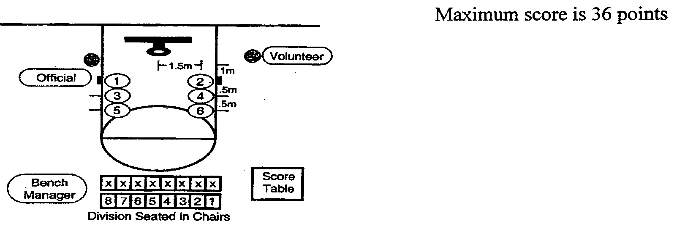
1) Purpose: To measure an athlete's skill in shooting a basketball.
2) Equipment: Two basketballs, chalk or floor tape, measuring tape and a 3.05m [10 foot] regulation goal with backboard. For junior division competitions age 15 and under, a 2.44m (eight feet) goal may be used if indicated on the official entry form. For women and junior divisions (age 15 and under) an NCAA regulation women’s basketball may be used, but must be indicated on official entry form. Wheelchair Athletes may choose to use a women’s or men’s size of basketball as well the hoop height of 8 feet or 10 feet; the ball size and hoop height must stay the same for qualifying scores and competition play (must be indicated on official entry form).

3) Description: Six spots are marked on the floor. Start each measurement from a spot on the floor under the front of the rim. The spots are marked as follows:

#1 and #2 = 1.5m (4' 11") to the left & right plus 1m (3' 3 1/2") out
#3 and #4 = 1.5m (4' 11") to the left & right plus 1.5m (4' 11") out
#5 and #6 = 1.5m (4' 11") to the left & right plus 2m (6' 6 3/4") out
The athlete attempts two field goals from each of six spots. The attempts are taken at spots #2, #4 and #6 and then at spots #1, #3 and #5.

A wheelchair placement shall be determined by the front axel.

4) Scoring: For every field goal made at spots #1 and #2, two points are awarded. For every field goal made at spots #3 and #4, three points are awarded. For every field goal made at spots #5 and #6, four points are awarded. For any field goal attempt that does not pass through the basket but does hit either the backboard and/or the rim, one point is awarded. The athlete's score will be the sum of the points from all 12 shots.

- FINAL SCORING: THE ATHLETE'S FINAL SCORE FOR THE INDIVIDUAL SKILLS LEVEL 1 IS DETERMINED BY ADDING TOGETHER THE SCORES ACHIEVED IN EACH OF THE THREE EVENTS. USE THIS SCORE FOR THE QUALIFYING SCORE ON DISTRICT REGISTRATIONS.

- INDIVIDUAL SKILLS LEVEL 2 (Higher-Skilled Athletes): A regulation men’s sized basketball and 10-foot hoop will be used for all three Level 2 events.

a. Event #1: 12m Dribble
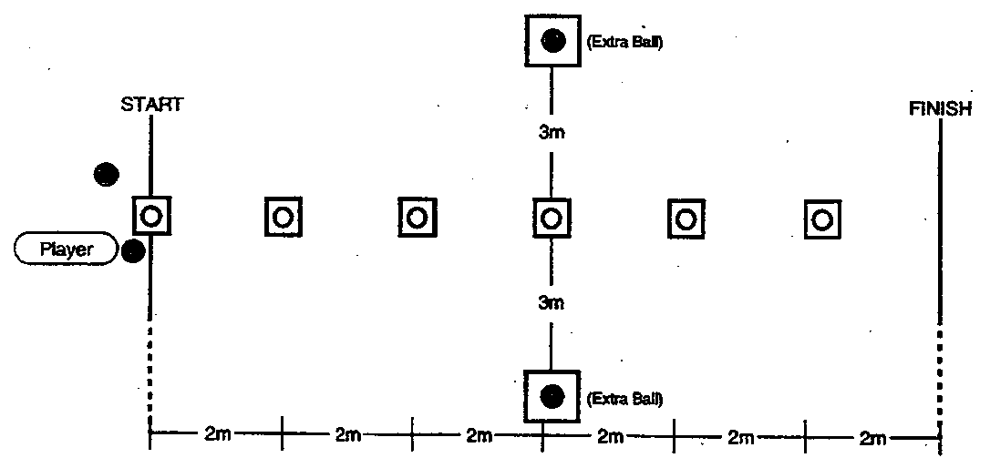
1) Set-Up: An area of the basketball court (preferably along a side line or down the center line), six cones, floor tape, and four basketballs (one that the athlete is provided initially, two others that are for back-up in case the basketball bounces away, and one more to continue the test).

2) Contest: (Time: 60 seconds for one trial.) A player is instructed to dribble the ball while passing alternately to the right and to the left of six obstacles placed in a line, 2m (6' 6 3/4") apart, on a 12m course. The player can start to the right or to the left of the first obstacle but must pass each obstacle alternately, thereafter. When the last obstacle is passed and the FINISH line reached, the player puts the ball down, sprints back to the START for the next ball, and repeats the slalom. The player continues until 60 seconds have elapsed. If a player loses control of the ball, the clock continues to run. The player recovers the ball or picks up the nearest back-up ball and may re-enter at any point along the course.

3) Scoring: One point is awarded each time a cone is passed. For example, if the player successfully dribbles the ball from the starting line, weaves in and out through the entire obstacle course one time, and places the ball down at the finish line, a score of five has been achieved. The player must use legal dribbles and must have control of the ball in order to get credit for that cone successfully passed. The player must put the ball down and bring it to a controlled stop upon reaching the finish line. Failure to do so will result in the loss of a point. The player's score is how many cones he/she successfully passes in 60 seconds.

4) Staging: Volunteers administer the test and are not to interfere with any player who is performing the test. Volunteer A will give a basketball to the player who will take the test, ask him/her if ready, will then say, "Ready, Go," and will count how many cones the player passes in 60 seconds. Volunteers B and C who are standing behind the extra balls will retrieve and replace the basketball whenever it goes out of play. Volunteer D will time and record the athlete's score. Each volunteer is to administer the test and manage their area only.

b. Event #2: Perimeter Shooting
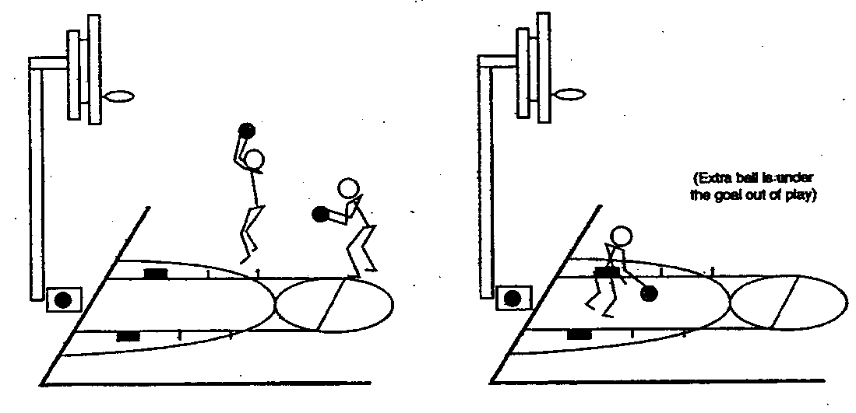
1) Set-Up: A goal, the official NGB free throw lane, floor tape, and two basketballs (one that the athlete is provided initially, another that is for back-up in case the basketball rebounds away).

2) Contest: (Time: one trial of one minute.) A player stands at the juncture of the free throw line and lane, either to the left or right. The player dribbles toward the goal and attempts a field goal of his/her choice outside the 2.75m (9') arc. This attempt must be taken anywhere outside the 2.75m arc marked off by a dotted line. (This arc intersects with the bottom of the free throw restraining circle and is measured by standing centered directly below the backboard.) The player then rebounds the basketball (made or missed shot) and dribbles anywhere outside the arc before attempting another field goal. (A player must return to the spot of a rebounded shot and dribble outside of the arc if he/she did not dribble out originally.) The player shall make as many field goals as described above in a single, one minute trial.

3) Scoring: Two points are awarded for each field goal made within the one minute trial.

- Staging: Volunteers administer the test and are not to interfere with any player who is performing the test. Volunteer A will give a basketball to the player who will take the test, ask him/her if ready, and then say, "Ready, Go," and will count how many field goals the player makes in one minute. Volunteer B who is standing behind the extra ball will retrieve and replace the basketball whenever it goes out of play. Volunteer C will time and record the athlete's score. Each volunteer is to administer the test and manage their area only.

- Event #3: Catch and Pass

•Ball Feeder (usually Team Coach)
Cone C

O Spare Ball sitting on tee

Scorer • •Ball collector
3m 3m

Place 600mm strip of Tape
across sideline 3m apart
X
• Athlete stands here to start exercise holding the ball
Cone A Court Sideline 3m apart Cone B

- Purpose: To measure an athlete’s skill in receiving a pass and then properly making a return pass.
- Equipment:
- 3 Cones, 1 Tee, 2 Basketballs, Floor Tape, Airhorn/whistle, Scorebench and Clock
- Two strips of tape 600mm long are laid across the court sideline 3 meters apart at Cones A & B. Cone C is laid out 3 meters from each end of the sideline forming a triangle.
- A small cross made of tape is laid in the middle of Cones A and B where the athlete stands holding the basketball ready to begin the exercise.
- The ball feeder stands behind Cone C. This person is usually the team’s coach as he/she knows the players reaction time and abilities.
- A spare ball is placed on a tee near Cone C.
- Description:
- On go, the athlete passes the ball to the feeder and moves quickly to either cone A or B.
- As the athlete approaches or reaches the end line the feeder passes the ball to the athlete to catch.
- The athlete MUST have at least ONE foot over the end line at the point of catching the ball.
- The athlete must catch the ball, then pass it back to the feeder from behind the end line. One or both feet can be grounded but both should be behind the line at the moment of passing the ball back to the feeder.
- When the athlete has passed the ball, he/she moves quickly to the opposite cone to receive the next pass
- The athlete continues passing, moving along the line and catching the ball for 60 seconds
- A bounce pass maybe used with lower ability/less able athletes
- Timing: 60 seconds for one trial.
- Scoring:
- 1 point is scored for each good pass made to the feeder (the pass must be catchable)
- 1 point is scored for each good catch made by the athlete (i.e. no fumbles)
- The athletes must have the ball under control or no point can be scored

- FINAL SCORING: THE ATHLETE'S FINAL SCORE FOR THE INDIVIDUAL SKILLS LEVEL 2 IS DETERMINED BY ADDING TOGETHER THE SCORES ACHIEVED IN EACH OF THE THREE EVENTS. USE THIS SCORE FOR THE QUALIFYING SCORE ON DISTRICT REGISTRATIONS.

3. ATHLETE ATTIRE
In all events competitors must wear their Agency uniform or sports clothing. Athletes must wear flat rubber sole athletic shoes during competition (no clogs or slip-on shoes). Objectionable items include but are not limited to: denim jeans, khaki pants, skirt, dress or any clothing not intended to be worn for sports competition. The only exceptions allowed will be for an athlete’s religious reasons which must be submitted on a Special Needs Form with the athlete’s registration materials by the tournament registration deadline. Failure to comply with the uniform rules will cause the athlete to forfeit competition.

SPECIAL OLYMPICS WISCONSIN Basket: 10 foot 8 foot

SCORECARD (8-15 age group) Ball: Men’s Women’s
SPOT SHOT |  |  |  |  |  |  |  |  |  |  |  |  |  |  |  |  |  | SUM OF 1 – 6
1 Point |  |  |  |  | No basket but ball hits backboard and/or rim
2 Points |  |  |  |  | For spots 1 & 2
3 Points |  |  |  |  | For spots 3 & 4
4 Points |  |  |  |  | For spots 5 & 6

SIX TRIALS – TWO SHOTS PER SPOT
SPOT 2 |  |  | SPOT 4 |  |  |  | SPOT 6 |  |  | SPOT 1 |  |  | SPOT 3 |  | SPOT 5

TARGET PASS |  |  |  |  |  |  |  |  |  |  |  |  | SUM OF 1 -- 5
 |  |  |  | 3 Points |  |  | Hits wall inside square
 |  |  |  | 2 Points |  |  | Hits lines of the square
 |  |  |  | 1 Point |  |  | Hits wall (not in or on square)
 |  |  |  | 0 Points |  |  | Ball bounces before hitting wall
 |  |  |  | *Extra 1 Point |  |  | Controlled catch of rebounding ball

FIVE TRIALS –Four Points Maximum Per Trial
1 |  | 2 |  |  | 3 |  |  | 4 |  | 5
CONVERSION TABLE
TEN – METER DRIBBLE | TWO TRIALS |  |  | BETTER OF 1 & 2
Minimum: 1 Point  One second penalty for each illegal dribble  See Time Conversion Table | 1 | 2
TEN – METER DRIBBLE
SECONDS | 0 – 2 | 2.1 – 3 | 3.1 – 4 | 4.1 – 5 | 5.1 – 6 | 6.1 – 7 | 7.1 – 8 | 8.1 – 9
POINTS | 30 | 28 | 26 | 24 | 22 | 20 | 18 | 16
SECONDS | 9.1 – 10 | 10.1 – 12 | 12.1 – 14 | 14.1 – 16 | 16.1 – 18 | 18.1 – 20 | 20.1 – 22 | 22.1+
POINTS | 14 | 12 | 10 | 8 | 6 | 4 | 2 | 1

TOTAL POINTS
(Sum of 1 – 5 of all three events)

SPECIAL OLYMPICS WISCONSIN

SCORECARD (16+ age group)

TARGET PASS |  |  |  |  |  |  |  |  |  |  |  |  | SUM OF 1 -- 5
  SPOT SHOT |  |  |  |  |  |  |  |  |  |  |  |  |  |  |  |  |  | SUM OF 1 – 6
  1 Point |  |  |  |  | No basket but ball hits backboard and/or rim
  2 Points |  |  |  |  | For spots 1 & 2
  3 Points |  |  |  |  | For spots 3 & 4
  4 Points |  |  |  |  | For spots 5 & 6
  SIX TRIALS – TWO SHOTS PER SPOT
  SPOT 2 |  |  | SPOT 4 |  |  |  | SPOT 6 |  |  | SPOT 1 |  |  | SPOT 3 |  | SPOT 5
 |  |  |  | 3 Points |  |  | Hits wall inside square
 |  |  |  | 2 Points |  |  | Hits lines of the square
 |  |  |  | 1 Point |  |  | Hits wall (not in or on square)
 |  |  |  | 0 Points |  |  | Ball bounces before hitting wall
 |  |  |  | *Extra 1 Point |  |  | Controlled catch of rebounding ball

FIVE TRIALS –Four Points Maximum Per Trial
1 |  | 2 |  |  | 3 |  |  | 4 |  | 5

TEN – METER DRIBBLE | TWO TRIALS |  |  | BETTER OF 1 & 2
Minimum: 1 Point  One second penalty for each illegal dribble  See Time Conversion Table | 1 | 2

CONVERSION TABLE
TEN – METER DRIBBLE
SECONDS | 0 – 2 | 2.1 – 3 | 3.1 – 4 | 4.1 – 5 | 5.1 – 6 | 6.1 – 7 | 7.1 – 8 | 8.1 – 9
POINTS | 30 | 28 | 26 | 24 | 22 | 20 | 18 | 16
SECONDS | 9.1 – 10 | 10.1 – 12 | 12.1 – 14 | 14.1 – 16 | 16.1 – 18 | 18.1 – 20 | 20.1 – 22 | 22.1+
POINTS | 14 | 12 | 10 | 8 | 6 | 4 | 2 | 1

TOTAL POINTS
(Sum of 1 – 5 of all three events)

SPECIAL OLYMPICS WISCONSIN
SCORECARD: LEVEL 2

CATCH AND PASS | ONE TRIAL |  |  | POINTS
One point for each good pass  One point for each good catch | Passes | Catches

DRIBBLING | TRIAL |  | POINTS
1 point each time athlete reaches midpoint between two cones.  One-Minute Trial | 1

PERIMETER SHOOTING |  | TRIAL |  | POINTS
2 Points Per Basket | One Minute Trial | 1
After a made or missed shot, the athlete must dribble anywhere outside the arc before attempting another shot.

If the athlete does not dribble out before taking a shot, the basket does not count and the athlete must return to original rebound spot and dribble out before taking the next shot.

TOTAL POINTS
(Sum of all three events)

