ATHLETICS (TRACK & FIELD)

2015 GENERAL RULES

The Official Special Olympics Sports Rules shall govern all Special Olympics athletics competitions. As an international sports program, Special Olympics has created these rules based upon Internationale Amateur Athletic Federation (IAAF) and National Governing Body (NGB) rules for athletics. IAAF or National Governing Body rules shall be employed except when they are in conflict with the Official Special Olympics Sports Rules. For more information, visit www.iaaf.org.

DEVELOPMENTAL EVENTS
1. Assisted Run (regional level only, non-advancing)
2. 50m Run*
3. 25m Walk*
4. Standing Long Jump*
5. Softball Throw* (Athletes throwing over 15m should compete in the shot put or mini jav; athletes who have thrown more than 20m in a SOWI competition will be ineligible to participate in softball throw following that season.)

6. 25m Non-Motorized Wheelchair*
7. 30m Non-Motorized Wheelchair Slalom*
8. 30 and 50m Motor Wheelchair Slalom*
9. 25m Motor Wheelchair Obstacle Course*
10. 4x25m Non-Motorized Wheelchair Shuttle Relay*
*These events with an asterisk are considered developmental events and provide meaningful competition for athletes with lower ability levels and are not meant to be paired with other events (except field events) when entering athletes in competition.

OFFICIAL EVENTS OFFERED

1. 100, 200, 400, 800, 1500, 3000m Run
2. 100, 200, 400*, 800*, 1500m* Walk
3. High Jump – no longer offered as an event
4. Long Jump
5. Shot Put
6. Mini Jav (formerly known as Turbo Jav)
7. 4x100m Walking Relay
8. 4x100m Relay
9. 4x200 m Relay
10. 4x400m Relay
11. Pentathalon – no longer offered as an event
12. 100, 200m Non-Motorized Wheelchair
13. Wheelchair Shot Put

* NOTE: At the State competition, the long distance walking events are scheduled in the same time slot used for relays. For this reason, it is suggested that athletes competing in the long distance walking events refrain from participating on relay teams.

EVENT CATAGORIES
IMPORTANT: Athletes may participate in three events from only one category (see chart below). An athlete may participate in a maximum of three events (three individual, two individual and one relay, or one individual and two relays). Motorized wheelchair athletes may not enter non-motorized events (and vice versa). NOTE: Bicycles or tricycles (i.e. gear/pedal-powered vehicles) are not legal in wheelchair competition. Please refer to your Region’s schedule of athletics events when selecting athletes' events. Entering athletes in some combinations of events may not be practical due to scheduling conflicts.

CATEGORY | EVENTS SELECTION
Category A | 25m walk or 50m run; standing long jump or running long jump; softball throw or shot put and/or mini jav***
Category B | All wheelchair events; softball throw or wheelchair shotput and/or mini jav***  Wheelchair athletes are allowed to participate in the 25m assisted walk (non-advancing)
Category C | All walking events (except 25m walk); softball throw or shotput and/or mini jav***; standing long jump or running long jump; 4x100m walking relay*
Category D | All running events (except 50m run); running relays; running long jump or standing long jump; softball throw or shot put and/or mini jav***
*Walking Relays may only be registered for by athletes participating in Category C events (Walking). Running Relays may only be registered for by athletes participating in Category D events (Running).
***Athletes competing in the softball throw may not compete in mini jav or shot put; however, athletes may compete in both mini jav and the shot put.

SECTION A – GENERAL RULES AND MODIFICATIONS
- Athlete Attire
  - In all events, competitors must wear athletic clothing including an athletic shirt, shorts or sweatpants and athletic shoes. The clothing must be made of a material which is non-transparent even if wet. Objectionable items include, but are not limited to, denim jeans, slacks, skirts or dresses, or any clothing not intended to be worn for sports competition. The only exceptions allowed will be for religious reasons which must be submitted on a “Special Needs” form with the athlete’s registration materials by the tournament registration deadline. No hats or head coverings may be worn during competition. The only exceptions allowed will be for medical reasons which must be submitted on a Special Needs form and accompanied by a doctor’s note with the athlete’s registration materials by the tournament registration deadline.

  - All relay team members shall wear identical singlets or shirts.
  - Athletes may compete in shoes with spikes provided the host facility allows spikes. Check with the competition organizing committee on and the maximum length of spikes allowed.

  - No jewelry may be worn during competition.

- Assisted Events
  - Assisted Run - This transitional event is intended for use by those athletes who are not ready to participate fully in the competition experience, but need to gain experience in the competition environment itself. In the case of athletics or aquatics, examples of competition environment are: staging, the start gun or horn, spectator noise, volunteers, etc. Athletes registered in these transitional and non-advancing events are eligible to register and participate in one additional advancing event. Host Regions will determine how these transitional events will be implemented during existing tournaments. Contact your host Region for details.

- Running Events
a. False starts – a runner is allowed one false start in SOWI athletics competition.
b. In races up to and including the 400m, the athletes have the option of using or not using starting blocks. The start command shall be “on your marks”, “set” and when all competitors are set, the gun shall fire. Athletes wishing to use blocks must provide their own and have a Special Needs Form submitted by the tournament registration deadline.

c. 200m/400m races will use staggered starts and racers stay in their lanes for the duration of the race.

d. In 800m races or longer, the start command shall be “on your marks” and when all the competitors are steady, the gun shall fire. A competitor shall not touch the ground with his or her hands.

  - The 800m race will use a staggered start and racers may break into inside lanes after the first curve if they do not impede or obstruct another runner's stride.

  - The 1500m and 3000m races will utilize a waterfall start and racers may break to the inside as soon as possible without impeding or obstructing other runners' progress.

  - 4 x 100m and 4 x 200m relay participants must stay in their lanes for the entire race.
  - 4 x 100m, 4 x 200m and 4 x 400m relay races will use staggered starts.
  - In the 4x400m relay, the first leg, as well as the part of the second leg through the end of the first turn of the second leg shall be run entirely in lanes. The runners of the second leg shall be free to move over to any lane position at the entrance to the straightaway after the first curve. Runners three and four will be placed in lanes represented by where their incoming teammate enters the final straightaway.

  - All races up to, and including, the 100m shall be run on a “straight-away” on a regular 400m track.

  - All runners shall start from behind the start line. A runner completes the race when his or her torso crosses the finish line.

- Race Walking
a. The 200m, 400m, 800m, 1500m race walking events may be held off-track.
b. Athletes must have one foot in touch with the ground at all times.

c. In all race walking events, an athlete does not have to have a straight support leg while competing.

d. In race walking events up to, and including, the 400m, the competitor shall be disqualified with no prior warning when, in the opinion of two or more officials, an advantage has been gained.

e. Athletes who require use of a mobility device (i.e. crutches, walkers, etc.) in order to walk may utilize the device while competing as long as an advantage is not gained by use of the device.

- Long Jump
a. In order to legally and safely participate in the long jump, an athlete must be able to jump at least 1m (which is the minimum distance between the toe board and the sand pit). Athletes who are unable to complete a jump at the minimum starting distance are ineligible to advance to the next level of competition.

b. A jump is measured in meters from the front of the toe board (end of board nearest the pit) to the closest impression in the sand made by any part of the body including arms or hands. The front of the toe board is 1m from the landing pit and the toe board or taped representation (solid taped area) of the board must be 20cm (8") long and the width of the runway.

c. Each competitor shall be allowed three non-consecutive jumps. The athlete’s best jump shall be used for scoring.

d. All legal jumps shall be measured and recorded for the purpose of breaking ties.
- Prior to competition, athletes may have assistance from an official to mark their take-off mark.
- Practice run-throughs are at the discretion of the event manager.
- Standing Long Jump
a. Competitors shall start with both feet on a designated take-off line.
b. When starting, competitor's toes shall be behind the edge of the sand pit, which will be on a solid surface.

c. The standing long jump shall be held using the running long jump's sand pit for a landing area.
d. A competitor shall use both feet on the take-off. He/she may rock backward and forward lifting his/her heels and toes alternately, but he/she may not lift either foot clear off the ground.

e. Each competitor shall be allowed three non-consecutive jumps. The athlete's best jump will be used for scoring.
    - Distance will be measured in meters from the closest impression on the landing area made by any part of the body including arms or hands to the take-off line.

    - Prior to competition, athletes may have assistance from an official to mark their take- off mark.

f. Practice run-throughs are allowed at the discretion of the event manager.
- Shot Put
a. The shot may be steel, brass, or a synthetic-covered implement. Minimum weight for implements:

a) Men (12 years and older) | 4 kg / 8.8 lbs
b) Women (12 years and older) | 2.72 kg / 6 lbs
c) Men (8 - 11 years) | 2.72 kg / 6 lbs
d) Women (8 - 11 years) | 1.81 kg / 4 lbs

Wheelchair Shot Put
Men | 1.81 kg / 4 lbs
Women | 1.81 kg / 4 lbs

b. A legal put shall be made from within the circle and the athlete, or his/her wheelchair, may not touch the top edge of the toe board, the line of the circle, or any surface outside of the circle. It is legal to touch the inside of the toe board.

c. The use of any mechanical aid shall not be allowed. For protective purposes only, the wrist, the hand, or as many as two adjoining fingers may be taped. There shall be no connecting tape between the fingers and the palm, fingers and the back of the hand, wrist and the palm, wrist and the back of the hand, fingers and the wrist, or the front and back of the hand between the fingers.

d. A competitor in the shot put may enter and exit the circle without a foul providing it occurs within the time allowed for the trial and before the competitor starts his/her attempt beginning with the pause.

e. A legal put must be initiated from the shoulder and the crotch of the neck with one hand only so that during the attempt the shot does not drop below the shoulder or beyond the sagittal plane through the shoulder joint. A competitor must start from a stationary position inside the circle and must exit the back half of the circle upon the completion of the put.

f. The put shall be declared foul, and it shall not be measured, if after entering the circle and starting the put, the competitor commits any of the following:
1) Uses any method contrary to the definition of legal put
2) Causes the shot to fall on or outside the lines marking the putting sections
3) Puts a shot which does not conform to the legal requirements
4) Wears any illegal device or taping on the putting arm, wrist, hand or fingers
g. Shot put diagram and measurement:
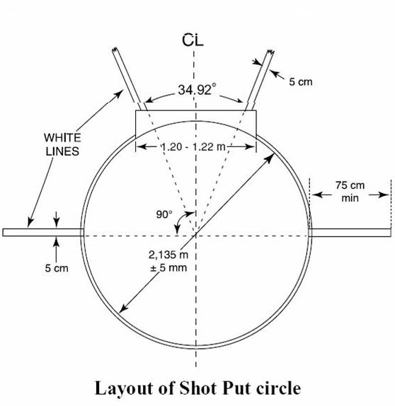

Shot put is measured in meters from the nearest mark made by the fall of the shot to the inside circumference of the circle, pulling the tape measure along a line from the mark through the center of the circle.

h. Three non-consecutive puts will be allowed. Measurement of all legal throws is required for the purpose of breaking ties.

i. Athletes shall pick up the shot put along the back of the circle. NOTE: Volunteers should not hand the shot put to the athlete.

- Softball Throw
a. A 30cm (11 3/4") in circumference softball shall be used.

b. Competitors may use any type of throw. The same throwing motion must be used for qualifying and final throws. Maximum approach distance will be 3m beyond the back of the throwing box.

c. The throwing area should be set up as follows:
1) Mark off two parallel lines which are 2.85m in length with each of the ends being 2 m apart. At the back end of the throwing area, place a mark 0.10 inch in length directly in the middle of the two end lines. (This is your pull-through point for measurement.) From this mark, extend an imaginary parallel line out three meters, mark this point, and draw an arc connecting both sidelines which intersect this point. The ball must land within a sector determined by a 40-degree angle emanating from the center of the back line. Extend two lines out which intersect both points where the arc meets the sidelines.

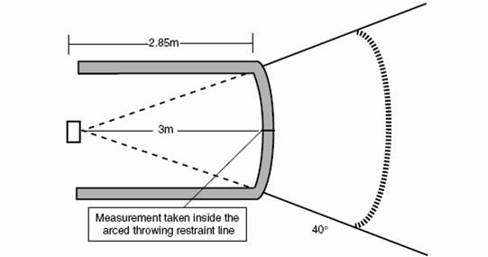

d. Each competitor shall be allowed three non-consecutive throws. The longest measurement of the three throws will be used for scoring. Throws will be measured in meters from the inner edge of the arced-throwing restraining line.

- Mini Jav (formerly known as Turbo Jav)

NOTE: SOWI mini jav rules are local to Wisconsin and do not follow Special Olympics, Inc. or IAAF rules for the mini-javelin.

a. A 300 gram mini jav may only be used for athletes 15 and under (weight standards are minimum). A 500 gram mini javelin must be used for athletes 16 and older (weight standards are minimum). An athlete may throw a heavier mini jav than the minimum if they choose. Mini javelins are available by contacting MF Athletics at www.everythingtrackandfield.com.

b. Only one thrower should be on the approach area at a time.

c. The mini jav must be held by the grip with the point facing forward.

d. The mini jav must be thrown using an over-hand throwing motion of the throwing arm.

e. The thrower may not use a 360-degree turn of their body during their approach. Each thrower is allowed three non consecutive throws. Each fair throw must be measured and the longest measurement of the three throws will be used for scoring. Throws will be measured in meters from the inner edge of the arced-throwing restraining line. Measurement of all legal throws is required for the purpose of breaking ties.

f. A thrower is allowed one minute to initiate a trial after their name is called.

g. The mini jav must land nose first. Otherwise, the throw shall be called a foul and thus not measured.

h. The thrower must throw the mini jav within the 40-degree sector lines. If the mini jav lands outside the sector lines, the throw will be called a foul and thus not measured.

i. During their approach, the thrower may not step on or over the side lines or the foul line.

j. After their throw the athlete must wait for the mini jav to land and the official to announce MARK or FOUL before exiting to the rear of the approach.

k. The throwing area should be set up as follows:
1) Mark off two parallel lines which are 2.85m in length with each of the ends being 2m apart. At the back end of the throwing area, place a mark 0.10 in length directly in the middle of the two end lines. (This is your pull-through point for measurement.) From this mark, extend an imaginary parallel line out 3m, mark this point, and draw an arc connecting both sidelines which intersect this point. The mini jav must land within a sector determined by a 40-degree angle emanating from the center of the back line. Extend two lines out which intersect both points where the arc meets the sidelines.

- Blind and Deaf Athletes
a. A rope or bell may be provided to assist athletes who are visually impaired. A tap start may be used only for an athlete who is both deaf and blind. A sighted guide may not pull or prompt the athlete in any manner. NOTE: The need for a sighted guide must be noted on a SOWI Special Needs Form that is submitted by the tournament registration deadline.

SECTION B – RULES FOR NON-MOTORIZED WHEELCHAIR EVENTS
1. To qualify to compete in wheelchair events, the athlete must require use of a wheelchair for every day movement.

2. Non-motorized wheelchair participants may enter up to three events. (Events must be non-motorized wheelchair, the softball throw or wheelchair shot put and/or mini jav).

3. Athletes shall start with the first two wheels behind the start line plane.
4. Motorized wheelchairs shall not be allowed in regular wheelchair races.
5. Only athletes who ambulate by use of a non-motorized wheelchair may participate in these events.
6. Athletes shall not be pushed, pulled or otherwise assisted during these events.
7. Bicycles, tricycles or similar vehicles powered via chain-driven propulsion are not legal wheelchairs and will not be allowed entry into non-motorized wheelchair competition.

8. The lanes for the wheelchair events shall be made two track-lanes wide.
9. 25m and 100m non-motorized wheelchair races
a. Competitors start with the first two wheels behind the start line plane.
  - A competitor completes the race when the leading wheels cross the finish line plane.
c. Each competitor must keep in his/her lane from start to finish and may not interfere, obstruct or impede the progress of another competitor. Infractions, at the discretion of the judges, may result in disqualification.

10. 30m Non-Motorized Wheelchair Slalom
a. The slalom race shall consist of competitors maneuvering through five cones. Beginning at the start line, place one cone in each lane at five-meter intervals. Cones should be placed in the middle of the lanes. Competitors must go in between all cones or be disqualified.

- No penalty will be incurred by touching a cone. Knocking down or displacing a cone constitutes a violation and a three-second penalty will be assessed per infraction.

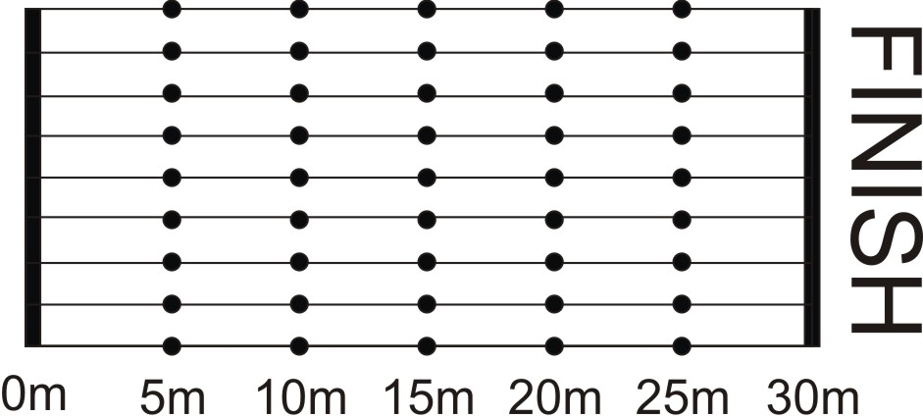

11. 4x25m Wheelchair Shuttle Relay
a. Four persons shall make up a team. Each competitor will complete 25m of the relay.

b. The second, third and fourth competitors of a team may not leave the start line until the leading wheel(s) on the wheelchair of the teammate who precedes him/her crosses a takeoff line 1m in front and parallel to the starting line.

c. The fourth competitor completes the race when the first two wheels cross the finish line.

d. Diagram:

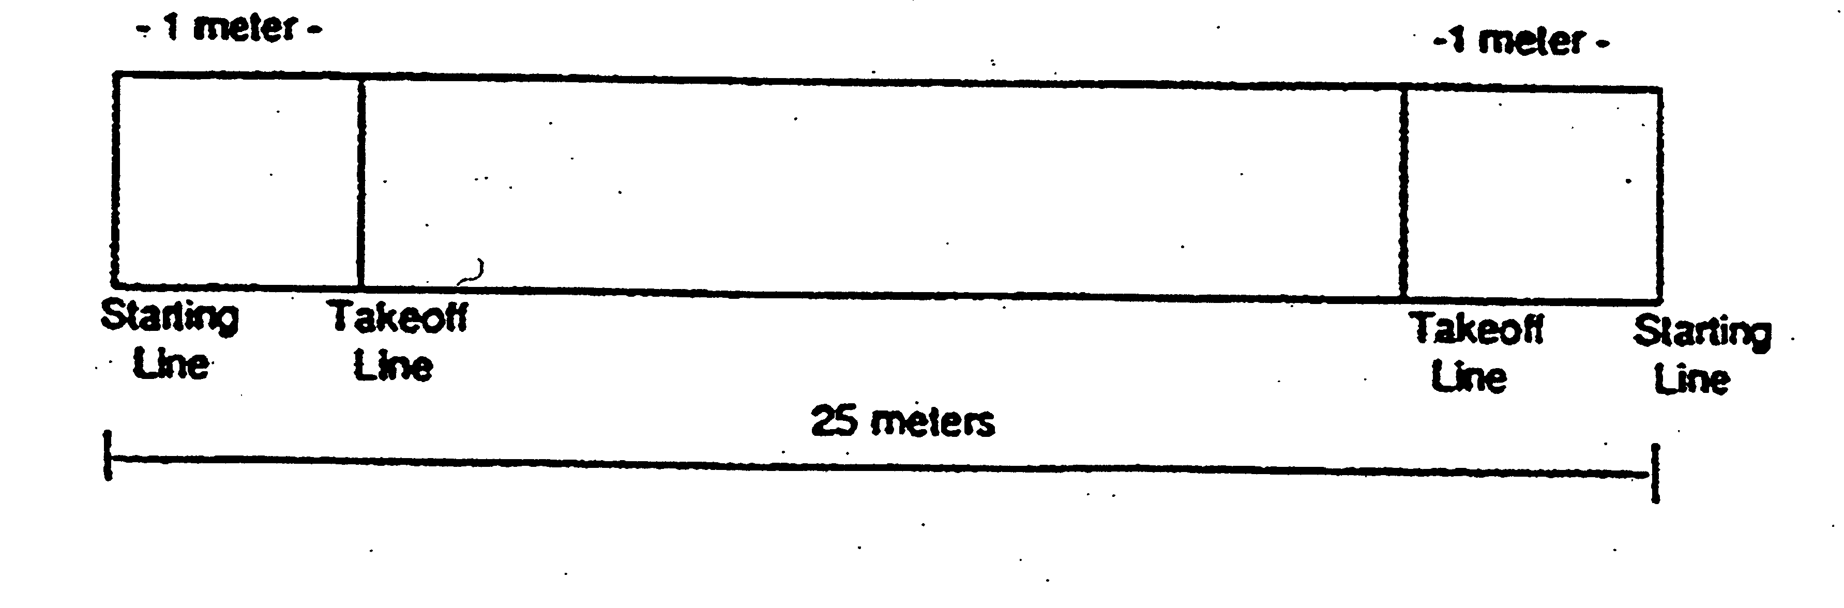

SECTION C – GENERAL RULES FOR MOTORIZED WHEELCHAIR EVENTS
1. To qualify to compete in wheelchair events, the athlete must require the use of a wheelchair for every day movement.

2. Motorized wheelchair participants may enter up to three events. (Events must be motorized wheelchair events, the softball throw or wheelchair shot put and/or mini jav).

3. These events are restricted to motorized wheelchairs only. Bicycles, tricycles, etc. are not legal wheelchairs (see non-motorized section).

4. The leading wheels on each competitor's wheelchair will be regarded as the starting and finishing points of all races.

5. Competitors start with the first two wheels behind the start line plane.
6. If a competitor varies from a sequence of obstacles, he/she must, without notice from any official, resume progress at the point prior to the incorrectly passed obstacle before entering the next obstacle and complete the course in its entirety, or be disqualified. In essence, failure to complete the course as designed will result in disqualification.

7. A competitor will be disqualified if that individual's coach (or assistants) enters the course boundaries during the running of the obstacle course. Coaches may instruct from outside the marked boundaries of the course. Judges and officials will not give directional cues.

8. 30m and 50m Motorized Wheelchair Slalom
a. Rules
1) The athlete begins slalom with the leading wheels of the wheelchair behind the start line.

2) The athlete starts slalom at the sound of the starter's gun.
- The athlete maneuvers his/her chair through the course and across the finish line without touching the cones or impeding another athlete on the course.

- Cones are placed 5m apart with the first cone placed 5m from the starting line.

- Knocking down or displacing a cone constitutes a violation and a three-second penalty will be assessed per infraction.
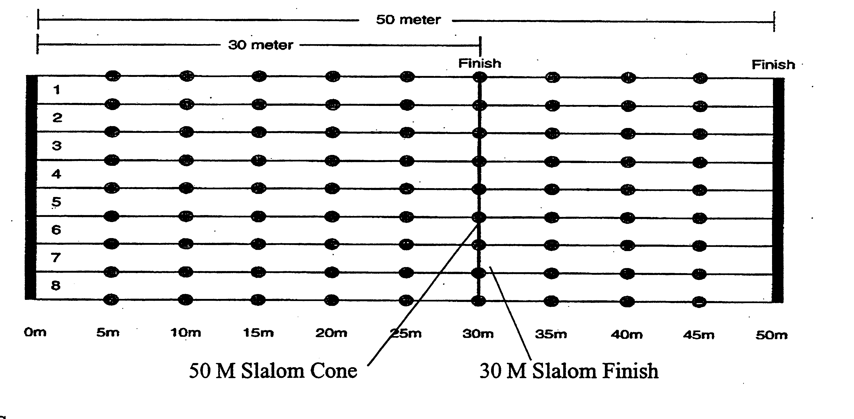

b. Score
1) The athlete is timed from the sound of the starter's gun to when the leading wheels on the motorized wheelchair cross the plane of the finish line.

2) No penalty will be incurred as a result of touching a cone. Knocking down or displacing a cone constitutes a violation and one three-second penalty will be assessed per infraction.

3) If a tie exists, a run-off will be held between the tied competitors.
9. 25m Motorized Wheelchair Obstacle Course
a. Rules
1) The athlete starts facing the course.
2) When inside or near the box, the athlete in the wheelchair completes a 360-degree circle. The athlete is not deducted any points or time for touching the lines on the box. The box is only an indicator for the athlete to do a complete circle with his/her wheelchair.

3) After the 360-degree circle is completed, the athlete weaves in and out of cones set at three meters apart, and then enters the second turning box.

4) The athlete completes a 360-degree circle near or within the box, and then continues forward to the finish line.

5) The box (three meters in diameter) is used only as an indicator for the athlete to complete a 360-degree circle between either the starting line and the first cone, or the third cone and the finish line. The box can be outlined with tape or chalk.

- There will be no penalties if an athlete strikes a cone or knocks over a cone. However, it is up to the official to determine that the athlete was making an honest effort to go around the cones, and not drive over the cones in a straight-line pattern. If it is determined that the athlete drove his/her wheelchair over the cone without an effort to go around, that athlete shall be disqualified.

- There shall be no more than three athletes per race.
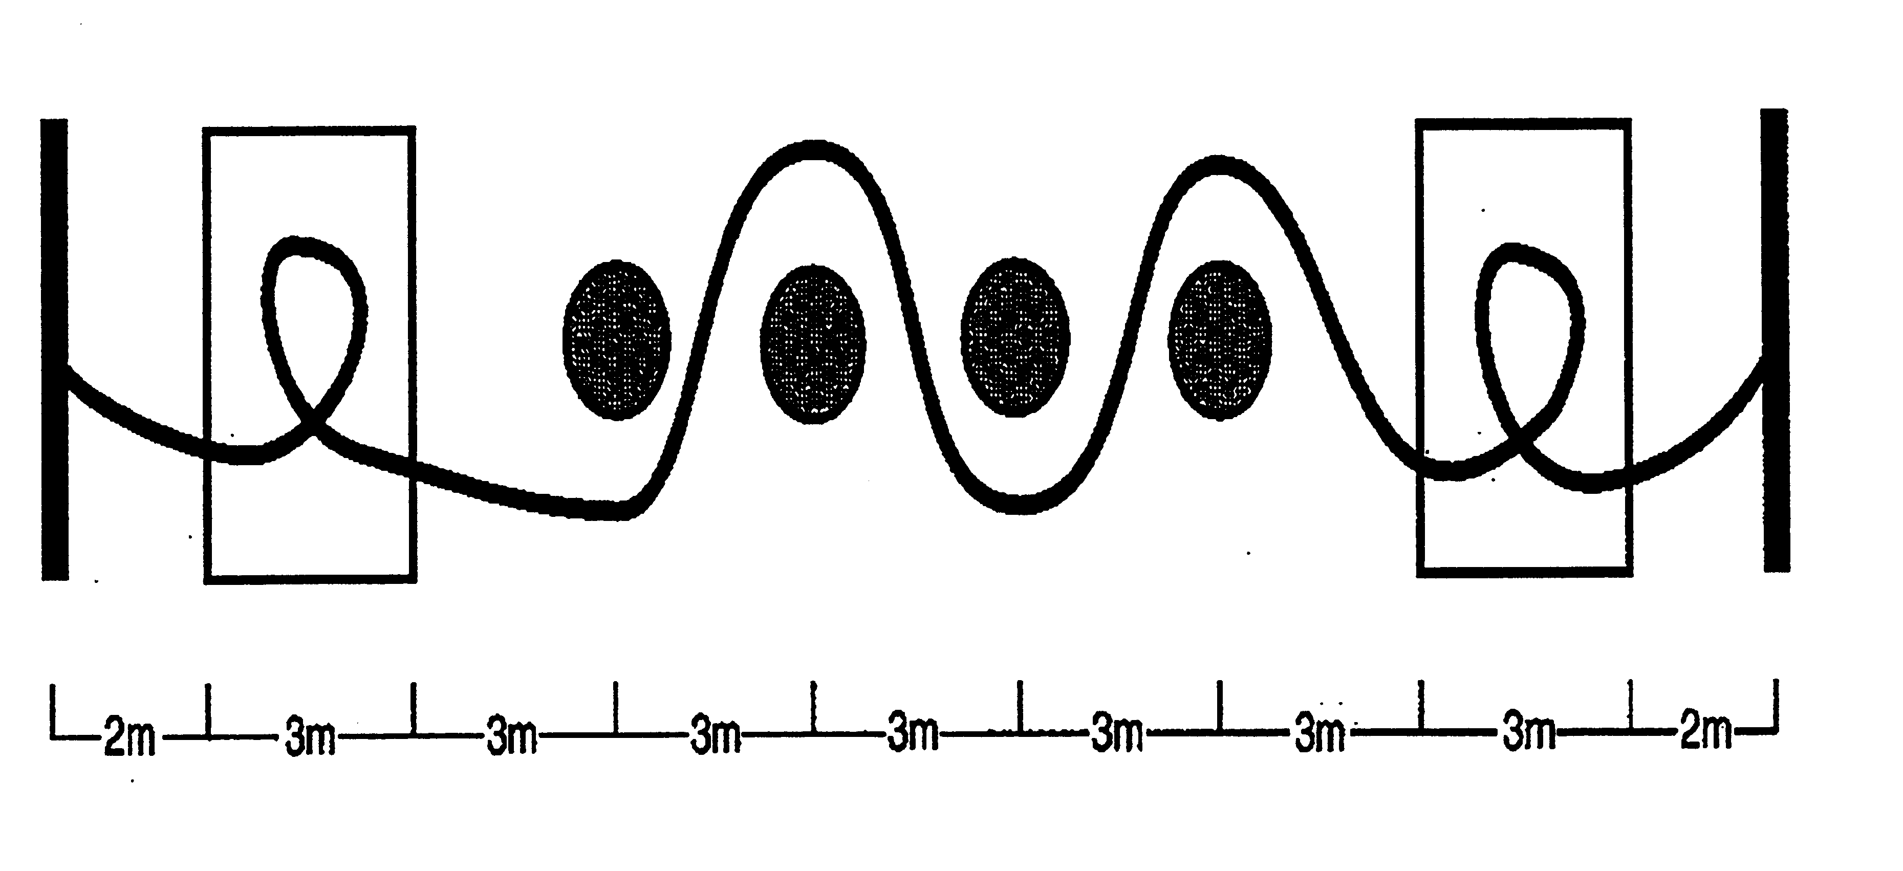

b. Score
1) Time is started when the starter's gun is sounded, and is stopped when the leading wheels of the wheelchair cross the finish line.

Athletics Competition Schedule Conflict Policy
If an athlete competing in athletics has a scheduling conflict in two of the events they are entered in, the following policy and procedure shall apply:

Track events shall take precedent over field events. The athlete will report when called to report to the track staging area. The athlete’s coach or their designee shall report to the field event staging area that the athlete is in a track event and will report to the field event as soon as the track event is completed. The athlete upon completion of the race will report immediately to the field event staging area without waiting to receive their track event award. The athlete’s coach or their designee shall inform the track award station that the athlete will return to receive their award as soon as they complete their field event.

If there is a scheduling conflict for the athlete in two field events, then the athlete shall report to one of the field event staging areas when called to report for staging and the athlete’s coach and/or designee shall inform the other field event staging area that the athlete has a scheduling conflict and will report as soon as their field event trials are completed. The athlete will forego the award ceremony as stated in the previous procedure (#1).

A division of athletes shall not be held in the staging area for more than 30 minutes from when the division was called to report. If an athlete is missing from a division due to a scheduling conflict, the athlete must report back to the staging area within 30 minutes of their event being called to report. Should the athlete fail to report within the 30-minute hold period, the division shall be released to compete in the event with the missing athlete receiving a scratch for each missed attempt. The athletes in a division shall each make an attempt in the order they are listed on the division card. If when it is the turn of the missing athlete to make an attempt and they have not reported, that attempt will be recorded as a scratch. Missed attempts cannot be made up.

A division of athletes in a field event may be sent to compete with an athlete missing due to a scheduling conflict. If the missing athlete has not returned by the time the awards area is ready to present awards to the division, the awards area shall present the awards based on the results in hand. Should the missing athlete return to compete within the previous listed parameters, the athlete shall have their final score compared against the rest of the athletes within the division and the athlete shall receive the place based on the comparison. The awards presented previous to the return of the missing athlete shall not be affected by the missing athlete’s award position (place). Should there be a duplication of final awards places (i.e. two first places awarded, two second places awarded, etc.) within the division, the official awards entry shall list it as a tie event though the scores do not match.

